Report on Heights

Ladan Foroughi

21/06/2021

The Heigth dataset is in dslab package in R that is used in this report. In this datasets the height based on different gender (Male and Female) are meaured. The 6 rows of these datasets are shown below:

Heights Datasets

|  |  |
| --- | --- |
| sex | height |
| Male | 75 |
| Male | 70 |
| Male | 68 |
| Male | 74 |
| Male | 61 |
| Female | 65 |

## Including Plots

You can also embed plots, for example:

Average of Height in Female/Male group

|  |  |  |
| --- | --- | --- |
| sex | Average_of_Height | standard_deviation |
| Female | 64.9 | 3.76 |
| Male | 69.3 | 3.61 |

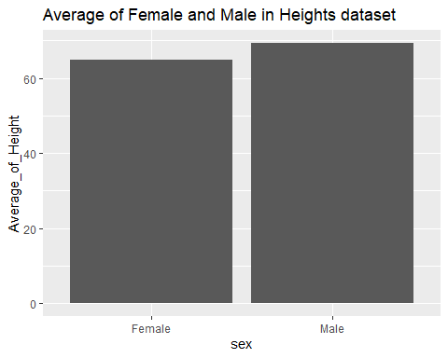

The end