Heights Datasets (sex-height)

Ladan Foroughi

22/06/2021

This report is prepared based on Heights datasets in dslabs packages in R. All the library need to used in this analysis are:

The 6 rows of these dataset is shown below:

Heights Datasets

|  |  |
| --- | --- |
| sex | height |
| Male | 75 |
| Male | 70 |
| Male | 68 |
| Male | 74 |
| Male | 61 |
| Female | 65 |
| ## Analys | is data |

Based on the analysis of this datasets, the percentage and number of female and male are in table below:

Percentage and Number of Female and Male in Heights Dataset

|  |  |  |  |
| --- | --- | --- | --- |
| F_perc. | M_perc. | F_no. | M_no. |
| 0.227 | 0.773 | 238 | 812 |

## Plot of avgerage of height in female and male

The specifivation of average height and standard deviation for each gender is shown in figure below:

Average of Height in Female/Male group

|  |  |  |
| --- | --- | --- |
| sex | Average_of_Height | standard_deviation |
| Female | 64.9 | 3.76 |
| Male | 69.3 | 3.61 |

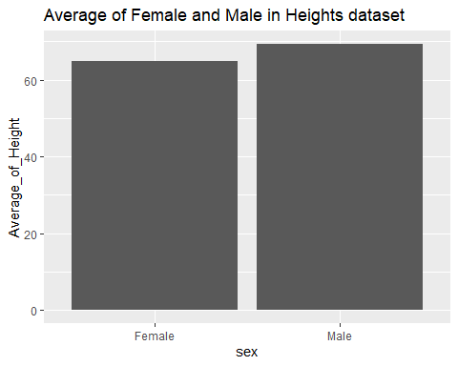

## Conclusion

the results of this report show that the average height in male is higher than female.