**Sanket - Technology Demonstration of Antenna Deployment System**

**on PSLV Stage 4 Orbital Platform**

1Karan Jagdale, 1Mrigi Munjal, 1Prashant Kurrey, 1Ashay Wakode, 1Pushkar Lohiya, 1Puneet Shrivas, 1Anmol Sikka,

1#Sanskriti Bhansali, 1Abhishek Kejriwal, 1Amrutha Lakshmi Vadladi, 1Ankit Kumar, 1Atharva Savarkar, 1Hemant Dilip Gidewar, 1Hrithik Agarwal, 1Mohit Dhaka, 1Pranav G Kasat, 1Ritul Shinde, 1Shreya Laddha, 1Adesh Yadav, 1Akshat Mehta,

1Dhanush S, 1Ishan Phansalkar, 1Jayant Saboo, 1Kriti Verma, 1Leena Chaudhari, 1Navjit Debnath, 1Shreeya Shrikant Athaley,

1Shreyas Sabnis, 1Vidushi Verma, 1Vineet Gala, 1Yatin Jindal

1Student Satellite Lab*, Aerospace Department, IIT Bombay, Mumbai, 400076, India

#E-mail: [pm.satlab.iitb@gmail.com](mailto:pm.satlab.iitb@gmail.com)

**Abstract**

An Antenna Deployment System has become an essential component of any pico- or nano-satellite design due to space constraints during launch. The Sanket mission is a technology demonstration designed to be flown on the Indian Space Research Organization’s PSLV Stage-4 Orbital Platform (PS4-OP) [1]. It aims to qualify the team’s Antenna Deployment System (ADS) in Ultra High Frequency (UHF) band to a Technology Readiness Level (TRL)-7 in Low Earth Orbit (LEO). Sanket comprises of an ADS and an Auxiliary system. The purpose of the auxiliary system is to test the ADS on PS4-OP simulating a 1U CubeSat mission life cycle and conditions. Sanket will be mounted on PS4-OP which remains in LEO for around six months. Our Antenna Deployment System is developed as an independent module that is compatible with standard CubeSat sizes 1U, 2U, and 3U.

**Keywords**

Antenna Deployment System, CubeSat, PS4-OP, Student Satellite, Technology Demonstration, UHF Antenna

**Nomenclature and Acronyms**

ADS = Antenna Deployment System

AUX = Auxiliary System

Downlink = Signal transmitted from deployed antenna to ground station

EEPROM = Electrically Erasable Programmable Read-Only Memory

GFSK = Gaussian Frequency Shift Keying

HM = Health Monitoring

OOK = On Off Keying

PSLV = Polar Satellite Launch Vehicle

Telemetry = Signal transmitted from the antenna on PS4-OP

Telecommand = Signal transmitted to the antenna of PS4-OP

Uplink = Signal transmitted from ground station to the deployed antenna

**I. Introduction**

“Sanket”, literally meaning “Signal” in Sanskrit, is the name of the mission to demonstrate the ADS, designed and developed for CubeSat applications by the IIT Bombay Student Satellite Program. As the number of CubeSat missions in India continues to grow, the need for indigenously developed, reliable communication systems become more pressing. Various international firms manufacture and sell Antenna Deployment Systems for CubeSat applications. However, these are associated with steep costs and accessibility issues. The reliable power and telemetry subsystems of PS4-OP provide the perfect opportunity to test the ADS. The payload will be verified by establishing a half-duplex communication link between the deployed antenna and ground station. Post successful technology demonstration, technology will be transferred to the Indian industry to aid and promote future CubeSat missions in India as an indigenous solution.

**II. System Description and Methodology**

**Mechanical Structure:** The ADS comprises of an in-house manufactured antenna, support and interface structures for the antenna, a deployment mechanism and the ADS PCB. The antenna, made of stainless-steel tape spring, is rolled and held inside the module with the help of a flexible PVC/PVA sheet. The retention and release mechanism uses a nichrome burn-wire design that releases the stowed antenna by thermally cutting a nylon thread held in tension connected to the flexible PVC/PVA sheet. This ADS is mounted on the AUX, which is inspired by Advitiy (2nd Student Satellite of IIT Bombay) a standard 1U CubeSat [2]. The structure is made of Al-6061-T6 (SS), and the PCB is made of FR04 polymer. The system design is carried out through an iterative process from making the configuration layout to its CAD, simulating it. The model is then manufactured for testing and checking the manufacturability to resolve the concerns in the upcoming iteration. Prototypes and Engineering models are manufactured for better visualisation and testing purposes, whereas Qualification Model and Flight Model are made for complete rigorous testing and launch respectively.

____________________________________

*Student Satellite Program, IIT Bombay, is an initiative taken up by the students to make IIT Bombay a centre of excellence in space science and technology. The first satellite, Pratham, was launched on-board the PSLV-C35 on 26th September 2016. The team now works on designing space systems for CubeSats. With this objective, an Antenna Deployment System and a Star Tracker based Attitude Determination System are being developed and are aimed to be tested on-board PSLV’s Orbital Platform.

URL: <https://www.aero.iitb.ac.in/satlab/>

Static, Harmonic, Modal and Random vibrations simulations are performed for PSLV launch loads on the structure and stress analysis is carried out. These, as well as simulations for thermal analysis [3], are performed in ANSYS. These simulations are done to ensure that the system is safe to fly on the PSLV and faces no damage during the flight and later in orbit. The system mechanically integrates to PS4 Orbital Platform through 8 M6 fasteners via the protrusions present on the lower chassis.

Table. 1: System Description

|  |  |  |
| --- | --- | --- |
|  | **Dimensions** | **Mass** |
| **ADS** | 98mm x 98mm x 8.6mm | 74.90 g |
| **Sanket (ADS + AUX)** | 126mm x 433mm x 100mm | 713.05 g |

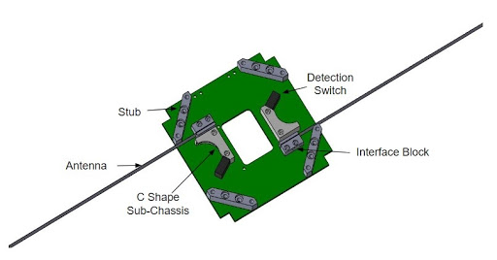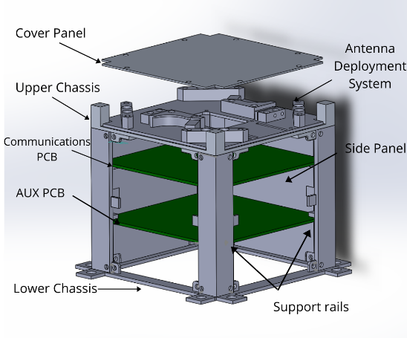

Fig. 1. ADS Fig. 2. Sanket

**Electrical design:** Sanket accommodates AUX, Communication and ADS PCBs (refer Fig. 2). The system will electrically interface with the PS4-OP via a D-connector to receive unregulated power of 28V-10W. The fluctuations will be mitigated by the EMI filter (SVRMC28), and the Voltage Regulator (SVRHF283R3S) will step down the voltage to a fitting 3.3 Volts to power the whole system. Current limiters (TPS7H2201-SP) are used to avoid over-current damage of the components on the PCBs and also act as controlled switches. The AUX PCB has its AUX microcontroller (ATmegaS128) which is responsible for the scheduling of tasks, communicating with the PS4-OP for telemetry and telecommand, collecting HM Data and enabling the power supply to the ADS and Communication PCB. The collected HM Data is stored on the EEPROM (AT69170F). When scheduled, the ADS PCB would use the buck converter (TPS-50601A-SP) to lower the down the voltage received from AUX PCB and apply it to the nichrome wire which thermally cuts the nylon wire and deploy the antennas. The deployment will be detected by a Single Pole Double Throw (SPDT) switch, one for each pole of the dipole antenna. All PCBs are designed in EAGLE and undergo pre-fabrication and post-fabrication quality checks. Flight codes are written in Atmel Studio and are simulated on Proteus. Version control is done using Git.

**Communication design:**Deployable dipole antennas are designed to work in the UHF band (435-438 MHz) and will be used to communicate with the ground station. The UHF band requires small antenna pole length and hence is ideal for CubeSat use. The antenna is designed and simulated in ANSYS HFSS and optimised for minimum S11 in the required frequency band. Tapered traces on ADS PCB ensure impedance matching between the antenna and the feed. The Communication PCB is responsible for RF communication. A single transceiver (CC1125), programmed by the communication microcontroller (ATmegaS128) handles both, the uplink as well as the downlink channel. The communication microcontroller also collects the HM data from AUX microcontroller, which is transmitted along with the identity (name + callsign) as OOK modulated downlink. A high-power amplifier (CMX901) amplifies the downlink signal before it is transmitted by the antenna. The GFSK modulated uplink commands received by the antenna is amplified by a low noise amplifier (MAAM-011229) before being demodulated. The switching of signals between the uplink and downlink channels is going to be done by a high-power switch (HMC574A).

**The design development proceeds in the following order:**

**Prototype → Engineering Model → Qualification Model (QM) → Flight Model (FM)**

The Prototype is made to prove the concept, Engineering Model is a working system with cost components, Qualification model and Flight Model will be made using the space-grade components.

The design process followed by the team is based on the V-model derived from the principles of Systems Engineering. All requirements on every subsystem are listed, and a checklist or a set of test cases to qualify the requirements is prepared to use at each development stage for Quality Assurance (QA). An Interface Control Document (ICD) is maintained, which defines how all parts integrate into the final design. Risk analysis is performed on the system to identify and take actions to eliminate or reduce failures.

**III. Analysis**

Electrical components need to be shielded from ionizing radiation, and thus simulations were performed on SPENVIS. Therefore, it is decided to cover the system with panels of 3mm thickness to reduce the effects on crucial electronics effectively. Fixtures are designed to facilitate the integration of Sanket and ADS.

Bolt preload study is done to find fasteners and the optimal preload (torque) that should be applied to screws, nuts and bolts to reduce the chances of failure at all the joints. The AUX and Communications PCBs are fixed, one from above and one from below (see fig.2) to tackle integration constraints.

All the electrical components selected are of space-grade qualification and radiation-hardened or having space heritage with an operating temperature range of -55℃ to 125℃, selected after considering power requirements and efficiency parameters in accordance to the power budget. All on-board decisions are going to be made by the AUX microcontroller, including switching between uplink and downlink. A high power switch is used to facilitate this switching between uplink and downlink channels instead of a circulator because the circulator has larger dimensions and more weight. Health Monitoring (HM) data will be collected and analysed on-board at regular intervals so that any unusual voltage or current values can be detected immediately. Apart from this, all the data will be stored and sent through PS4 telemetry for future analysis. HM data received through downlink will be cross-checked with the data received through telemetry to ascertain the functioning of the deployed antenna. OOK modulation has been chosen for downlink since it has the best signal to noise ratio (least required threshold) out of all the modulations. GFSK will be used for uplink modulation as it provides higher data rates with a better noise immunity and moderate signal to noise ratio requirement. The uplink and the telecommand can be used to Kill (disable) or Restart the Sanket. Provisions for an uplink command for verification of uplink have also been made. Acknowledgement of the instructions uplinked will be taken in telemetry to test uplink.

The Student Satellite Program has a dedicated Ham team and a ground station segment which has developed expertise in satellite tracking through regular satellite tracking sessions. The team receives and processes downlink data received from various satellites like NOAA, ISS, FOX AO and QO100.

**IV. Results and Discussions**

**Structural Simulation results:** To investigate the structural safety of Sanket during the launch, Equivalent (Von-Mises) (denoted by E) stresses from various types of simulations are checked. The factor of safety (FOS) is calculated for every part of the system from ANSYS simulation results.

Table. 2: Structural Simulation Results

|  |  |  |  |  |  |  |
| --- | --- | --- | --- | --- | --- | --- |
|  | **Static (Max. Stress in MPa)** | **1st Frequency (Hz)** | **Harmonic (Max. Stress in MPa)** | **Random Vibration (Max Stress MPa)** | | |
| **x-axis** | **y-axis** | **z-axis** |
| **Components** | Bottom Cage | PCB | Support Rail | Bottom Cage | Bottom Cage | PCB |
| **Operational Limits** | 275 | 90 (min.) | 275 | 275 | 275 | 120 |
| **Simulation Results** | 11.49 | 252.76 | 5.22 | 29.45 | 32.18 | 54.63 |
| **FOS** | 23.93 | - | 52.68 | 9.34 | 8.55 | 2.20 |

**Thermal Simulations results:** Simulation of a simplified model of Sanket was performed in ANSYS for one orbit period. Over the time period, the maximum temperature of 79.362℃ was recorded on the C-Shaped sub-chassis and the minimum temperature of -85.402℃ was recorded on the antenna. High-Power Amplifier, EMI Filter and voltage regulator are the most critical components in the system which radiated maximum thermal radiation.

**Deployment tests:** These tests were performed on the acrylic prototype of ADS (refer Fig. 3a & 3b) to find the range of current across the nichrome wire that would ensure the cutting of nylon wire in around two seconds. A digital power source was used to generate a potential difference between the ends of nichrome wire, which is 32 AWG and 1.5 cm in length, the test was concluded under 4V. When tested in room temperature, it was observed that the time to break the nylon thread is less than 2 seconds when the current in Nichrome is around 1.2 Ampere. At this current, the temperature of Nichrome reaches more than 200℃, which is significantly higher than the temperature of PS4-OP during launch. This test ensured that thermal cutting is not initiated automatically, due to unexpected temperature variations of the system. Double-stranded braided nylon was tested which showed improved strength and similar thermal cutting time as compared to its single-stranded counterpart. A better alternative for nylon, Vectran, will be used for further deployment tests.

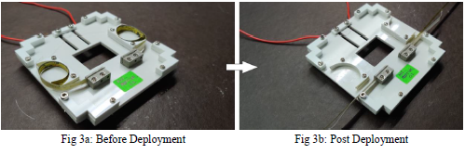

Fig. 3a: Before Deployment Fig. 3b: Post Deployment

**Antenna Simulation:**

Modelling of the antenna is done in ANSYS HFSS-15 by assuming the PS4-OP as a hollow aluminium cylinder of radius 1 meter, length 2 meters and thickness 0.2 meters. The CubeSat was modelled as a 1U hollow aluminium box and placed on one of PS4OP’s flat surfaces. The dipole antenna’s poles are modelled as stainless-steel strips with width 6 mm, thickness 0.1 mm and variable length (to be optimised).

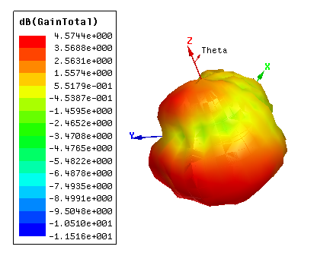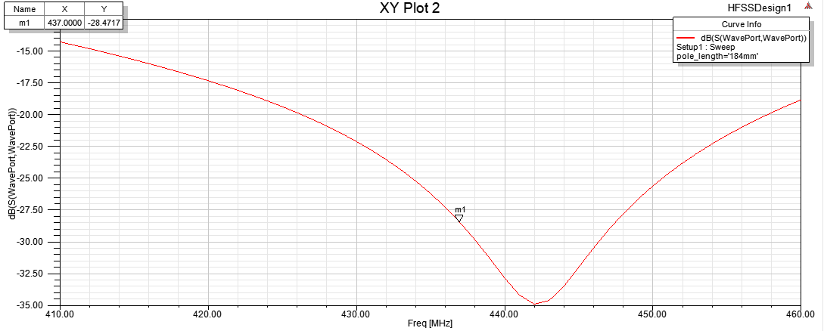

Fig. 4: 3D Radiation Pattern                                             Fig. 5: S11 Plot

Table. 3: Simulation for the pole length

|  |  |  |  |  |  |
| --- | --- | --- | --- | --- | --- |
| **Pole length (mm)** | **S11 at 437 MHz (dB)** | **Freq of min S11 (MHz)** | **Min S11 (dB)** | **Max Gain (dB)** | **HPBW (degrees)** |
| **180** | -18.83 | 456 | -31.82 | 4.45 | 75.46 |
| **182** | -23.38 | 447 | -40.29 | 4.47 | 73.53 |
| **184** | -28.47 | 442 | -34.85 | 4.57 | 72.47 |
| **186** | -25.41 | 432 | -26.66 | 4.49 | 75.24 |

One pole of the dipole antenna is grounded, and the other pole is the feed. The PS4-OP is taken as the ground.

It was observed in all the cases that the radiation pattern is asymmetrically skewed towards the direction of the feed pole. The most favourable S11 (lowest) and radiation pattern (high gain & high beamwidth) were obtained for pole length = 184 mm.

**V. Conclusions**

Antenna simulations show that the radiation pattern is expected to get highly distorted due to the large metallic body of PS4-OP. The gain of the antenna is significantly higher than the conventional dipole antennas making the radiation pattern directive. This puts the requirement of precise control on the platform for continuous signal reception. Due to the unavailability of anechoic chambers, it is decided to measure the radiation pattern in an open ground to minimize the inaccuracy due to signal absorption.

The deployment tests show that the deployment time is less than 1 second at room temperature, but it increases as the surrounding temperature decreases. This encourages the necessity of deployment testing at different temperature and pressure conditions. Following this need, manufacturing of vacuum chamber has been initiated.

The structural simulations indicate that every mechanical component has FOS >1.5. The mission is at a stage where the design is finalized, and component level testing has started according to the V-model design approach.

The reliable power and telemetry subsystems of PS4-OP provide the perfect opportunity to test the ADS for different communication modes. The telemetry will help to closely monitor the system status even if the deployment is failed. This gathered data of system status will be crucial for future missions.

**Acknowledgements**

We would first like to express our sincere gratitude to ISRO for inspiring young minds to venture into the domain of space science and technology and guiding us over the last 12 years. We would thank Prof. Varun Bhalerao,

Prof. Prabhu Ramachandran and Prof. Arnab Maity, our Faculty Advisors for giving us timely inputs and suggestions as also freedom and space for our design. We extend thanks to Industrial Research and Consultancy Centre (IRCC), IIT Bombay for providing us with the funds needed for a project of this magnitude and the Department of Aerospace Engineering, IIT Bombay for providing us laboratory space. We want to thank IIT Bombay as a whole for creating an environment conducive for growth and excellence. Finally, we would like to thank the families of our team members who support us. 

**References**

[1] Indian Space Research Organisation, 2019. Announcement of Opportunity for Orbital Platform. *Bangalore- 560 231*

[2] Kothari, H., Lohiya, P., Zubair, A. and Singh, S., 2020. Satellite Structure of Advitiy (Second Student Satellite of IIT Bombay). In *Advances in Small Satellite Technologies* (pp. 535-544). Springer, Singapore, pp. 535 - 544.

[3] Garzon, M. M., 2012. Development and Analysis of the Thermal Design for the OSIRIS-3U CubeSat.