Telesupport hub: cloud-based telecom support with flask on aws

Project Report

1. Introduction
In the rapidly evolving digital landscape, effective customer support acts as the backbone of customer retention and overall business success. TeleSupport Hub is a comprehensive web-based customer support portal meticulously designed to streamline interactions between customers seeking assistance and support agents providing resolutions. The platform facilitates a seamless, end-to-end experience for users, allowing them to register, purchase specific service plans, raise support tickets categorized by priority, and securely manage their historical interactions with the company.
Concurrently, TeleSupport Hub empowers support agents through a centralized, secure dashboard. This backend interface enables agents to efficiently track, manage, and prioritize customer issues in real-time, effectively reducing resolution delays and preventing tickets from falling through the cracks. The system operates on a robust architecture, utilizing a Flask backend and a highly available MySQL database hosted on Amazon Web Services (AWS) Relational Database Service (RDS).

2. Project Member
Developed By: Amruta Khade

3. Project Overview
TeleSupport Hub is an advanced web application leveraging the power of Python's Flask framework combined with state-of-the-art frontend styling known as Glassmorphism. The project bridges the communication gap between service providers and consumers by establishing an organized ticketing pipeline.
The project handles multiple distinct user roles. Customers have access to a clean, intuitive interface where they can view their customized dashboard, browse a catalog of available services, execute purchases, and raise detailed support requests. Agents, on the other hand, are provided with an authoritative view of the entire ticket database, allowing for immediate triage and action.

4. Objectives
The primary objectives of the TeleSupport Hub project include:
- To provide a 24/7 accessible platform for customers to log issues without waiting in telephonic queues.
- To categorize and prioritize support requests dynamically based on customer input.
- To securely manage customer authentication and session states utilizing server-side validation.
- To implement scalable database connectivity using AWS RDS and MySQL connection pooling.
- To deliver a highly responsive, modern, and aesthetically premium User Interface.

5. Requirement Analysis

5.1 Functional Requirements
- User Registration & Login: The system must allow users to securely register and log in.
- Role-Based Access: The system must differentiate between 'Customer' and 'Agent' roles.
- Service Catalog: The system must display available service plans fetched from the database.
- Ticket Generation: Authenticated customers must be able to submit tickets with descriptions and priorities.
- Ticket Dashboard: Agents must be able to view a tabular list of all active tickets.

5.2 Non-Functional Requirements
- Performance: The application should load pages in under 2 seconds and handle concurrent database connections efficiently via pooling.
- Security: User passwords must be protected. Session variables must securely enforce access control.
- Usability: The UI must be intuitive, fully responsive across devices, and visually engaging (Glassmorphism).
- Availability: The database hosted on AWS RDS must ensure high availability and data durability.

5.3 Feasibility Study
Technical Feasibility: The tech stack (Python, Flask, MySQL, HTML/CSS) is well-documented, highly supported, and capable of handling the project requirements. AWS RDS provides seamless cloud database hosting.
Economic Feasibility: Utilizing open-source frameworks (Flask) minimizes development costs. AWS offers a free tier suitable for MVP deployment, making it highly economically feasible.

6. Database Architecture & Schema
The application utilizes a relational database management system (RDBMS) configured with strict referential integrity. The schema consists of five primary tables:
- Customers Table: Stores user demographic and authentication data (ID, Name, Mobile, Email, Password, Address).
- Agents Table: Stores internal support staff credentials.
- Categories Table: A reference table containing available service plans and their descriptions.
- Tickets Table: Stores customer support requests, linking the Customer ID to the issue description, plan type, and priority level.
- Orders Table: Tracks service purchases, linking Customer IDs to Category IDs with a timestamp.

7. Use Case Scenarios

Use Case 1: Customer Registration
Actor: Customer
Pre-condition: User must not have an existing account.
Post-condition: A new account is created and saved in the RDS database. User is redirected to login.
Main Flow: Customer enters details -> Submits Form -> System Validates -> Record Inserted.

Use Case 2: Raising a Ticket
Actor: Customer
Pre-condition: User must be authenticated.
Post-condition: A new ticket record is created linking to the user's ID.
Main Flow: Customer navigates to 'Raise Ticket' -> Selects Priority -> Enters Details -> Submits -> System stores ticket.

Use Case 3: Agent Ticket Review
Actor: Agent
Pre-condition: Agent must be authenticated with valid credentials.
Post-condition: Agent views a complete list of tickets.
Main Flow: Agent logs in via /agent -> System fetches tickets -> Agent views Dashboard.

8. User Interface & Screenshots
The user interface was built meticulously using Vanilla CSS, avoiding heavy external frameworks to ensure maximum performance and customizability. A 'Glassmorphism' effect was achieved using background blurs and semi-transparent overlays against a rich, dark gradient backdrop.
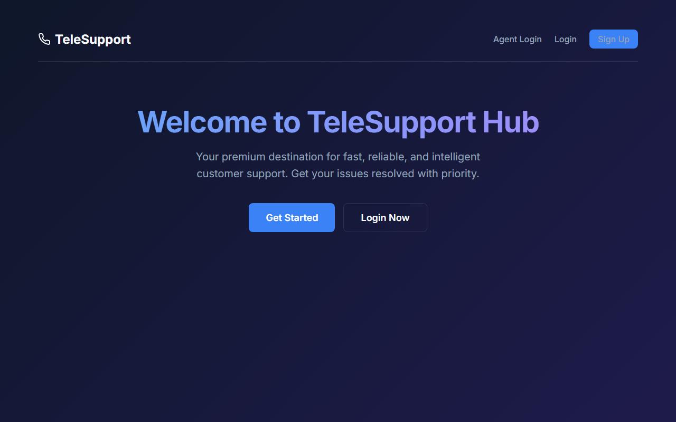
Figure 1: Home Landing Page
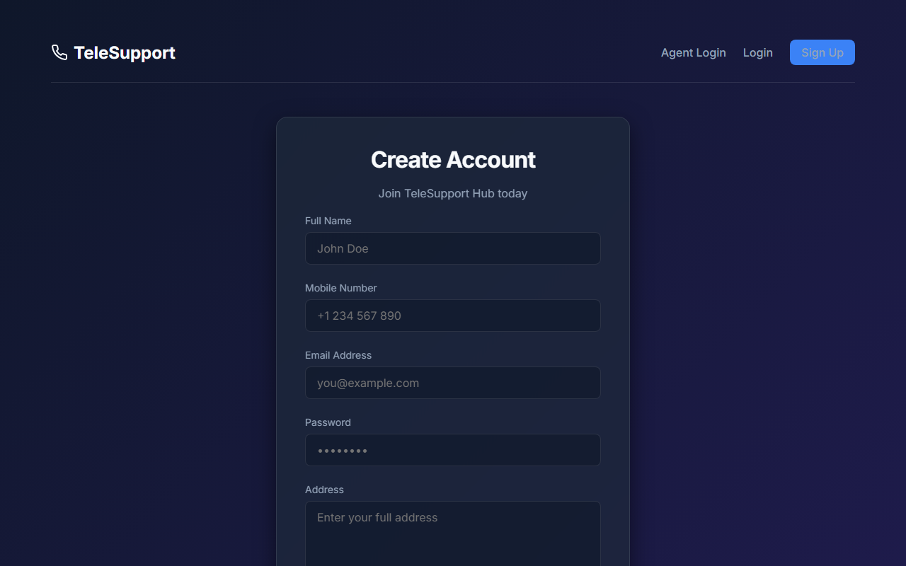
Figure 2: Customer Registration Portal

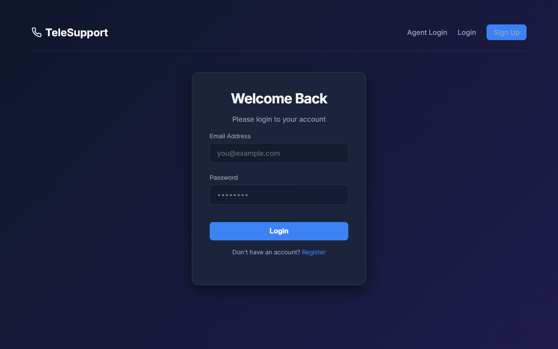
Figure 3: Customer Login Portal

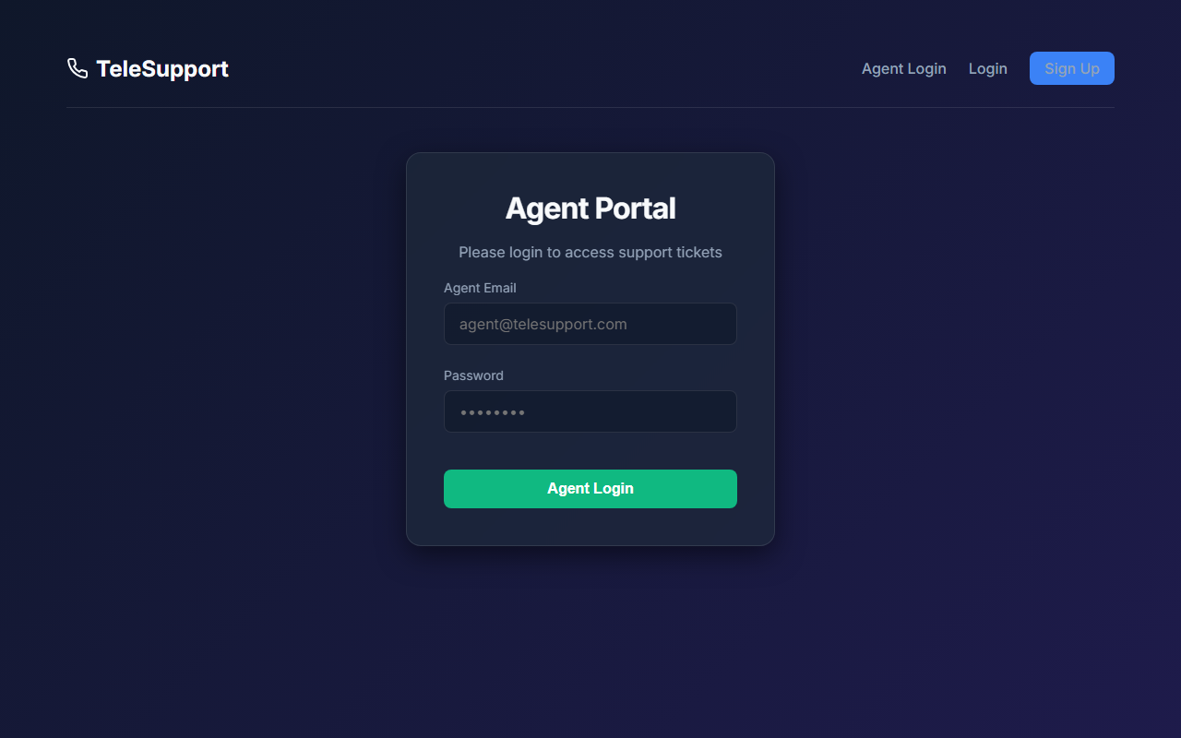
Figure 4: Agent Secure Portal

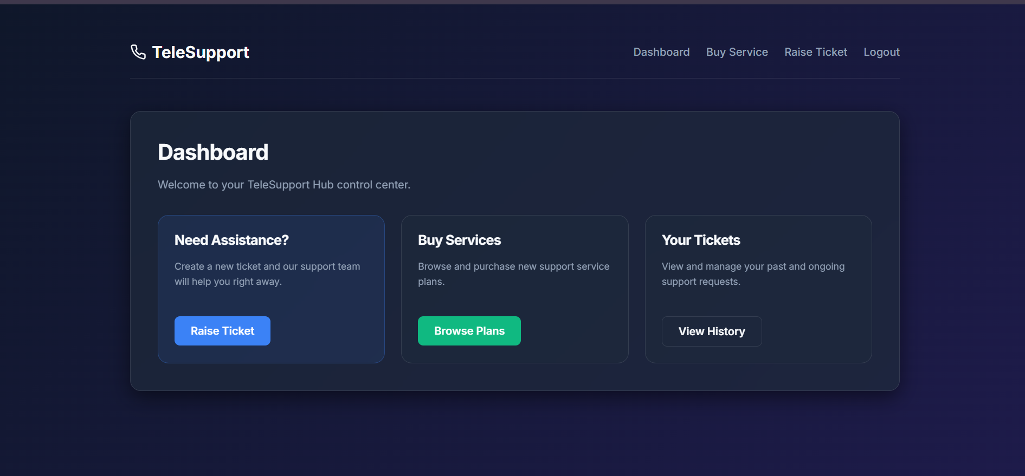
Figure 5: Customer Dashboard

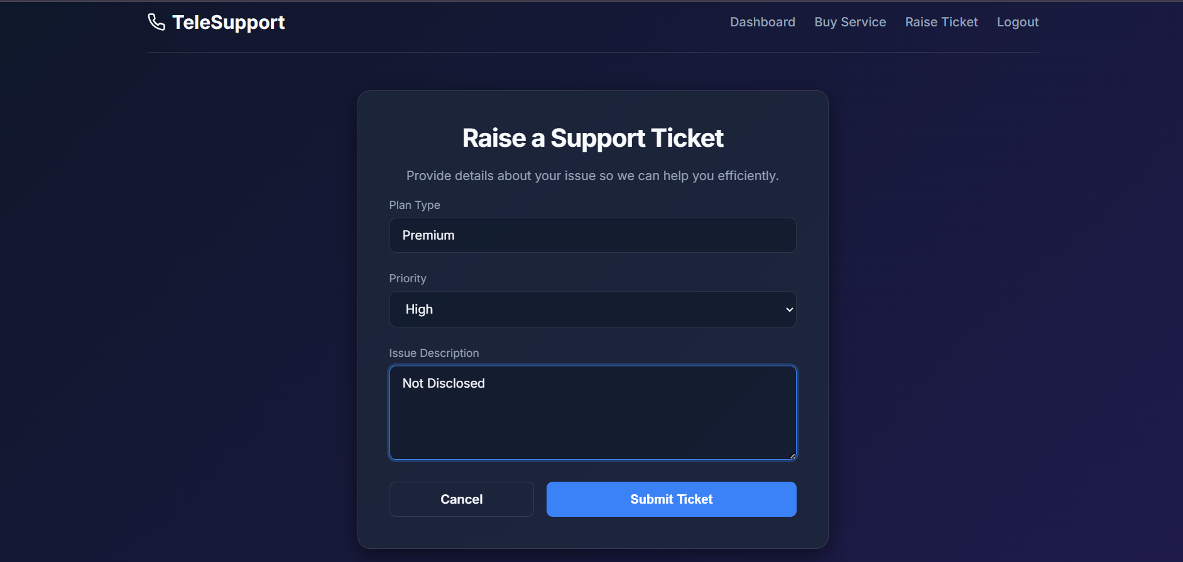
Figure 6: Raise a Ticket

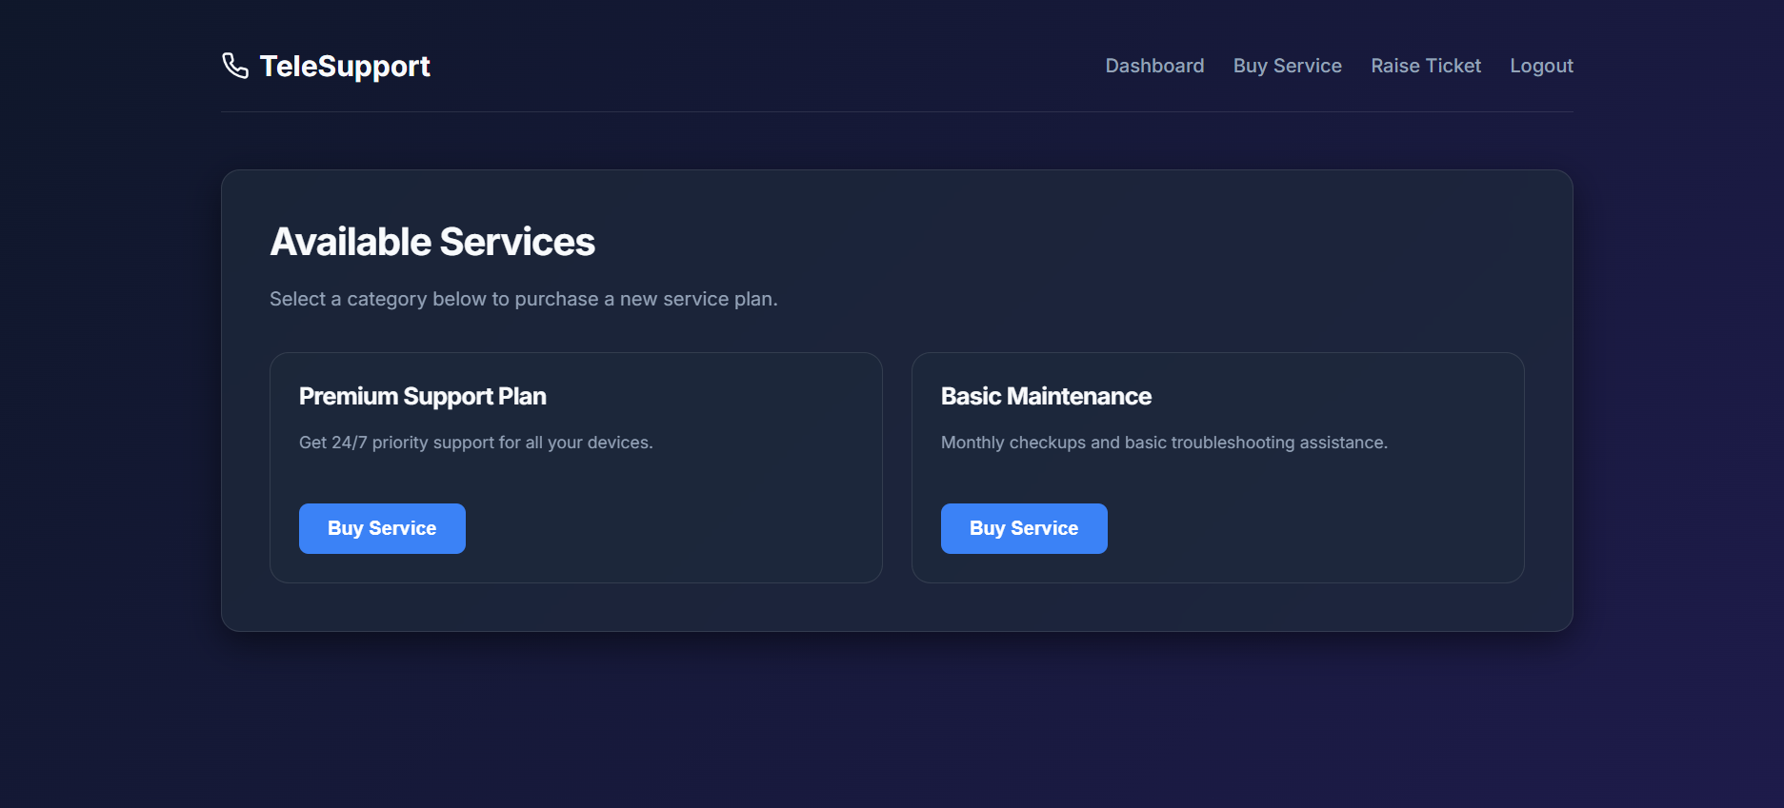
Figure 7: Buy a Service

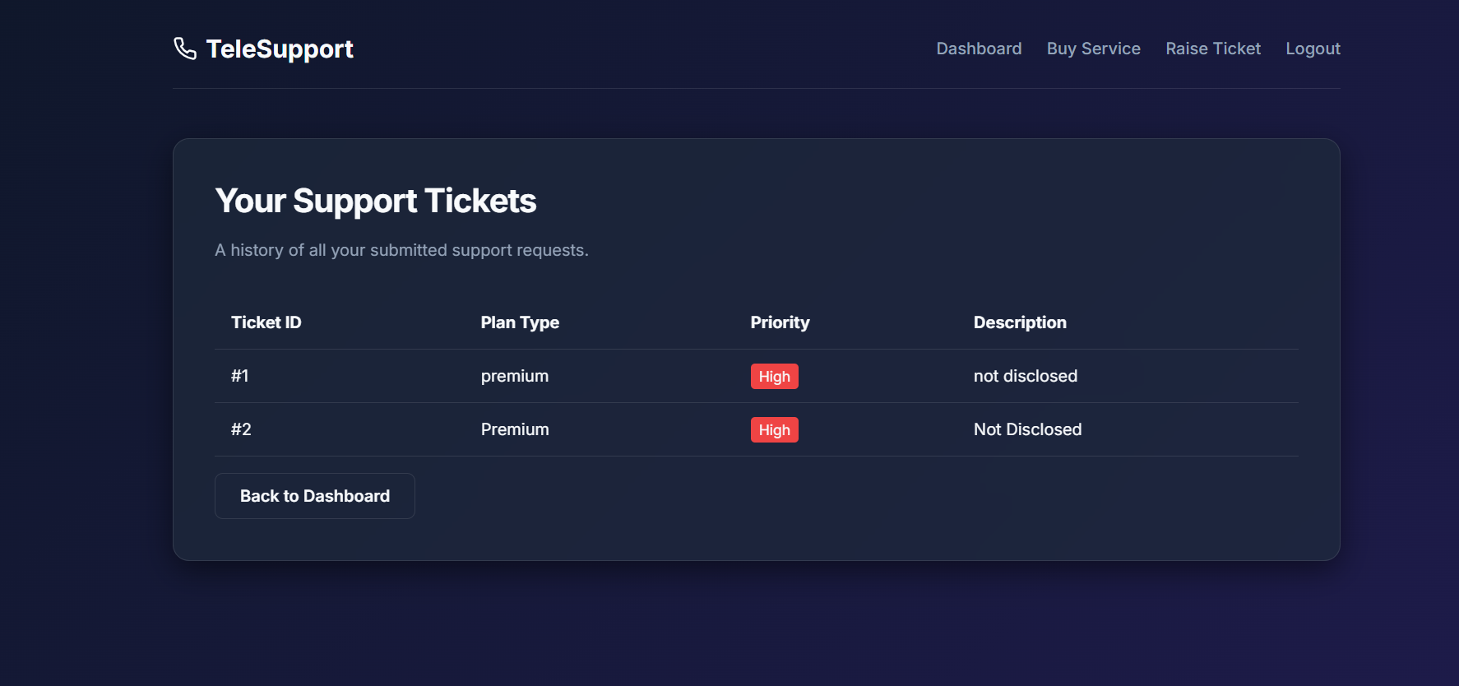
Figure 8: View Ticket

9. Key Features & Implementation

9.1 Connection Pooling:
Rather than creating a new TCP connection for every database query, the application uses mysql.connector.pooling. A pool of 5 persistent connections is maintained, drastically reducing latency and preventing the RDS instance from being overwhelmed.

9.2 Jinja2 Template Inheritance:
A base.html layout is utilized. This allows the navigation bar and core CSS to be written once and inherited by every other page. The navigation bar dynamically checks the session dictionary to display relevant links (e.g., 'View Tickets' for agents, 'Dashboard' for customers).

10. Technologies Used
Frontend: HTML5, CSS3, Inter Font Family
Backend: Python 3.10, Flask 2.x
Database Engine: MySQL 8.0
Cloud Infrastructure: Amazon Relational Database Service (AWS RDS)
Version Control & Editor: Git, Visual Studio Code

11. Advantages & Disadvantages

Advantages
- Platform Independence: Accessible from any modern web browser on any OS.
- Centralized Data: AWS RDS ensures data is safely backed up and globally accessible.
- Clean Architecture: Separation of concerns between routing (app.py) and presentation (templates/).

Disadvantages
- State Volatility: Currently relies on default Flask sessions which may reset on server restart.
- No Automated Emailing: Customers are not actively notified when their ticket status changes.

12. Conclusion
TeleSupport Hub demonstrates a robust, full-stack approach to solving real-world customer service inefficiencies. By enforcing strict role-based access control and leveraging a cloud-hosted database, the application is both secure and scalable. The implementation of modern UI/UX design paradigms ensures that users have a visually pleasing and intuitive experience. The project successfully meets all outlined objectives and stands as a highly functional MVP.

13. Future Enhancements
- Integration of AI-driven chatbots to handle Tier-1 generic support queries.
- Implementation of JWT (JSON Web Tokens) for highly secure, stateless API authentication.
- Adding a real-time notification engine using WebSockets (Socket.io).
- Building an Admin Dashboard with data visualization (graphs/charts) to track ticket resolution metrics.
- Exporting ticket histories to PDF or Excel formats for internal auditing.

14. References
- Flask Official Documentation: https://flask.palletsprojects.com/
- MySQL Connection Pooling: https://dev.mysql.com/doc/connector-python/en/connector-python-connection-pooling.html
- Amazon RDS User Guide: https://docs.aws.amazon.com/rds/
- Glassmorphism UI Principles: https://uxdesign.cc/glassmorphism-in-user-interfaces
- MDN Web Docs (CSS & HTML): https://developer.mozilla.org/

