AIM: Implement one of the following case studies using big data analytics:
a) Healthcare Data b) Web Clickstream Data
c) Social Media Data d) Educational Data
Require Software& Tools: Tableau Public
Procedure: step:-1
- Open tableau public and insert the exel sheet data (pateint_blood_test)
- Create new sheet and rename as patient count ,set the font style,size,color
- Drag sheet1(count) to rows then select text table
- Right click on count(50) format select worksheet -> change font color and size
Then go to allignment -> pane-> center
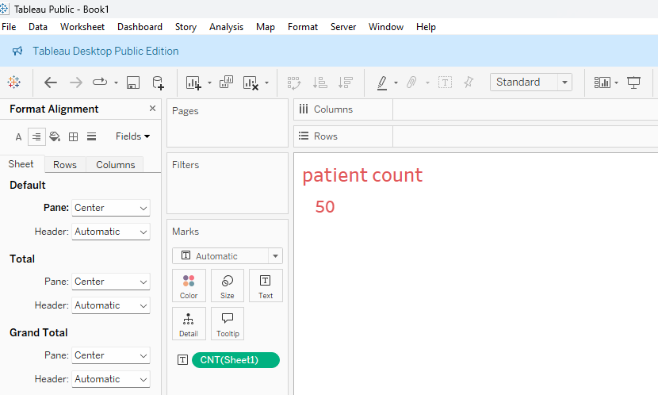
step:-2
- Duplicat patient count and rename avarage age
- Remove previous sheet count by draging left side of the screen
- Drag age to rows and convert SUM( age) to AVG(age)
- Right click on avarage age format select worksheet -> change font color and size
Then go to allignment -> pane-> center

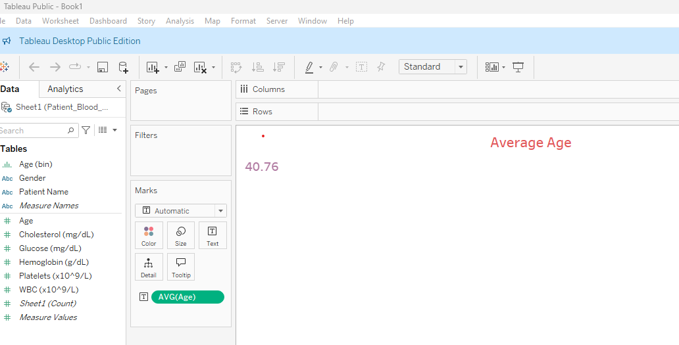
STEP 3:
- Duplicat average age and rename avarage Hemoglobin
- Remove previous sheet average age by draging left side of the screen
- Drag age to rows and convert SUM( Hemoglobin) to AVG(Hemoglobin)
- Right click on avarage Hemoglobin format select worksheet -> change font color and size Then go to allignment -> pane-> center

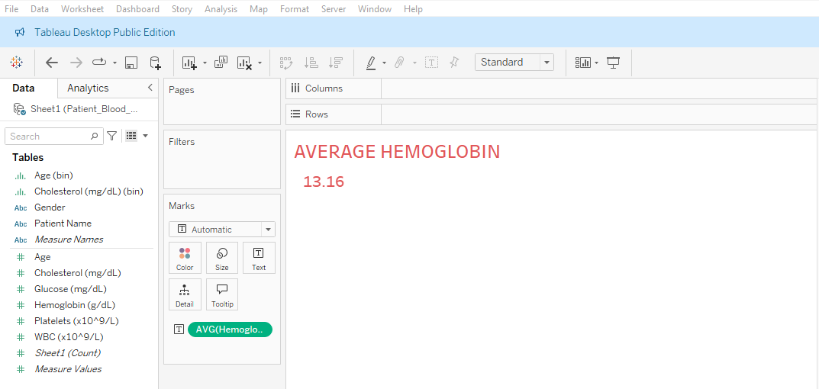

Step:-4
- Duplicate average Hemoglobin and rename average Glucose
- Remove previous sheet average Hemoglobin by draging left side of the screen
- Drag age to rows and convert SUM( Glucose) to AVG(Glucose)
- Right click on avarage Glucose format select worksheet -> change font color and size Then go to allignment -> pane-> center

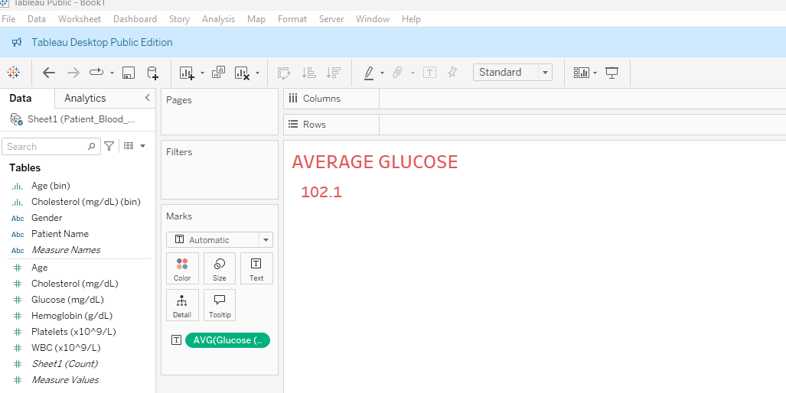

Step:-5
- Click on dash board symbol.
- Click on objects->Text and type Patient blood test analysis dash board.
- Right Click on patient blood test analysis dash board ->size-> change maximum size to 950px
- Drag from sheets paitent count,average age, average hemoglobin,average Glucose .
- Select patient count window and right click and select fit-> fit width
- Select Average age window and right click and select fit-> fit width
- Select Average Hemoglobin window and right click and select fit-> fit width
- Select Average Glucose window and right click and select fit-> fit width

Step:6

- Select new sheet and name it as count of patient by gender
- Drag Gender to columns and Sheet1(count) to rows
- Select pie chart
- To label the pie chart drag gender to label and sheet1 (count) to label.
- Go to dash board and from sheets drag patient by gender to the down of the
Patient count.

Step 7:- Select new sheet and name it as Age Distribution.
- Drag Age to columns and Sheet1(count) to rows
- And select histogram
- Left hand side table click on Age(bin)->edit-> change the bin size to 10.
- Go to dash board and from sheets drag Age distribution to the down of the
Avg age.

Step 8:- Select new sheet and name it as WBC VS PATELETS
- Drag platelets to columns and WBC to rows or vice versa
- Select Scatter plots
- Go to Analysis on menu bar-->Aggregate measures
- Go to Analysis on menu bar-->trend lines-->show trend lines
- Go to dash board and from sheets drag WBC VS PATELETS to the down of the avg hemoglobin.

Step 9:- Select age distribution sheet and rename it as cholesterol insights
- Drag cholesterol to columns

- Select histogram and click on swap rows and column symbol
Go to dash board and from sheets drag cholesterol insights to the down of the avg glucose.

Out put:

