step1:open vm ware workstation and start ubuntu
Step2:click on home then go to the pig folder then select bin folder and right click open in terminal
Step3: check the pig version :$pig –version
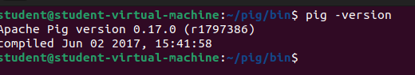
Step4:Create a text file
Step5:gedit studata.txt write the some text
Data
Krishna,1,22,cse
rani,2,21,csd
raju,3,22,aiml
sita,2,20,cse
rama,1,23,csd
hari,1,22,aiml
vishnu,3,25,cse
laxmi,3,20,csd
vishva,2,22,aiml
teja,4,23,cse
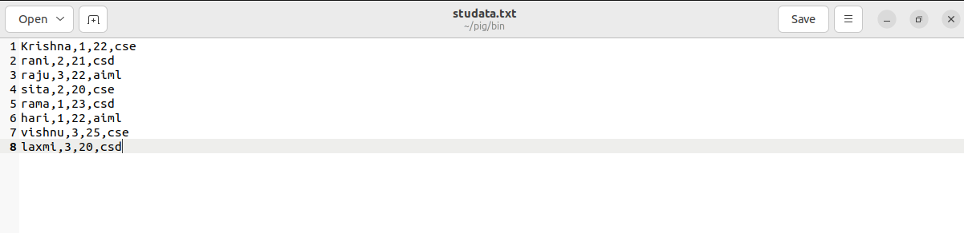
step6:save and close
step7:start pig: pig –x local
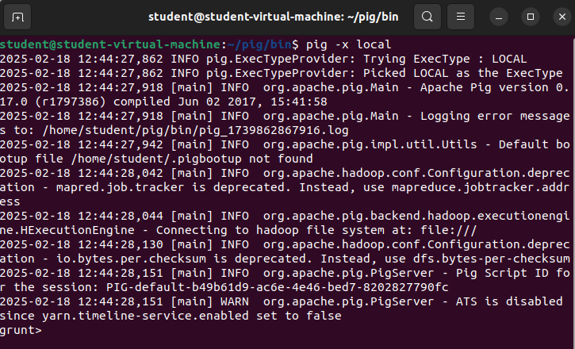
step8:To load data from local system
mydata = LOAD '/home/student/pig/bin/studata.txt' USING PigStorage(',') AS (name:chararray, rollnumber:int, age:int, class:chararray);
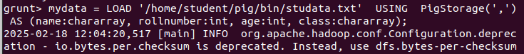
step9:To dump the loaded data: dump mydata;
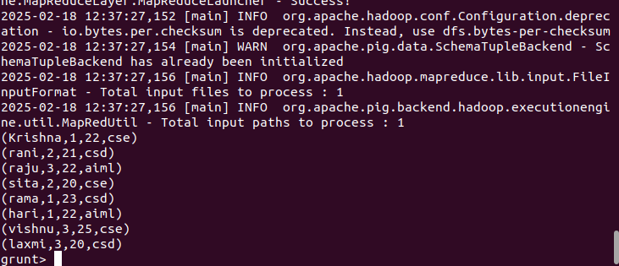
step10:to describe the data :describe mydata;
step11:Query 1: Grouping All Records Class.
(This command will group all the records by the column Class)

Step12:grunt> studentsbranch = GROUP mydata BY class;
To see the output
Step13: dump studentsbranch;
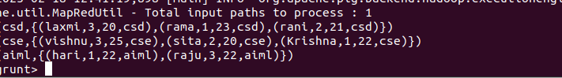
Step14: To store data into local system
STORE studentsbranch INTO 'result.txt' USING PigStorage(',');
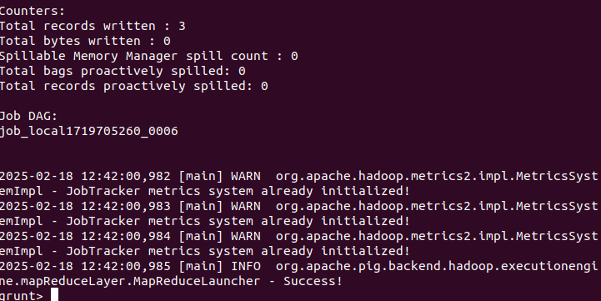
Step15: see the output in bin folder select the output txt the open part-r-00000
