Review Questions for HSMP410

Ted Laderas

2018-05-14

## Week 1.2 Introduction to Bioinformatics

1. What is an Odds Ratio and why do we use it to quantify association?

## Week 2.2 Introduction to Genomics

1. What are some differences between a mutation and a sequencing error?

## Week 4.1 Data Literacy and Visualization

Given the following boxplot, what do you conclude?

iris %>% ggplot(aes(x=Species, y=Sepal.Length, fill=Species)) + geom_boxplot()

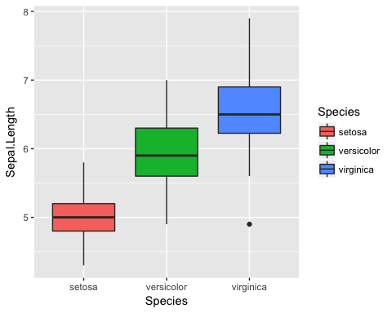

## Week 4.2 Data Science

Given the following dataset, what variables would you need to calculate horsepower divided by miles per gallon?

head(mtcars)

## mpg cyl disp hp drat wt qsec vs am gear carb  
## Mazda RX4 21.0 6 160 110 3.90 2.620 16.46 0 1 4 4  
## Mazda RX4 Wag 21.0 6 160 110 3.90 2.875 17.02 0 1 4 4  
## Datsun 710 22.8 4 108 93 3.85 2.320 18.61 1 1 4 1  
## Hornet 4 Drive 21.4 6 258 110 3.08 3.215 19.44 1 0 3 1  
## Hornet Sportabout 18.7 8 360 175 3.15 3.440 17.02 0 0 3 2  
## Valiant 18.1 6 225 105 2.76 3.460 20.22 1 0 3 1

## Week 6.1 Ethics

A nurse posted on her instagram feed a selfie with her patient, naming names.

Of the four ethical principles (beneficience, non-maleficience, justice, autonomy), take two principles and say whether they are in conflict in this situation.

## Week 7.2 Ontologies and Standards

What are some uses for an ontology?