

Project Title: Unicom TIC Management System (UMS
Submitted by: Devaraj Ladhurshika
UT Number: UT010350
Submitted to: Unicom TIC
Date of Submission: 21st June 2025
Duration of Project:
Start Date: 1st June 2025
End Date: 21st June 2025
Total Duration: 20 Days

Acknowledgement
I would like to express my sincere gratitude to my lecturers, Mr. Kathir and Miss. Tharshika, for their valuable guidance and insightful lectures throughout this project. I also sincerely thank the lab assistants for their continuous support and assistance during the practical sessions.
I also thank Unicom TIC for providing the necessary facilities and a great learning environment.
Special thanks to my family and friends for their motivation, and to everyone who helped in testing and validating this project.
This experience has enhanced my skills in C#, database design, and MVC architecture, and has helped me understand real-world software development practices.

Abstract
This project presents a Unicom TIC Management System (UMS) developed using C# Windows Forms and SQLite database, following the Model-View-Controller (MVC) architecture. The system aims to streamline the management of school operations including administration, student records, course and subject management, staff and lecturer details, and timetable scheduling.
Key modules implemented include user authentication, role-based access control, CRUD operations for students, courses, subjects, staff, and lecturers, and an intuitive user interface for easy navigation. The system leverages SQLite for efficient data storage and retrieval, ensuring data integrity and consistency.
This solution addresses the need for a centralized and automated system to replace manual record-keeping, reducing errors and improving efficiency in daily school management tasks. Testing demonstrates reliable performance and usability for end-users.
The project demonstrates the application of software engineering principles, database management, and user interface design to provide a practical tool for educational institutions. Future enhancements may include web-based access and advanced reporting features.

Objective of the project
The main objective of the Unicom TIC Management System (UMS) is to automate and streamline the essential operations of a school such as student admission, staff handling, course and subject allocation, and academic record-keeping. By replacing manual data entry and paper-based management, the system ensures accuracy, security, and efficiency in daily operations.
This application is built using C# Windows Forms with SQLite database and follows the Model-View-Controller (MVC) design pattern along with a dedicated Service Layer. This promotes better separation of concerns, modularity, and easier maintenance.
The system is capable of handling multiple user roles including Admins, Staff, and Students, with role-based access and dashboard control. Key modules allow the management of users, student information, guardian details, course-subject relationships, and basic infrastructure elements like room allocation and timetabling.
The specific objectives include:
- To provide secure login functionality with role-based dashboard access
- To manage student details along with guardian information in a structured manner
- To manage admin, lecture and staff users through role-specific access
- To manage academic structures like courses and subjects with flexible linking
- To enable room assignment and basic scheduling
- To follow a scalable architecture that allows future enhancements like attendance, exams, marks, and reporting
- To implement the MVC pattern for code clarity and separation between UI, logic, and data
- To store all data locally in a lightweight SQLite database ensuring offline usage

System Requirements
Software Requirements
- Operating System: Windows 10 or higher
- Programming Language: C# (.NET Framework)
- Front-end Interface: Windows Forms (WinForms)
- Database: SQLite
- IDE/Tools: Visual Studio 2022
- Architecture Used: MVC (Model-View-Controller) + Service Layer

Functional Requirements
- Secure login system for Admin, Staff, and Students
- Add, update, and delete student, staff, and admin data
- Link students with guardian details
- Manage courses and subjects
- Role-based dashboard and data access
- Room allocation or timetable management

Non-Functional Requirements
- User-friendly graphical interface
- Fast and lightweight performance using SQLite
- Local data storage with offline access
- Maintainable and modular code structure (MVC)
- Scalable for future additions like attendance and exam modules

Module Description
This section outlines the key modules developed as part of the School Management System. Each module represents a core functional component that performs specific tasks within the system. The modular structure allows for easy maintenance, testing, and future upgrades.
Login Module
The login module provides secure access to the system based on the role of the user. It checks credentials stored in the Users table and redirects the user to their corresponding dashboard. Only valid users can log in, and invalid attempts are denied with an error message. The module supports Admin, Staff, and Student roles.
Dashboard Module
The dashboard displays options and functionality based on the logged-in user’s role. It uses a Tree View menu to present modules such as Student Management, Course Management, and Staff Management. The content loaded dynamically depends on the user’s access level (Admin, Staff, etc.).
Admin/Staff Management Module
This module allows the administrator to add, update, or remove staff or admin accounts. Credentials are stored in the Users table, and personal details are saved in the respective Admins or Staff tables. Role-based access is enforced, and data is displayed using a Data Grid View with search and update features.
Student Management Module
The student management module is responsible for managing student information, including name, date of birth, gender, course, and address. Each student is linked to a user login from the Users table and a guardian entry in the Guardians table. The module supports adding, editing, and deleting student records, as well as displaying them in a Data Grid View.
Course and Subject Management Module
This module allows users to manage courses and their related subjects. Courses and subjects are stored in separate tables and linked using a Course Subjects junction table. The form allows users to add, update, delete, and view course-subject mappings, and supports searching by course.
Room and Timetable Management Module
This module handles the allocation of rooms to specific sections or classes. It prevents overlapping of room bookings and allows the administrator to schedule classes according to availability. Timetable logic can be extended further if needed.
Exam Management Module
This module enables the creation of exams for different subjects and classes. Admins or staff can define exam names, associated courses, subjects, dates, and sections. The system ensures no schedule conflict and helps organize upcoming assessments.
Marks Management Module
The marks management module allows the entry and viewing of students' exam results. Staff members can record marks per subject per student. This data can be used to generate progress reports and for academic evaluations.

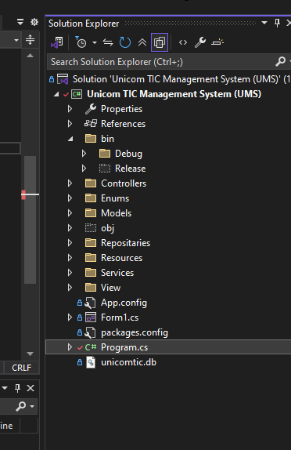
Architecture of the project

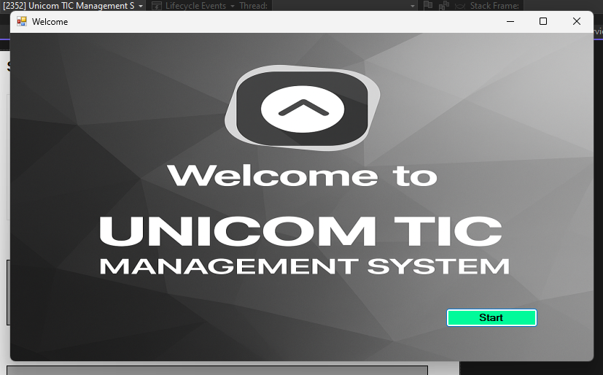
Front page design – click the start button

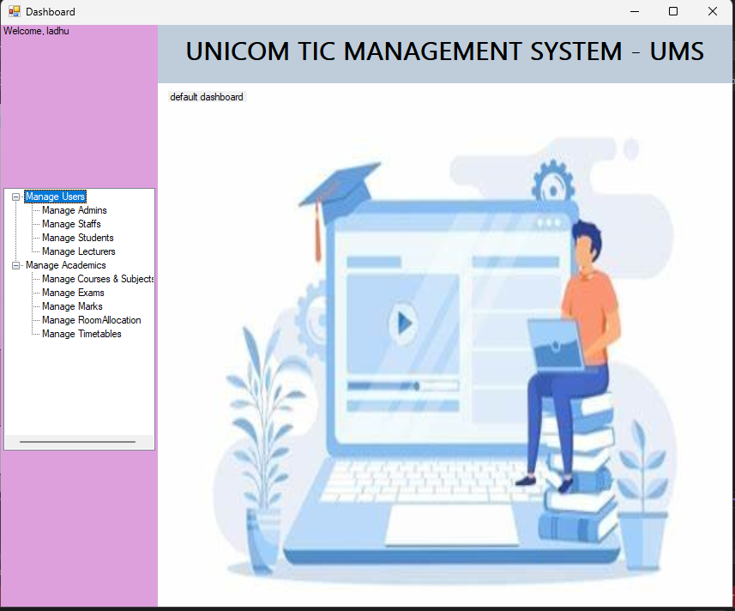
Main Dashboard with treeview

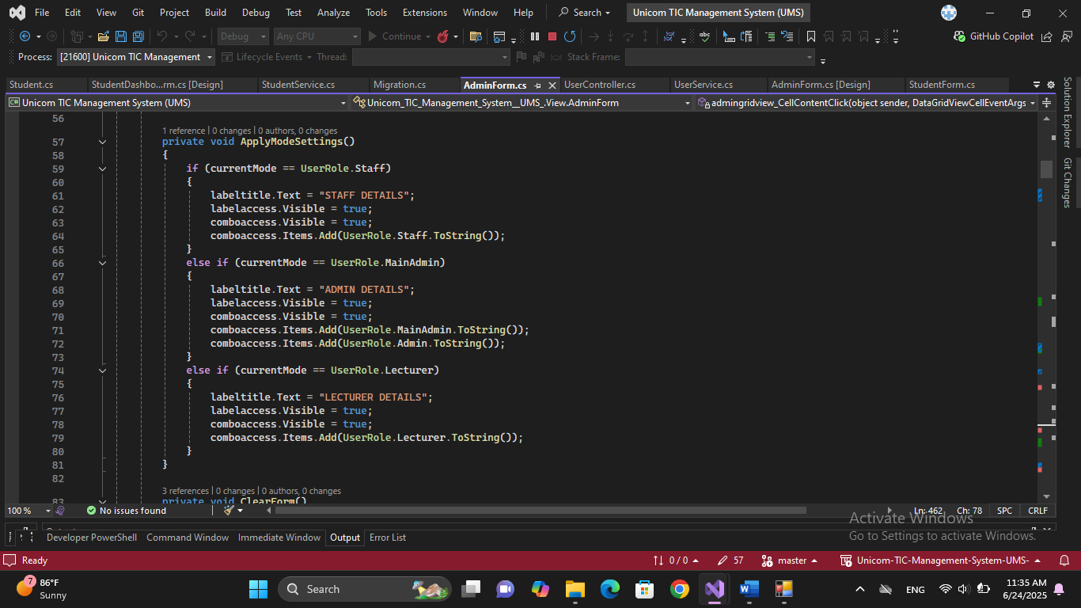
Using one form for staff ,lecture,admin

Challenges And Solutions
During the development of the School Management System, a few key challenges were faced and resolved:
Role-based access control:
Initially, all users could access all modules. This was fixed by loading the dashboard based on user role.
Multi-table insertion (Students + Guardians + Users):
Linking student data across three tables was difficult. The issue was solved by capturing the inserted User ID and using it in other insert queries.
Course-Subject linking:
Implementing many-to-many relationships was confusing. This was resolved by using a junction table and custom service methods.
Gender enum errors:
Enum parsing caused runtime errors. The ComboBox was updated to load enum values correctly and parse them safely.
Update/Delete from DataGridView:
Tracking selected rows for update/delete was hard. A simple ID variable was used to store the selected record’s key.
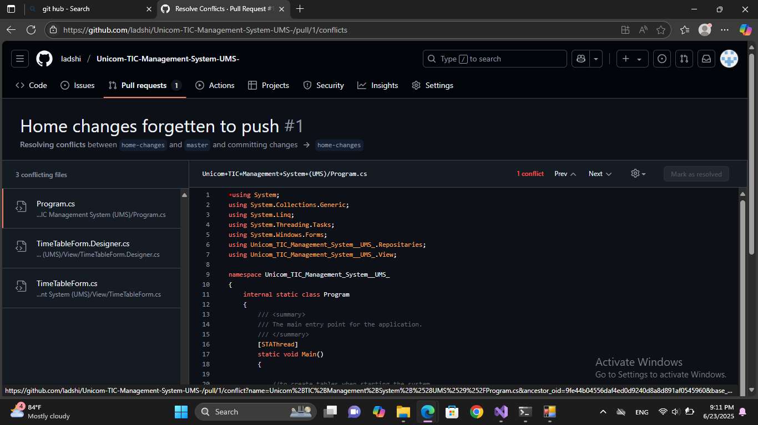
Git hub conflict issues

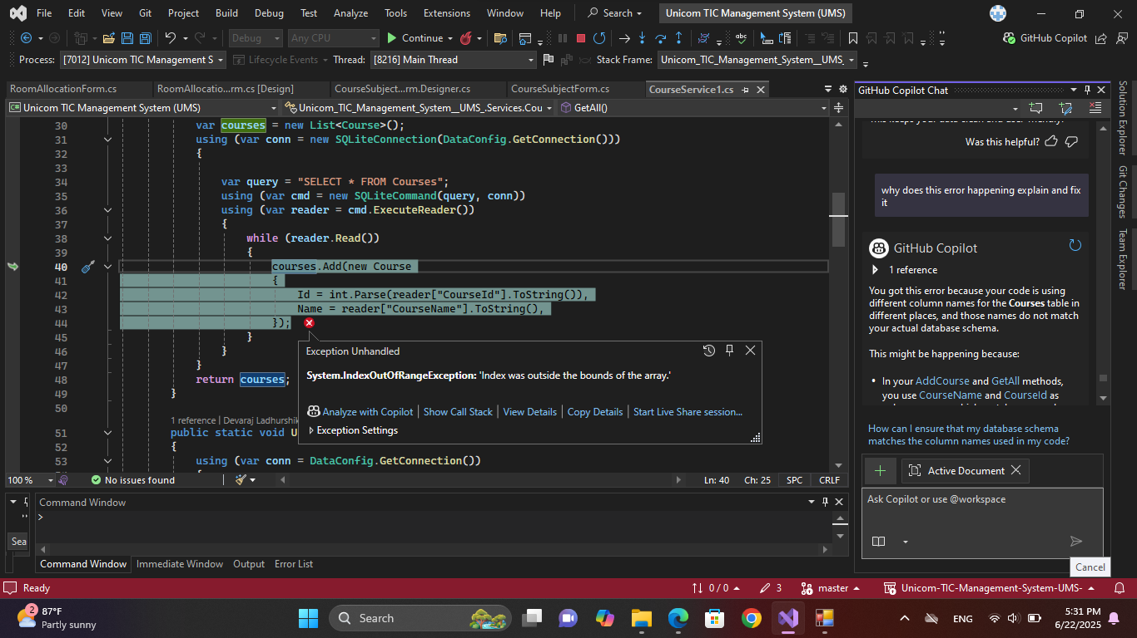
Run time error fixing

Conclusion
Unicom TIC Management System project successfully meets its objective of simplifying and automating key school operations. Through the use of C# Windows Forms and SQLite, the system provides secure role-based login, effective student and staff management, and organized handling of academic data such as courses and subjects.
The use of the MVC architecture with a service layer helped in maintaining clean, structured code and separating the user interface from business logic. Data was stored locally, allowing the system to function without an internet connection.
The application is user-friendly, modular, and can be extended in the future with features such as attendance tracking, grade reports, and communication tools. Overall, the project demonstrates a strong foundation for school administrative software built with reliability and simplicity in mind.

Future Enhancements
Although the current system covers core functionalities such as user login, student management, staff records, course-subject handling, and basic scheduling, several features can be added to improve the system further:
- Attendance Management:
To track daily student and staff attendance, integrated with date-wise reports.
- Marks Analysis and Grade Report Generation:
Auto-generated grade sheets based on exam scores with printable reports.
- Parent Notifications and Communication:
SMS or email notifications to guardians regarding student progress, attendance, and announcements.
- Online Access:
A web-based version of the system to allow access from outside the school premises.
- Backup and Restore Feature:
To secure data with backup options in case of data corruption or system failure.
- Fee Management Module:
To record and manage student payments, due alerts, and fee structure automation.
These enhancements will make the system more robust, scalable, and suitable for larger institutions with broader administrative needs.

