PREDICTIVE SALES ANALYTICS: 6-MONTHS FORECAST DASHBOARD
A Project Report on Data Science & Analytics
By: Tanvi Lad
1.INTRODUCTION
In today's competitive business environment, data-driven decision making is crucial. This project analyzes 4 years of Superstore sales data and predicts future sales for next 6 months using Microsoft Power BI. The interactive dashboard helps businesses optimize inventory and marketing strategies.
2. PROBLEM STATEMENT
Excel reports lack forecasting and interactivity. Businesses cannot predict demand accurately. This dashboard provides automated analysis + 6-month sales prediction with 95% confidence interval.
3. DATASET
Source: Superstore Sales Dataset - Kaggle
Period: Jan 2014 to Dec 2017
Records: 9,994 orders
Key Columns: Order Date, Sales, Profit, Region, Segment, Category, Discount
4. METHODOLOGY
Step 1: Data Cleaning - Removed nulls, fixed dates, removed duplicates using Power Query
Step 2: Visualization - Created 12 visuals: 4 KPI cards, line charts, donut charts, filled map, bar charts
Step 3: Analysis - Used Region/Category slicers. Found West region + Technology segment = top performers
Step 4: Forecasting - Applied Power BI built-in Time Series Forecast for 6 months with 95% CI
Step 5: Dashboard - Combined all visuals with green theme + interactivity

5. DASHBOARD VISUALIZATIONS
Full Dashboard Screenshot Predictive Sales Forecast - Next 6 Months Chart
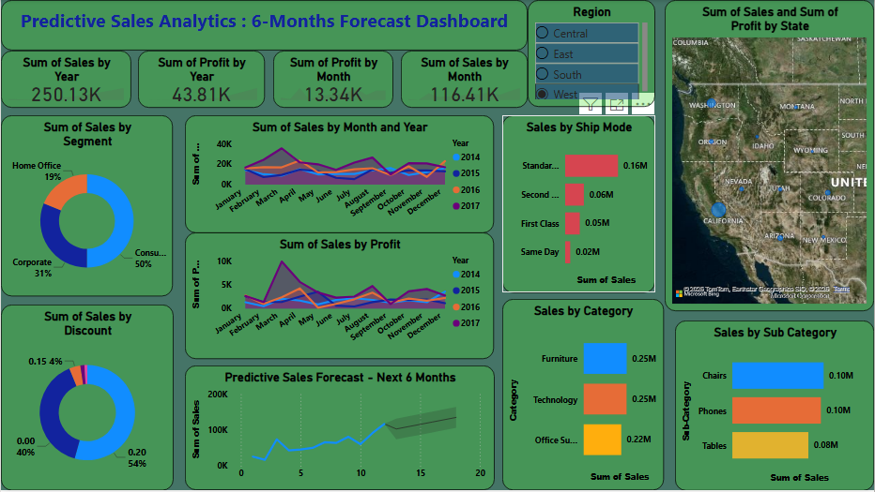
US Region Map
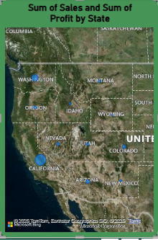
Predictive Sales Forecast : Next 6 Months
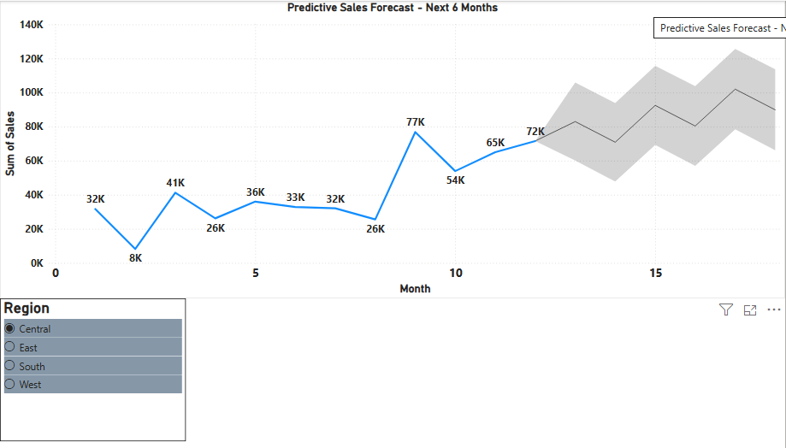
6. RESULTS & KEY INSIGHTS
Sales Growth: Dashboard shows growth from 13.64K to 1,01.10K over 4 years Top Segment: Technology segment leads in sales
Best Discount: 0.2 discount level generates maximum revenue
Regional Trend: West + East US = highest sales on map
Forecast: 6-month prediction shows upward trend, indicating business growth
Interactivity: Year filter updates all charts dynamically
7. CONCLUSION
Dashboard successfully converts raw data into strategic insights. 6-month forecast enables proactive planning. Interactive design helps non-technical users explore data easily. Project proves BI tools are essential for data-driven decisions.8.
8. FUTURE SCOPE.
- Integrate Python ARIMA/Prophet for better accuracy.
- Add Customer RFM Segmentation.
- Deploy to Power BI Service with auto-refresh.
- Create mobile view + drill-through pages.

