***SellingGetChestList:***

Code:

router.get('/SellingGetChestList',

    Authentication,

    isMyProvider,

    get__All__Uuid_departmentGroup,

    // get__All__Uuid_department,

    get__All__Uuid_chest,

    (req, res) => {

    const pageIndex = req.query.pageIndex;

    const pageSize = req.query.pageSize;

    const all_uuid_chest = req.all_uuid_chest;

    const all_uuid_chest_sq = [];

    for (let i = 0; i < all_uuid_chest.length; i++) {

        const uuid_chest__ = {uuid_chest: all_uuid_chest[i]};

        all_uuid_chest_sq.push(uuid_chest__);

    }

    chestCRUD.sellingRead(all_uuid_chest_sq, Number(pageIndex), Number(pageSize), (chestList, err) => {

        if (err) {

            logEvents(`${req.url}---${req.method}---${err}`);

            return res.status(500).send(err);

        } else {

            if (chestList && chestList!==null) {

                return res.status(200).json({

                    chestList: chestList,

                    success: true,

                    message: `Chest list is read successly (${service}) !`

                });

            } else {

                return res.status(200).json({

                    chestList: chestList,

                    success: false,

                    message: `Chest list is NOT read successly (${service}) !`

                })

            }

        }

    })

})

Middleware:

* **isMyProvider**: Ensure provider that you store in cookie is your.
* **get__All__Uuid_departmentGroup**: only take uuid_departmentGroup
* **get__All__Uuid_chest:** take uuid_chest
* **main code:** implement main task.

Database:

* 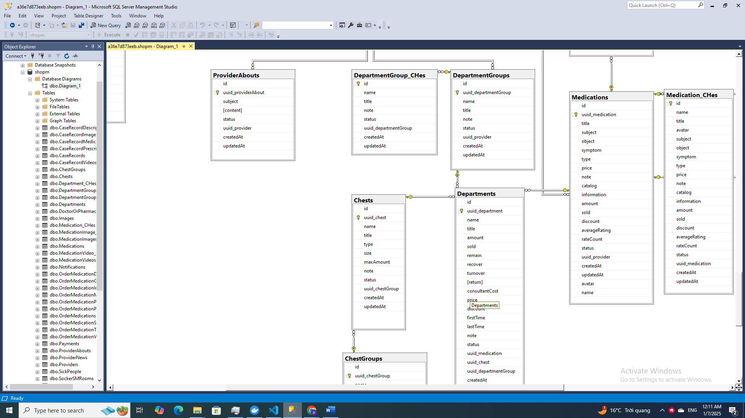
* We can’t get chest directly. It must via other table. Steps is middles.