Serverless lambda stack created as documented in https://github.com/awslabs/aws-serverless-java-container/tree/master/samples/springboot/pet-store

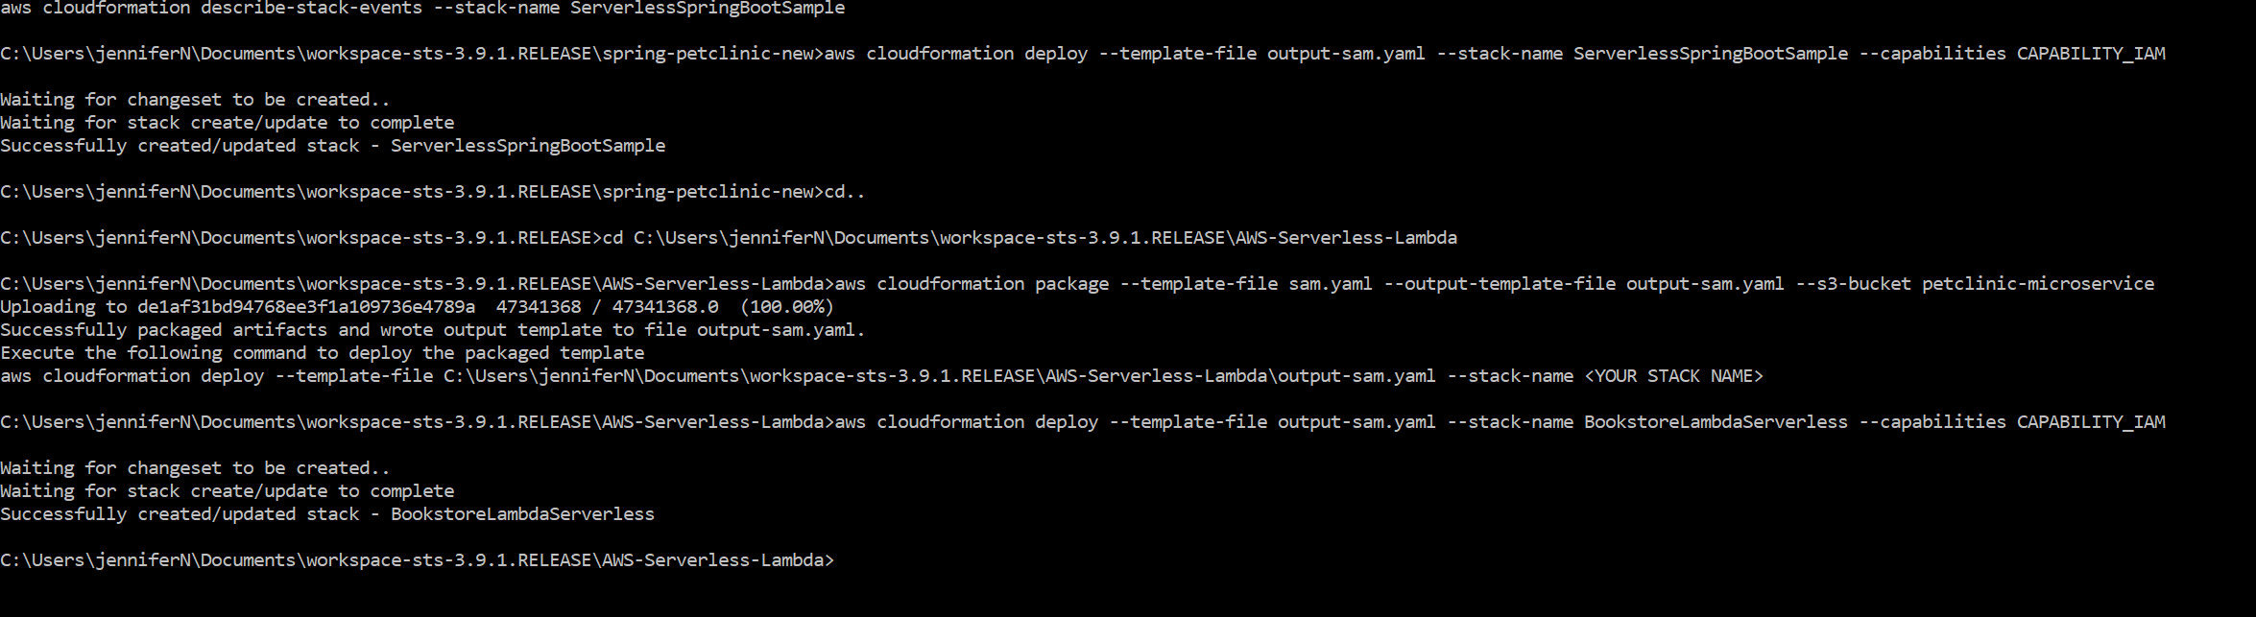

Lambda is invoked and loads fine but request times out although it works fine in the localhost

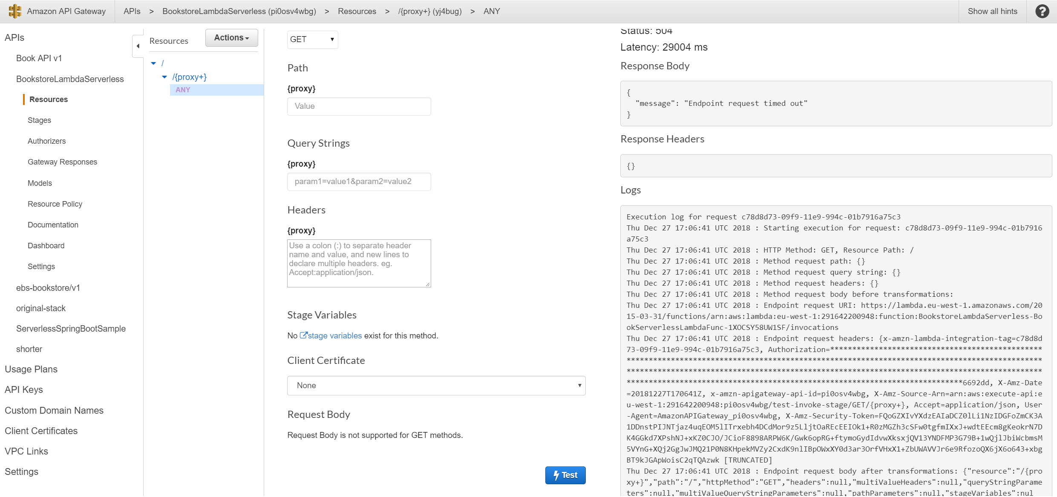

Same problem with the aws-serverless-java-container petclinic example in git as well

