Digital Signal Processing

Lab 03: Linear Systems, Impulse Response and Convolution

Tutorial: Learning Outcomes

  - Understand linear systems and impulse responses
  - Understand the convolution method
  - Use convolution to calculate a system’s output. Application to audio digital effects (amplification, echo, room reverberation).

Impulse response and convolution

Linear system theory tells us the system property can be fully characterised by its impulse response. Therefore to find out the system outputs of any inputs signal, we can simply use the convolution method to calculate the output signal by convoluting the input signal by the system impulse response.

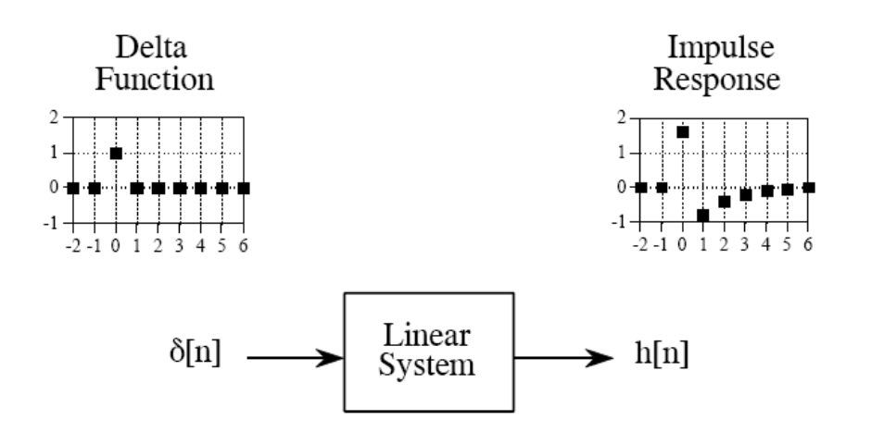
Figure 1 impulse response of linear system

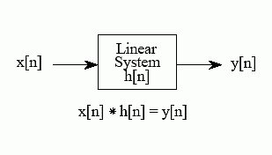
Figure 2 calculate output signal by convolution

Digital Echo Effects

In the real world, the original sound and the reflected sound from the surrounding environment is perceived by the human ear as echo. The reflected sound, which contributes to echo is normally attenuated and delayed. Acoustically, the natural environment is very complicated, there are multiple echoes and echo paths. The group of reflected sounds can be reflected again and again. The surfaces of different objects are different which not only cause a time delay and attenuation but also alter the frequency properties. This results in reverberation.

To simplify the problem and establish a mathematical model, we can use simple impulse response model to simulate a very simple echo. The simple impulse response of echo system can be viewed as the following equation. In here, δ(n) is the unit impulse function, ‘a’ is the attenuation factor, and ts is the echo delay:
h(n) = δ(n) + aδ(n − ts)
To generate any echo version of a sound, you can simply convolve input signal (original sound) with h(n). The result shall be the echoic sound.

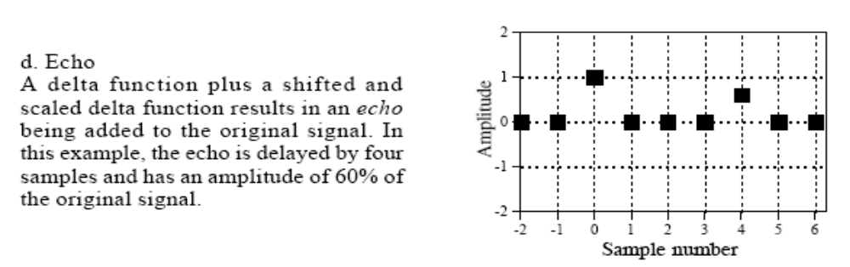
Figure 3 Simple digital Echo impulse response

Example Code:

ir = zeros(1, 50000);

ir([1, 1000, 5000, 10000, 15000]) = [1, 0.8, 0.7, 0.6, 0.5];
% create an impulse response

[sig, fs] = wavread('pluck.wav'); %Read Signal

y = conv(sig, ir);
% convolve the two signals

subplot(211), plot(sig);

subplot(212), plot(y);
% plot both signals on same figure.

Try this:

Try changing the impulse response (ir) variable to vary the length of the echo. Plot the signals using the plot() function. Try and specifically delay an echo by 500ms, how would you do this?

Common Impulse Responses
The following patterns are typical impulse responses for DSP processes:

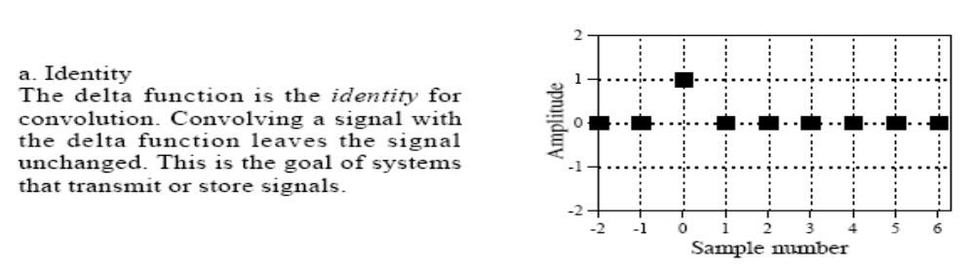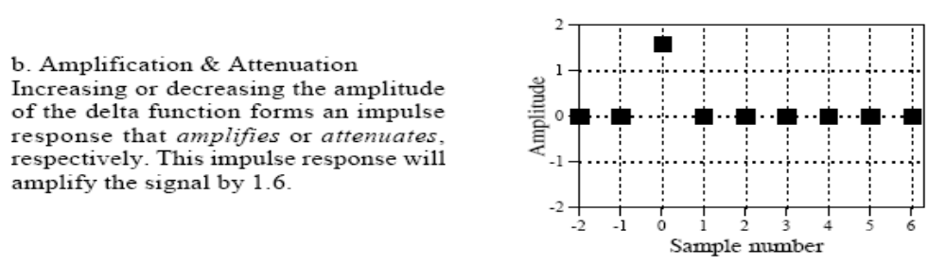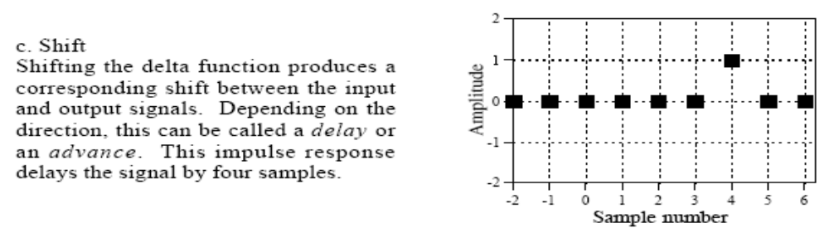

Try and code each one of these in Matlab and then apply it to our original signal using convolution.

Exercises

1. ROOM REVERBERATION. Read an audio signal x (there will be one on the VLE page) into matlab’s environment by using the ‘audioread()’ function. This can be done as follows:

[x, Fs] = audioread(‘filename.wav’)

Download an impulse response from the open air IR library online (accessible via: http://www.openairlib.net/) and use convolution to apply reverberation to your signal ‘x’. Play both the original and processed sounds and notice the effect.
Note that the impulse response and the sound you apply it to MUST have the same sampling frequency. What would you do if the sampling frequencies are not the same?

2. ECHOES. Create an echo effect that creates delay taps every 0.5 seconds, and an amplitude of 1/n, and apply it to an audio file (e.g. pluck.wav on the VLE). The sample rate of the audio needs to be derived from the wav file, during the audioread process, however it can be assumed to be 44100Hz. Play both the original and processed sounds and notice the effect.

