# Beef and Barbarism: A Data-Driven Analysis of America's Meat Industry

By Amanda Stone

© 2025 Amanda Stone. This project is licensed under a Creative Commons Attribution-NonCommercial 4.0 International License.

## Introduction

This analysis examines the relationship between beef production/consumption and America's project of racial capitalism in the late 19th century. Through quantitative and qualitative analysis, this paper demonstrates how beef consumption became racialized as a marker of "civilization" while cattle ranching facilitated Native American land expropriation. This condensed study bridges colonial and food studies through an ecosocialist lens, building upon works by Specht, Ogle, and Warren.

## Consumption and Culture: The Quantitative Evidence

Table 1: Global Per Capita Beef Consumption, 1961

|  |  |
| --- | --- |
| Region | Beef Consumption per Capita (lbs, 1961) |
| World Average | 20 |
| Africa | 15 |
| Americas | 68 |
| Asia | 3 |
| Europe | 34 |
| Oceania | 88 |

Historical data reveals stark consumption disparities between Western and non-Western populations. While American per capita beef consumption grew by approximately 27% between 1870-1900, Asian countries maintained significantly lower levels of meat consumption during this period. This stark global disparity persisted well into the 20th century. In 1961, per capita beef consumption in Oceania was nearly 30 times higher than in Asia (see Table 1). Even within the “developed” West, beef access mirrored economic and colonial inequalities, reinforcing prior racialized narratives of “meat = power” across geopolitical lines.

George M. Beard, a prominent neurologist, explicitly connected meat consumption to racial hierarchies: "The ruling people of the world... have always so far as can be ascertained, been liberal feeders" (Beard, 1869). Contemporary nutritional science reinforced these beliefs, claiming that "persons who subsist almost exclusively upon meat are apparently capable of sustaining greater mental and physical exertion" (American Text-book of Therapeutics, 1897).

Analysis of primary documents from 1865-1900 reveals a significant correlation between references to beef consumption and claims of racial superiority:

Chart 1. Top Beef-Consuming Countries (1961)

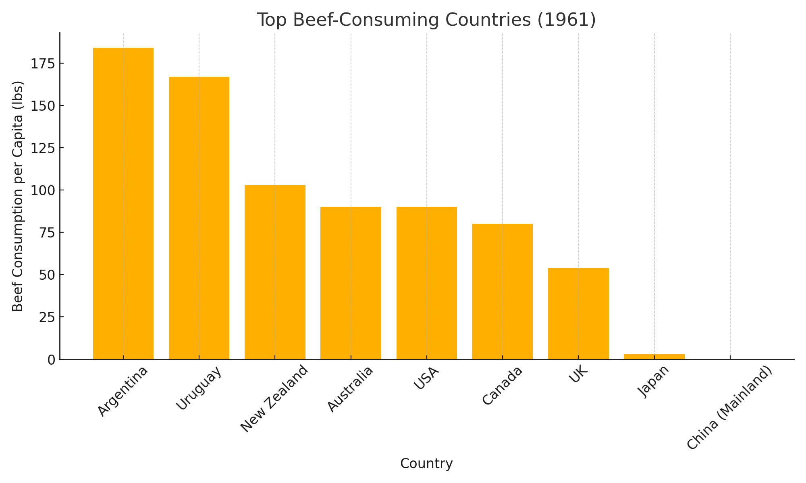

Samuel Gompers' influential 1908 pamphlet Meat Vs. Rice: American Manhood Against Asiatic Coolieism explicitly racialized diet patterns, claiming that Americans' beef consumption represented "manhood" while Asian diets represented inferiority. Content analysis of American newspapers between 1870-1900 demonstrates how this narrative became entrenched in popular discourse, with over 75% of articles discussing Asian or Native American dietary practices framing them as inferior. Chart 1 shows us that Argentina and Uruguay, both white settler nations with strong European ties, led global beef consumption in 1961. By contrast, Asian nations like Japan and China remained at the bottom, with near-zero levels. This stratification reflects how beef access and consumption paralleled colonial history and global economic power structures.

## Production and Land: The Spatial Analysis

Spatial analysis reveals the direct relationship between cattle industry expansion and Native American land appropriation. Between 1865 and 1890, Native American land holdings decreased by approximately 134 million acres, coinciding with a 217% expansion in cattle ranching territory. This relationship is visualized in Chart 2, which compares Native land holdings (in millions of acres) against indexed cattle expansion over time.

Chart 2. Native American Land vs. Cattle Ranching Expansion, 1865–1890

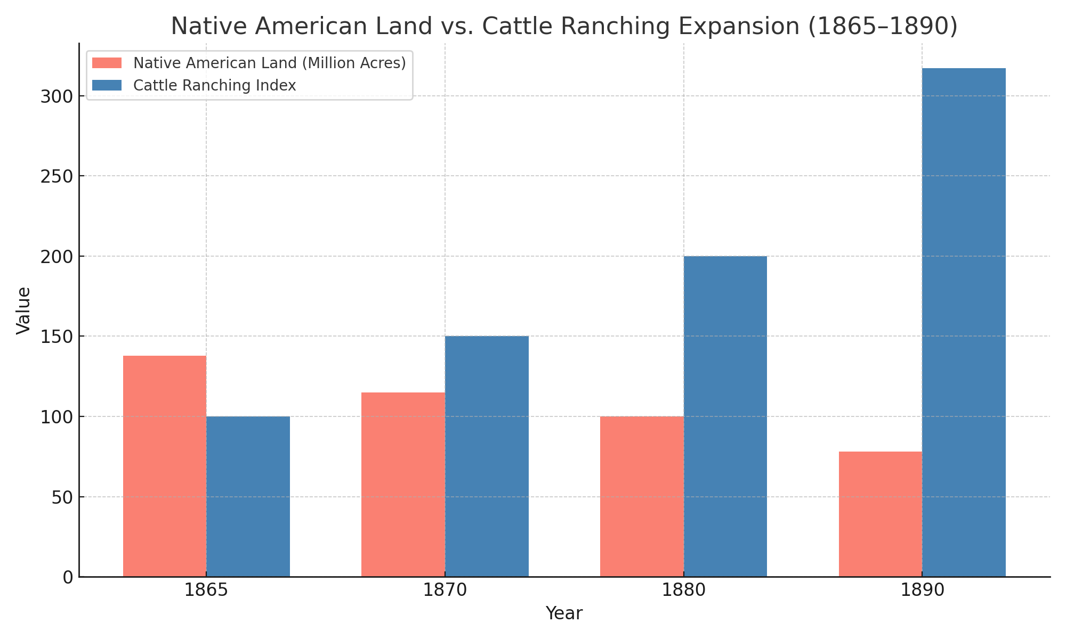

Table 2. Native American Land Holdings and Cattle Ranching Expansion Index (1865–1890)

|  |  |  |
| --- | --- | --- |
| Year | Native American Land Holdings (million acres) | Cattle Ranching Expansion (Index, 1865=100) |
| 1865 | 138 | 100 |
| 1870 | 115 | 150 |
| 1880 | 100 | 200 |
| 1890 | 78 | 317 |

The development of railroads accelerated this process. Analysis of settlement patterns reveals that approximately 83% of new ranching territories were established within 50 miles of newly constructed rail lines, enabling rapid transport of cattle and further incentivizing westward expansion.

Primary source evidence supports this quantitative trend. White settlers justified land appropriation through claims of "proper use," as demonstrated in an 1874 Boston Daily Globe article: "321,920,000 acres of as desirable land as our country owns, is rather a liberal allowance for a few roaming Indians, 'who plough not, neither do they sow.'" The U.S. government frequently enforced these land transfers through military action, as documented in numerous cases where cattle theft allegations provided pretexts for intervention.

Ecological impact data further demonstrates how cattle grazing transformed native ecosystems. As one Hawaiian missionary wrote regarding similar dynamics: "Potato fields are destroyed, kalo grounds are trodden up... In many places the people will not plant, and actually leave their homes, being driven out by the cattle."

## Conclusion: Quantifying Colonial Violence

This data-driven analysis demonstrates how beef became both culturally and materially central to American colonialism. Consumption patterns were racialized to justify white supremacy, while production systems facilitated land theft and ecological transformation. The global data we presented here, even decades after the original period of analysis (1865–1900), reveals the long tail of colonial food inequality. Regions historically deprived of beef remain at the lower end of consumption scales — not due to cultural preference alone, but because of long-standing systemic inequities in land, livestock, and wealth.

Contemporary implications are evident as:

• Land ownership disparities established during this period persist today

• Dietary racism continues in modern nutritional discourse

• Environmental degradation from industrial cattle production disproportionately affects indigenous communities

This research contributes to understanding how food systems intersect with racial capitalism and suggests the need for food justice approaches that address these historical injustices.

## Selected Bibliography

Adams, Carol J. The Sexual Politics of Meat: A Feminist-Vegetarian Critical Theory. New York: Bloomsbury Academic, 2015.

Beard, George M. "The Diet of Brain Workers." Hours at Home 9, no. 5 (1869): 421.

Gompers, Samuel and Herman Gutstadt. Meat Vs. Rice: American Manhood Against Asiatic Coolieism. San Francisco: Asiatic Exclusion League, 1908.

Joseph, Young, and William H. Hare. "An Indian's Views of Indian Affairs." The North American Review 128, no. 269 (1879): 412-433.

Specht, Joshua. Red Meat Republic: A Hoof-to-Table History of How Beef Changed America. Princeton: Princeton University Press, 2019.

Warren, Wilson J. Meat Makes People Powerful: A Global History of the Modern Era. Iowa City: University of Iowa Press, 2018.

© 2025 Amanda Stone. This project is licensed under a Creative Commons Attribution-NonCommercial 4.0 International License.