**Space Weather Activity Warnings**

This document explains the Space weather activity threshold warning system. The thresholds used for the various space weather properties are listed and lastly, a process chart is presented explaining the flow of one of the properties (Activity Index).

**Properties in use:**

* Radio Blackouts
* Radiation Storms
* deltaH for Ny-Ålesund, Tromsø and Dombås
* dH/dt for Ny-Ålesund, Tromsø and Dombås

**Thresholds used for the various properties:**

* Radio Blackouts (NOAA R-Scale)

1. Strong (R3): GOES 0.1-0.8nm X-ray flux >= 10e-4 and < 10e-3 (X1)
2. Severe (R4): GOES 0.1-0.8nm X-ray flux >= 10e-3 and < 2*10e-3 (X10)
3. Extreme (R5: GOES 0.1-0.8nm X-ray flux >= 2*10e-3 (X20)

* Radiation Storms (NOAA S-Scale)

1. Strong (S3): GOES >= 10MeV particle flux >= 10e3 and < 10e4
2. Severe (S4): GOES >= 10MeV particle flux >= 10e4 and <10e5
3. Extreme (S5): GOES >= 10MeV particle flux >=10e5

* Geomagnetic Activity Index (deltaH) Ny-Ålesund and Tromsø:

1. Strong: Ground disturbance >= 801nT and < 1321nT
2. Severe: Ground disturbance >= 1321nT and < 2001nT
3. Extreme: Ground disturbance >= 2001nT

* Geomagnetic Activity Index (deltaH) Dombås:

1. Strong: Ground disturbance >= 300nT and < 495nT
2. Severe: Ground disturbance >= 495nT and < 750nT
3. Extreme: Ground disturbance >= 750nT

* GIC Proxy (dH/dt) Ny-Ålesund, Tromsø and Dombås:

1. Severe: Ground disturbance >= 20nT/s (experimental)

The flow chart below describes the decision-making process for sending emails for specific thresholds. The Use Case described is the ‘Strong’ Geomagnetic Activity.

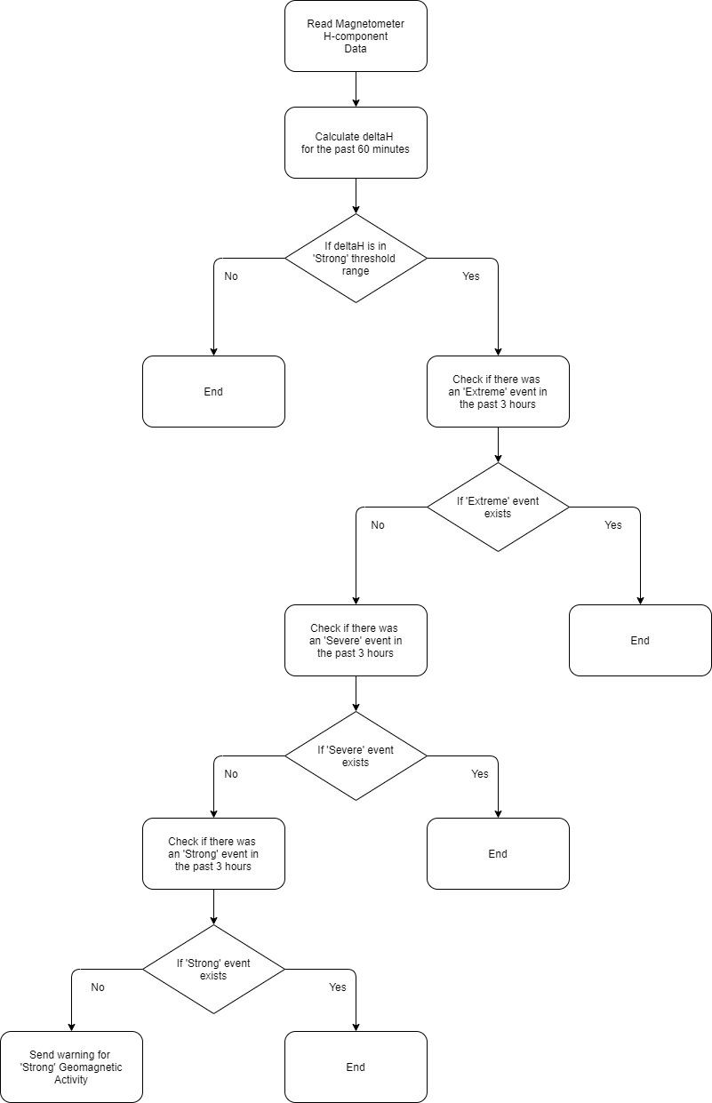

**Flow chart for Geomagnetic Activity Index (Strong)**