Test Report - Generated on 2025-05-22 19:49:52

Screenshot: reports\screenshots\Successful_login_with_valid_credentials\test_report_20250522_194941\Email Input - Username Input_20250522_194941.png

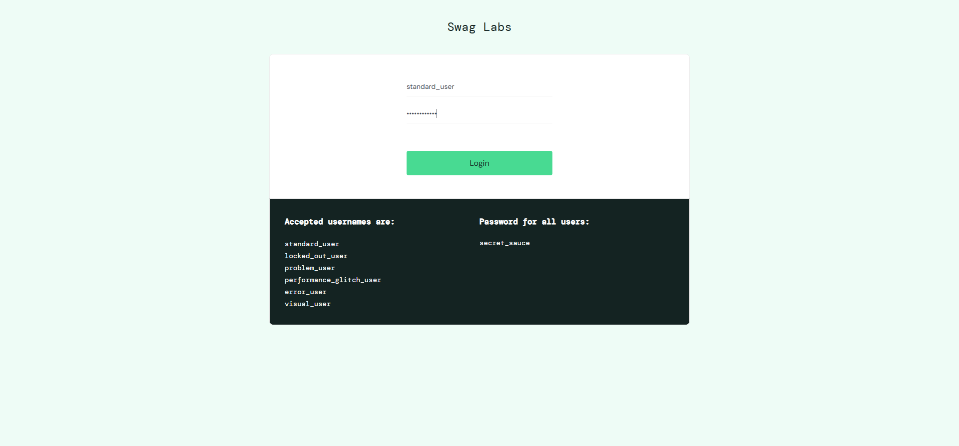



Screenshot: reports\screenshots\Successful_login_with_valid_credentials\test_report_20250522_194941\Product List - Product List_20250522_194952.png

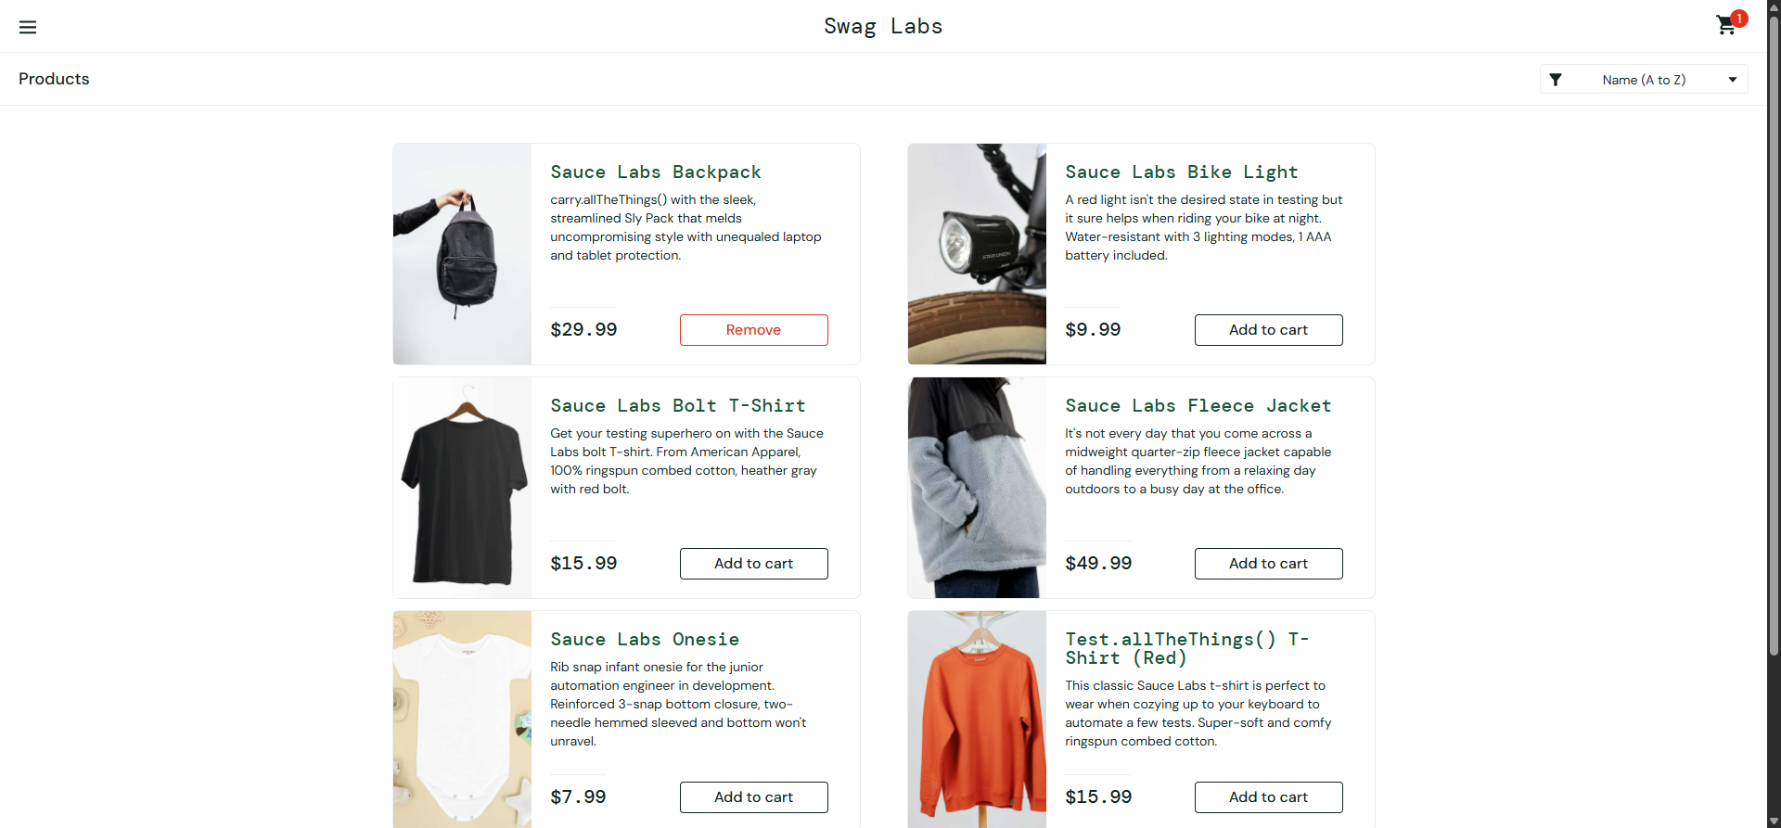



Screenshot: reports\screenshots\Successful_login_with_valid_credentials\test_report_20250522_194941\Product Added to Cart - Product Added to Cart_20250522_194952.png

