Test Report - Generated on 2025-05-22 20:03:29

Screenshot: reports\screenshots\Successful_login_with_valid_credentials\test_report_20250522_200327\Email Input - Username Input_20250522_200327.png

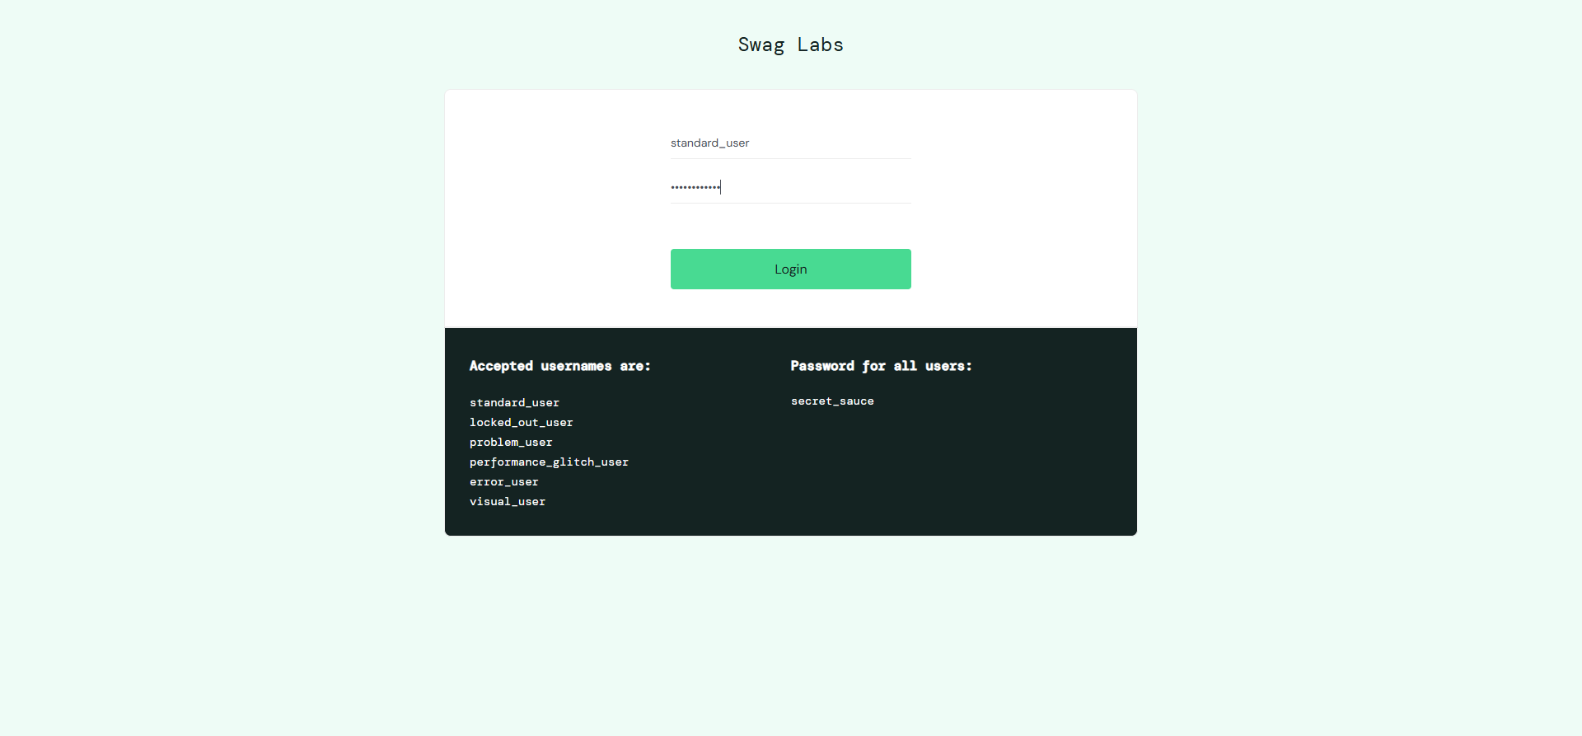



Screenshot: reports\screenshots\Successful_login_with_valid_credentials\test_report_20250522_200327\Product List - Product List_20250522_200328.png

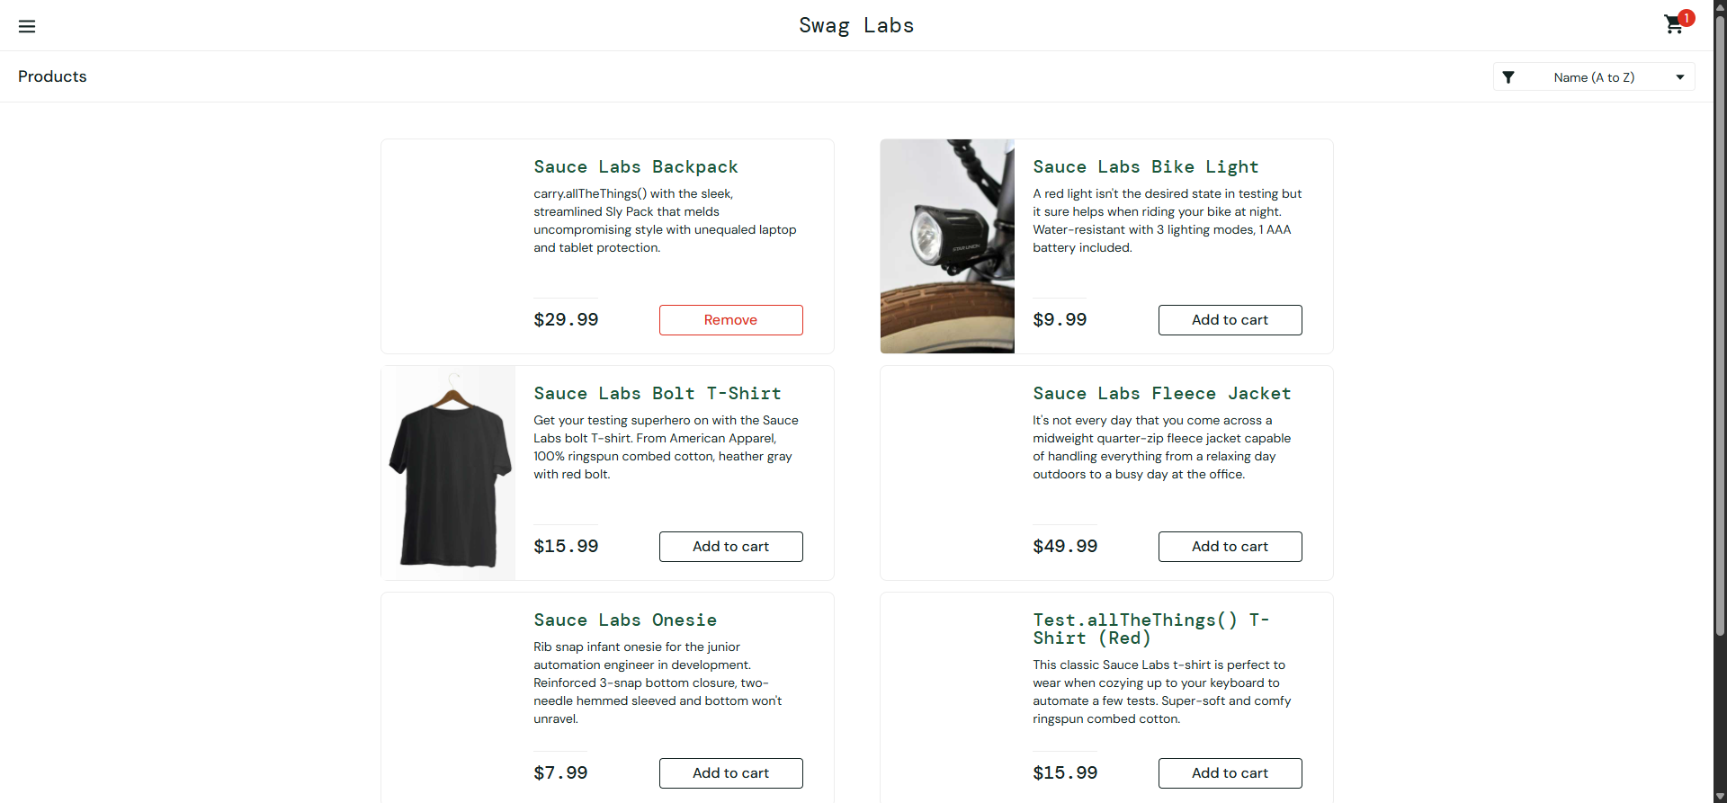



Screenshot: reports\screenshots\Successful_login_with_valid_credentials\test_report_20250522_200327\Product Remove to Cart - Product Remove to Cart_20250522_200329.png

