How to Use This Template

Delete this page before printing or sending the packet — it is for internal use only.
What stays the same for every audience
Who We Are, Founder’s Story, Why Partnerships Matter, and Our Philosophy are approved, evergreen AgroHouse Foundation™ messaging. Reuse them as written for any networking audience.
What to customize per event
- Cover page — “Prepared for” line (audience or event name)
- Today section — optional: tailor examples if the audience is very local (e.g. specific partner or program mentioned)
- Contact page — confirm website / email / phone / social handle are current
Cover letters
Use the companion Networking Cover Letter Template (one per recipient) rather than duplicating letters inside this file. Keep each letter relationship-focused: no direct asks, no fundraising or political language.

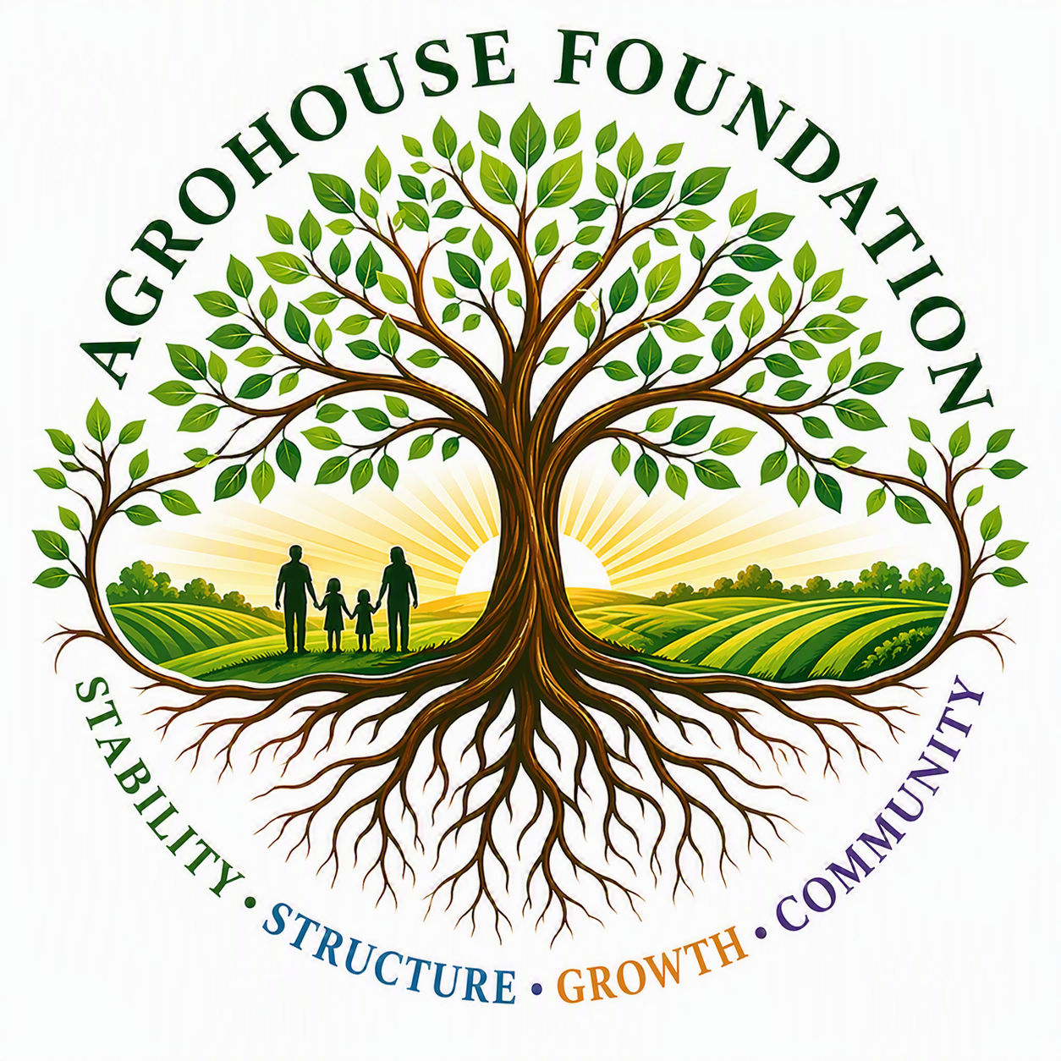
AgroHouse Foundation™
Growing Hope • Building Stability • Strengthening Community

Helping individuals and families move from crisis to stability,
and from stability to opportunity.
Florida Nonprofit Corporation
FDACS Registration Number: CH84790
EIN: 42-4075687
Prepared for [Event / Audience Name]

Who We Are

AgroHouse Foundation™ is a community-focused nonprofit organization helping individuals and families move from crisis to stability — and from stability to opportunity.
We work alongside the churches, businesses, and neighbors who already show up for East Pasco County every day, adding capacity and consistency to the outreach they've built.
Today, we strengthen communities through:
- Community partnerships with local churches and organizations
- Volunteer engagement and coordination support
- Food assistance support
- Hygiene support
- Hydration programs
- Community collaboration and resource-sharing
Our approach
AgroHouse Foundation™ follows a phased-growth model centered on sustainability, stewardship, partnerships, and measurable community impact. We build carefully and debt-free, so that every commitment we make to the community is one we can keep.

Founder’s Story

AgroHouse Foundation™ was created after recognizing that many individuals and families facing hardship often encounter multiple challenges at the same time, including food insecurity, limited access to resources, barriers to employment, and a lack of long-term support systems.
Through conversations with community members, outreach organizations, and local leaders, it became clear that many needs were being addressed individually, but fewer efforts were focused on connecting immediate support with opportunities for long-term stability and self-sufficiency.
Rather than creating another organization that simply provides short-term assistance, AgroHouse Foundation™ was established to help build pathways from crisis to stability and from stability to opportunity.
The organization began with a focus on strengthening existing community outreach efforts through partnerships, resource support, and sustainable program development. The long-term vision includes workforce development, agricultural education, and future vocational initiatives that help individuals build skills, confidence, and independence.
AgroHouse Foundation™ was intentionally built on principles of responsible stewardship, sustainable growth, and community collaboration. Every step of the organization's development has emphasized strong governance, financial accountability, partnerships, and long-term impact.
Today, while still in its early stages of growth, AgroHouse Foundation™ remains committed to strengthening communities through practical support, meaningful partnerships, and opportunities that help individuals and families achieve lasting stability.
Maggie Baty — Founder & Executive Director
AgroHouse Foundation™

Today & Tomorrow

Building Stability Today
Today, AgroHouse Foundation™ focuses on helping strengthen the systems that already support our community.
We work alongside churches, outreach organizations, volunteers, and community partners to help stabilize existing efforts through resource support, logistics, collaboration, and outreach assistance.
Our goal is not to replace the organizations already serving East Pasco County.
Our goal is to help strengthen them.
By helping support existing community efforts, AgroHouse Foundation™ seeks to create more consistent, sustainable, and reliable pathways of assistance for individuals and families facing difficult circumstances.
Creating Opportunity Tomorrow
Tomorrow, AgroHouse Foundation™ envisions a community where support does not end when a crisis ends.
Our long-term vision is inspired by international Agro House concepts that integrate sustainability, opportunity, education, self-sufficiency, and community development into a connected ecosystem.
As AgroHouse™ grows responsibly over time, we hope to expand opportunities through workforce development, educational initiatives, self-sustaining resource systems, and future AgroHouse™-inspired community models that help individuals and families build lasting stability.
Every future initiative shares the same purpose: helping people move from crisis to stability, and from stability to opportunity.
Our Philosophy
Meaningful change happens in phases.
That is why AgroHouse Foundation™ is committed to growing deliberately, stewarding resources responsibly, strengthening community partnerships, and ensuring that each stage of growth is sustainable before moving to the next.
Today's work lays the foundation for tomorrow's opportunities.

Why Partnerships Matter

Strong Communities Are Built Together
AgroHouse Foundation™ was founded on a simple belief: no single organization can solve every challenge facing a community.
Across East Pasco County, churches, nonprofits, businesses, volunteers, and community leaders are already making a meaningful difference every day.
Rather than duplicating those efforts, AgroHouse Foundation™ exists to help strengthen them. We believe sustainable community impact comes from collaboration rather than competition.
By helping connect resources, strengthening outreach efforts, supporting community initiatives, and building relationships across organizations, AgroHouse Foundation™ seeks to create stronger systems of support for individuals and families throughout the community.
This partnership-first philosophy guides every decision we make and reflects our commitment to stewardship, sustainability, and long-term community impact.
What We Are Looking For
We are not looking for transactions.
We are looking for relationships.
AgroHouse Foundation™ welcomes opportunities to connect with community leaders, businesses, churches, nonprofits, volunteers, and organizations that share a commitment to strengthening communities and expanding opportunity for others.

Let’s Stay Connected

AgroHouse Foundation™ is actively building relationships with community leaders, businesses, churches, nonprofits, volunteers, sponsors, donors, and community partners across East Pasco County.
Contact
[Website]
[Email]
[Phone]
[Social Media Handle]
[ QR Code ]
Thank you for taking the time to learn about AgroHouse Foundation™.
We look forward to strengthening communities and creating opportunities together.

