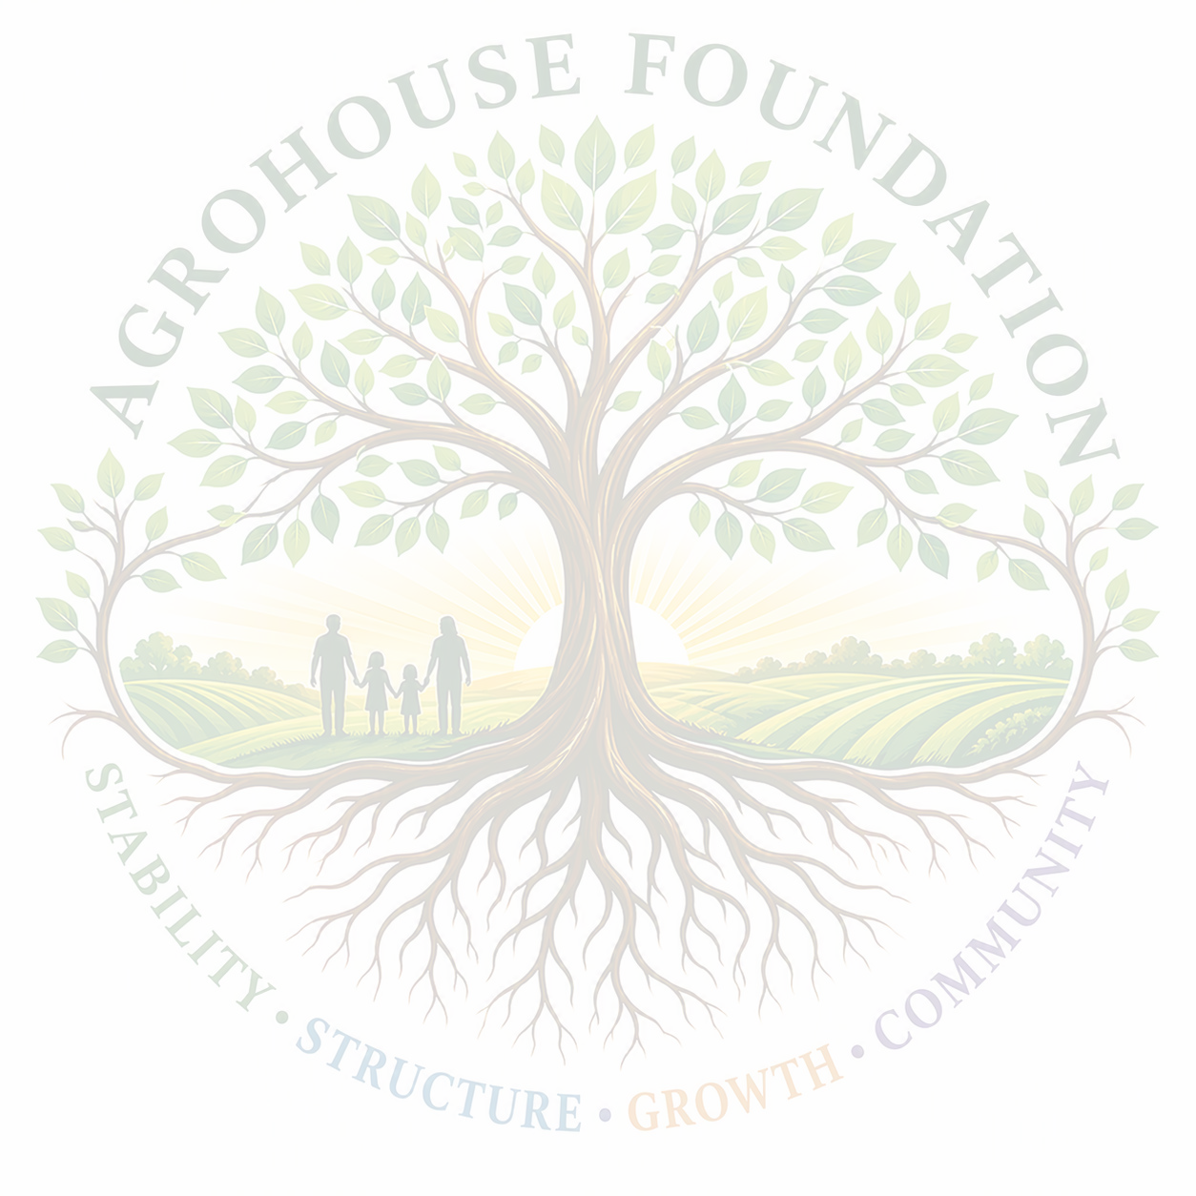
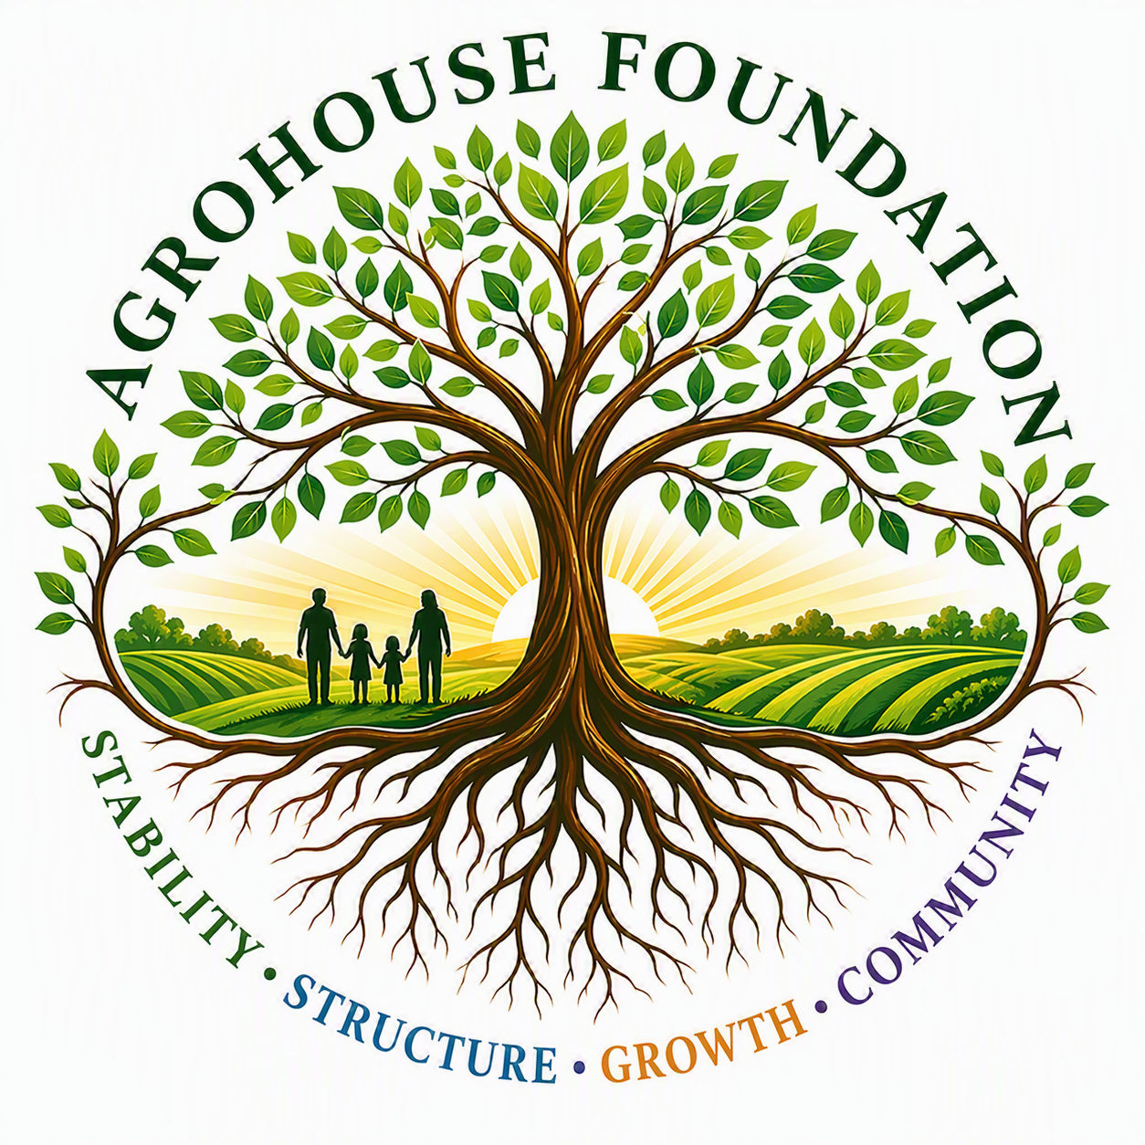
AgroHouse Foundation
Growing Stronger Communities — One Family at a Time

OUR MISSION  AgroHouse Foundation exists to strengthen communities through outreach stabilization, food security, sustainable agriculture, workforce development, and future vocational housing — helping individuals and families achieve lasting stability, self-sufficiency, and dignity.  WHAT WE DO  Our current initiative, the Community Outreach Stabilization Program, provides practical, hands-on support to individuals and families facing hardship — meeting immediate needs while building toward long-term self-sufficiency.  ● Community meals & hydration support  ● Food assistance & hygiene supplies  ● Community resource referrals  ● Volunteer engagement opportunities  ● Community partnership development  Looking ahead, we are developing:  ● Farm Program — agricultural education, food production & sustainability  ● Workforce Development Program — job training & career readiness  ● Vocational Housing Initiative — housing paired with workforce & life-skills training | COMMUNITY IMPACT  Every meal, resource, and referral is a step toward stronger individuals, stronger families, and a more resilient community.  ● Individuals — meeting urgent needs with dignity  ● Families — building pathways to stability  ● Workforce — developing future job readiness  ● Community — strengthening local partnerships  GET INVOLVED  ● Volunteer your time  ● Donate to support our programs  ● Become a community partner  ● Sponsor a program  ● Support grant & funding opportunities  ● Help us expand services  "Providing Hope, Stability, Opportunity, and Community Through Service, Education, and Sustainable Development."

Get In Touch  Website: www.agrohousefoundation.org | Email: info@agrohousefoundation.org  Phone: 813-364-3921 |   Scan to Visit Us

