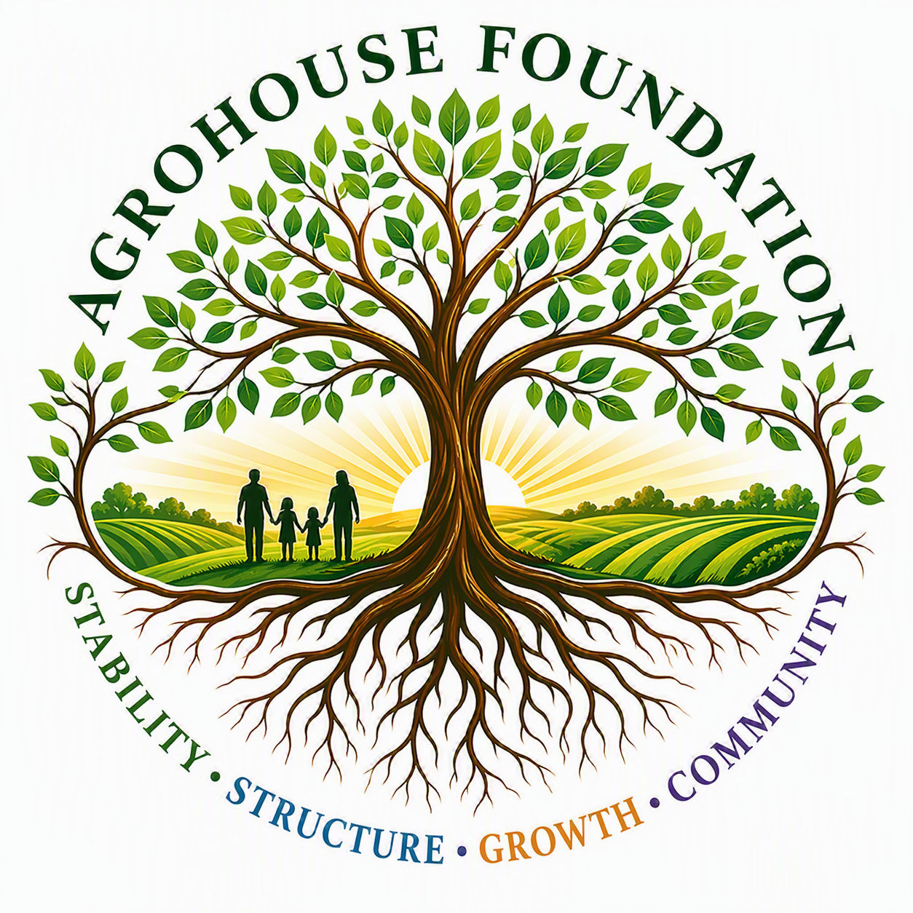
AGHF INC.
d/b/a AgroHouse Foundation
BOARD ROLE SUMMARY
Director Orientation Document
TEMPLATE — CUSTOMIZE PER BOARD MEMBER
Stability • Structure • Growth • Community
Name | [Full Name]
Board Position | [Title, e.g. Board Member / Officer]

Primary Responsibility
Provide governance, oversight, and strategic input in support of the mission and long-term development of AgroHouse Foundation™.

Core Responsibilities
• Participate in Board-level discussions and decisions
• Provide insight based on experience and area of expertise
• Support alignment between planning and execution
• Ensure the organization remains structured, compliant, and sustainable

Role Clarification
This role is governance-based and does not include day-to-day operational responsibilities unless separately authorized by the Board through a specific staffing appointment or compensation agreement.

Additional Position-Specific Duties
[Insert any officer-specific duties here — e.g. Treasurer financial oversight, Secretary recordkeeping, Chairperson meeting facilitation — drawn from the Bylaws.]
AGHF Inc. d/b/a AgroHouse Foundation™ — Board Role Summary — TEMPLATE

