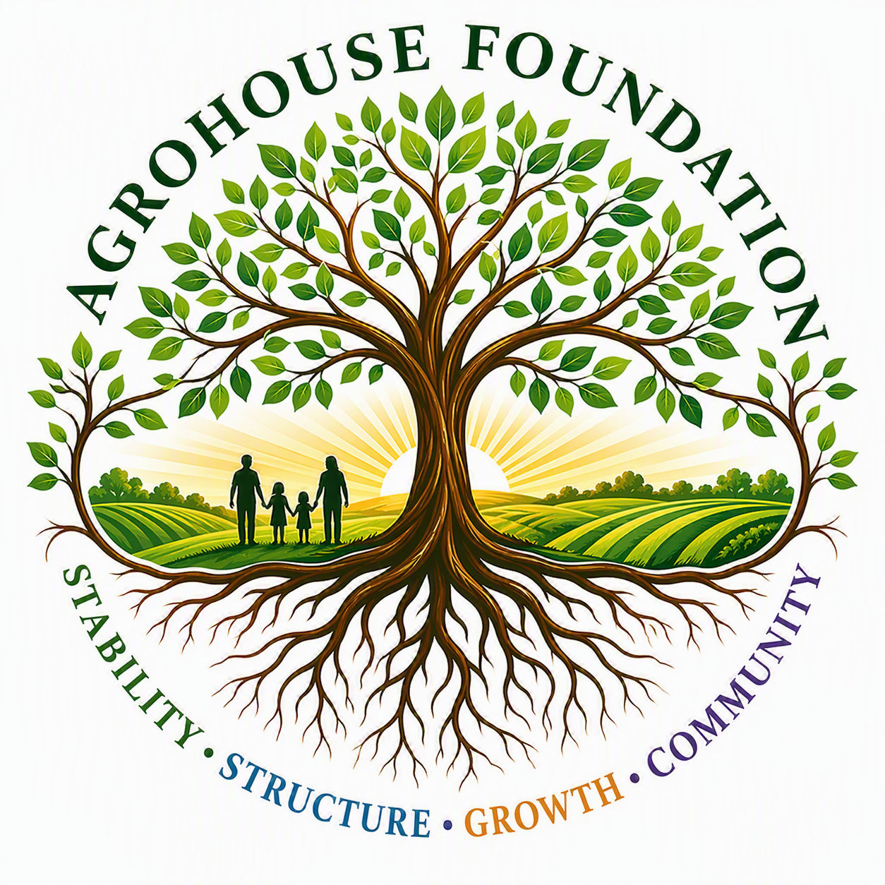
AGHF INC.
d/b/a AgroHouse Foundation
MISSION & VISION
Organizational One-Pager
Stability • Structure • Growth • Community

Mission
AgroHouse Foundation exists to strengthen communities through outreach stabilization, food security, sustainable agriculture, workforce development opportunities, and future vocational housing systems that promote long-term stability, self-sufficiency, and dignity.

Vision
To create a sustainable ecosystem where outreach, agriculture, workforce development, and vocational opportunities work together to strengthen individuals, families, and communities.

Core Values
Stability | Creating reliable systems that communities can depend upon.
Sustainability | Building long-term solutions rather than temporary responses.
Stewardship | Managing resources responsibly, ethically, and transparently.
Community | Working alongside existing organizations and community partners rather than replacing them.
Opportunity | Creating pathways for growth, education, employment, and self-sufficiency.
Dignity | Serving individuals with respect while preserving personal choice, independence, and self-worth.

Current Priority
Program 1 — Community Outreach Stabilization is AGHF's active, Board-approved operating program, serving Wesley Chapel, Zephyrhills, Dade City, Land O' Lakes, and East Pasco County, Florida.
AGHF Inc. d/b/a AgroHouse Foundation™ — Mission & Vision One-Pager — TEMPLATE

