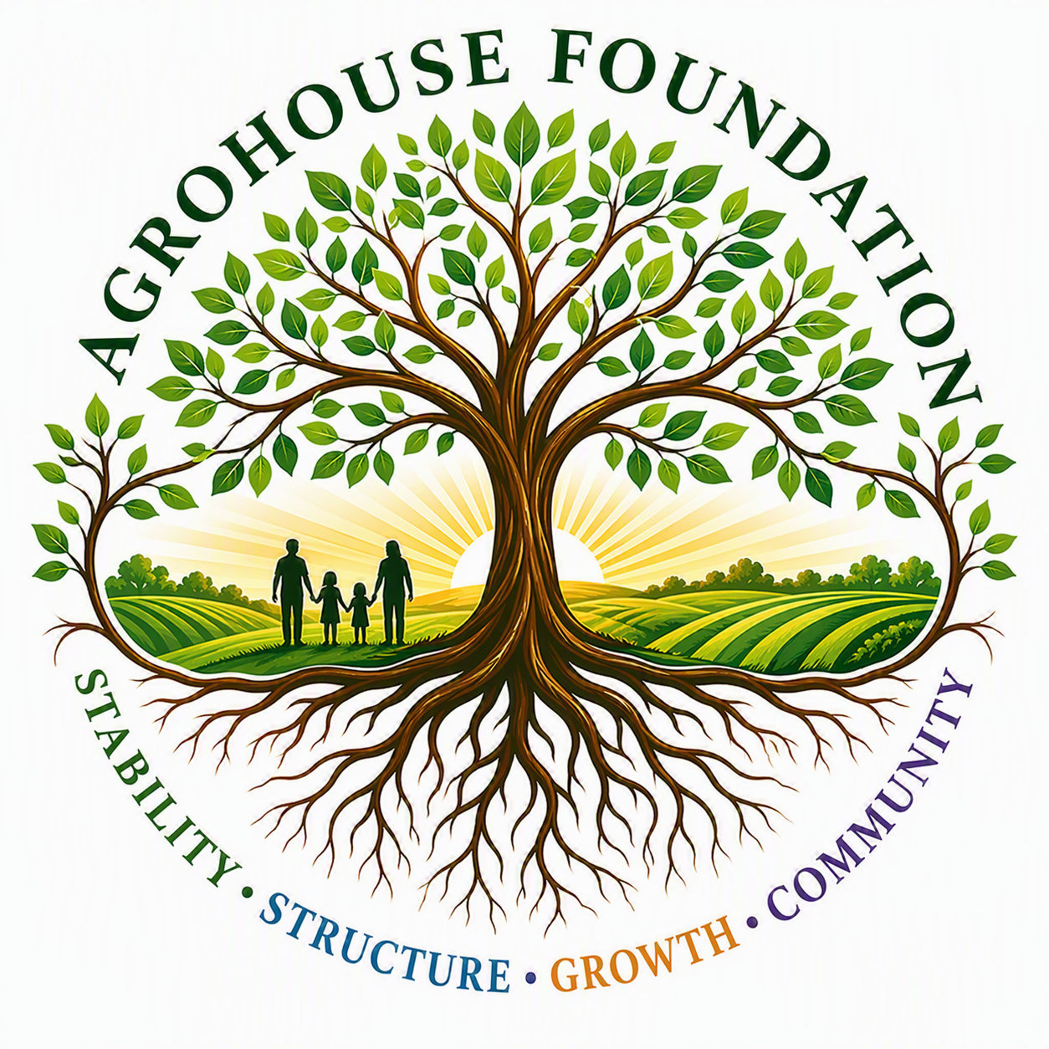
AGHF INC.
d/b/a AgroHouse Foundation
BOARD MEMBER AGREEMENT
Roles, Responsibilities & Expectations
TEMPLATE — CUSTOMIZE PER BOARD MEMBER
Stability • Structure • Growth • Community
Name | [ ]
Board Position / Title | [ ]
Date of Appointment | [ ]

Purpose of This Agreement
This agreement outlines the roles, responsibilities, and expectations of [Name] as a Board Member of AgroHouse Foundation™, ensuring clear governance, accountability, and alignment with the organization's mission and long-term development.

Organization Overview
AgroHouse Foundation™ is an integrated system designed to support community stability through:
• Sustainable food production
• Workforce development
• Structured community support
• Vocational housing

Board Member Role
As a Board Member, [Name] agrees to:
• Support the mission and purpose of AgroHouse Foundation™
• Participate in Board discussions and decision-making
• Provide oversight and strategic guidance
• Act in the best interest of the organization

Board Contribution
[Name] contributes to the Board through: [insert area(s) of expertise or focus, e.g. financial oversight, community engagement, legal/compliance, agriculture]. This contribution is advisory in nature and does not constitute operational authority within the organization unless separately authorized by the Board.
X ________________________________________
[Name], Board Member
Date: ________________________________________
AGHF Inc. d/b/a AgroHouse Foundation™ — Board Member Agreement — TEMPLATE

