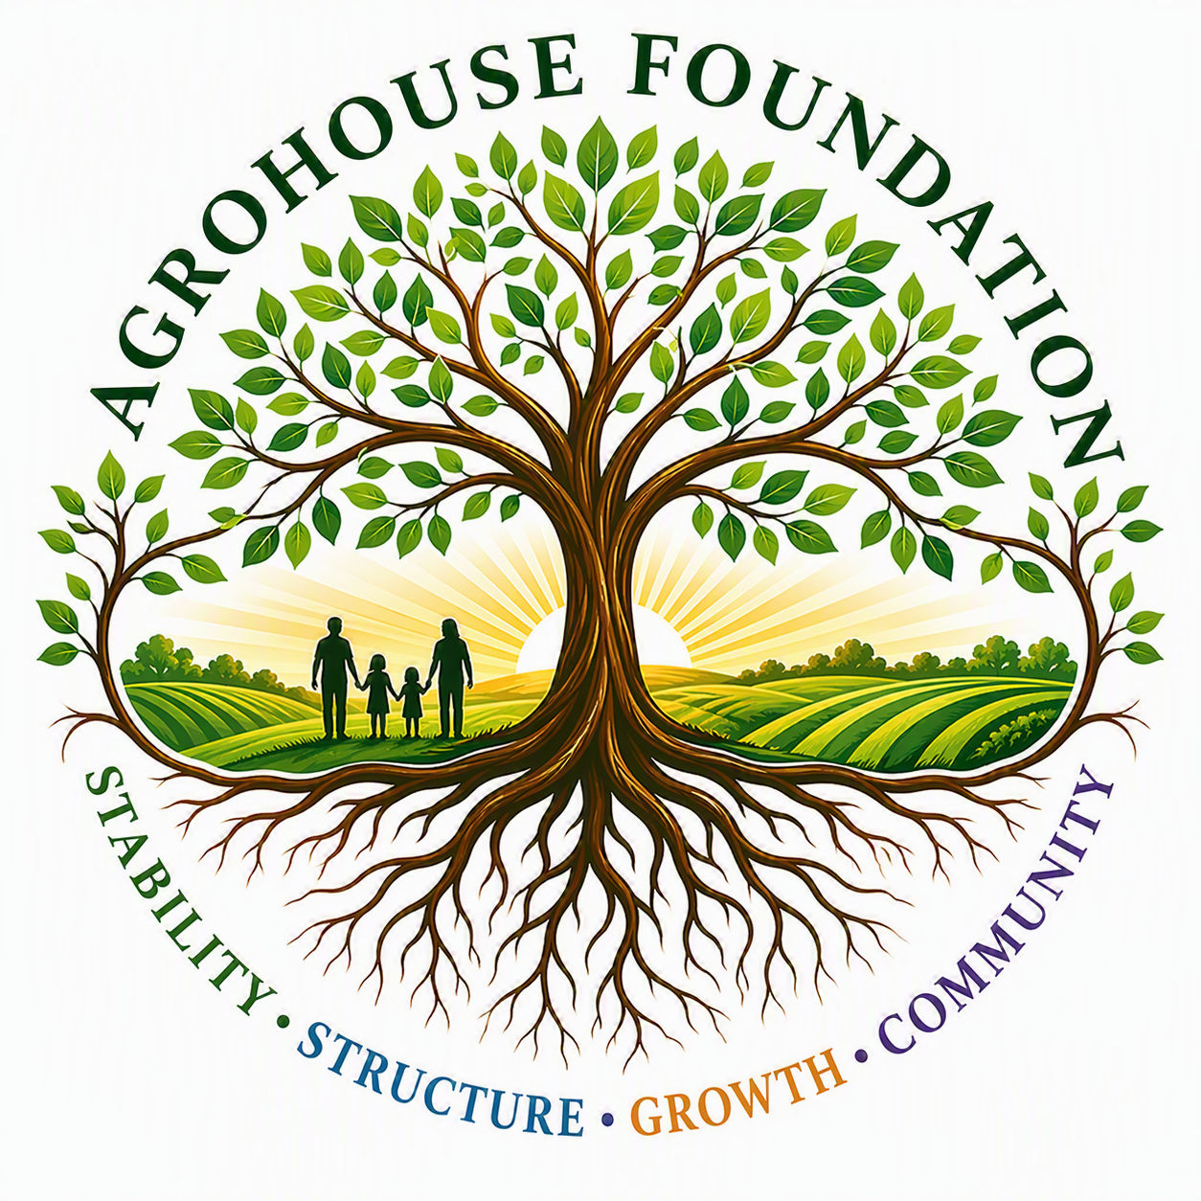
AGHF INC.
d/b/a AgroHouse Foundation
GIFT / IN-KIND VALUATION POLICY
AGHF Inc. d/b/a AgroHouse Foundation
TEMPLATE — FOR BOARD ADOPTION
Stability • Structure • Growth • Community
Adopted: ________________________________________

1. Purpose
This policy establishes consistent procedures for identifying, valuing, and recording in-kind (non-cash) donations received by the Corporation.

2. Types of In-Kind Gifts
• Food and beverage donations for meal service
• Hygiene and personal care supplies
• Storage, refrigeration, or transportation equipment
• Use of facility space
• Furniture, office equipment, and supplies

3. Valuation Method
In-kind gifts shall be valued at fair market value as of the date of donation, based on donor-provided documentation, comparable retail pricing, or professional appraisal for gifts exceeding $[Amount].

4. Recordkeeping
The Treasurer shall maintain a log of all in-kind gifts received, including donor name, description, estimated value, valuation method, and date received.
X ________________________________________
[Name], Chairperson
Date: ________________________________________
AGHF Inc. d/b/a AgroHouse Foundation™ — Gift/In-Kind Valuation Policy — TEMPLATE

