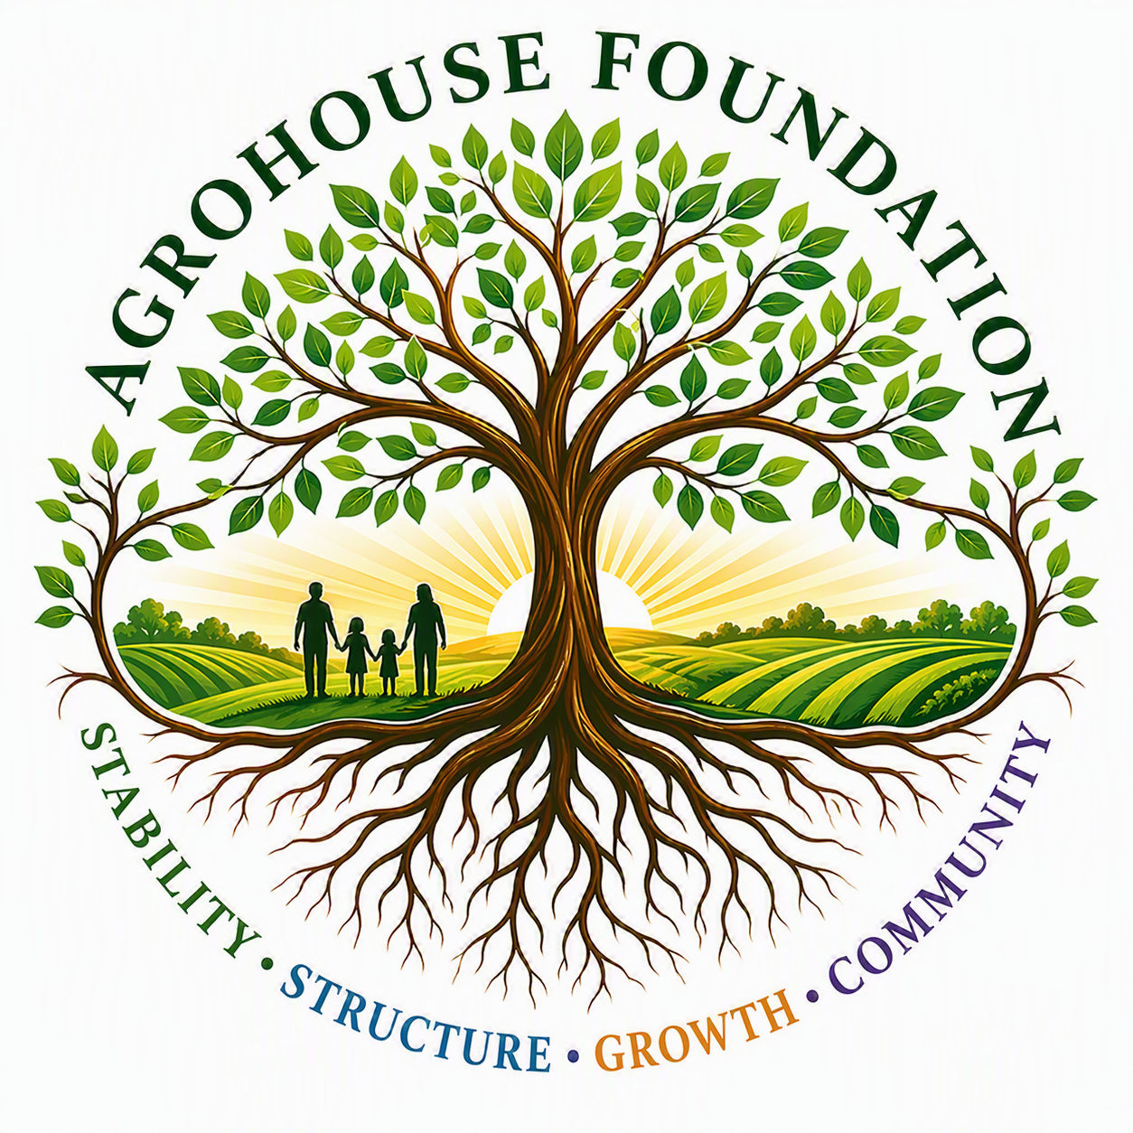
AGHF INC.
d/b/a AgroHouse Foundation
FUNDRAISING STRATEGY FRAMEWORK
AGHF Inc. d/b/a AgroHouse Foundation™
TEMPLATE — ANNUAL PLANNING DOCUMENT
Stability • Structure • Growth • Community

Guiding Principle
All fundraising and sponsorship efforts shall reflect a debt-free, relationship-first, no-pressure, mission-driven approach — no high-pressure tactics, no exaggerated impact claims.

Fundraising Channels

Events
[Describe planned fundraising events for the period.]

Sponsorships
[Describe sponsorship tiers/targets — see Sponsorship Tracker for prospects.]

Individual Donations
[Describe recurring/one-time giving strategy, e.g. online giving, direct appeal letters.]

Grants
[Describe grant targets and application calendar.]

Annual Priorities
• [Priority 1]
• [Priority 2]
• [Priority 3]

Reporting
Fundraising and marketing activity shall be reported to the Board no less than quarterly.
X ________________________________________
[Name], Treasurer
Date: ________________________________________
AGHF Inc. d/b/a AgroHouse Foundation™ — Fundraising Strategy Framework — TEMPLATE

