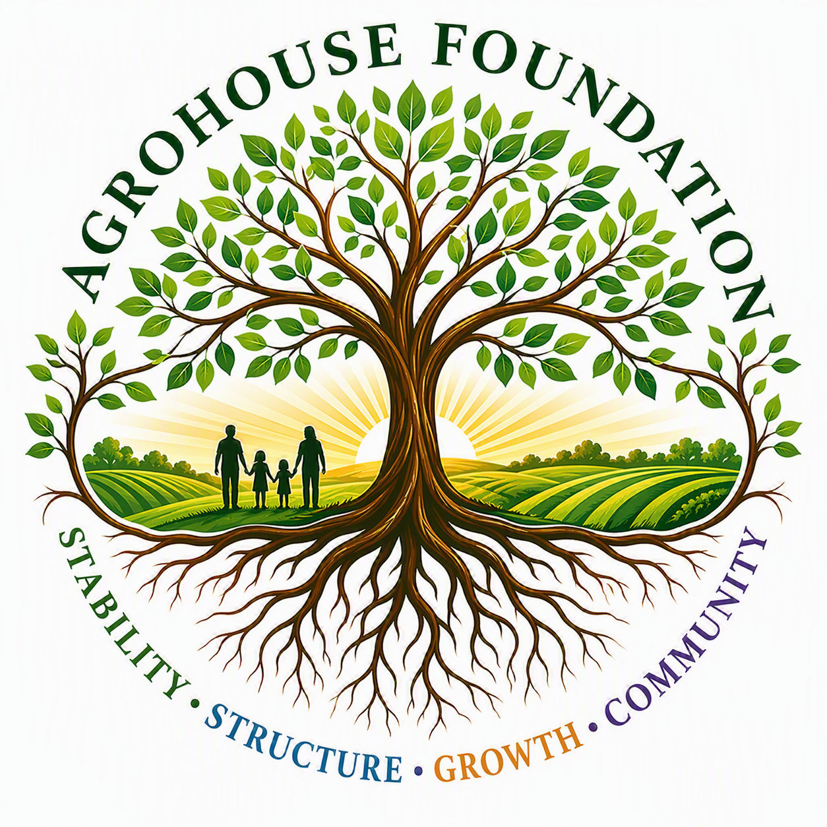
AGHF INC.
d/b/a AgroHouse Foundation
CODE OF ETHICS POLICY
AGHF Inc. d/b/a AgroHouse Foundation
TEMPLATE — FOR BOARD ADOPTION
Stability • Structure • Growth • Community
Adopted: ________________________________________

1. Purpose
This Code of Ethics Policy establishes the standards of conduct expected of all directors, officers, employees, volunteers, and contractors, in furtherance of the Corporation's mission and its obligations as a 501(c)(3) public charity.

2. Core Principles
All covered individuals shall act in accordance with the Corporation's core values:
• Stability — creating reliable systems that communities can depend upon
• Sustainability — building long-term solutions rather than temporary responses
• Stewardship — managing resources responsibly, ethically, and transparently
• Community — working alongside existing organizations and community partners
• Opportunity — creating pathways for growth, education, employment, and self-sufficiency
• Dignity — serving individuals with respect while preserving personal choice and self-worth

3. Standards of Conduct
Covered individuals shall act honestly and in good faith, comply with applicable law, avoid conflicts of interest, safeguard confidential information, and represent the Corporation professionally in all public and donor-facing communications.

4. Reporting Violations
Suspected violations of this Code shall be reported per the Whistleblower Policy.
X ________________________________________
[Name], Chairperson
Date: ________________________________________
AGHF Inc. d/b/a AgroHouse Foundation™ — Code of Ethics Policy — TEMPLATE

