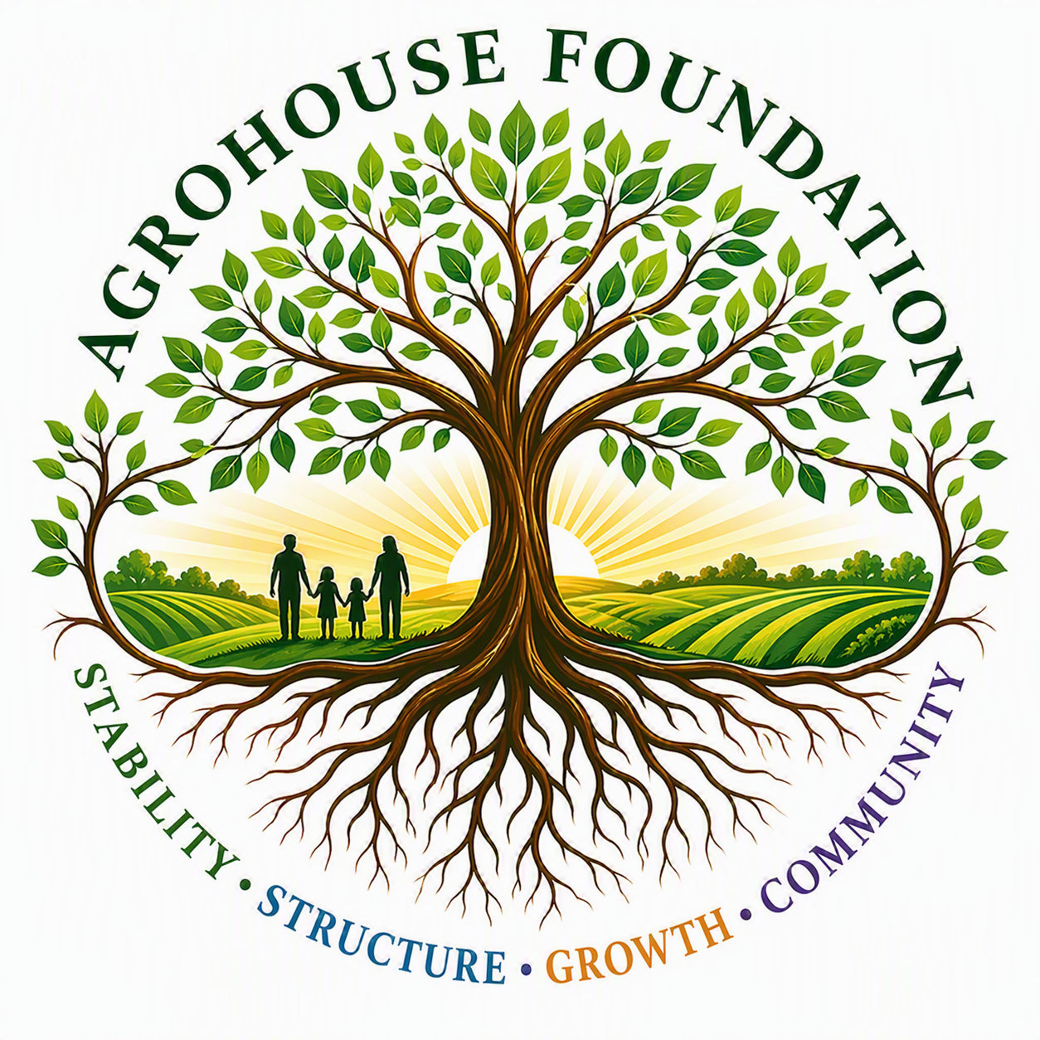
AGHF INC.
d/b/a AgroHouse Foundation
BOARD RECRUITMENT & SUCCESSION POLICY
AGHF Inc. d/b/a AgroHouse Foundation
TEMPLATE — FOR BOARD ADOPTION
Stability • Structure • Growth • Community
Adopted: ________________________________________

1. Purpose
This policy guides the Corporation's approach to Board growth, officer succession, and filling Board vacancies, to ensure continuity of governance and mission alignment.

2. Board Composition Goals
The Board shall seek Directors with diverse skills relevant to the organization's needs, including finance, fundraising, legal, agriculture, and community relations, consistent with the Bylaws' requirement of not fewer than four and not more than eleven Directors.

3. Recruitment Process
Prospective Directors shall be identified by current Directors, complete an informational interview with the Chairperson, and be presented to the full Board for a vote, consistent with Bylaws Article V.

4. Officer Succession
Officer positions shall be reviewed annually. The Vice Chairperson is the presumptive successor to the Chairperson in the event of a vacancy, subject to Board vote.

5. Vacancies
Board vacancies shall be filled by majority vote of the remaining Directors, per Bylaws Article V, Section 6.
X ________________________________________
[Name], Chairperson
Date: ________________________________________
AGHF Inc. d/b/a AgroHouse Foundation™ — Board Recruitment & Succession Policy — TEMPLATE

