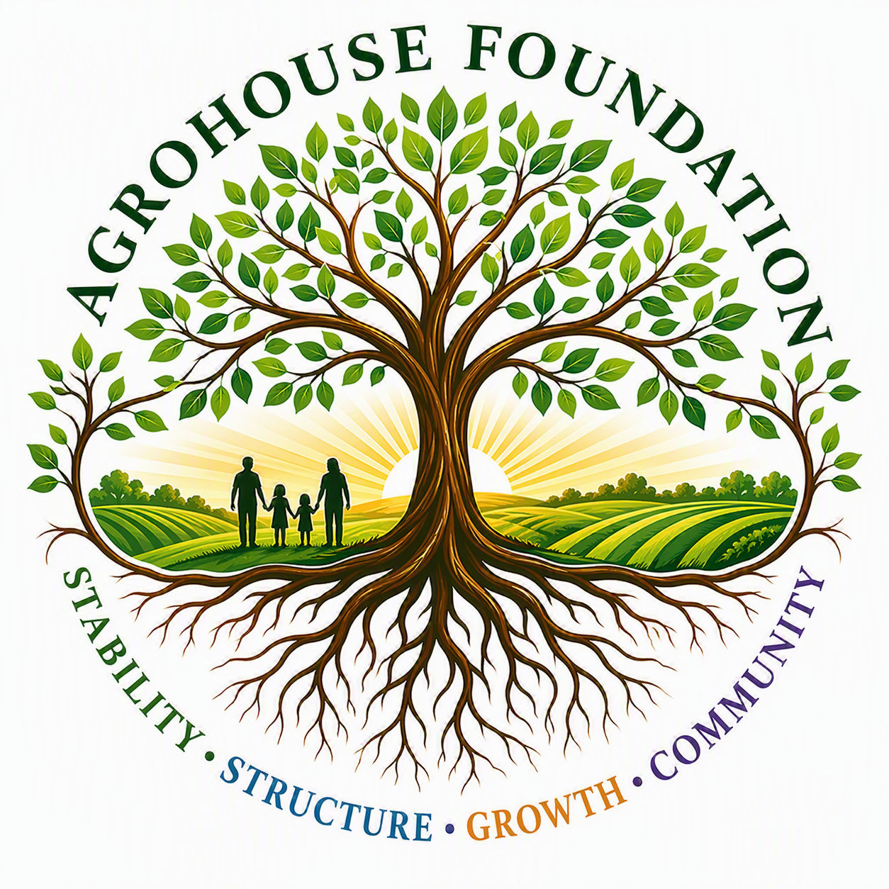
AGHF INC.
d/b/a AgroHouse Foundation
GRANT / DONATION APPLICATION
Application Readiness Review & Board Authorization
TEMPLATE — FOR EACH GRANT OR DONATION REQUEST
Stability • Structure • Growth • Community
This document reviews AGHF Inc.'s readiness to submit a grant or in-kind donation request in support of [Program Name].

Application Summary
Organization | AGHF Inc. d/b/a AgroHouse Foundation™
Funder / Donor | [Funder Name]
Program | [Program Name]
Requested Support | [e.g., in-kind food donations, monetary grant]
Requested Amount / Value | $[Amount]
Partner Organization (if applicable) | [Partner Name]
Intended Use | [Describe how funds/goods will be used]

Readiness Checklist
• ☐ Application accurately discloses AGHF's pending 501(c)(3) status
• ☐ Requested amount reviewed against Financial Controls Policy thresholds
• ☐ Board authorization obtained (if required)
• ☐ Reporting plan established for use of funds

Board Authorization
This application is submitted under the authority of the Grant Application Authorization Resolution. Applications exceeding $[Threshold] require Board approval prior to submission.
X ________________________________________
[Name], Executive Director
Date: ________________________________________
AGHF Inc. d/b/a AgroHouse Foundation™ — Grant / Donation Application — TEMPLATE

