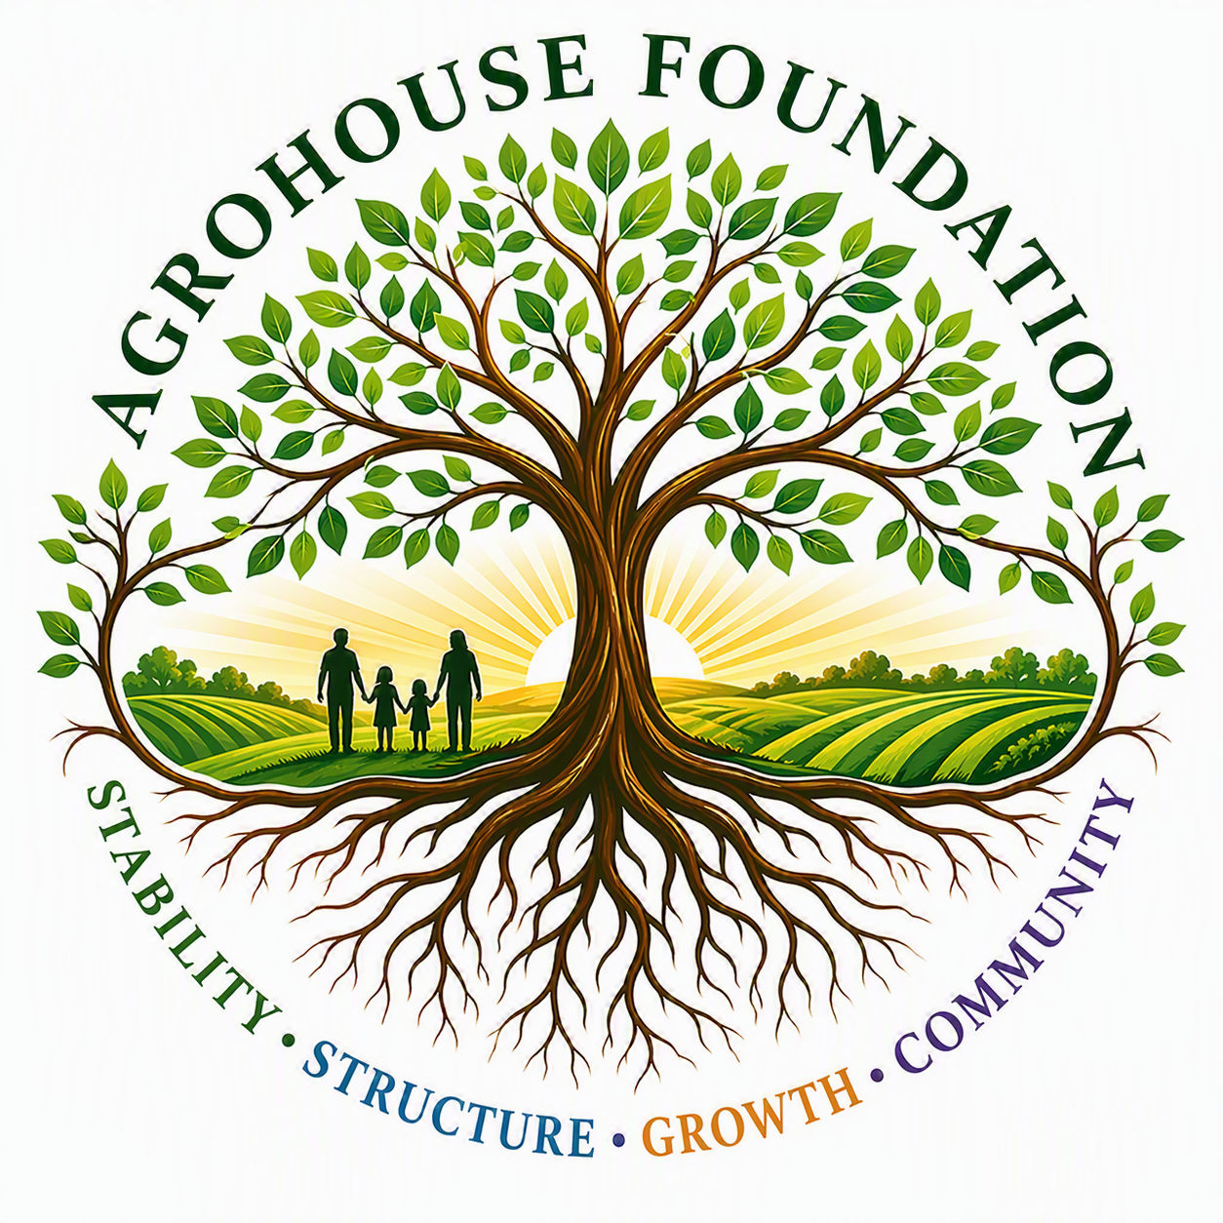
AGHF INC.
d/b/a AgroHouse Foundation
ACKNOWLEDGMENT FORM
Receipt of Governing Documents / Policy
TEMPLATE — TO BE SIGNED UPON RECEIPT
Stability • Structure • Growth • Community
I acknowledge that I have received, read, and understood the following document(s) of AGHF Inc. d/b/a AgroHouse Foundation:
Document Title(s) | [ ]
Recipient Name | [ ]
Recipient Role | [ ]
I agree to comply with the terms of the document(s) listed above for as long as I serve in the capacity noted.
X ________________________________________
[Name]
Date: ________________________________________
AGHF Inc. d/b/a AgroHouse Foundation™ — Acknowledgment Form — TEMPLATE

