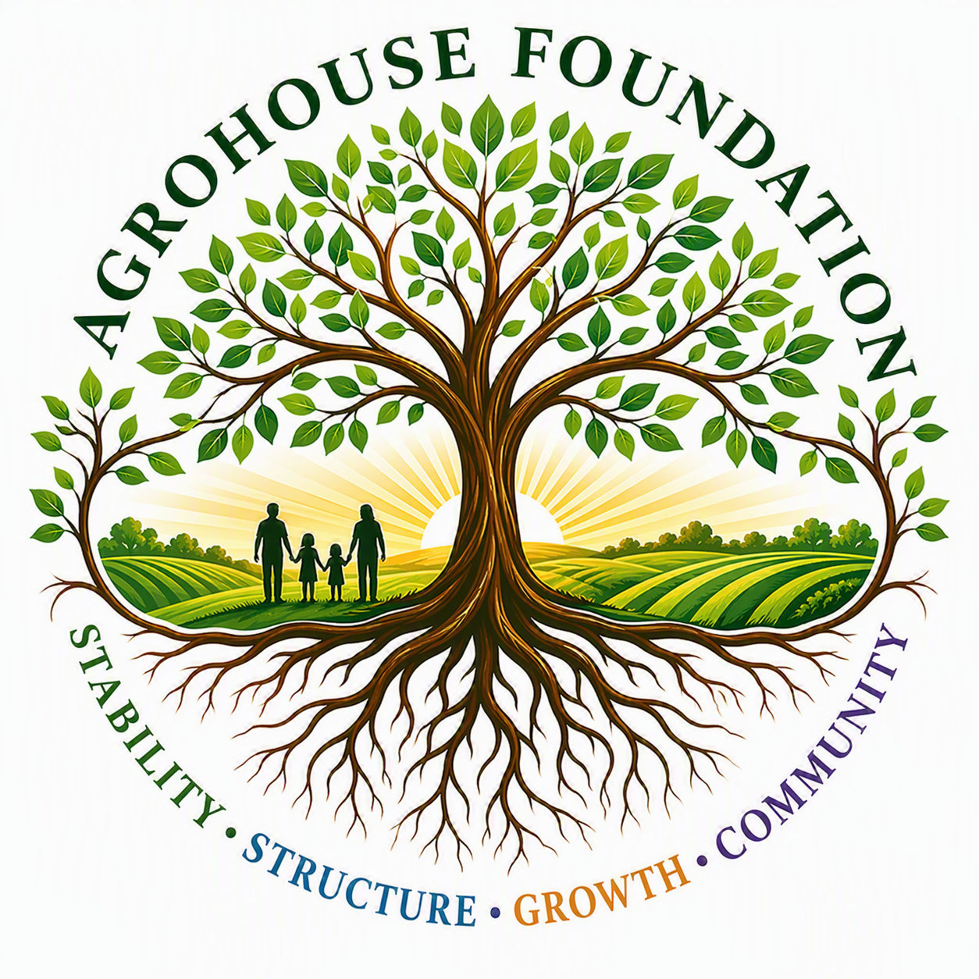
AGHF INC.
d/b/a AgroHouse Foundation
[PROGRAM / EVENT NAME]
AGHF Inc. d/b/a AgroHouse Foundation™
Stability • Structure • Growth • Community

What We Do
AgroHouse Foundation strengthens communities through outreach stabilization, food security, sustainable agriculture, workforce development, and future vocational housing systems.

[Program / Event Name]
[Describe the program or event, who it serves, and how the community can get involved.]

How to Get Involved
• [Volunteer opportunity]
• [Donation opportunity]
• [Partnership opportunity]

Contact
[Website] | [General inquiry email] | [Phone, if public]
AGHF Inc. d/b/a AgroHouse Foundation™ — Marketing Flyer / One-Pager — TEMPLATE

