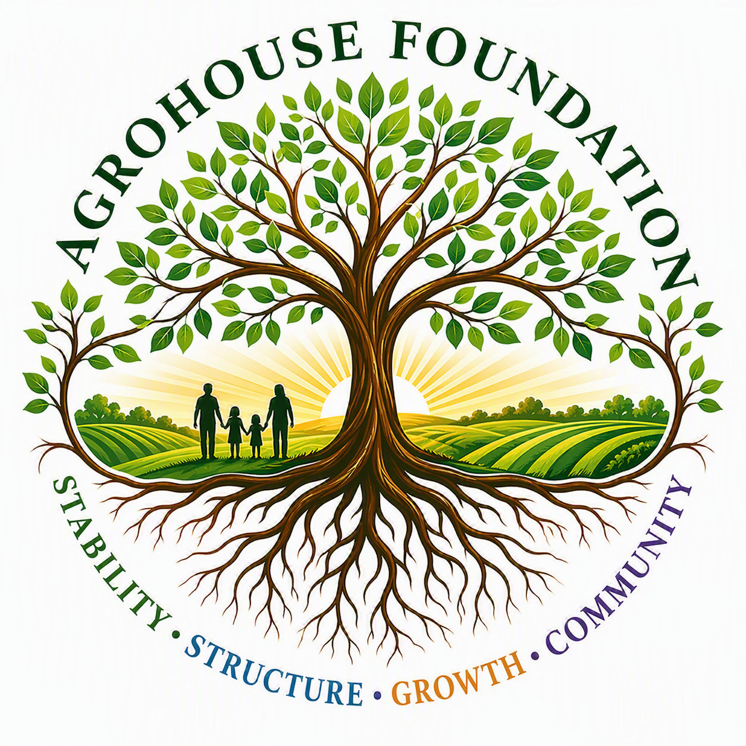
AGHF INC.
d/b/a AgroHouse Foundation
ORGANIZATIONAL COMMUNICATION STANDARDS
AGHF Inc. d/b/a AgroHouse Foundation™
TEMPLATE — FOR BOARD ADOPTION
Stability • Structure • Growth • Community
Adopted: ________________________________________

Preferred Organizational Voice
• Professional
• Community Focused
• Mission Driven
• Grant Ready
• Data Informed
• Partnership Oriented
• Faith-Friendly
• Solution Focused

Communication Themes
• Food Security
• Community Stabilization
• Sustainable Agriculture
• Workforce Development
• Self-Sufficiency
• Responsible Stewardship
• Community Partnerships

Avoid
• Political messaging
• Partisan advocacy
• Unverified impact claims
• Corporate jargon
• Exaggerated fundraising language

Pre-501(c)(3) Disclosure Language
All fundraising communications made prior to receiving IRS 501(c)(3) determination shall clearly disclose that the Corporation's tax-exempt status is pending.
X ________________________________________
[Name], Chairperson
Date: ________________________________________
AGHF Inc. d/b/a AgroHouse Foundation™ — Organizational Communication Standards — TEMPLATE

