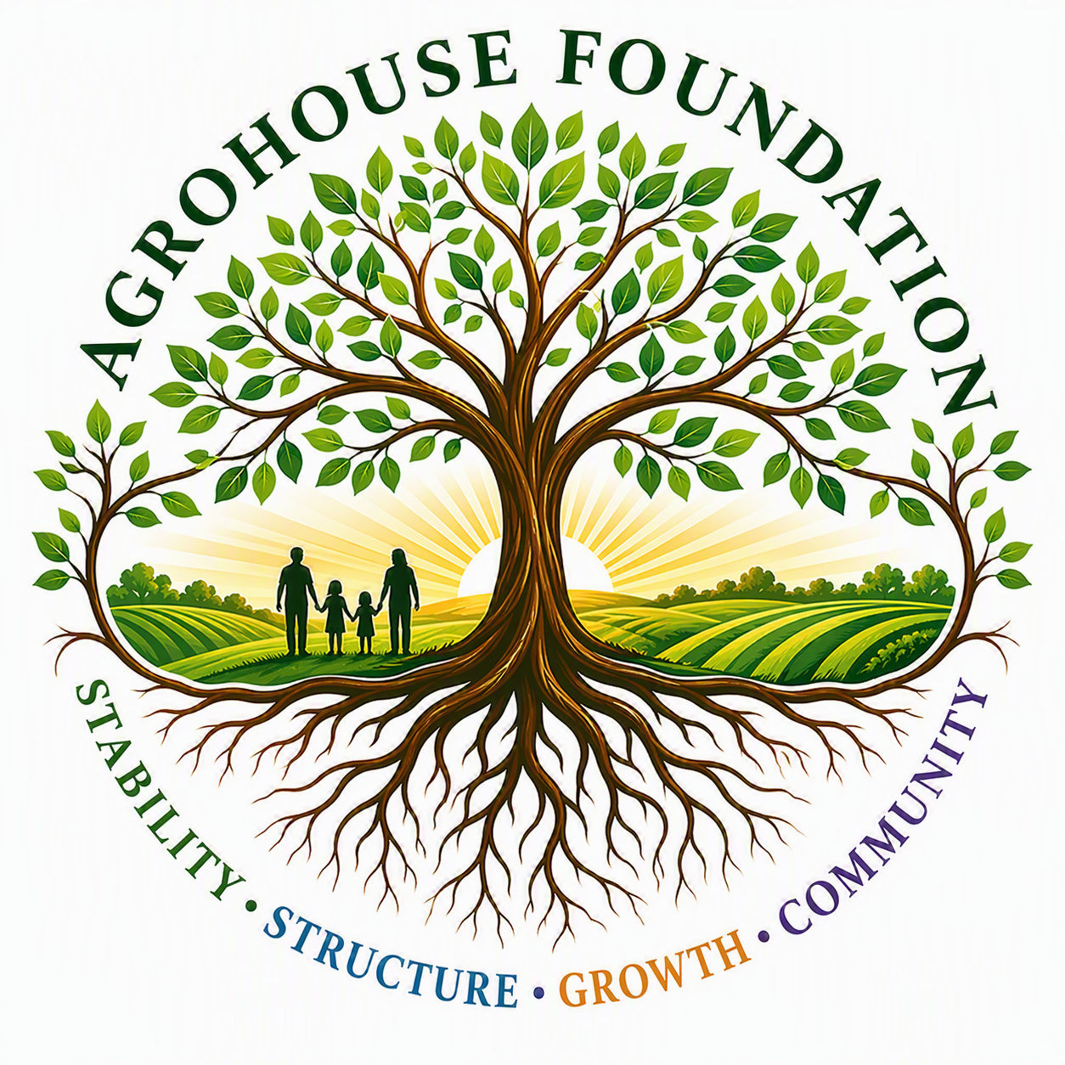
AGHF INC.
d/b/a AgroHouse Foundation
PROGRAM CHARTER
[Program Name] — AGHF Inc. d/b/a AgroHouse Foundation™
TEMPLATE — FOR BOARD APPROVAL
Stability • Structure • Growth • Community

Program Overview
[Program Name] is a program of AGHF Inc. d/b/a AgroHouse Foundation™, established to [describe purpose], consistent with the Organization's mission and tagline: Stability • Structure • Growth • Community.

Purpose & Goals
• [Goal 1]
• [Goal 2]
• [Goal 3]
• [Goal 4]

Scope of Services
[Describe the specific services, resources, or activities this program will provide, and the population or area served.]

Program Structure
[Program Name] operates under the direction of the [Program Manager title], who reports to the Executive Director and the Board of Directors.

Program Leadership
Role | Assigned To
[Program Manager Title] | [Name]
[Support Role] | [To be hired / Name]

Board Oversight & Reporting
The Board shall receive regular program updates no less than [quarterly], including metrics described in the Program's success measures, and shall approve any material change in scope, budget, or staffing.
X ________________________________________
[Name], Chairperson
Date: ________________________________________
AGHF Inc. d/b/a AgroHouse Foundation™ — Program Charter — TEMPLATE

