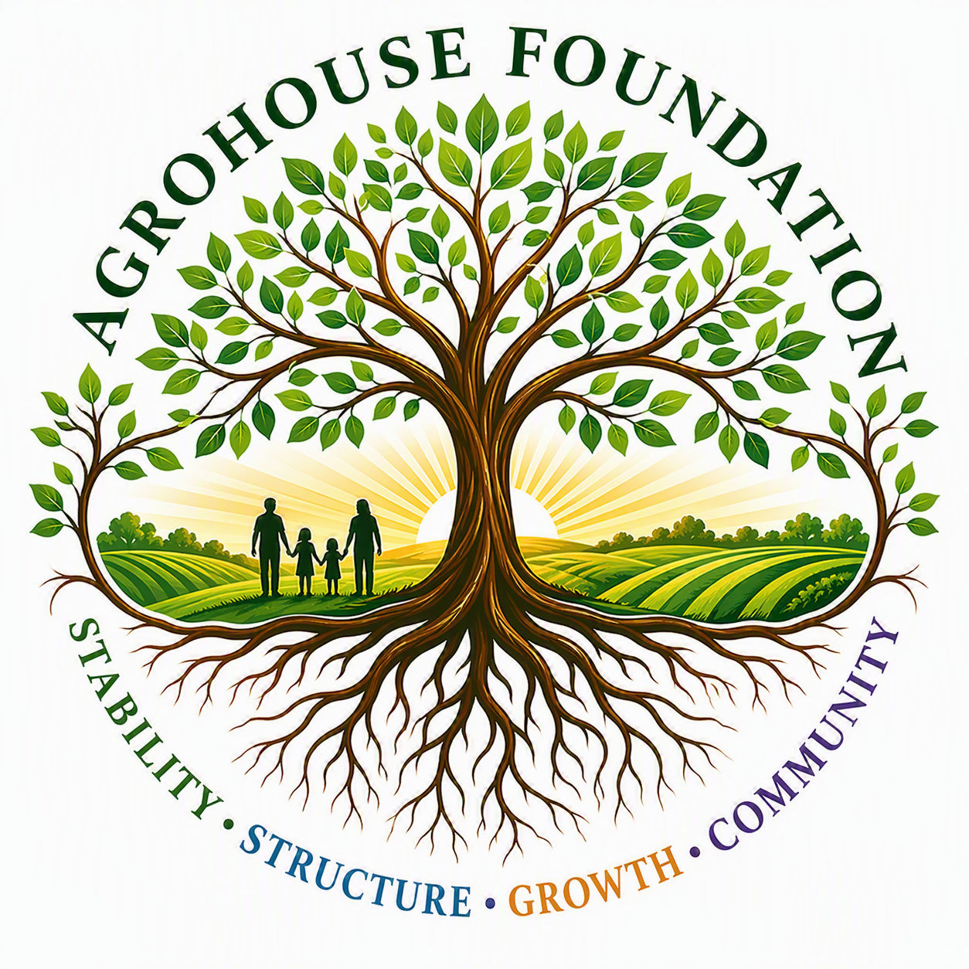
AGHF INC.
d/b/a AgroHouse Foundation
PROGRAM OPERATING POLICY
[Program Name] — AGHF Inc. d/b/a AgroHouse Foundation™
TEMPLATE — FOR BOARD APPROVAL
Stability • Structure • Growth • Community

Purpose
This Operating Policy governs the day-to-day administration of [Program Name] to ensure consistent, safe, and mission-aligned service delivery.

Program Hours & Availability
[Describe staffing hours, scheduling authority, and any budget constraints on hours.]

Intake & Service Delivery Procedures
• [Describe how individuals/families/partners access the program — referral, walk-in, outreach]
• [Describe the needs assessment or intake process]
• [Describe documentation and recordkeeping requirements]
• [Describe follow-up procedures, if applicable]

Roles & Responsibilities
Role | Responsibilities
[Program Manager Title] | Program oversight, partner coordination, staff supervision, reporting to Executive Director/Board
[Support Role] | [Day-to-day duties]

Resource Procurement & Inventory
[Describe how supplies/resources are procured, tracked, and replenished.]

Donation & Volunteer Management
[Describe how in-kind donations and volunteers are coordinated, consistent with the Donation Acceptance Policy and Community Partnership Policy.]

Program Reporting
The [Program Manager Title] shall report program metrics and activity to the Executive Director and Board no less than [monthly/quarterly].
X ________________________________________
[Name], Chairperson
Date: ________________________________________
AGHF Inc. d/b/a AgroHouse Foundation™ — Program Operating Policy — TEMPLATE

