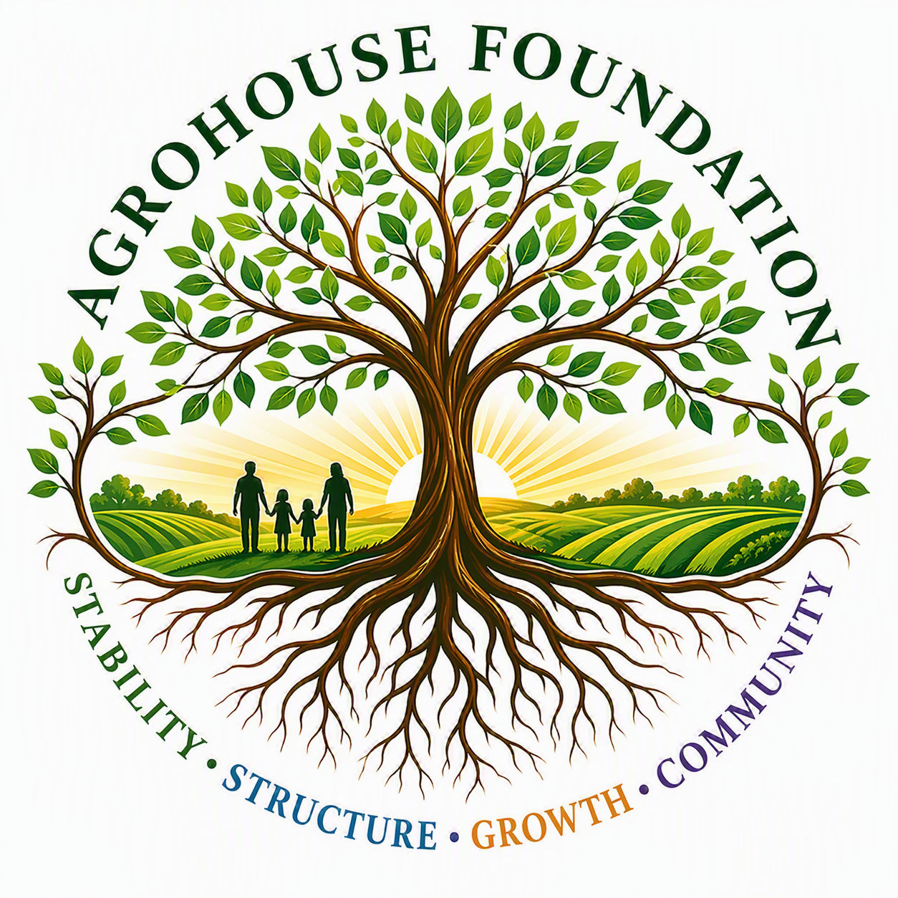
AGHF INC.
d/b/a AgroHouse Foundation
COMMUNITY PARTNERSHIP POLICY
AGHF Inc. d/b/a AgroHouse Foundation
TEMPLATE — FOR BOARD ADOPTION
Stability • Structure • Growth • Community
Adopted: ________________________________________

1. Purpose
This policy establishes standards for AGHF's partnerships with churches, nonprofits, and other community organizations, consistent with the Corporation's principle of supporting and strengthening existing outreach rather than replacing it.

2. Partnership Standards
• Partner organizations must share alignment with AGHF's mission and values
• Partnerships shall be documented in a Memorandum of Understanding (MOU) approved per the Partnership Authorization Resolution
• AGHF shall not control, manage, supervise, or direct a partner's programming, volunteers, or activities

3. MOU Requirements
Each MOU shall define the responsibilities of both parties, outreach schedule (if applicable), duration, and termination terms.

4. Facility-Use Approvals
Any use of a partner's facility by AGHF staff or volunteers requires written approval from the partner organization and shall be noted in the applicable MOU.

5. Representation Standards
AGHF representatives shall accurately describe the nature of the partnership in all public and donor communications, consistent with the Organizational Communication Standards.
X ________________________________________
[Name], Chairperson
Date: ________________________________________
AGHF Inc. d/b/a AgroHouse Foundation™ — Community Partnership Policy — TEMPLATE

