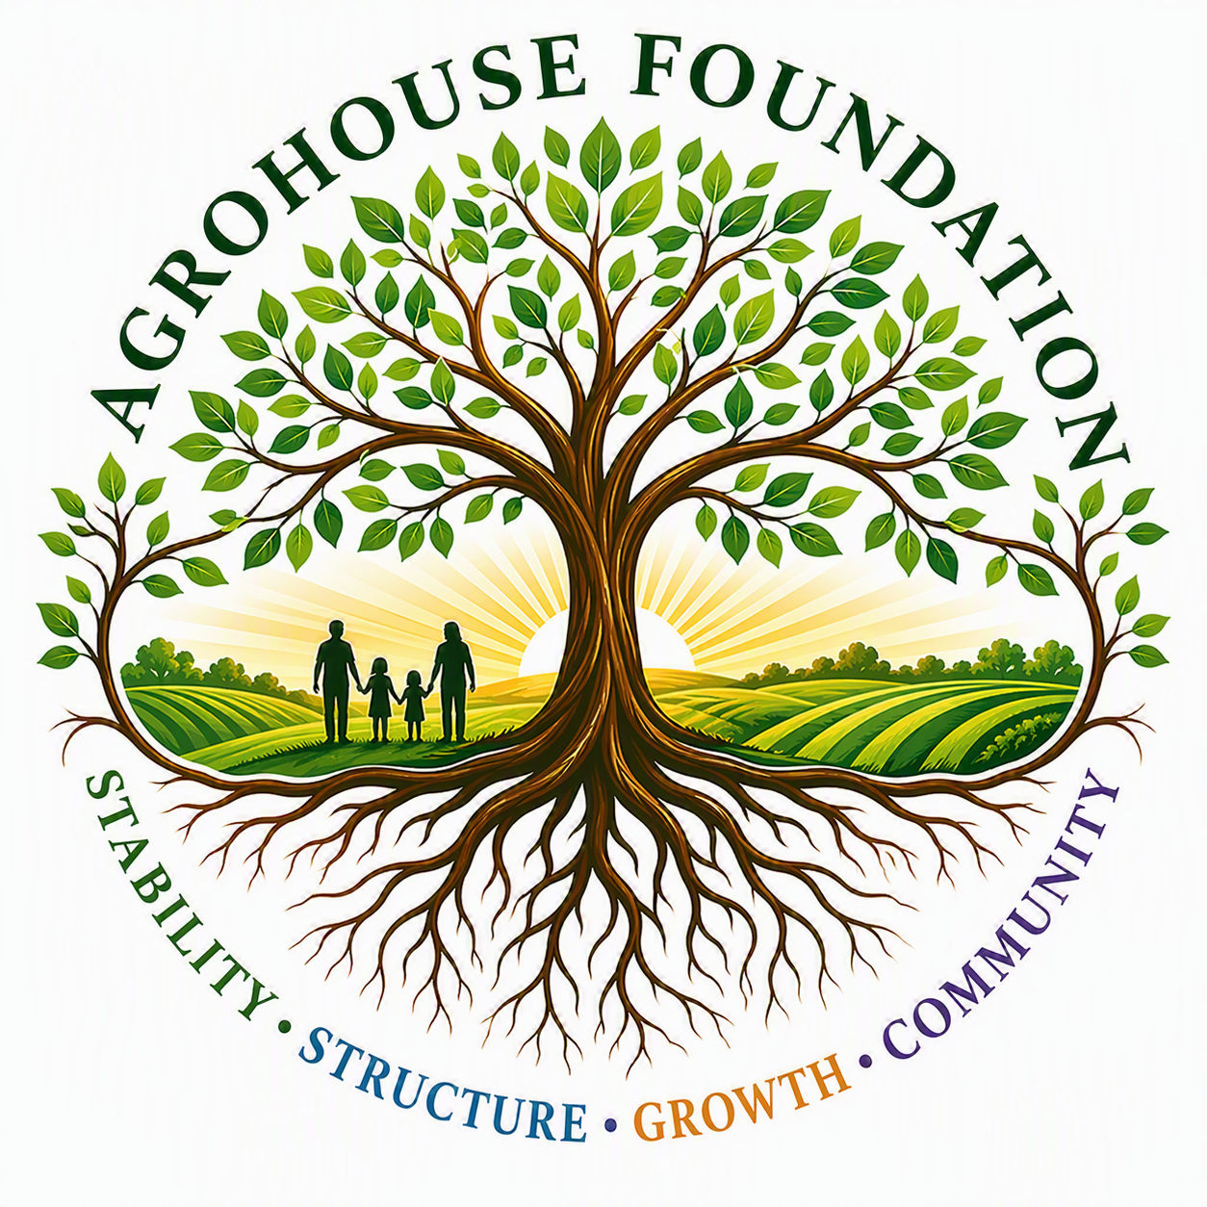
AGHF INC.
d/b/a AgroHouse Foundation
MEMORANDUM OF UNDERSTANDING
Community Outreach Partnership
TEMPLATE — BETWEEN AGHF INC. AND [PARTNER ORGANIZATION]
Stability • Structure • Growth • Community
BETWEEN: AGHF Inc. d/b/a AgroHouse Foundation
AND: [Partner Legal Name] d/b/a [“Partner DBA”]
Effective Date: ________________________________________
This Memorandum of Understanding (“MOU”) is entered into as of the Effective Date shown above, by and between AGHF Inc., a Florida nonprofit corporation d/b/a AgroHouse Foundation (“AgroHouse Foundation”), and [Partner Legal Name], a [entity type] d/b/a [“Partner DBA”] (“[Partner Short Name]”), operating in [City, Florida]. AgroHouse Foundation and [Partner Short Name] may be referred to individually as a “Party” and collectively as the “Parties.”

1. Background
• [Partner Short Name] operates [describe the partner's outreach/ministry/program], currently serving an estimated [Number] individuals per [week/month].
• AgroHouse Foundation is a Florida nonprofit corporation (AGHF Inc.) organized to strengthen communities through outreach stabilization, food security, sustainable agriculture, workforce development, and future vocational housing initiatives.
• AgroHouse Foundation's Community Outreach Stabilization Program (“Program 1”) strengthens existing community outreach efforts through the procurement and distribution of meals, hygiene resources, hydration resources, logistical support, storage solutions, and related infrastructure.

2. Responsibilities of [Partner Short Name]
• Operate outreach activities and coordinate volunteers
• Maintain outreach schedules
• Provide approved facility access
• Support community engagement

3. Responsibilities of AgroHouse Foundation
• Resource procurement
• Meal support
• Coffee and hydration stations
• Hygiene blessing bags
• Storage infrastructure and logistics support

4. Important Partnership Principle
AgroHouse Foundation supports and strengthens [Partner Short Name]'s outreach operations but does not control, manage, supervise, or direct its programming, volunteers, or activities.

5. Term & Termination
This MOU shall remain in effect for [Term] and may be terminated by either Party upon [Notice Period] written notice.
X ________________________________________
[Name], Chairperson, AGHF Inc. d/b/a AgroHouse Foundation
Date: ________________________________________
X ________________________________________
[Name], [Title], [Partner Organization]
Date: ________________________________________
AGHF Inc. d/b/a AgroHouse Foundation™ — Memorandum of Understanding — TEMPLATE

