**Programming Assignment #5 – A Parser for Calc**

Part 1 – Please show you datatype for representing lexical tokens, and then show 3 expressions and how they can be represented as a list of tokens. (You can screenshot your code and paste it in the space below.)

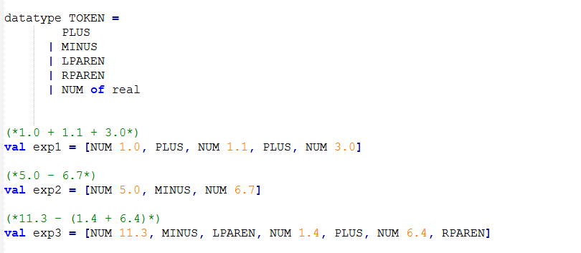

Part 2 – Show you code for creating parse trees. This will include a datatype for representing trees and your functions for generating the trees themselves. (Please put a screenshot of your code in the space provided below.)

**this makes much more sense now. we appreciate all the time and help.**

**thank you so much for the debugging lines! They made all the difference ☺**

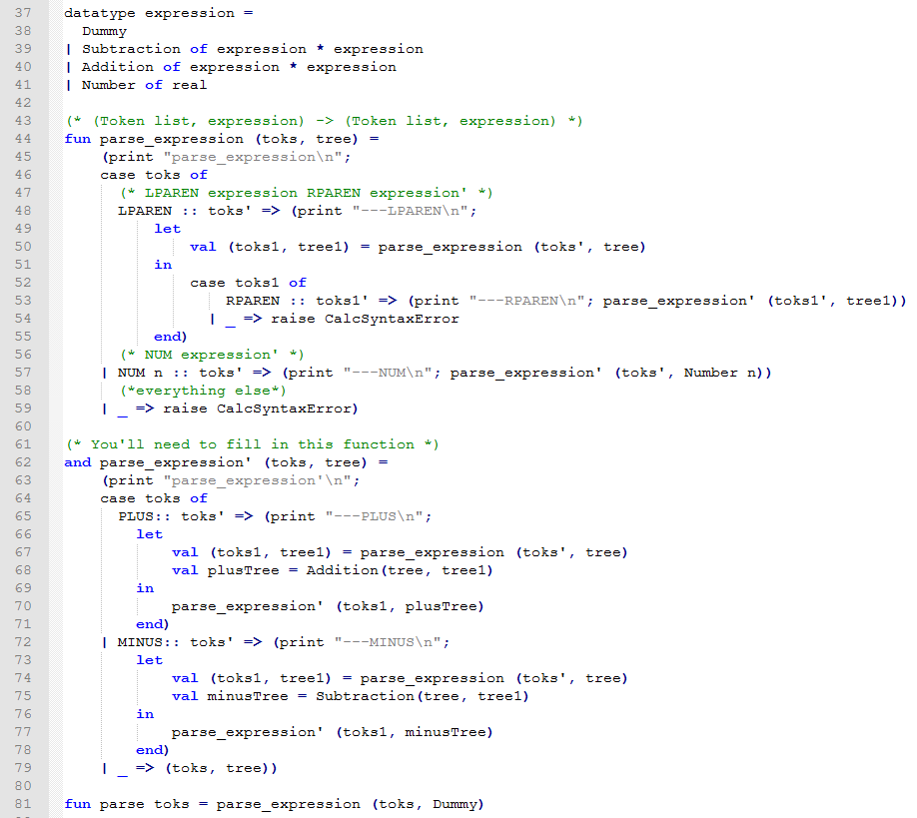

Part 3 – Code for evaluating parse trees (evaluating the expression to a single numerical value). (Please put a screenshot of your code in the space provided below.)

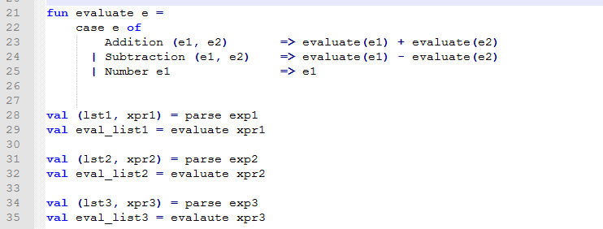

Part 4 – Below, please show a screenshot of your interacting with your code in the SML/NJ interpreter. Show that it can turn a list of tokens into a parse tree, and that it can evaluate the given parse tree.

