1. 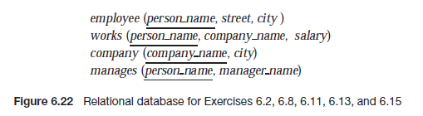**[60 points; 10 points each] Consider the relational database of Figure 6.22, page 250 of the textbook.**

**Give an expression in relational algebra to express each of the following queries:**

* 1. **Find the names of all employees who live in the city "Brooklyn".**
 $$\prod_{person_name}{(σ_{city="\text{Brooklyn"}}\left(employee\right))}$$

 2. **Find the names and cities of residence of all employees who earn a salary of at least $50,000.**
 $$\prod_{person_name, city}{{(σ}_{salary ≥50000}(employee⋈ works))}$$

 3. **Find the names of all employees who work for the company "Fedco" and earn a salary of at least $50,000.**
 $$\prod_{person_name}{(σ_{company_name="\text{Fedco"}\bigwedge{salary≥50000}}(employee }⋈works ⋈company))$$

 4. **Find the names and cities of residence of all employees who work for a company located in the city "Brooklyn".**
 $$\prod_{person_name, employee.city}{(σ_{company.city="Brooklyn"}(company ⋈employee))}$$

 5. **Find the number of employees managed by each manager.**

*manager_name* G*count(person_name)*(*manages*)

* 1. **Find the names of all employees who earn more than every employee of "Small Bank Corporation"**

*r* ←G*max(salary)*()

1. **[40 points; 10 points each] 6.14 (parts a, b, c, d) page 253 of the textbook.**

**Consider the following relational schema for a library:** 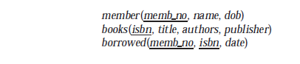

**Write the following queries in relational algebra.**

* 1. **Find the names of members who have borrowed any book published by “McGraw-Hill”.**
 $$\prod_{name}{(σ_{publisher="McGraw Hill\text{"}}(member }⋈books ⋈borrowed))$$

 2. **Find the name of members who have borrowed all books published by “McGraw-Hill”.**
 $$r borrowed ÷(\prod_{isbn}{\left(σ_{publisher="McGraw Hill"}\left(books\right)\right)}$$

 $$\prod_{name}{(member⋈r )}$$

3. **Find the name and membership number of members who have borrowed more than five different books published by “McGraw-Hill”.**

$$r \prod_{isbn, memb_no}{\left(σ_{publisher="McGraw Hill"}\left(borrowed⋈ books\right)\right)}$$

*s* ←*memb_no* G*count(isbn)as num ( r )*

* 1. **For each publisher, find the name and membership number of members who have borrowed more than five books of that publisher.**

$$r \prod_{isbn, memb_no, publisher}{\left(borrowed⋈books \right)}$$

*s* ←*publisher, memb_no* G*count(isbn)as num ( r )*

$$\prod_{name, memb_no, publisher}{\left(σ_{num>5}\left(s⋈member\right)\right)}$$