Consider the E-R diagram for the university database as given on page 282 of the text book. 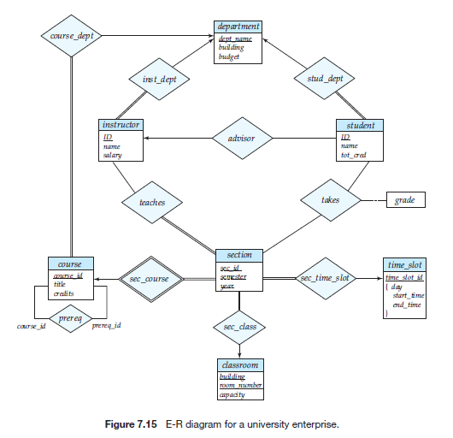

Answer the following questions:

1. [5 points] Name one weak entity set.
   1. section
2. [5 points] Name one recursive relationship set.
   1. prereq
3. [5 points] What does the double line that joins the entity set instructor with the relationship set inst_dep indicate?
   1. The total participation of *instructor* in the relationship set *inst_dept*
4. [5 points] What does the double-lined diamond shape around the relationship set sec_course indicate?
   1. That the relationship is linked to a weak entity set
5. [30 points] Translate the lower part of the E-R diagram --shown on slide 63 of Chapter 7 PowerPoint slides-- into a relational database (i.e., translate this part of the E-R diagram into relational schemas.)

Course (course_id, title, credits, dept_name)

Prereq (course_id, prereq_id)

Section (course_id, sec_id, semester, year, building, room_number, time_slot_id)

Classroom (building, room_number, capacity)

Time_slot (time_slot_id, day, start_time, end_time)