The data I used was “House Prices: Advanced Regression Techniques”, and it came from the Kaggle competition section from Kaggle website. In total, there were 81 variables and 1460 records in the training dataset. The link to Kaggle and the data set is https://www.kaggle.com/erikbruin/house-prices-lasso-xgboost-and-a-detailed-eda/data. The methodology used in my project included SQL to query my data set on phpMyAdmin, and I used tableau and excel for visual encoding. The tools I used from AWS included EC2, VPC, Subgroups, Security Groups, and RDS. Also, I tried to run a predictive model using SAS Enterprise Miner.

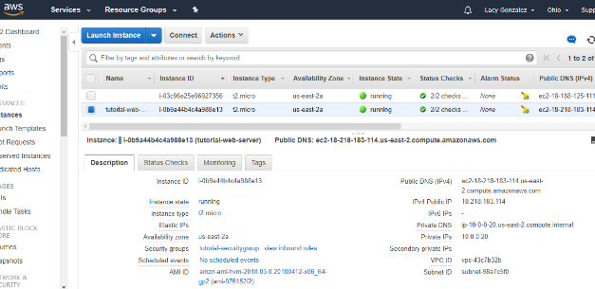
EC2 phpMyAdmin
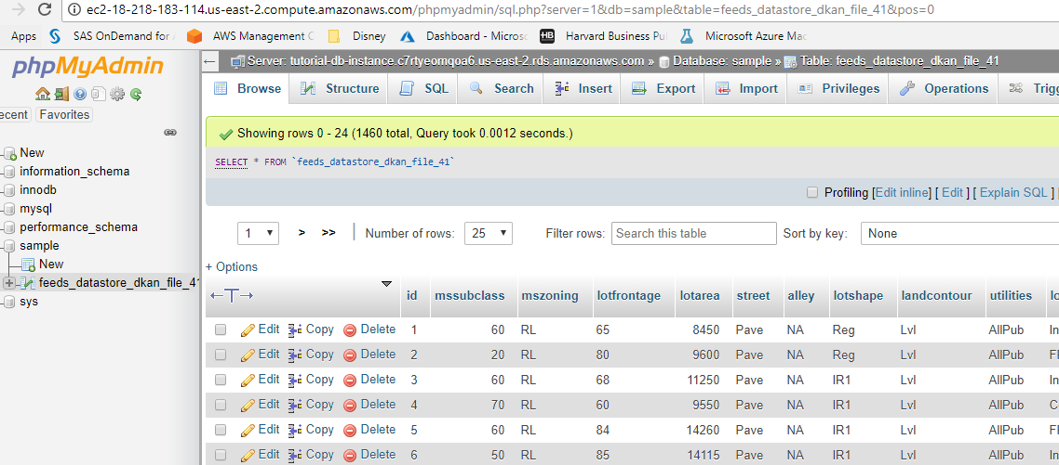

VPC Subgroups
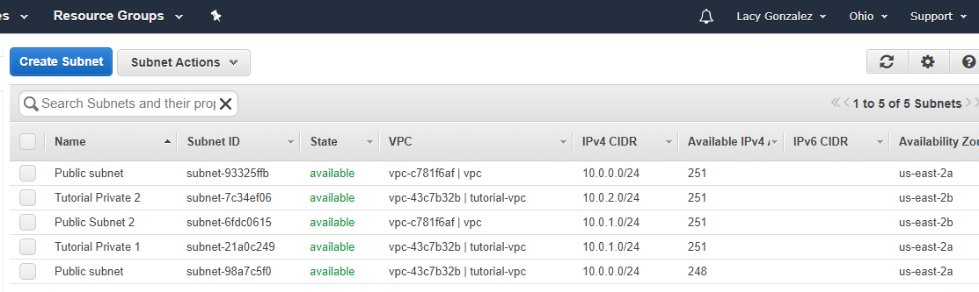
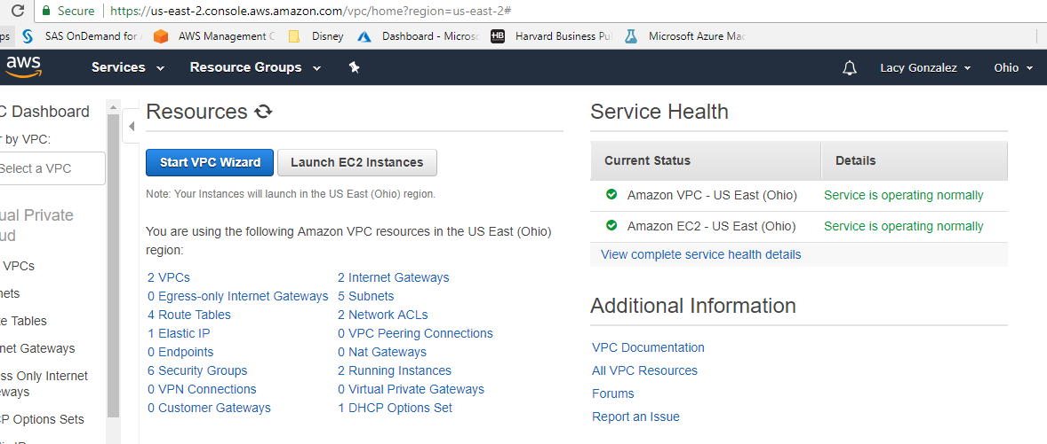
Security Groups RDS



Question 1: What is the relation between the square footage of a house and price?
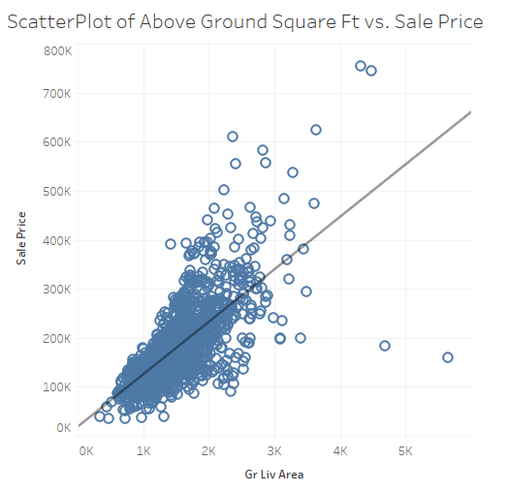
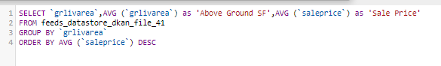
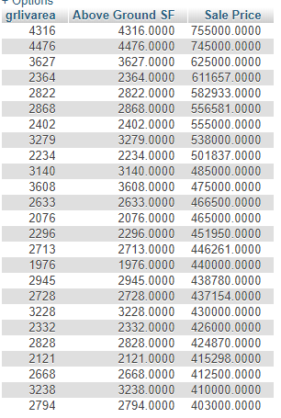
Conclusion about Scatterplot: The expectations were that a line would be a good model to capture the relationship between price and above ground square feet. The shown line seems to be guided by the amount of data below 3000 square feet, but it looks like an exponential model could describe the data better it is hard to tell given the sparse data above 3000 feet.

Question 2: What can we learn about house pricing in neighborhoods?
From experience, we know that neighborhoods seem to be pockets of affluence. I was curious whether we could see some of those patterns in the data. I decided to organize the neighborhoods by the standard deviation and average home price and the quality of the homes.
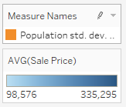
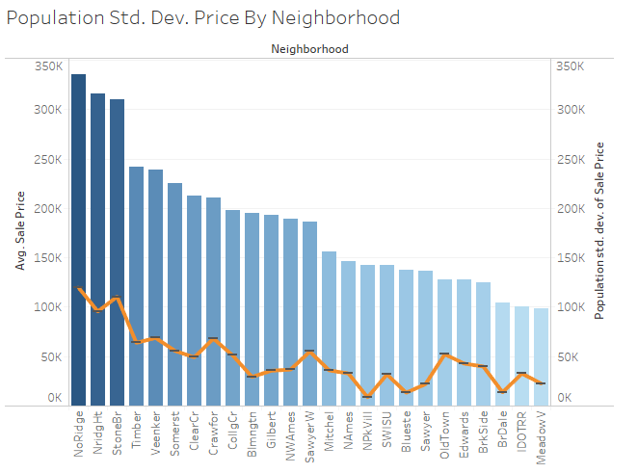

Conclusion: One of my expectations was to see tight groupings of home prices in each neighborhood. Surprisingly, the richest neighborhoods seem to also have the greatest range of pricing in their homes. There also appears to be some natural groupings in the neighborhoods. The graph looks like a staircase in which each step could be considered a category. The four categories seem to follow a normal distribution (most of the neighborhoods are in the two center categories).

Question 3: What adds more value to a house: a swimming pool or a car garage?
I have determined the variables that I need to keep constant are Neighborhood and above ground square footage.
Note: Square footage of 1118 could not be exactly matched; therefore, I used the closest values to 1118. The end values used were 1115, 1118, and 1120.
Difference in Value: The SQL output is showing the value of a house in Mitchel neighborhood that has an above ground square footage of 1118ft. with a pool in good conditions that has a pool square footage of 578ft. subtracted from the value of a similar house in Mitchel neighborhood with similar above ground square footage of 1115 ft. The result of $14,750 is telling use the value that swimming pool has on the pricing of the house. The queries for the pool/no pool and calculations are shown below.
$171000 - $156250= $14,750

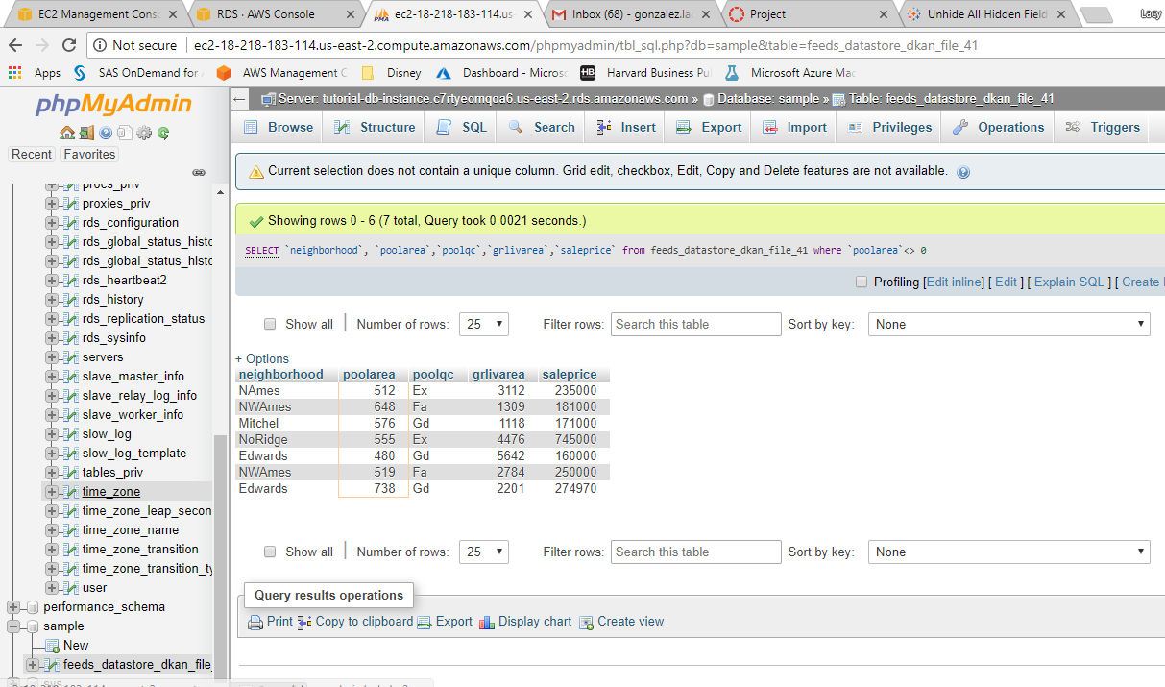
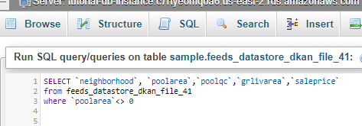
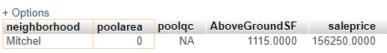
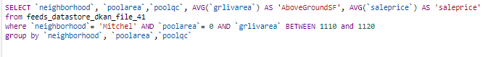
Difference in Value: I will assess the value of a house in Mitchel with and without a car garage of similar housing square footage as the above scenario (1118 square feet) of a house with pool/no pool and see which feature increase the house of this neighborhood the most and by what value. The queries for the garage/no garage. Calculation below show the value of a house of 1118 square feet with a 1 car garage of 358 square feet and a value of $171,000 subtracted from a house with 1120 above ground square feet no garage has a value of $147,000. This equation shows that a house of similar size in Mitchel has $24,000 in value when a car garage is added.
$171000 - $ 147000= $24,000
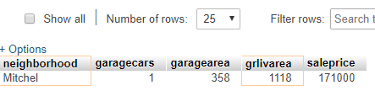
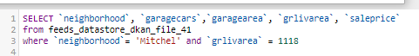
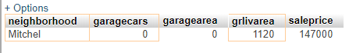
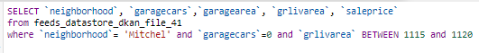
Conclusion about Mitchel Investigation:
A house in Mitchel that has similar above ground square footage has a higher selling price if features like a swimming pool or car garage are included. When we compare which of the two features bring higher value the car garage would be the answer. The calculation below shows the added value of a pool subtracted from the added value of a car garage in Mitchel. The car garage adds a $9,250 value that the swimming pool does not. $24,000 – $14,750= $9,250
Question 4: Is there a way to know which features of a house affect their value the most?

The first step I took to determine which features are important in housing price was to perform a correlation chart in excel on all the integer variables. By doing this, I could see which variables were highly correlated with selling price of a house. These data values are in the second column in the correlation chart and are highlighted red.
The values that are not highlighted are below the correlation cutoff of 0.65 or 65%. Overall, the integer variables that are highly correlated with house are overallqual, TotalBsmtSF, GrLivArea, GarageCars, and GarageArea.
Note: GarageCar and overallqual are highly correlated with each other too. Therefore, if running in a multilinear regression one should be eliminated due to multicollinearity. However, they both are highly correlated with sale price and will influence only that variable when not ran together.
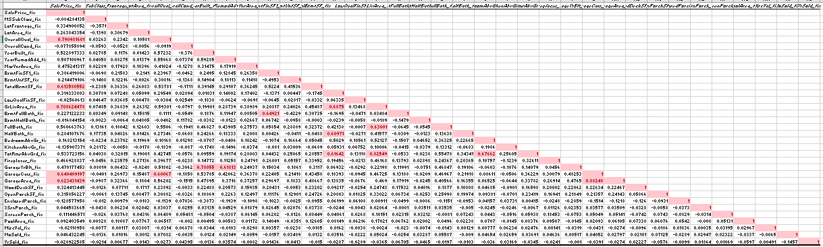

Question 5: How do car garages and basements affect the price of a house?
I chose to compare the affect that the variables car garage and basement square footage have on selling price. As seen in the query and tableau charts below.
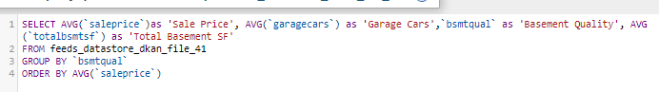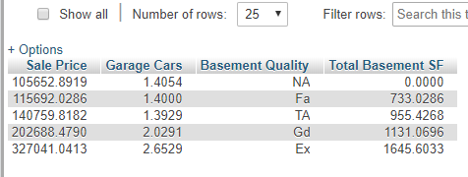

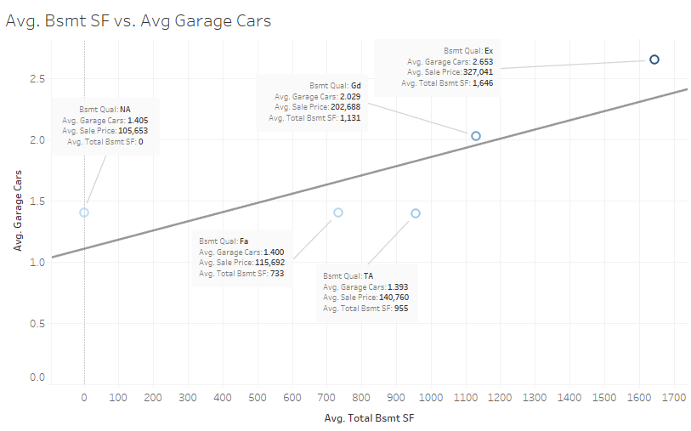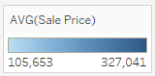

Conclusion About Car Garage and Total Basement Square Footage:
A linear relationship can be seen between the size of the car garage and the square footage of the basement. The regression line shows a general positive correlation (as seen in the excel correlation chart) between the two variables and as both variables increase the price of housing and quality of the basement tends to increase as well. These two variables would be useful to look at when investing in a house as they are good indicators of how pricing increases in a home.
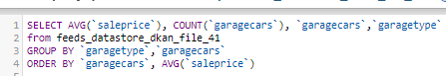
Question 6: Given the importance of a car garage, what other interesting information can we extract from this variable?
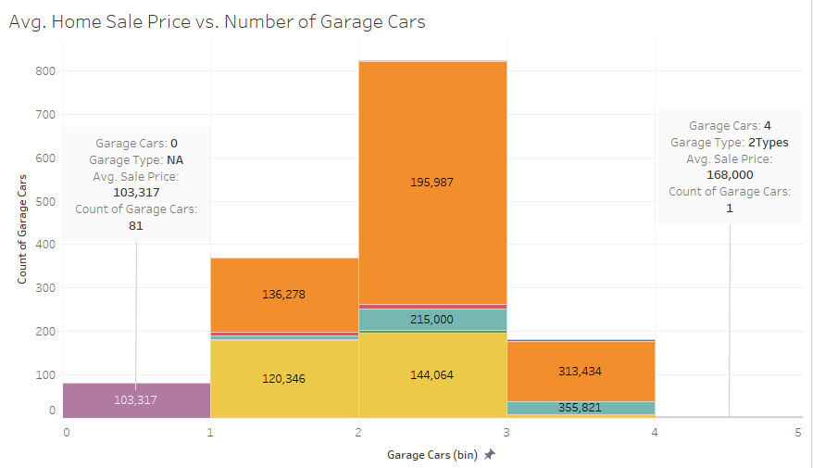
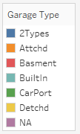
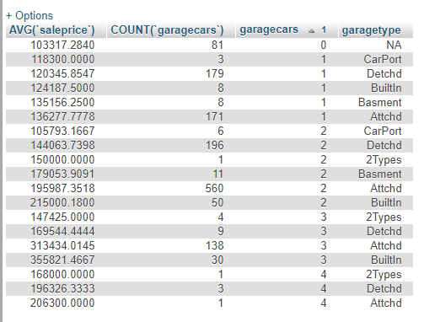
Conclusion about Extracted Car Garage Information: A few insights can be seen about car garages after digging deeper into the variable. First, the most common type of garage is an attached car garage. Second, the most expensive car garage’s are in bin 3 which means they hold 3 cars. Lastly, very few homes are built with car garages that will hold 4 cars.

Question 7: What is the effective range of overall qualilty?
I want to know in which range of quality does most houses fall. The query below shows that most of the housers are between overall quality range 4 (lower quality of house) and 8 (higher quality of house).
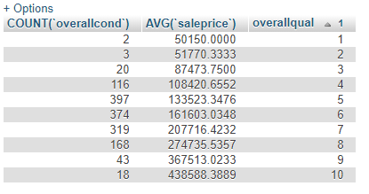
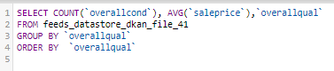

Conclusion: As expected, lower quality houses cost less than higher quality houses. Most of the houses in my data set are between quality ranges 4 and 8.
Question 8: How does overall quality of a house relate to how expensive a house is in a neighborhoods?
I figured a good stradegy would be to compare and contrast the neighborhoods with most affordable housing to most expensive housing. This representation of extremes will give a better understanding of how the overall quality variable is spread and its effects on all homes. Using the chart “Population Std. Dev. Price By Neighborhood” in question 2, I identified the neighborhood with the lowest average price and highest average price.

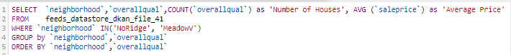
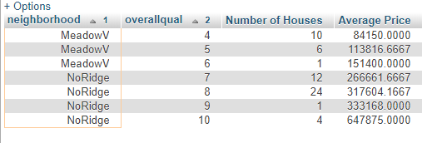
Conclusion about Extremes: MeadowV is the cheapest neighborhood in the dataset (determined by question 2 graph), and it has the lowest overall quality of housing with most of the housing in this neighborhood a rank value of 4 and 5. NoRidge is the most expensive neighborhood, and the majority of its’ houses have a value of 7 and 8.
The expectations were that there would be a more prominent gap between the quality of houses in these neighborhoods but the gap in quality is not as extreme as I would have expected. If it is possible to get good quality housing in most neighborhoods (which is what the data shows), then what is driving the price of the most expensive neighborhoods? Quality does not seem to be it.
Question 9: How is sale price affected by the two variables that are most highly correlated with it?
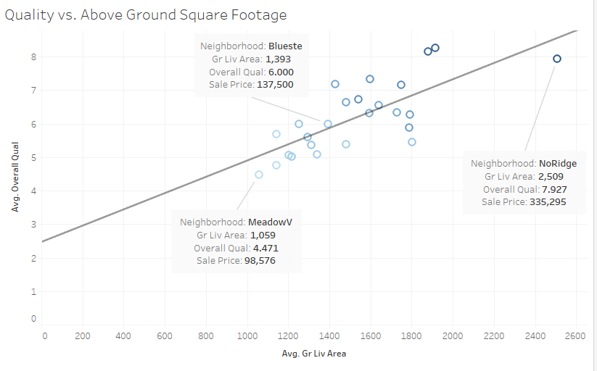
Conclusion of Scatterplot: The previous question had me wondering what was driving the price of the most expensive neighborhoods since there wasn’t a big gap in quality rating. It seems that one driving force is above ground square footage of a house. Looking at the graph, NoRidge (most expensive housing) neighborhoods not only have highest overall quality but also larger housing sizes. However, MeadowV (most affordable housing) neighborhoods have the lowest overall quality along with the smallest size housing.
Question 10 I tried to build a Linear regression model in SAS Enterprise Miner. The model did not turn out to be a very good one because I used variables of categorical values with large bins. However, I thought I would still show the work I did regardless of how bad the model turned out.
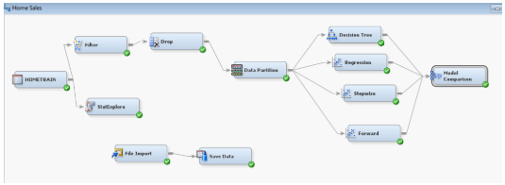

StepWise Winner: Summary Below
