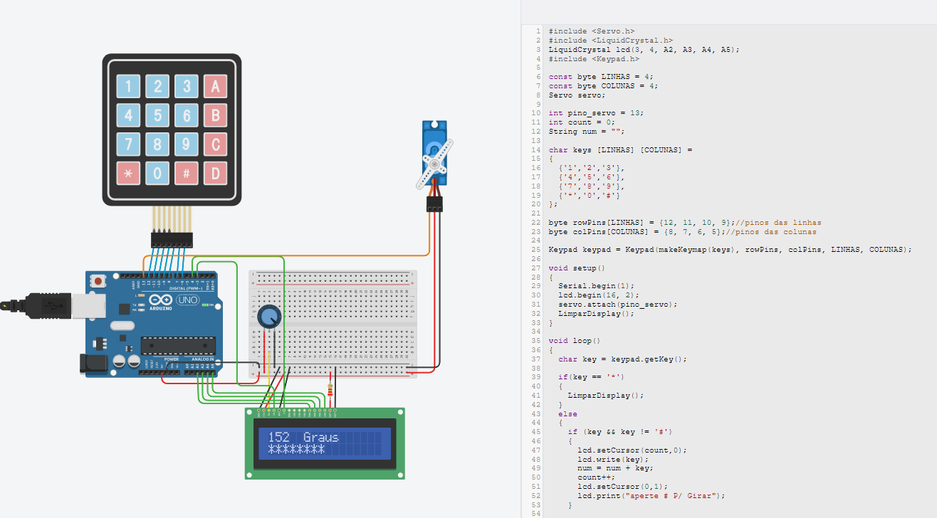

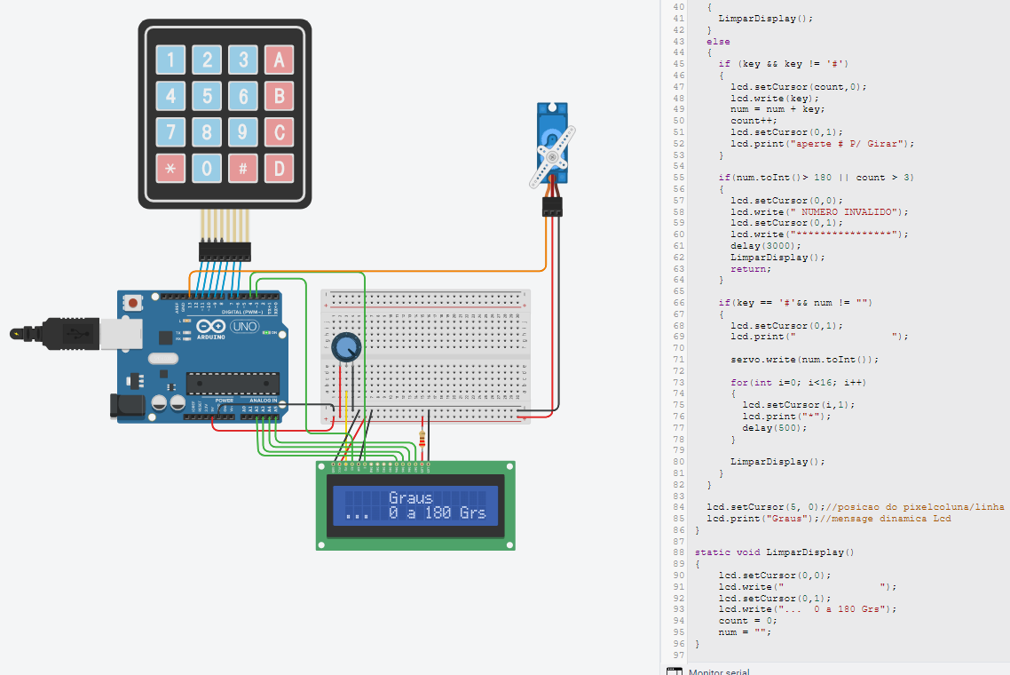

#include <Servo.h>

#include <LiquidCrystal.h>

LiquidCrystal lcd(3, 4, A2, A3, A4, A5);

#include <Keypad.h>

const byte LINHAS = 4;

const byte COLUNAS = 4;

Servo servo;

int pino_servo = 13;

int count = 0;

String num = "";

char keys [LINHAS] [COLUNAS] =

{

{'1','2','3'},

{'4','5','6'},

{'7','8','9'},

{'*','0','#'}

};

byte rowPins[LINHAS] = {12, 11, 10, 9};//pinos das linhas

byte colPins[COLUNAS] = {8, 7, 6, 5};//pinos das colunas

Keypad keypad = Keypad(makeKeymap(keys), rowPins, colPins, LINHAS, COLUNAS);

void setup()

{

Serial.begin(1);

lcd.begin(16, 2);

servo.attach(pino_servo);

LimparDisplay();

}

void loop()

{

char key = keypad.getKey();

if(key == '*')

{

LimparDisplay();

}

else

{

if (key && key != '#')

{

lcd.setCursor(count,0);

lcd.write(key);

num = num + key;

count++;

lcd.setCursor(0,1);

lcd.print("aperte # P/ Girar");

}

if(num.toInt()> 180 || count > 3)

{

lcd.setCursor(0,0);

lcd.write(" NUMERO INVALIDO");

lcd.setCursor(0,1);

lcd.write("****************");

delay(3000);

LimparDisplay();

return;

}

if(key == '#'&& num != "")

{

lcd.setCursor(0,1);

lcd.print(" ");

servo.write(num.toInt());

for(int i=0; i<16; i++)

{

lcd.setCursor(i,1);

lcd.print("*");

delay(500);

}

LimparDisplay();

}

}

lcd.setCursor(5, 0);//posicao do pixelcoluna/linha

lcd.print("Graus");//mensage dinamica Lcd

}

static void LimparDisplay()

{

lcd.setCursor(0,0);

lcd.write(" ");

lcd.setCursor(0,1);

lcd.write("... 0 a 180 Grs");

count = 0;

num = "";

}