Evidence document

|  |  |  |
| --- | --- | --- |
| Project | Execution time | Final Result |
| Test Automation Framework | 20.38 | Passed |

# test_invalid_login_1

Login_was_successfull_1568129416558.png

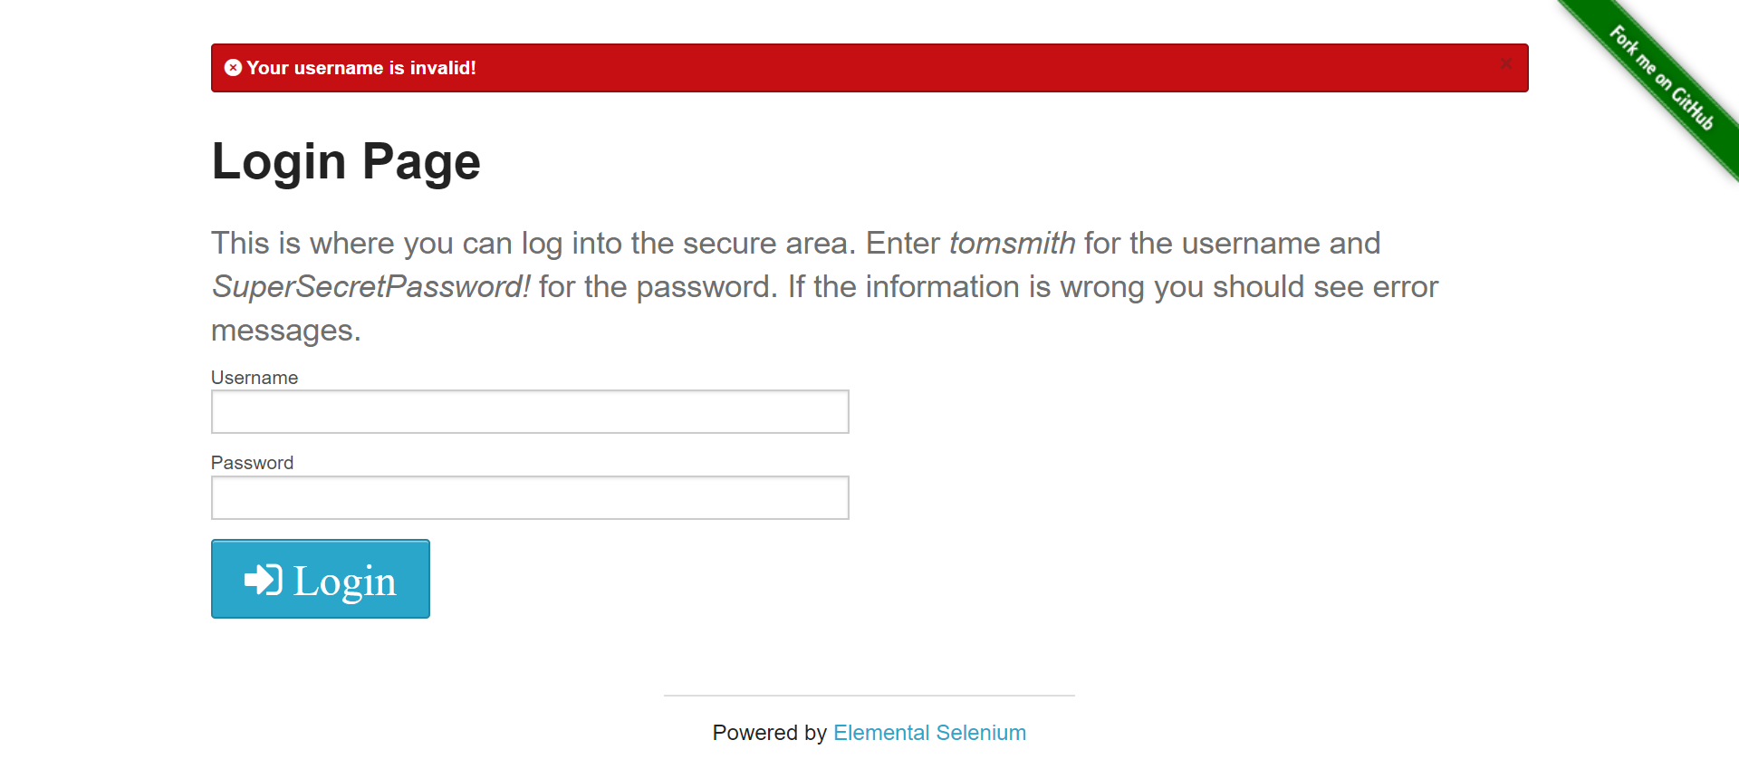

# test_valid_login_1

Login_was_successfull_1568129426195.png

