**Help Section**

**1. Overview**

VisuaLite is a powerful data analysis tool designed to visualize data from FCM logs. It is exclusively intended for internal use of ALFA LAVAL employees and should not be distributed to external personnel.

Key Features:

- Quickly display time trends of various variables.

- Perform cross-analysis.

- Search for specific working conditions, alarms, or events.

Important Notes:

- Files must adhere to standard data formatting as when exported, and all logs should pertain to the same machine.

- The tool itself will not modify the logs.

- Supported machine types include:

- FCM One / FCM 1.5

- FCM Basic 2.b.

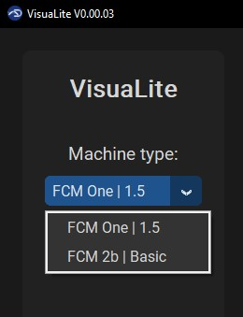

Feedback and Troubleshooting:

VisuaLite creates the folder “_vlog” in the same folder where the app is saved. If you encounter any issues, please save the visuaLite_debug.log file in another location and share it with your contact person in the PD FCS & Modules Team.

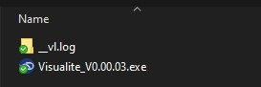

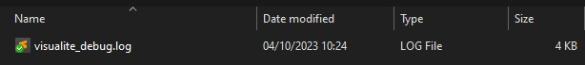

**2. Getting Started**

To begin using the tool effectively, ensure that the log files you wish to analyze are accessible and stored in a single folder on your PC. Then, select the folder where the logs are stored.

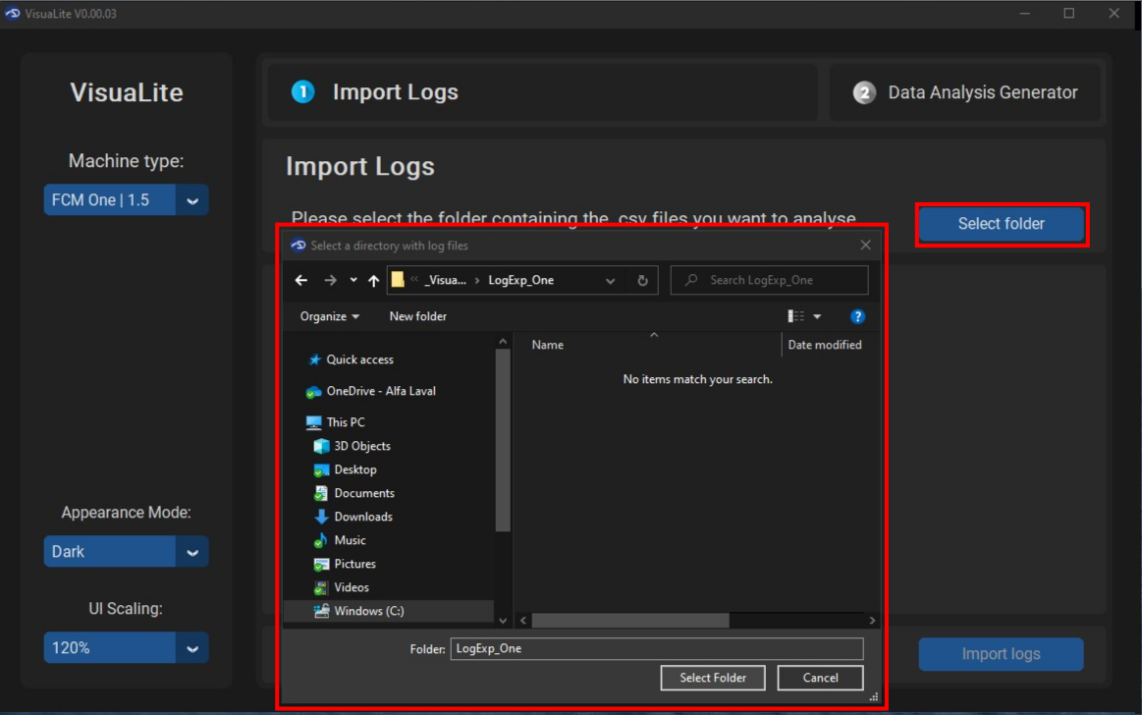

After this step, you can choose another folder at any time (1). In the central panel, all .csv files in the selected folder are loaded (2). You can select specific log files for analysis by checking/unchecking the corresponding checkboxes (3). Finally, click the “Import Logs” button (4). Please note that only "Standard Logs" (Values, Alarms, Events) will be processed; "IMO logs" (Values, Events), or other .csv files will not be considered. To reset the application to its initial state, use the “Clear All” button (5).

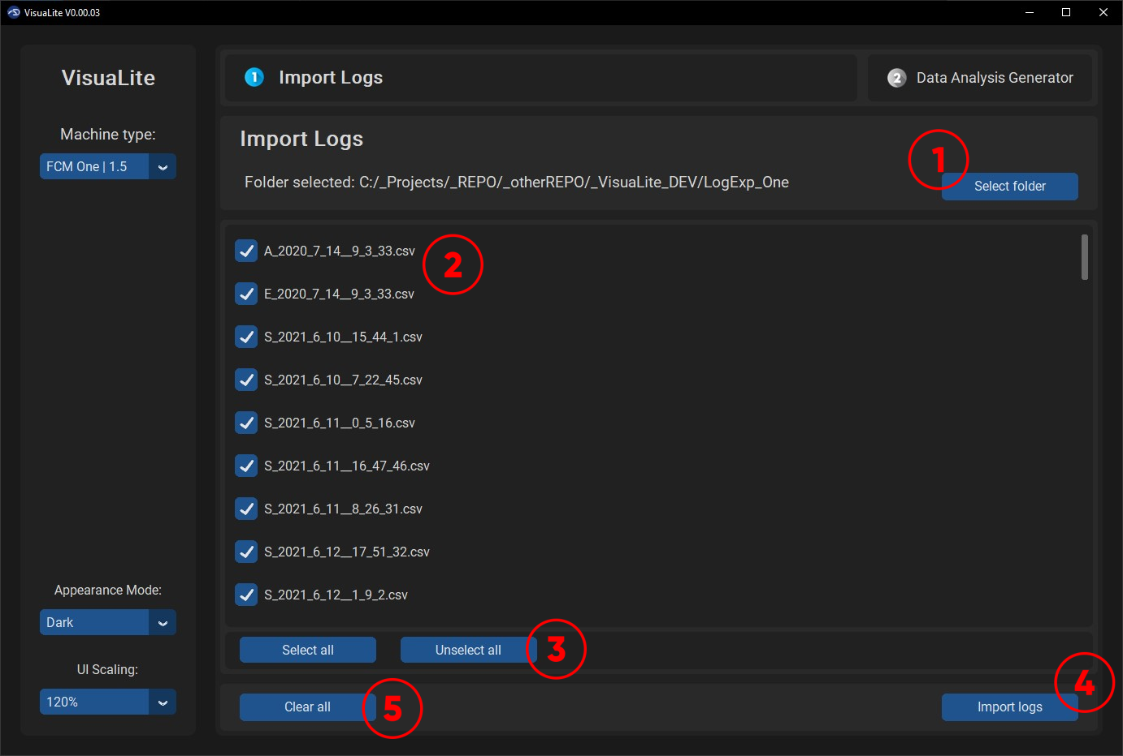

**3. Importing Logs**

After clicking "Import Logs," the tool will attempt to import data from the selected .csv files that adhere to the naming standard. If the machine type does not match or the files are not from the same machine, a pop-up will display the first incorrect file found.

If all prerequisites are met, but the app does not respond after more than 2 minutes, close the app and follow the “Feedback and Troubleshooting” instructions in section 1. Alternatively, try selecting fewer .csv files during the next startup of the application.

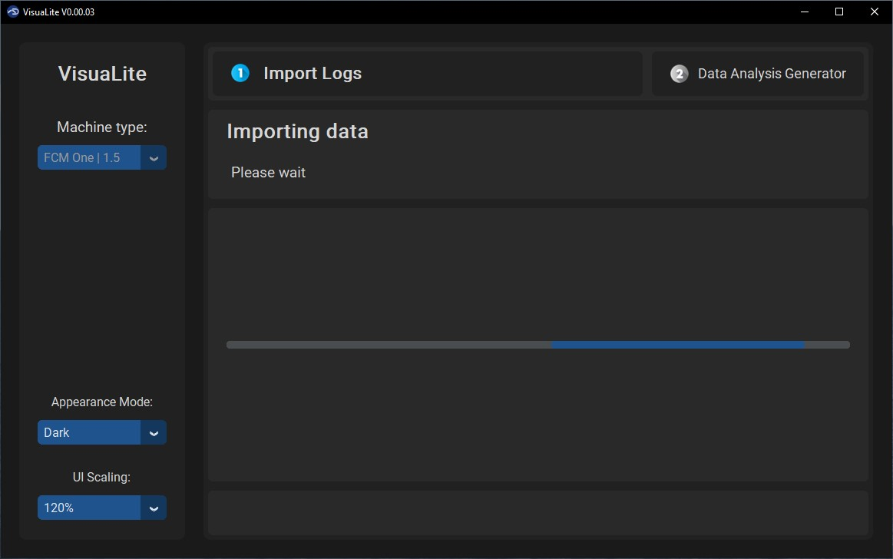

**4. Data Analysis**

After successfully importing data, you can perform various types of data analysis:

**a. Changeover**

- The tool will identify changeovers in the data and display them in this panel. On the left side panel, you can see a preview of each changeover (1). Meanwhile, on the right side panel, a list of all identified changeovers in the logs is shown (2).

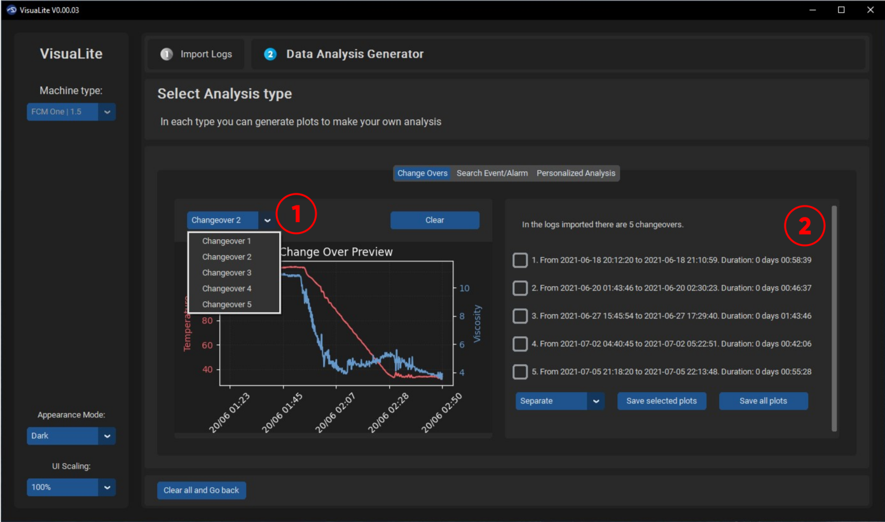

User can select the changeover of interest, and to export the plots it is possible to choose between a “Separate” or “Overlap” plot which only affects the formatting of the plot. Try both, and decide which one works better for you.

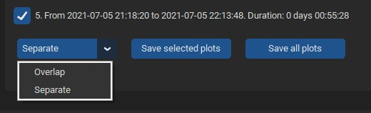

**b. Search Alarm Event**

In this tab, as well as in “Personalized Analysis,” you can view the auxiliary plot (1), which helps you see an overview of all imported logs. For a more detailed explanation, refer to section 4.3.

VisuaLite allows you to search for an Alarm or Event (2) (if Alarm or Event logs were imported) and select a specific value available from the logs (3).

After clicking “Search,” the tool will locate all occurrences of the selected event in the results.

Customize the analysis by choosing variables of interest from the right panel (5) and specifying the time interval before and after the event (6).

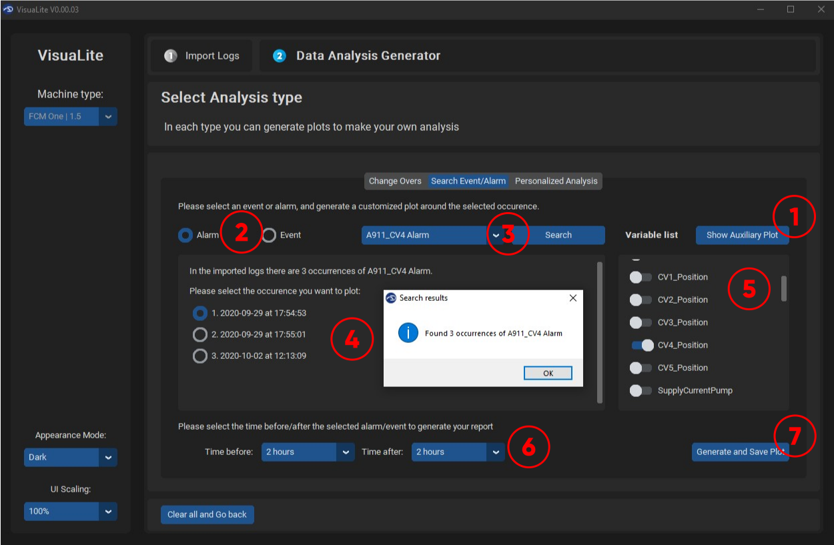

**c. Personalized**

Similar to section 4.2, you can generate custom plots in this case without the search function. To do so, manually select the date-time interval (2) and variables to plot (3). Utilize the auxiliary plot (1) to visualize the trends of the most significant variables and the date range of imported logs.

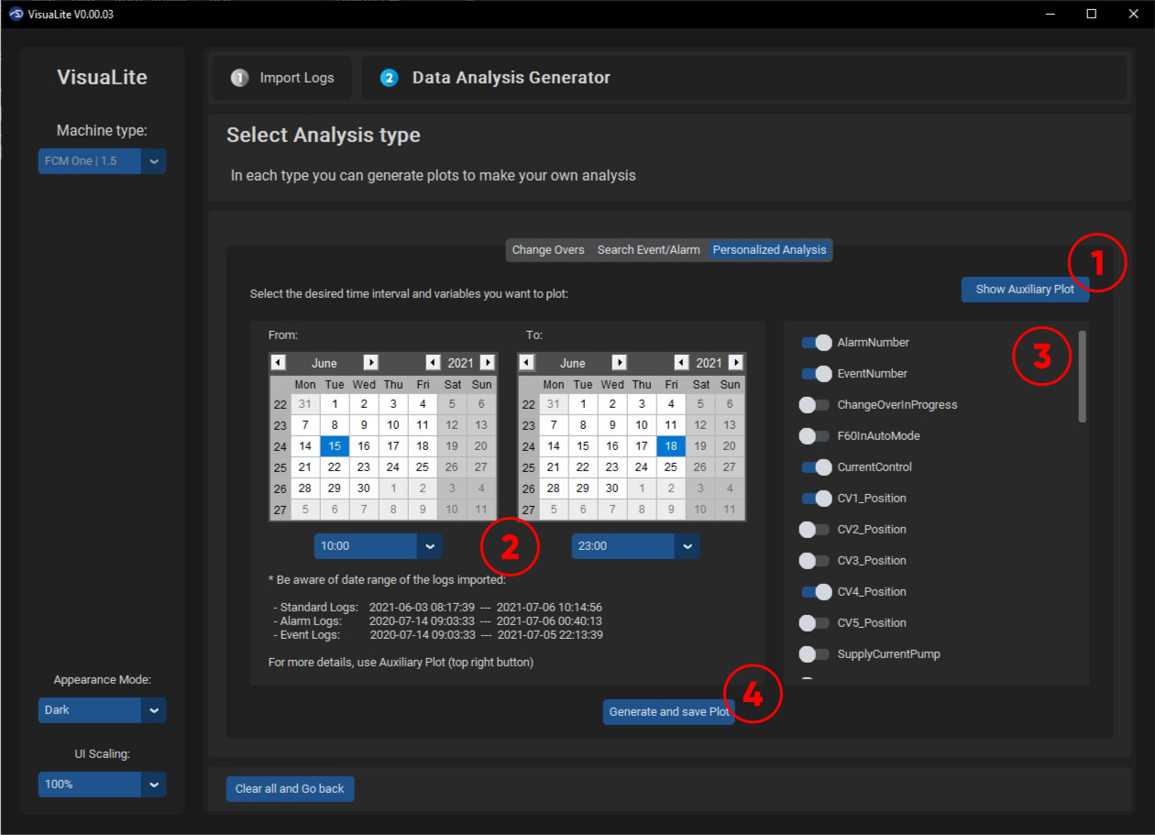

The auxiliary plot contains the imported logs date range (1) and the trend of main variables (2): Temperature, Viscosity, Flow.

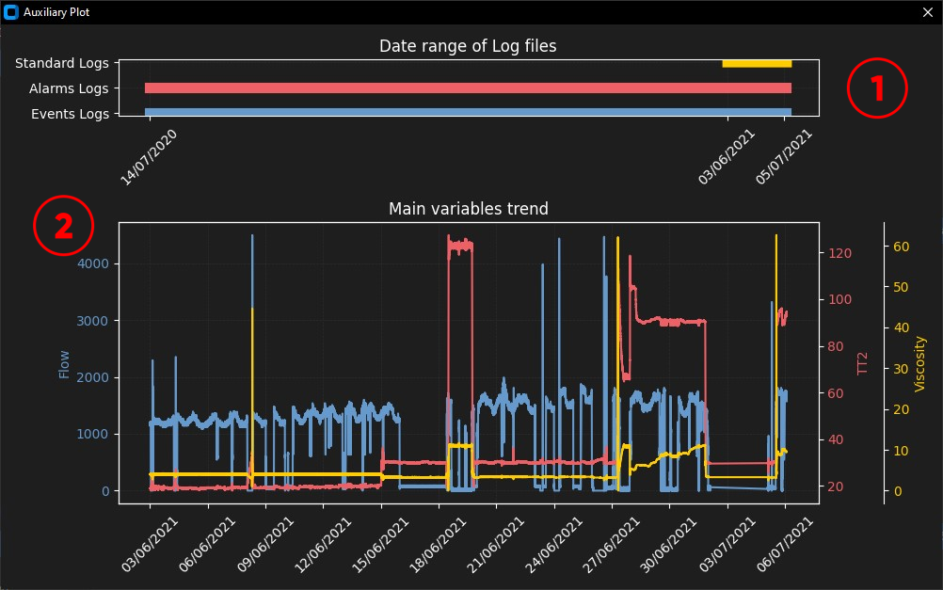

**5. Output Files**

Output files generated by the tool are in .html format and can be opened in a web browser. Key features include:

- Zoom, move, or reset plot controls in the top right corner.

- Download a PNG file of the current view by clicking the camera icon.

- Toggle the visibility of variables by clicking on the legends in the right panel.

- Double-clicking a group of variables will show or hide the entire group.

