Zonski Pty Ltd
23/47 Murray Street
Waverly
NSW
2024
Australia
Selatra Limited
National Software Centre
Loughmahon
Blackrock, Cork
Ireland

Dear Sir or Madam:
My name is Chris Glover, the director of Zonski Pty Ltd. Zonski is currently in the final stages of the production of a small role playing game for mobile devices. I think you'll find that the game, which is tentatively called Godhood - The Eye of Ascension, is unlike anything available for wireless devices, on the market today.

Selatra has come to my attention as an innovator in the wireless entertainment market, and as such, a potential reseller for Godhood – The Eye of Ascension. In a nutshell, Zonski would be willing to provide the final game executables to Selatra in exchange for a share of the profits from the sale of the game.

I strongly believe that the product speaks for itself. Thus I have attached a brief, playable demo, illustrating some of the games more interesting features.

If you have any queries or comments do not hesitate to contact me.

Sincerely,
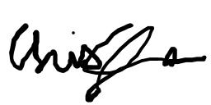
Chris Glover
Director

+61403546660
chris@zonski.com

This demo is also available from the project website, http://www.zonski.com/godhood/html

