IST 263

# Lab 02

## This lab covers:

1. HTML Attributes, External Links and Target attribute
2. Mail Links
3. Images
4. Embedding Content

## What will You hand IN?

In blackboard before this lab is due provide:

## Setup

1. Start your lab by creating a new page with the required HTML tags. If you forgot how to do this, refer to lab 1. The title of your page should be "Contact".
2. Save your new page in your Github folder on your computer as contact.html.
3. Put a main header on the page called "Contact" – make sure you use the correct tag.
4. Let's add name and address under that heading. Use the correct tags. If you don't want to publish your personal address use the university's address.

## HTML Attributes and Links

A basic link tag looks like this <a>text</a>. That tag is useless without and element attribute. Attributes are name value pairs that add additional info to the element. For the <a> tag the href attribute specifies the url the link forwards to. Following is a link to google.



I've added a second attribute into the tag, target="_blank". The target attribute specifies where you should open a link. Default is to open it in the same browser window as the link. If you want to do this, you don't need the target attribute. Another popular option is to choose _blank which opens the link in a new tab. Folks often do this when linking to a PDF or off their site. You can see all the values for that attribute at W3Schools here: <https://www.w3schools.com/tags/att_a_target.asp>.

We are going to start our work with links by creating a contact page for you. This page will contain your contact info, links to your professional social media presence and a map to your location.

1. On that page we are going to create a link to your LinkedIn page. You will need to lookup and copy the URL of your LinkedIn page. If you don't have a LinkedIn page then just create your link to the LinkedIn homepage.   
     
   Under your address add the text "My LinkedIn Profile" and use the <a> tag to create an external link to your LinkedIn page.

## Mail Links

We've just spent some time entering your contact info. Now let's add a clickable link for your email address. An email link follows the same format as a link to a page, we just add "mailto:" to the beginning of the href attribute. Here's how you would add an email link to me:



1. Add an email link to yourself on your contact page under the address.

## Images

1. We are going to add a LinkedIn logo to our contact page. To get started let's create a folder to separate the images from our web pages. In your github folder, create a folder called "images".
2. LinkedIn provides official versions of its logo image for use. You can find them here: <https://brand.linkedin.com/downloads>. Read the use requirements to make sure you are following LinkedIn's rules.   
     
   You can right click or control click on the logo you like best and choose to save it to the images folder you just created.
3. Now go back to your contact page. We are going to add this image inside the link to LinkedIn so that the user can either click on the "My LinkedIn Page" text or the image to get to your LinkedIn page. A basic image tag looks like the following. Make special note of the new alt attribute in this tag.  
     
   

The alt attribute stands for alternate and describes the image. It displays if the image can't load and is useful for search engines and folks who use screen readers to surf the web. It is also required to pass html validation. Make sure you include this attribute when you use an image tag.   
  
Go ahead and add the LinkedIn logo you downloaded now. Don't forget the rules to create a path to the image.  
  
Note: Don't worry if your image is too large or too small. We'll deal with editing images in the future.

## Embedding

The last thing we are going to do on our contact page is embed a map of your location using Google maps. Put the map at the bottom of your HTML document. The first step is to type your address into Google maps then look for the embed code. Once you find it paste the code into your contact page.

## Validation and checking your work

1. Here's a screen shot of my bio page. Check it against the page you created to make sure everything is in the correct place and you haven't missed any parts.  
     
   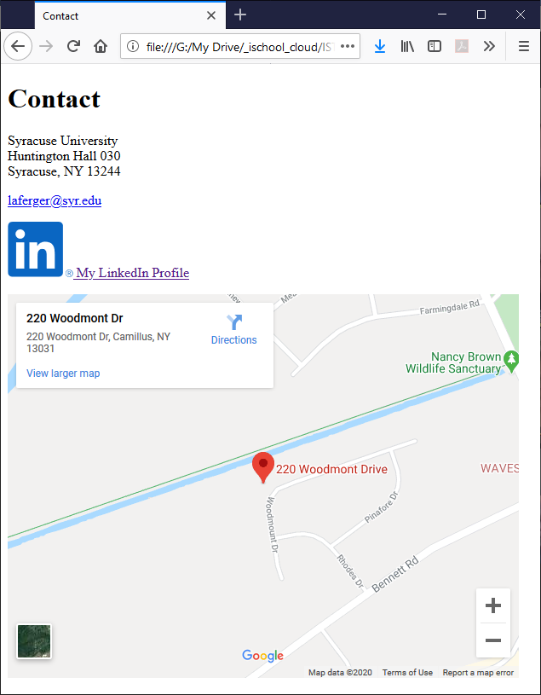
2. Before you finish you must validate you HTML. Go to the <https://html5.validator.nu/> and correct any errors that appear in validating.