Computer Science Technology
Network Management and Security (420.BR)
DEPLOYMENT OF AN ENTERPRISE MULTIPLATFORM
Course Number: 420-EC6-AS
Technical Report
Student: El Ouahmani Ilyas
Student Number: 2332531
Teacher: Iryna Projorovskaia
Semester: Winter 2026
Date of Completion: Winter 2026

Table of Contents
1. Appreciation and Dedication
2. Presentation of Project Specifications
3. Topological Diagram
4. IP Addressing Scheme and Naming Convention
5. Router and Switch Documentation
6. Server and Workstation Documentation
7. Problems Encountered and Troubleshooting
8. Glossary of Technical Terms
9. Conclusion

1. Appreciation and Dedication
I would like to express my sincere gratitude to my teacher, Iryna Projorovskaia, for her guidance, support, and expertise throughout this course. Her dedication to teaching complex networking concepts has been invaluable in helping me complete this project successfully.
I would also like to dedicate this report to all those who supported me throughout the Computer Science Technology program. This project represents the culmination of skills and knowledge acquired throughout the Network Management and Security program, and I am proud to have completed such a complex and comprehensive network design and implementation.
This project has provided me with hands-on experience in enterprise network design, configuration, and troubleshooting skills that will be essential in my future career as a network professional.

2. Presentation of Project Specifications

2.1 Project Overview
This project involves the design and implementation of a complex enterprise network for a company with multiple sites across five cities: Dublin, Cork, Galway, Limerick, and Edinburgh. The network was designed, simulated, and configured using Cisco Packet Tracer.

2.2 Company Requirements
- Human Resources: 20 employees
- Accounting: 25 employees
- Sales: 30 employees
- IT Support: 5 employees (maximum)
- Customer Services at Cork: 50 workstations
- External Mobile Sales at Limerick: 50 wireless laptops
- Edinburgh branch: 250 hosts (one large network)

2.3 Technical Requirements
- Private Class A addressing with VLSM for address efficiency
- Cork uses dual stack IPv4 and IPv6 (FC00::/7 ULA addressing)
- Internet access via Dublin using PAT mapped to public IP 200.1.1.1
- DHCP for all LANs with reserved addresses for servers and gateways
- OSPF multi-area routing protocol across all sites
- VLANs at Dublin: VLAN 10 Accounting, VLAN 20 HR, VLAN 30 Sales, VLAN 40 IT Support
- VTP version 2 with domain SWElectrical for VLAN propagation
- PPP CHAP authentication on Dublin-Cork and Dublin-Edinburgh links
- PPP PAP authentication on Dublin-Galway and Dublin-Limerick links
- HSRP for router redundancy at Edinburgh branch
- VPN connectivity between sites
- Wireless LAN at Limerick using Cisco WLC 2504 with 3 Lightweight Access Points
- ACLs for security between departments
- AAA/RADIUS server for centralized SSH authentication to Dublin router
- Zone-Based Policy Firewall (ZPF) on Dublin router
- EtherChannel using LACP on access switches
- NAT/PAT at ISP for internet access

3. Topological Diagram
The network topology below shows the complete enterprise network including all sites, routers, switches, servers, and end devices. The network spans five cities: Dublin (headquarters), Cork, Galway, Limerick, and Edinburgh.

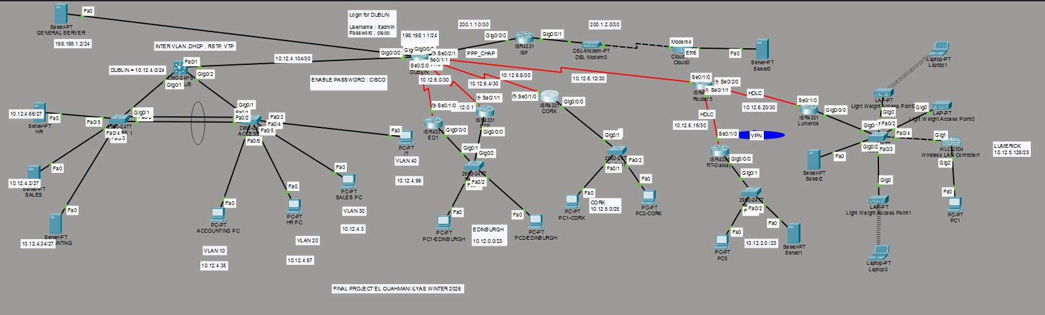
Figure 1 - Network Topology Overview
The topology includes the following key components:
- Dublin HQ: DUBLIN router, DISTURB Layer 3 switch, 2 access switches, 4 VLANs, General Server
- Cork: CORK router connected via PPP CHAP serial link, dual-stack IPv4/IPv6
- Edinburgh: ED1 and ED2 routers with HSRP redundancy, 250+ host network
- Galway: RT-Galway router connected via Router5 using HDLC
- Limerick: LUMERICK router with WLC and 3 Lightweight Access Points for wireless
- ISP: Internet connectivity with NAT/PAT services

4. IP Addressing Scheme and Naming Convention

4.1 VLSM Design Table
The following VLSM design maximizes IP address efficiency using private Class A address space 10.12.0.0:

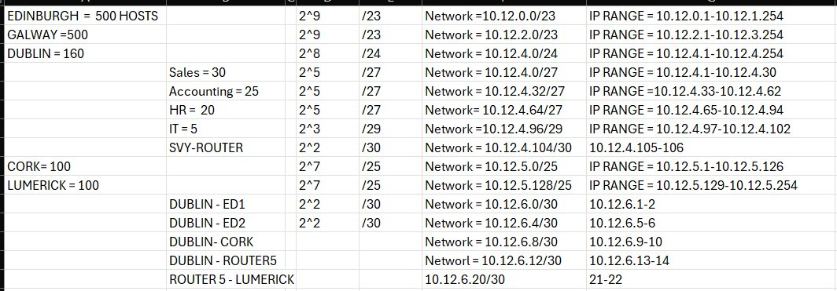
Figure 2 - VLSM Addressing Table

Network Name | VLAN | Hosts | Network Address | Subnet Mask | Gateway
Sales | 30 | 30 | 10.12.4.0/27 | 255.255.255.224 | 10.12.4.1
Accounting | 10 | 25 | 10.12.4.32/27 | 255.255.255.224 | 10.12.4.33
HR | 20 | 20 | 10.12.4.64/27 | 255.255.255.224 | 10.12.4.65
IT Support | 40 | 5 | 10.12.4.96/29 | 255.255.255.248 | 10.12.4.97
Cork | - | 100 | 10.12.5.0/25 | 255.255.255.128 | 10.12.5.1
Limerick | - | 100 | 10.12.5.128/25 | 255.255.255.128 | 10.12.5.129
Edinburgh | - | 500 | 10.12.0.0/23 | 255.255.254.0 | 10.12.0.1
Galway | - | 500 | 10.12.2.0/23 | 255.255.254.0 | 10.12.2.1

4.2 Dublin Router Interfaces
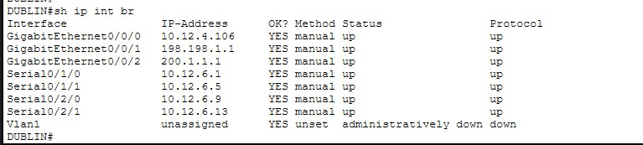
Figure 3 - Dublin Router Interface Summary

4.3 Device Naming Convention
- Routers: DUBLIN, CORK, ED1, ED2, Router5, RT-Galway, LUMERICK_ROUTER, ISP
- Distribution Switch: DISTURB (Layer 3)
- Access Switches: ACCESS1, ACCESS2
- WLC: LUMERICK (Cisco WLC 2504)
- Servers: GENERAL SERVER (198.198.1.2), HR Server (10.12.4.66), Accounting Server (10.12.4.34), Sales Server (10.12.4.2)

5. Router and Switch Documentation

5.1 VLAN Configuration
The following VLANs were configured on the DISTURB distribution switch and propagated to access switches via VTP:
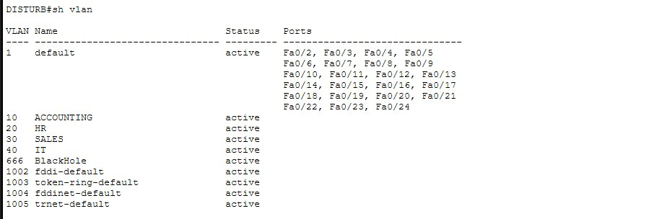
Figure 4 - VLAN Database on DISTURB Switch

5.2 VTP Configuration
VTP version 2 was configured with domain SWElectrical. The distribution switch operates in Server mode while access switches operate in Client mode:
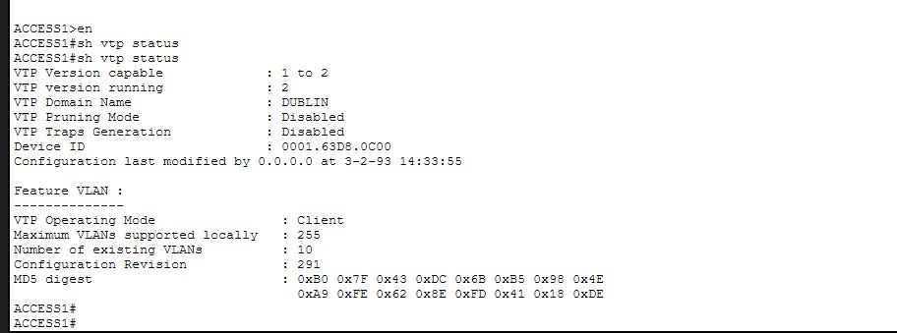
Figure 5 - VTP Status on Access Switch

5.3 EtherChannel
EtherChannel using LACP protocol was configured on the access switches to provide link redundancy and increased bandwidth:
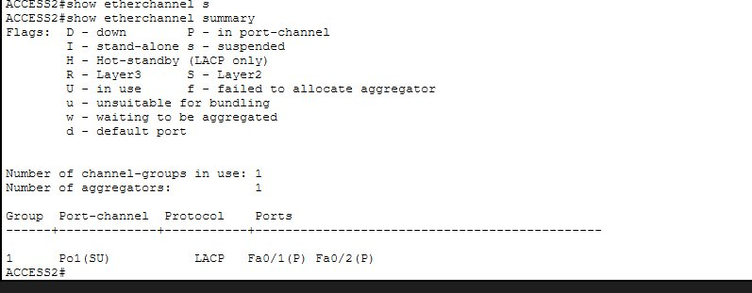
Figure 6 - EtherChannel Summary (LACP, Port-Channel 1 SU)

5.4 DHCP Bindings
DHCP pools were configured to automatically assign IP addresses to all workstations in each VLAN:
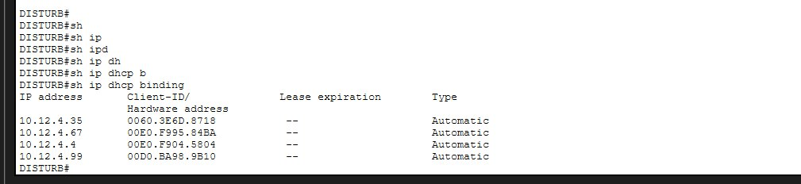
Figure 7 - DHCP Bindings showing PCs assigned to each VLAN

5.5 OSPF Routing
OSPF multi-area routing protocol was configured on all routers. Dublin shows 5 OSPF neighbors in FULL state:
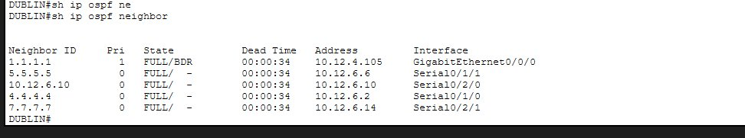
Figure 8 - OSPF Neighbor Table on Dublin Router

5.6 Routing Tables
Dublin routing table showing all networks reachable via OSPF:
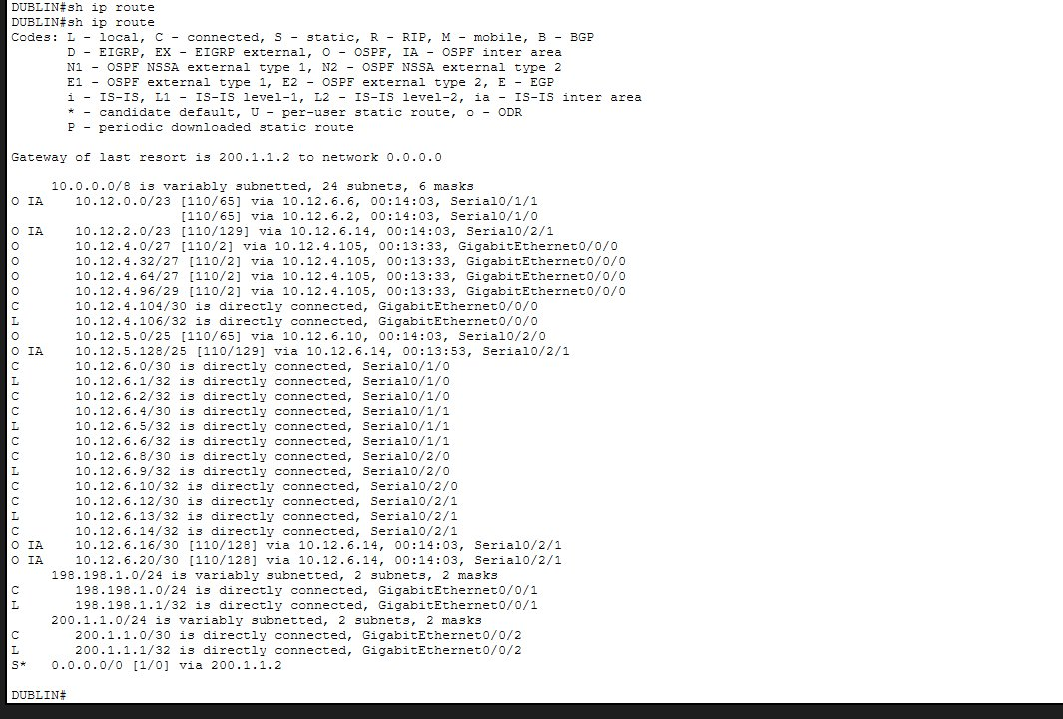
Figure 9 - Dublin Routing Table

Cork routing table — all networks reachable via Dublin:
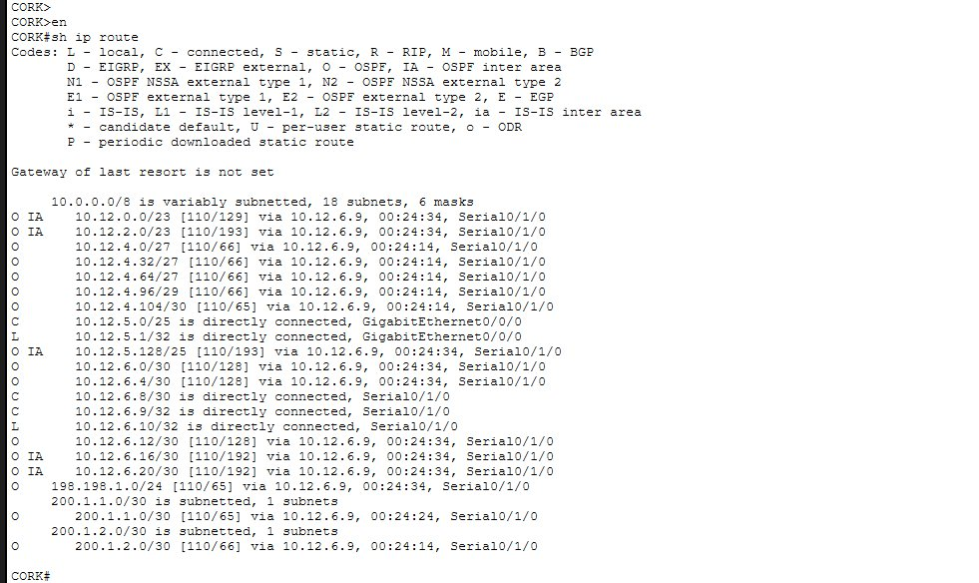
Figure 10 - Cork Routing Table

Galway routing table — all networks reachable via Router5:
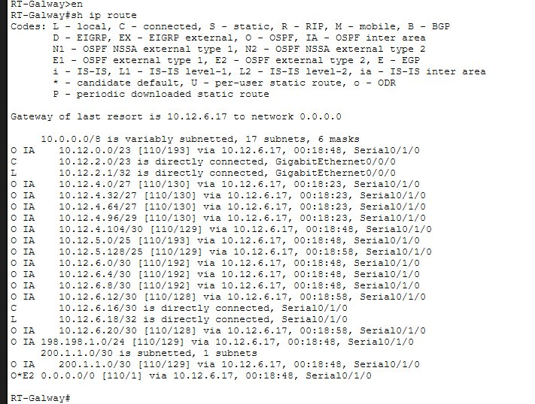
Figure 11 - Galway Routing Table

Limerick routing table — all networks reachable via Router5:
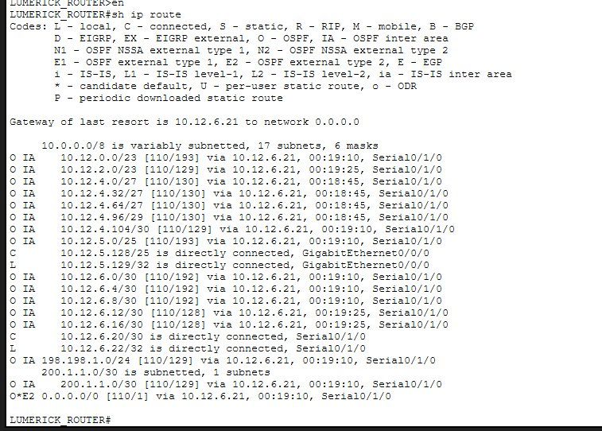
Figure 12 - Limerick Routing Table

Edinburgh ED1 routing table:
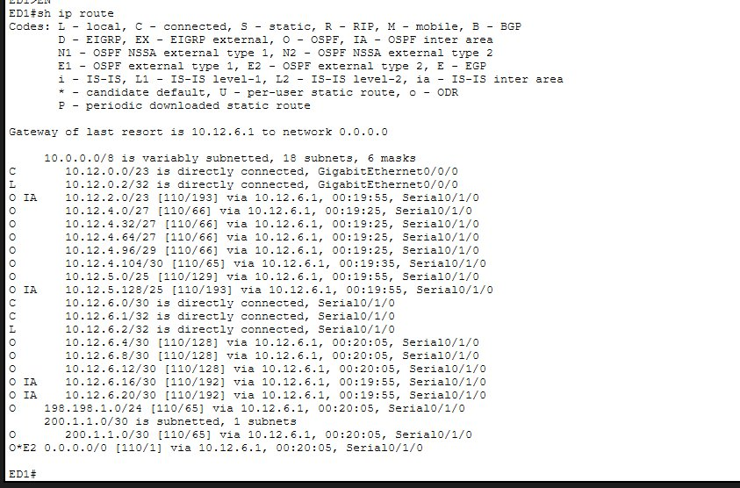
Figure 13 - Edinburgh ED1 Routing Table

Edinburgh ED2 routing table:
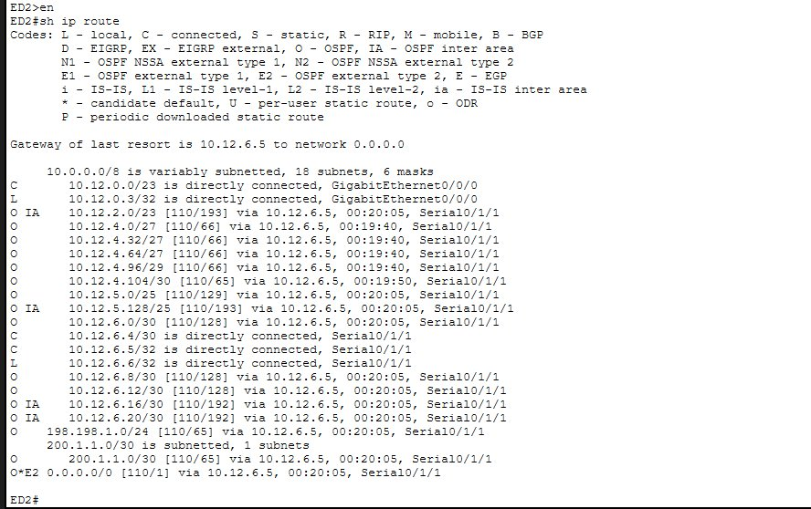
Figure 14 - Edinburgh ED2 Routing Table

5.7 HSRP Configuration
HSRP version 2 was configured on the Edinburgh routers for redundancy. ED1 is Active with priority 110, ED2 is Standby with default priority 100. Virtual IP is 10.12.0.1:
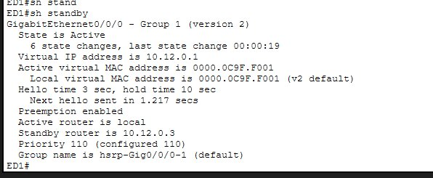
Figure 15 - HSRP Status on ED1 (Active Router, Priority 110)

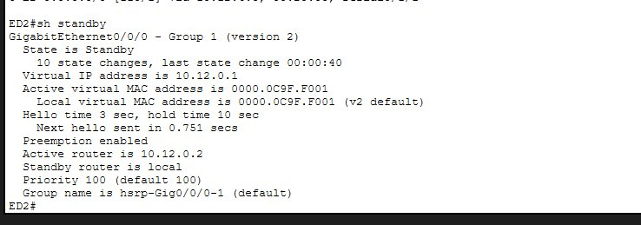
Figure 16 - HSRP Status on ED2 (Standby Router, Priority 100)

5.8 PPP Serial Links
PPP encapsulation was configured on all serial WAN links. CHAP authentication is used for Dublin-Cork and Dublin-Edinburgh. The serial interface shows LCP Open confirming PPP is working correctly:
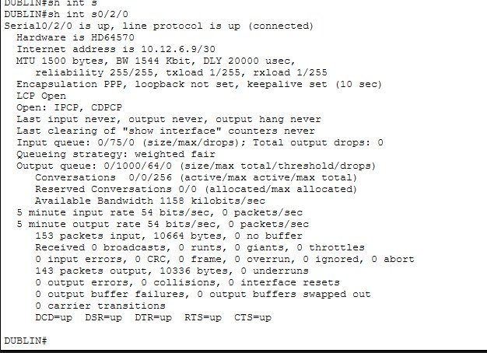
Figure 17 - PPP Serial Interface Status (LCP Open, line protocol up)

6. Server and Workstation Documentation

6.1 Server Summary
Server | IP Address | Services | Location
GENERAL SERVER | 198.198.1.2 | HTTP, FTP, DNS, AAA/RADIUS | Dublin (directly connected)
HR Server | 10.12.4.66 | HTTP, FTP | Dublin VLAN 20
Accounting Server | 10.12.4.34 | HTTP, FTP | Dublin VLAN 10
Sales Server | 10.12.4.2 | HTTP, FTP | Dublin VLAN 30
Server1 | 10.12.2.x | HTTP, FTP | Galway
Server2 | 10.12.5.x | HTTP, FTP | Limerick

6.2 Access Control Lists
Extended ACLs were configured on DISTURB to control inter-VLAN traffic and on Dublin to control internet access. The following ACLs are active on Dublin:
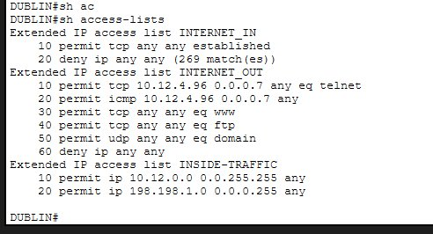
Figure 18 - Access Lists on Dublin Router

6.3 Zone-Based Firewall
ZPF was configured on Dublin to create INSIDE and OUTSIDE security zones. Traffic from inside is inspected and only established connections are allowed back in:
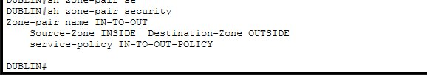
Figure 19 - Zone-Based Firewall Zone-Pair Configuration

6.4 AAA/SSH Authentication
AAA authentication using RADIUS was configured on Dublin. The General Server acts as the RADIUS server with user itadmin. IT Support PCs can SSH to Dublin using AAA credentials:
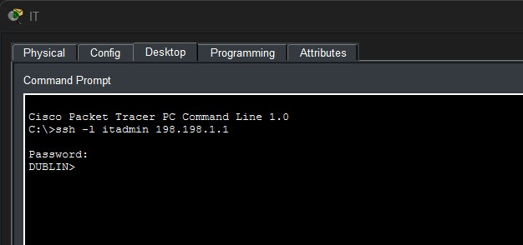
Figure 20 - Successful SSH Access from IT Support PC to Dublin

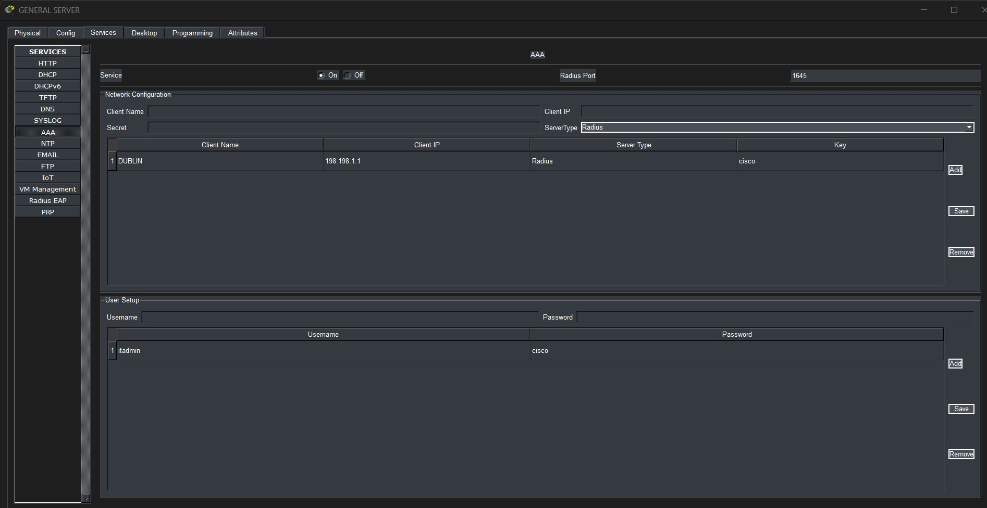
Figure 23 - General Server AAA/RADIUS Service Configuration

6.5 Internet Browsing
All PCs can browse the internet via HTTP. NAT/PAT at the ISP translates all internal addresses to the public IP. The ZPF and ACLs only allow HTTP/HTTPS traffic to the internet:
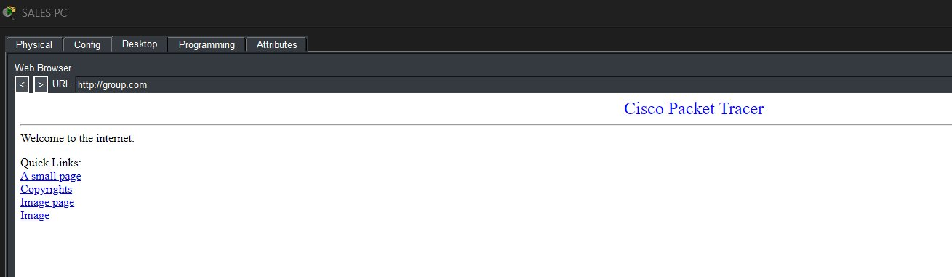
Figure 21 - Successful Internet Browsing from Sales PC

6.6 Wireless LAN
The Cisco WLC 2504 at Limerick manages 3 Lightweight Access Points. All 3 APs are Up and broadcasting SSID SWElectrical with WEP security:
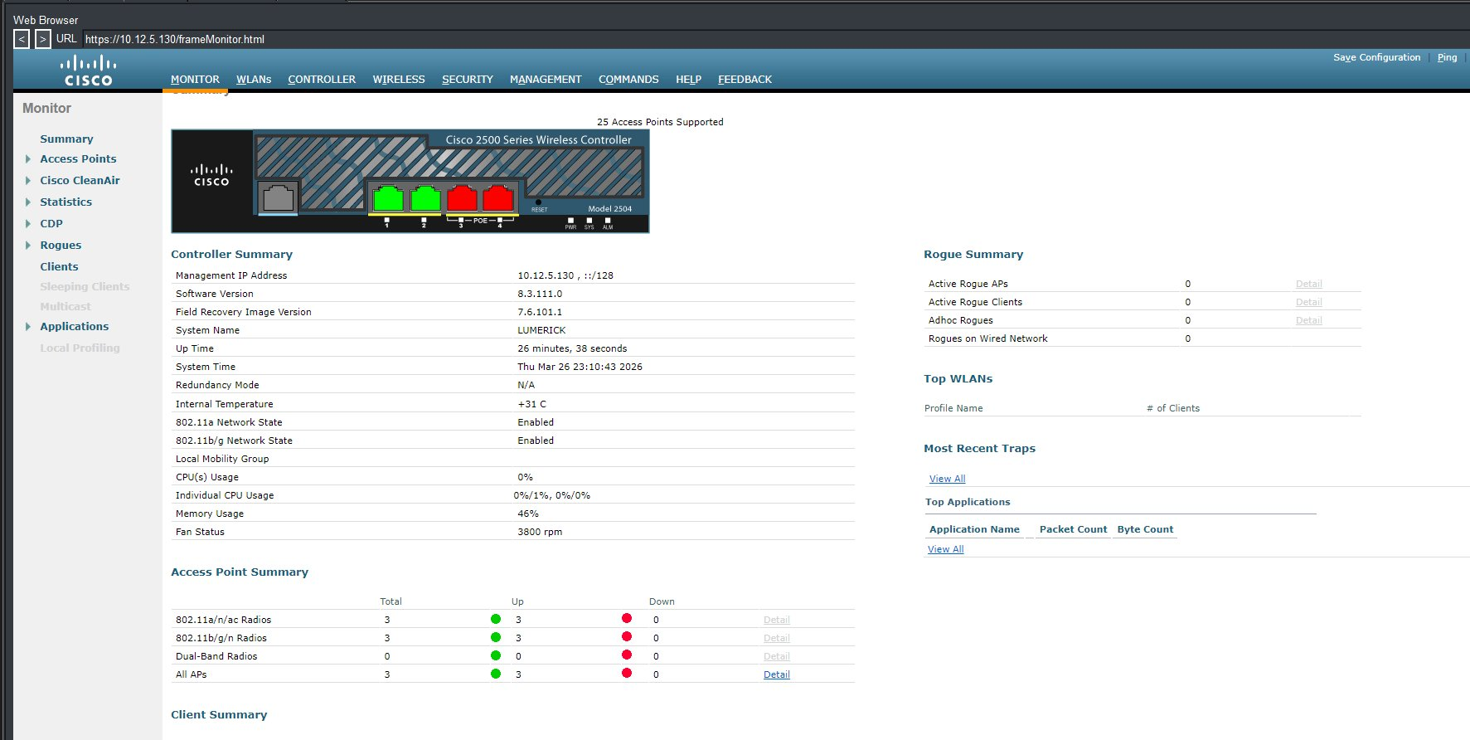
Figure 22 - WLC Summary showing 3 Access Points Up

SUPPLEMENTARY VERIFICATION

DHCP Verification

PC DHCP Configuration (IPv4)
The following screenshot shows an Accounting PC (VLAN 10) that has successfully received its IP configuration from the DHCP server. The PC received IP 10.12.4.35, subnet 255.255.255.224, gateway 10.12.4.33 and DNS 198.198.1.2:
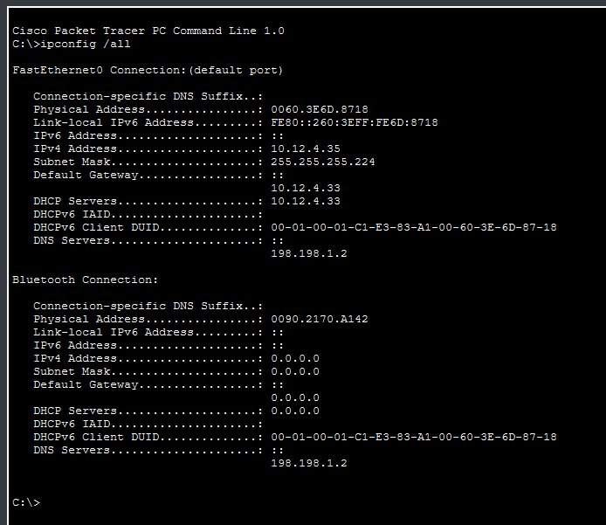
Figure A1 - Accounting PC DHCP Configuration (ipconfig /all)
✔ PC received IPv4 address 10.12.4.35 via DHCP from server 10.12.4.33
✔ DNS server correctly set to 198.198.1.2 (General Server)

Cork DHCPv6 Configuration
Cork is the only site using dual-stack (IPv4 + IPv6). The DHCPv6 pool on Cork router uses the FC12:12:12:5::/64 prefix from the FC00::/7 ULA range:
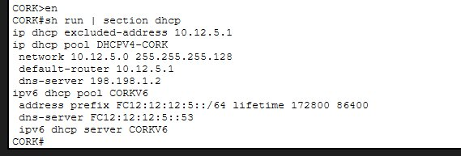
Figure A2 - Cork Router DHCPv6 Pool Configuration
✔ DHCPv4 pool configured for 10.12.5.0/25 (Cork subnet)
✔ DHCPv6 pool configured with ULA prefix FC12:12:12:5::/64

Cork PC Dual-Stack (IPv4 + IPv6)
PC1-Cork has successfully received both an IPv4 address via DHCP and an IPv6 address via DHCPv6. This demonstrates the dual-stack configuration working correctly:
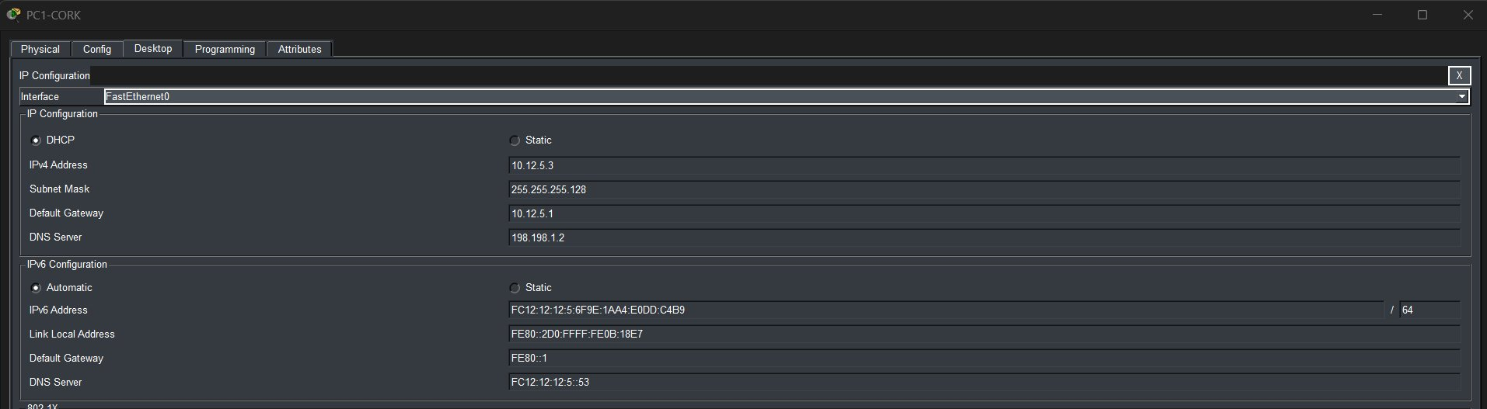
Figure A3 - Cork PC1 showing dual-stack IPv4 (10.12.5.3) and IPv6 (FC12:12:12:5::) addresses
✔ PC1-Cork received IPv4 10.12.5.3 via DHCPv4
✔ PC1-Cork received IPv6 FC12:12:12:5:6F9E:1AA4:E0DD:C4B9/64 via DHCPv6
✔ IPv6 DNS server FC12:12:12:5::53 correctly assigned

NAT/PAT Verification

NAT Translation Table
The following screenshot shows the NAT translation table on the ISP router. Internal private addresses (10.12.4.x) are being translated to public addresses for internet access. This confirms NAT/PAT is working correctly:
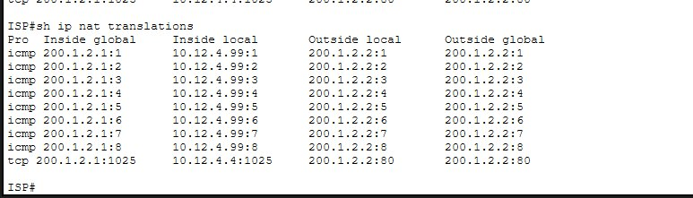
Figure A4 - NAT Translation Table on ISP Router
✔ IT Support PC (10.12.4.99) translated to public IP 200.1.2.x for ICMP
✔ Sales PC (10.12.4.4) translated for TCP port 80 (HTTP) browsing
✔ Multiple internal hosts sharing single public IP via PAT (overload)

Wireless LAN Verification

Wireless Laptop Connection
The wireless laptop at Limerick has successfully connected to the WLC-managed wireless network. The WLAN_EMPLOYEE SSID is visible and the laptop is connected:
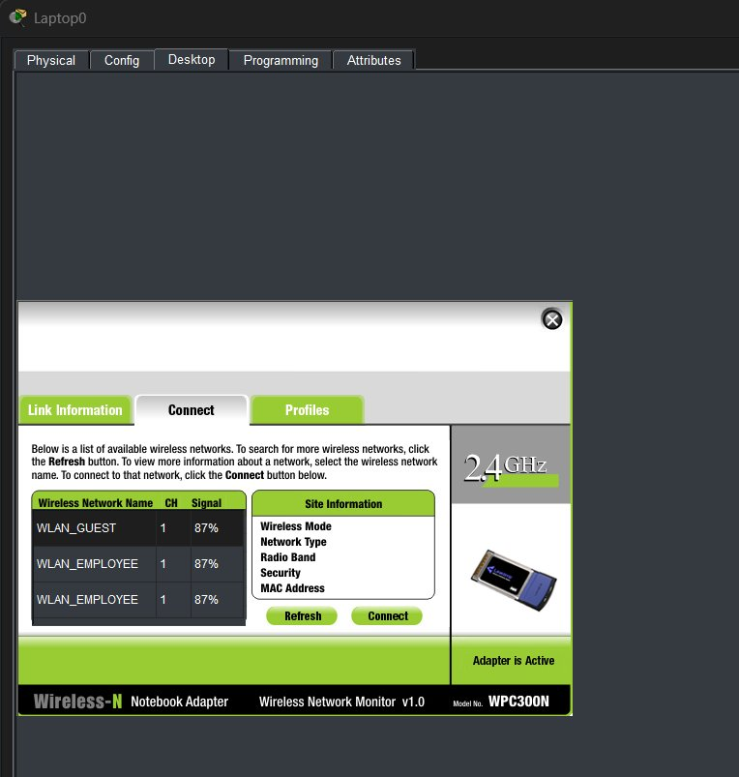
Figure A5 - Wireless Laptop showing available WLANs (WLAN_GUEST, WLAN_EMPLOYEE)

Wireless DHCP Assignment
The wireless laptop successfully received an IP address via DHCP after connecting to the wireless network. The IP 10.12.5.138 is within the Limerick subnet (10.12.5.128/25):
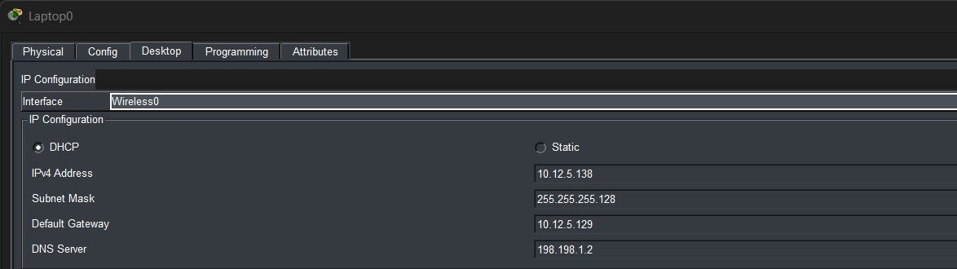
Figure A6 - Wireless Laptop IP Configuration showing DHCP address 10.12.5.138/25
✔ Laptop received IPv4 10.12.5.138 via DHCP over wireless
✔ Default gateway 10.12.5.129 correctly assigned
✔ DNS server 198.198.1.2 correctly assigned

ACL Verification

Access Lists on DISTURB Switch
The following ACLs are configured on the DISTURB Layer 3 switch to control inter-VLAN traffic between departments:
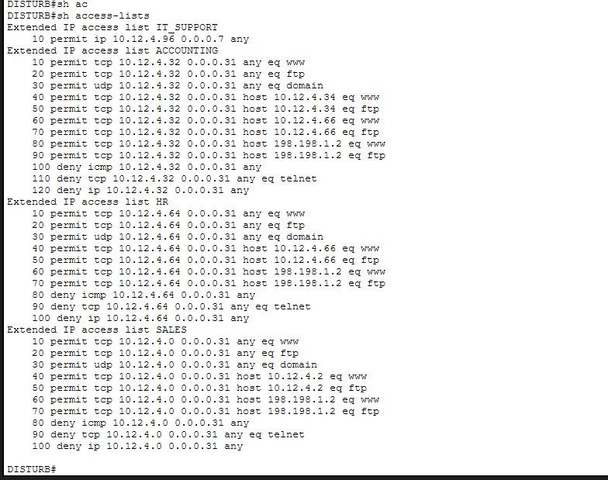
Figure A7 - Extended ACLs on DISTURB Switch (IT_SUPPORT, ACCOUNTING, HR, SALES)
✔ IT_SUPPORT ACL: permits all traffic from 10.12.4.96/29
✔ ACCOUNTING ACL: permits HTTP/FTP to own server, HR server and General Server only
✔ HR ACL: permits HTTP/FTP to own server and General Server only
✔ SALES ACL: permits HTTP/FTP to own server and General Server only
✔ All ACLs deny ICMP (ping) and Telnet for non-IT departments

FTP Access Verification
The following screenshot shows FTP access testing from the HR PC. HR PC cannot FTP to Accounting server (10.12.4.34) but can FTP to its own HR server (10.12.4.66), confirming ACLs are working correctly:
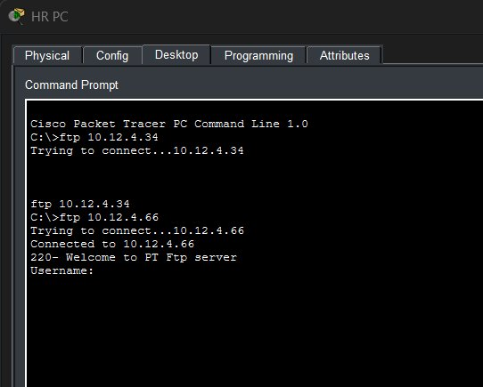
Figure A8 - HR PC: FTP to Accounting server FAILS, FTP to HR server SUCCEEDS
✔ HR PC FTP to Accounting server (10.12.4.34) - BLOCKED by ACL
✔ HR PC FTP to HR server (10.12.4.66) - ALLOWED by ACL

Problems Encountered and Troubleshooting

OSPF Neighbor Issues
Problem: OSPF neighbors were not forming between certain routers after initial configuration.
Troubleshooting Method:
- Used 'show ip ospf neighbor' to identify missing neighbors
- Used 'show run | section ospf' to verify network statements
- Discovered that some interfaces were missing from OSPF network statements
Resolution: Added missing network statements. The Cork LAN interface (10.12.5.0/25) was not included in OSPF, preventing PCs from being reachable. Added 'network 10.12.5.0 0.0.0.127 area 0' to resolve. DHCP Issues
Problem: PCs were not receiving IP addresses from DHCP pools on certain VLANs.
Troubleshooting Method:
- Used 'show ip dhcp pool' and 'show ip dhcp binding' to check pool status
- Used 'show run | section dhcp' to verify excluded addresses
- Verified inter-VLAN routing on DISTURB switch
Resolution: Corrected DHCP pool configurations and ensured excluded addresses did not overlap with pool ranges.

PPP Authentication Issues
Problem: Serial links were dropping after configuring PPP authentication.
Troubleshooting Method:
- Used 'show interface serial x/x/x' to check LCP status
- Used 'debug ppp authentication' to see authentication failures
- Verified usernames matched router hostnames exactly
Resolution: Corrected username entries to match exact hostnames. CHAP requires the username to match the remote router's hostname exactly.

ACL Ordering Issues
Problem: ACL rules were blocking internet access for all PCs even after configuring permit HTTP statements.
Troubleshooting Method:
- Used 'show access-lists' to check match counters
- Identified deny statements appearing before permit statements
Resolution: Rewrote all ACLs with correct ordering — permit statements placed before deny statements.

AAA/SSH Issues
Problem: SSH login was failing with 'Login invalid' even with correct credentials.
Troubleshooting Method:
- Used 'show run | section aaa' to verify AAA configuration
- Checked RADIUS server configuration on General Server
- Found that radius-server host command was missing from Dublin
Resolution: Added RADIUS server configuration using the newer IOS syntax: 'radius server MYRADIUS' with address and key. Also added itadmin username locally as backup authentication.

8. Glossary of Technical Terms
Term | Definition
OSPF | Open Shortest Path First - link-state routing protocol for finding best paths between routers
VLAN | Virtual Local Area Network - logical grouping of network devices regardless of physical location
VTP | VLAN Trunking Protocol - Cisco protocol for propagating VLAN information across switches
DHCP | Dynamic Host Configuration Protocol - automatically assigns IP addresses to network devices
NAT | Network Address Translation - translates private IP addresses to public IP addresses
PAT | Port Address Translation - maps multiple private addresses to single public IP using different ports
PPP | Point-to-Point Protocol - data link protocol used for WAN serial connections
CHAP | Challenge Handshake Authentication Protocol - secure PPP authentication method
PAP | Password Authentication Protocol - basic PPP authentication method
HDLC | High-Level Data Link Control - default Cisco encapsulation for serial interfaces
HSRP | Hot Standby Router Protocol - provides router redundancy with a virtual IP address
VPN | Virtual Private Network - secure encrypted tunnel over a public network
ACL | Access Control List - rules that permit or deny network traffic
AAA | Authentication, Authorization, Accounting - framework for network access control
SSH | Secure Shell - cryptographic protocol for secure remote access to network devices
ZPF | Zone-Based Policy Firewall - stateful firewall using security zones
WLC | Wireless LAN Controller - centrally manages multiple lightweight access points
LWAP | Lightweight Access Point - access point managed by a WLC via CAPWAP
VLSM | Variable Length Subnet Masking - allows subnets of different sizes within same network
EtherChannel | Bundles multiple physical links into single logical link for redundancy and bandwidth
STP | Spanning Tree Protocol - prevents network loops in switched networks
RADIUS | Remote Authentication Dial-In User Service - centralized authentication protocol
IPv6 | Internet Protocol version 6 - latest IP version with 128-bit addressing
ULA | Unique Local Address - IPv6 private addresses (FC00::/7)
LACP | Link Aggregation Control Protocol - standard protocol for EtherChannel negotiation

9. Conclusion
This project successfully demonstrated the design and implementation of a complex enterprise network spanning five cities. All required phases were completed and verified in Cisco Packet Tracer.
Key achievements:
- Designed hierarchical network using VLSM to maximize IP address efficiency
- Implemented VLANs at Dublin headquarters to separate departments and improve security
- Configured OSPF multi-area routing across all sites ensuring full network reachability
- Implemented PPP with CHAP and PAP authentication on all WAN serial links
- Deployed Wireless LAN at Limerick using WLC and three Lightweight Access Points
- Configured comprehensive ACLs enforcing security policies between departments
- Implemented AAA-based SSH access control for the Dublin router
- Deployed Zone-Based Firewall on Dublin to protect against unsolicited inbound traffic
- Configured HSRP for router redundancy at the Edinburgh branch
- Successfully verified all network connectivity requirements
This project provided invaluable hands-on experience with enterprise network technologies and reinforced the importance of careful planning, systematic troubleshooting, and thorough documentation in network engineering.

Report completed: Winter 2026
Student: El Ouahmani Ilyas
Student Number: 2332531

