**Lindsay Graham**

**Firewalls**

This document will outline a simple Iptables configuration for the Ubuntu and CentOS servers through a series of examples. Please note that **sudo** permissions are needed to make changes to the IPtables. The first section will explain each example’s purpose and then show the scripts that were used to accomplish them. The second section will focus on preventing a Distributed Denial of Service (DDoS) attack. The final section will test connectivity on the ports that were added and blocked in the first section.

To ensure the IPtables rules save after a reboot on the Ubuntu server, you must make them persistent (Reynolds, 2016). This can be done by installing the iptables-persistent package with the command **sudo apt install iptables-persistent**. For the CentOS server, I had to install iptables services with the command **sudo yum install iptables-services**. Next, the iptables services need to be enabled and started with the commands **sudo systemctl start iptables** and **sudo systemctl enable iptables**.

Originally, I had only used commands for the INPUT chain. During testing I made a modification to add commands to allow outgoing traffic on the OUTPUT chain.

**Example 1.** *Deal with web server (open needed ports, and forward port 80 traffic to 8080)*

Ports 80 and 443 are necessary ports for communicating with a web server and allowing web traffic (Peppas, 2019). Port 80 is used for hypertext transfer protocol (HTTP) traffic, and port 443 is used for hypertext transfer protocol secure (HTTPS) traffic.

The command syntax to allow incoming traffic on port 80 and 443 on the Ubuntu server is:

**sudo iptables -A INPUT -p tcp --dport 80 -j ACCEPT**

**sudo iptables -A INPUT -p tcp --dport 443 -j ACCEPT**

The command syntax to allow incoming on port 80 and 443 on the CentOS server is:

**sudo iptables -A INPUT -p tcp -m state --state NEW -m tcp --dport 80 -j ACCEPT**

**sudo iptables -A INPUT -p tcp -m state --state NEW -m tcp --dport 443 -j ACCEPT**

The command syntax to allow outgoing traffic on both servers is:

**sudo iptables -A OUTPUT -p tcp --dport 8080-j ACCEPT**

**sudo iptables -A OUTPUT -p tcp --dport 443 -j ACCEPT**

The outgoing port is 8080, because that is where port 80 will be sent to, so that will be the port used for replies.

For the Ubuntu server, a rule had to be created to enable port forwarding. To do this, the sysctl.conf file in the etc directory had to be modified (Asghar, 2024). Navigate to the etc directory and open the sysctl.conf file with a text editor. Remember to open the file as sudo so that the changes you make can be saved. Next, add a line that says “net.ipv4.ip_forward=1” and save the file. After saving the changes, they must be applied. To apply the changes use the command **sudo sysctl -p**.

**Figure A.1** Image of command to apply configuration changes

The command syntax to forward traffic from port 80 to 8080 on the Ubuntu server is:

**sudo iptables -t nat -A PREROUTING -p tcp --dport 80 -j DNAT --to-destination 10.0.0.49:8080**

The IP address 10.0.0.49 is the Ubuntu server’s external IP address.

The command syntax to forward traffic from port 80 to 8080 on the CentOS server is:

**sudo iptables -t nat -A PREROUTING -i eth0 -p tcp --dport 80 -j REDIRECT --to-port 8080**

**Example 2**. *Deal with MySQL service (open needed ports)*

To allow MySQL traffic, port 3306 needed to be added (Oracle, 2024). Applications use this port to establish network connections with applications.

The command syntax to allow incoming traffic on port 3306 on the Ubuntu server is:

**sudo iptables -A INPUT -p tcp --dport 3306 -j ACCEPT**

The command syntax to allow incoming traffic on port 3306 on the CentOS server is:

**sudo iptables -A INPUT -p tcp -m state --state NEW -m tcp --dport 3306 -j ACCEPT**

The command syntax to allow outgoing traffic on both servers is:

**sudo iptables -A OUTPUT -p tcp --dport 3306 -j ACCEPT**

**Example 3.** *Deal with SSH service (allow incoming and outgoing SSH, second script to deny SSH)*

The port that is used for Secure Shell (SSH) traffic that establishes secure connections to a remote device is port 22 (Peppas, 2019). The commands below show how to allow incoming and outgoing traffic on port 22. I also made a basic script to stop SSH for both servers (see Figures 1.3 and 2.3). The main difference in the command syntax is that instead of ACCEPT, DROP is used.

The command syntax to allow incoming and outgoing traffic on port 22 on the Ubuntu server is:

**sudo iptables -A INPUT -p tcp --dport 22 -j ACCEPT**

**sudo iptables -A OUTPUT -p tcp --dport 22 -j ACCEPT**

The command syntax to allow incoming and outgoing traffic on port 22 on the CentOS server is:

**sudo iptables -A INPUT -p tcp -m state --state NEW -m tcp --dport 22 -j ACCEPT**

**sudo iptables -A OUTPUT -p tcp --dport 22 -j ACCEPT**

**Example 4.** *Script to allow/block specific hosts, MAC addresses*

There may be times when it can be helpful to block a particular media access control (MAC) address. The mac option can be used with a command to block all incoming traffic from a particular host if the MAC address is known (Gite, 2005b). I made a basic script block MAC address, 01:23:45:67:89:ab, and allow MAC address, 08:00:27:e6:5a:c3 to communicate. The blocked address is made up, and the allowed address is my Kali Linux virtual machine. See Figures 1.2 and 2.2 for the scripts.

**Example 5.** *Write a script or command to block telnet, and another one to block ping.*

The Telnet protocol is considered a security risk because the packets are sent as plain text, unencrypted, and susceptible to eavesdropping and/or man-in-the-middle among other attacks (Rasmussen Software, 2024). Telnet communicates on port 23. To block ping, there needs to be a rule to block Internet Control Message Protocol (ICMP) traffic (Gite, 2005a).

The command syntax to block Telnet and ping on both the Ubuntu and CentOS servers are:

**sudo iptables -A INPUT -p tcp --dport 23 -j DROP**

**sudo iptables -A INPUT -p icmp -j DROP**

**Ubuntu Server Scripts**

**Figure 1.1** Script to configure IPtables

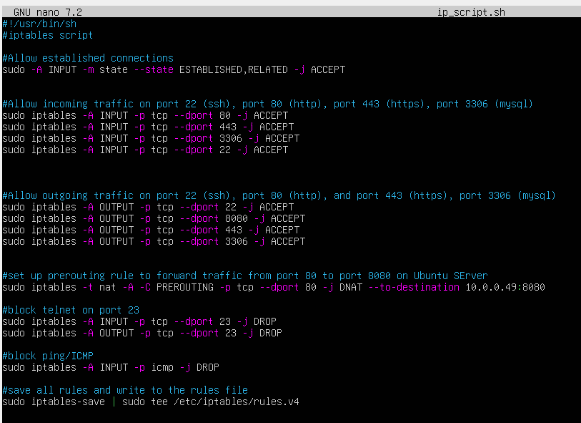

**Figure 1.2** Script to allow or block a specific host

**Figure 1.3** Script to stop SSH

**Figure 1.4** Original IPtables before rules were added

**Figure1.5** IPtables after rules were added

**CentOS Server Scripts**

**Figure 2.1** Script to configure IPtables

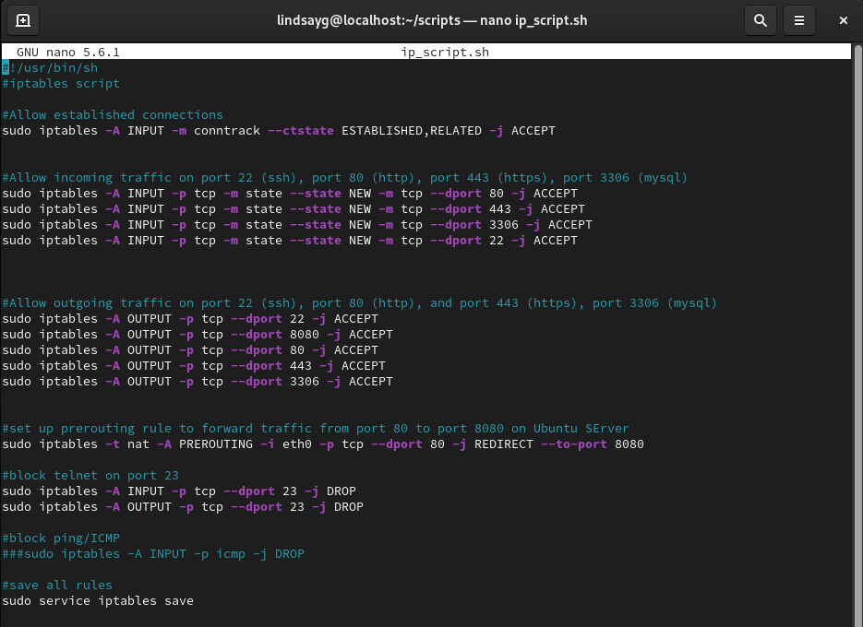

**Figure 2.2** Script to allow or block a specific host

**Figure 2.3** Image showing script that can be run to stop SSH on port 22

**Figure 2.4** Original IPtables before rules were added

**Figure 2.5** IPtables after rules were added

**Distributed Denial of Service (DDoS)**

A Distributed Denial of Service (DDoS) attack is when an attacker floods a server with traffic from multiple sources with a goal of paralyzing the server so that is inaccessible (First2Host, 2024). Recently, “botnet-for-hire” programs have become popular with ransom-seeking hackers looking for an inexpensive and easy way to attack a target (Day, 2023). Botnets represent a mass of compromised hosts who the hacker can control and direct so that they can send the traffic simultaneously from different geographic locations. DDoS attacks, even those without the ransom element, can result in lost revenue and productivity that can have a significant negative impact on an organization. IPtables can be used as a tool to help block some of the traffic types that are often associated with DDoS attacks. The next few paragraphs will detail a basic script that contains commands to block traffic that is often associated DDoS attacks.

The first line in the script focuses on null packets. In DDoS attacks, bots are often used to send null packets in an attempt to identify firewall vulnerabilities (First2Host, 2024). A flag-less packet would be considered a null packet, so the command sudo iptables -A INPUT -p tcp --tcp-flags ALL NONE -j DROP adds a rule that will block all null TCP packets. The second line focuses on dropping invalid, or non-standard packets which could signify an attack (Todorov, 2016). The command to drop invalid packets is sudo iptables -A INPUT -m conntrack --ctstate INVALID -j DROP.

The third line focuses on stopping SYN-Flood attacks. SYN-Flood attacks are a type of attack where a hacker connects to a server without sending or receiving any information so that they can consume resources that affect system availability and performance (First2Host, 2024). The IPtables command to stop this type of attack is sudo iptables -A INPUT -p tcp ! --syn -m state --state NEW -j DROP. The fourth line focuses on stopping XMAS packets. XMAS packets are not beautifully wrapped gifts, but instead malformed data packets that are often present in DDoS attacks. The command to stop XMAS packets is sudo iptables -A INPUT -p tcp –-tcp-flags ALL ALL -j DROP. The last command blocks packets that have unusual max segment sizes through the command sudo iptables -t mangle -A -C PREROUTING -p tcp -m conntrack --ctstate NEW -m tcpmss ! --mss 536:65535 -j DROP.

The script also has a command to save the iptables and write them to the configuration file, rules.v4. I used variables to store each of the commands in the script for readability, and simplicity should this script get more advanced.

**Ubuntu Server**

**Figure 1.6** DDoS script for Ubuntu

**Figure 1.7** IPtables after script is run

**CentOS Server**

**Figure 2.6** DDoS script for CentOS

**Figure 2.7** Iptables after script has run

**Testing**

**Ubuntu Server**

Tshark, the command line version of Wireshark was used to test the newly added rules. The command to add tshark was **sudo apt install tshark**. I used a Kali Linux virtual machine to test the rules.

All ICMP traffic should be blocked, so this is a test to see if the ping/ICMP will be successful. As the output in Figure 7.2 shows, there was 100% packet loss illustrating the ping was unsuccessful. ICMP uses port 23.

**Ping - Unsuccessful**

**Figure 1.8** Results of the ping request from the Kali system

**Figure 1.9** Tshark output from the Ubuntu server showing the unsuccessful ping request

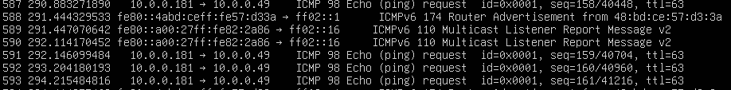

Next, I used Netcat from the Kali system to test ports 443, 3306, 80, 8080, and 22. I had to set up a Netcat listener on the Ubuntu Server. The command to set up a listener for a specific port is **netcat 10.0.0.49 “port number**” (thandel, 2019). I was unable to run Tshark in the same terminal as the listener, so I used Tmux with Tshark in one terminal with the listener in the main terminal. I knew that Tmux had that ability, but it was my first time using it. To start a Tmux session you can just type tmux. To detach from a session you select Ctrl+B then D. To reattach, you use the command tmux attach -d -t “session number” (StackOverflow, 2014).

**Port 443 – Successful Connection**

**Figure 1.10** Image of Netcat command on Kali Linux system



**Figure 1.11** Tshark capture showing the successful connection to port 443

**Port 3306 – Successful Connection**

**Figure 1.12** Image of Netcat command on Kali Linux system



**Figure 1.13** Tshark capture showing the successful connection to port 3306

**Port 80 – Connection Refused**

**Figure 1.14** Image of Netcat command on Kali Linux system

**Figure 1.15** Tshark capture showing the unsuccessful connection to port 80

Note – I think connection to port 80 was unsuccessful because of the PREROUTING rule that directs all traffic for port 80 to port 8080.

**Port 8080 – Successful Connection**

**Figure 1.16** Example of setting up the Netcat listener for port 8080

**Figure 1.17** Image of Netcat command on Kali Linux system

**Figure 1.18** Tshark capture showing the successful connection to port 8080

**Port 22 – Successful Connection**

**Figure 1.19** Image of Netcat command on Kali Linux system

**Figure 1.20** Tshark capture showing the successful connection to port 22

**CentOS Server**

For the CentOS server, I used the Wireshark GUI for testing. First, I had to install it using the command **sudo yum install wireshark**. I used a Kali Linux virtual machine to test the rules.

All ICMP traffic should be blocked, so this is a test to see if the ping/ICMP will be successful. As the output in Figure 7.2 shows, there was 100% packet loss illustrating the ping was unsuccessful. ICMP uses port 23.

**Figure 2.8** Results of the ping request from the Kali system

**Figure 2.9** Wireshark output showing the unsuccessful ping request



Next, I used Netcat from the Kali system to test ports 443, 3306, 80, 8080, and 22. I had to set up a Netcat listener on the CentOS Server. The command to set up a listener for a specific port is **nc -lvp port number** (thandel, 2019).

**Port 443 – Successful Connection**

**Figure 2.10** Image of Netcat command on Kali Linux system



**Figure 2.11** Wireshark capture showing the successful connection to port 443



**Port 3306 – Successful Connection**

**Figure 2.12** Image of Netcat command on Kali Linux system



**Figure 2.13** Wireshark capture showing the successful connection to port 3306



**Port 80 – Successful Connection**

**Figure 2.14** Image of Netcat command on Kali Linux system



**Figu** **re 2.15** Wireshark capture showing the successful connection to port 80



**Port 8080 – Successful Connection**

**Figure 2.17** Image of Netcat command on Kali Linux system



**Figure 2.18** Wireshark capture showing the successful connection to port 8080



**Port 22 – Successful Connection**

**Figure 2.19** Image of Netcat command on Kali Linux system

**Figure 2.20** Wireshark capture showing the successful connection to port 22



**References**

Asghar, A. (2024, September 16). *How to Forward Ports With Iptables in Linux*. Ultahost Knowledge Base. https://ultahost.com/knowledge-base/forward-ports-iptables-linux/

Day, B. (2023, August 14). *Preventing Linux DDoS Attacks with Minimal Cybersecurity Knowledge ...* Linux Security. https://linuxsecurity.com/features/preventing-linux-ddos-attacks

First2Host. (2024, February 6). *How to use IPtables to stop DDOS attacks*. First2Host. https://first2host.co.uk/blog/iptables-stop-common-ddos-attacks/

Gite, V. (2005a, June 28). *Linux Iptables allow or block ICMP ping request*. NixCraft. https://www.cyberciti.biz/tips/linux-iptables-9-allow-icmp-ping.html

Gite, V. (2005b, December 27). *Iptables MAC Address Filtering*. NixCraft. https://www.cyberciti.biz/tips/iptables-mac-address-filtering.html

Oracle. (2024). *MySQL :: MySQL Port Reference :: 3 MySQL Port Reference Tables*. Dev.mysql.com. https://dev.mysql.com/doc/mysql-port-reference/en/mysql-port-reference-tables.html

Peppas, N. (2019, May 7). *Liquid Web*. Liquid Web. https://www.liquidweb.com/blog/set-firewall-using-iptables-ubuntu-16-04/

Rasmussen Software. (2024). *A Guide to Telnet*. Anzio.com. https://www.anzio.com/resources/guide-telnet

Reynolds, L. (2016, August 28). *How to make iptables persistent after reboot on Linux*. LinuxConfig. https://linuxconfig.org/how-to-make-iptables-rules-persistent-after-reboot-on-linux

StackOverflow. (2014, May 1). *How can I reattach to tmux process*. Stack Overflow. https://stackoverflow.com/questions/23403368/how-can-i-reattach-to-tmux-process

thandel, lucky. (2019, May 3). *How To Use NetCat Tool In Linux - Technical Navigator*. Technical Navigator. https://technicalnavigator.in/how-to-use-netcat-tool-in-linux/

Todorov, M. (2016, March 1). *25 Useful IPtable Firewall Rules Every Linux Administrator Should Know*. Www.tecmint.com. https://www.tecmint.com/linux-iptables-firewall-rules-examples-commands/