Lindsay Graham

Assignment: Server Setup

September 8, 2024

In this assignment we need to create two Linux servers on virtual machines. The Linux Distributions that I chose were CentOS 9 and Ubuntu Server. I installed the Ubuntu Server first and had no significant challenges. I did have some trouble with the CentOS 9 Server. When I installed it, the graphical user interface (GUI) opened, and I panicked that I had downloaded the wrong machine. I couldn’t find another download for CentOS, so I am hoping what I have is correct. Moving forward, I only used the command line interface (CLI).

The most significant challenge I had was with transferring the file between the VMs. I seemed to have the correct syntax, but kept getting an error that the password was incorrect for the recipient machine. I adjusted the ssh configuration file to edit it to accept password authentication. Still, it didn’t work. In the process of reviewing IP addresses, I realized both machines had the same IP addresses. This was because I originally had selected Network Address Translation (NAT) in my network settings. To fix this, I switched both machines to the ‘Bridged Adapter’ option so that each VM would have its own IP address. After that, the transfer was successful.

This section will highlight the installation steps for setting up each server with Virtual Box. It will also discuss the file transfer setup that was used and instructions on how to use it.

**Ubuntu Server**

**Installation**

First, navigate to <https://ubuntu.com/download/server> and download the Ubuntu Server to your computer. Next, open Virtual Box and select ‘New’ to create the new machine.

Name the virtual machine and select the Ubuntu ISO Image from the downloads folder. I chose to select the option to ‘Skip Unattended Installation.’

Accept the recommended defaults and select next until finished. Once the machine is created, navigate to the Network settings and make sure that ‘Enable Network Adapter’ is enabled. Select ‘Bridged Adapter’ if using two remote machines.

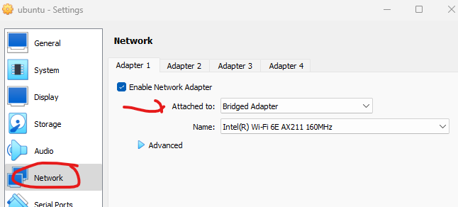

Start the machine and begin the installation.

Select English (or native language) for the language option. Then, select the type of installation. I selected the default Ubuntu Server.

Proceed to accept default settings. I selected to install the OpenSSH server because I thought it might be needed for secure file transfer.

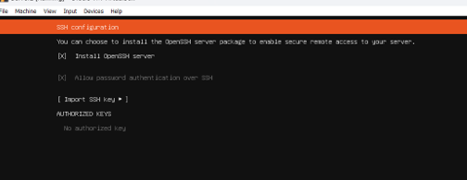

I did not install any snaps because I was unfamiliar with how to use them. When the installation completes, select ‘Reboot Now’ and then the machine was ready to be used.

**CentOS 9**

**Installation**

First, navigate to <https://www.centos.org/download/> and download the CentOS Stream to your computer. Next, open Virtual Box and select ‘New’ to create the new machine.

Name the virtual machine and select the CentOS ISO Image from the downloads folder. I chose to select the option to ‘Skip Unattended Installation.’

Accept the recommended defaults and select next until finished. Once the machine is created, navigate to the Network settings and make sure that ‘Enable Network Adapter’ is enabled. Select the ‘Bridged Adapter’ option.

Select English (or native language) for the language option and then ‘Done.’

Set a root password and then ‘Done.’

Select the installation destination and then ‘Done.’

Select ‘Begin Installation’

When complete, the machine will be ready for use.

**Network Connectivity and File Transfer**

To check network connectivity, I used the **ifconfig** command to display the network settings and make note of both virtual machine’s (VM’s) IP addresses. The **ifconfig** command did not work the first time. It had to be installed using the **sudo apt install net-tools command**.

(Note: I had originally named my VM Server2, but changed it to Ubuntu to better identify it. As shown in the CLI, some screenshots will have the former name. )

1.1 Ubuntu Server – ifconfig output

Figure 1.2 CentOS Server – ifconfig output

I wanted to use SCP (secure copy) to copy files and directories via the CLI. SCP uses the Secure Shell (SSH) protocol for authentication and encryption.

On the Ubuntu server, I made a directory called ‘documents’ using the **sudo mkdir** command. Next, I created a new text file for the ‘documents’ directory using the **touch** command. At first, I was unable to write to it using **nano** (a text editor), so I had to change the permissions. I used the command **chmod 666** with the filename to give read, write, and execute permissions to the owner, group, and others. I added basic text and saved the text to the file.

Figure 1.3 Sample text file open in nano  


Figure 1.4 Ubuntu Server – ls -l output showing original linux_server_file.txt permissions

Next, I used the **scp** command to transfer the file from the documents folder to the shared_dir folder. The command I used was **sudo scp linux_server_file.txt ~ /shared_dir/.** I could have also copied it directly, but wanted to test the functionality before attempting. The file transferred correctly.

Figure 1.5 Ubuntu Server – ls -l output showing the file in the shared_directory

The next test was to transfer a file from the Ubuntu machine to the CentOS machine. I had to install ssh on the CentOS machine as it wasn’t already there. I used the command **sudo yum install sshd**. Then, start it with **sudo systemctl start sshd** and enable it with **sudo systemctl enable sshd**.

Back in the Ubuntu machine, I used the scp command to transfer the file that I had created earlier to the home directory on the CentOS machine.

This is sample syntax for the scp command: **sudo scp ~/path/tofile remotehost@remotehostipaddress:~/path/todirectory**

I had to provide the CentOS’s password and then the file transferred.

Figure 1.6 Ubuntu Server – showing the scp transfer success

Figure 1.7 CentOS Server - showing the transferred file in the home directory

**References**

IBM. (2023, August 30). *ifconfig Command*. Www.ibm.com. https://www.ibm.com/docs/en/aix/7.2?topic=i-ifconfig-command

Kuppusamy, S. (2022, August 6). *CentOS Linux installation in VirtualBox - Selvaraj kuppusamy - Medium*. Medium; Medium. https://medium.com/@selvarajk/centos-linux-installation-in-virtualbox-719086f37e22

Linuxize. (2018, September 18). *How to Use SCP Command to Securely Transfer Files*. Linuxize.com; Linuxize. https://linuxize.com/post/how-to-use-scp-command-to-securely-transfer-files/

Tavares, P. (2021, January 7). *Installing and configuring CentOS 8 on Virtualbox [updated 2021] | Infosec*. Infosecinstitute.com. https://www.infosecinstitute.com/resources/general-security/installing-configuring-centos-7-virtualbox/

*In addition to the references above, I utilized the course resources and StackOverflow forums