IVR COLLEGE INFORMATION SYSTEM
A Mini Project Report Submitted to
NARAYANA ENGINEERING COLLEGE (AUTONOMOUS), NELLORE
(Affiliated to Jawaharlal Nehru Technological University, Anantapur, Ananthapuramu)

In partial fulfilment of the requirements for the award of Degree of
Bachelor of CSE – ARTIFICIAL INTELLIGENCE (CAI)

BY
K.MAHESH ( 24711A3127)

Under the guidance of
<< GUIDE NAME >>
<< DESIGNATION >>

DEPARTMENT OF CSE - ARTIFICIAL INTELLIGENCE (CAI)

October, 2026


CERTIFICATE

This is to certify that the mini project report entitled “IVR COLLEGE INFORMATION SYSTEM” submitted by K.MAHESH(24711A3127) of the Department of CSE – Artificial Intelligence (CAI), Narayana Engineering College (Autonomous), Nellore, is a bona fide record of the work carried out by them under my guidance and supervision during the academic year 2026-2027

Signature of the Guide Signature of the HOD
GUIDE NAME Dr. C. Rama Mohan _{M.Tech., Ph.D.}
Designation Professor & HOD
Department of CSE-AI (CAI) Department of CSE-AI (CAI)
Narayana Engineering College Narayana Engineering College
Nellore- 524004 Nellore- 524004

VISION OF INSTITUTION
To be one of the nation’s premier Institutions for Technical and Management Education and a key contributor for Technological and Socio-economic Development of the Nation.

MISSION OF INSTITUTION
Requirements & actions are identified to achieve the vision
 | M1 | To produce technically competent Engineers and Managers by maintaining high academic standards, world class infrastructure and core instructions.
 | M2 | To enhance innovative skills and multidisciplinary approach of students through well experienced faculty and industry interactions.
 | M3 | To inculcate global perspective and attitude of students to face real world challenges by developing leadership qualities, lifelong learning abilities and ethical values.

VISION OF DEPARTMENT
To empower students to become AI professionals, driving industry innovation to meet the needs of Industry and society through cutting-edge technologies along with research and consultancy, lifelong learning, leadership qualities and ethics.

MISSION OF DEPARTMENT
Requirements & actions are identified to achieve the vision
M1 | To establish a solid foundation by quality technical education in Artificial Intelligence and effectively teaching Learning process to make self sufficient individuals.
M2 | To develop resilient professionals by inculcating problem solving skills to create applications for industry innovation.
M3 | To cultivate professional behavior with ethical values, leadership and lifelong learning that have a positive impact on society through value based education.
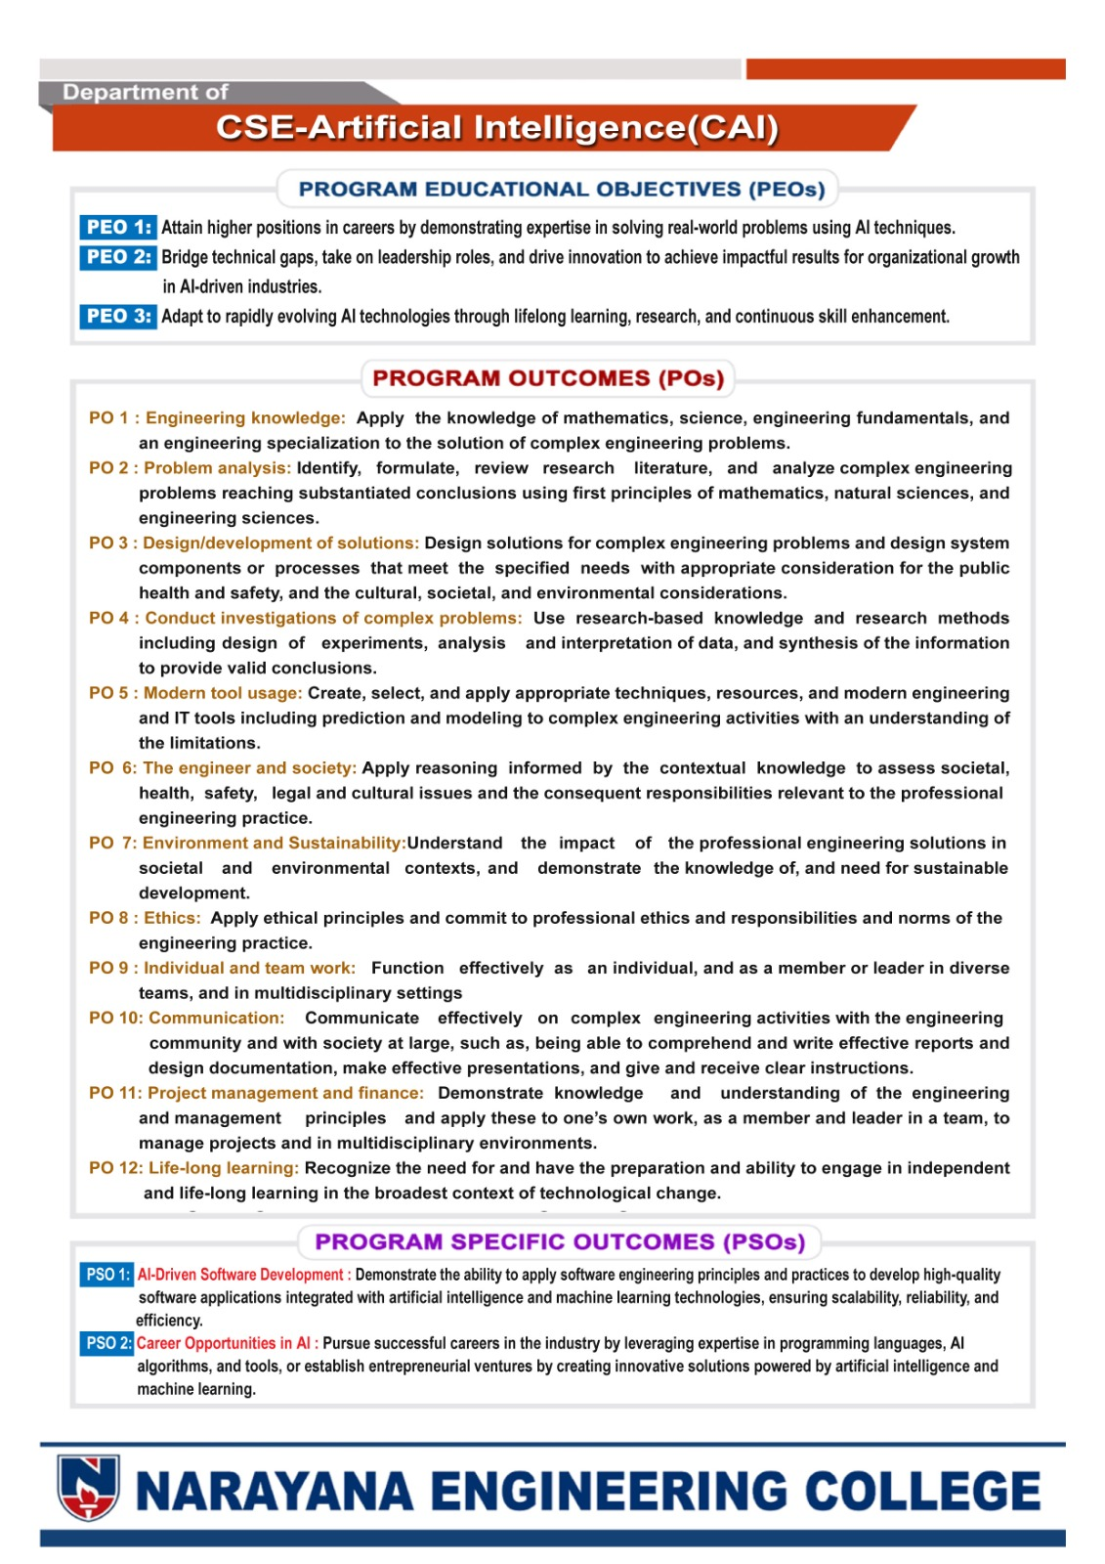

ACKNOWLEDGEMENT
I express my sincere gratitude to my Mini Project Guide, <<Mr. AAAAAA>>, <<Qualification>>, <<Designation>>, Department of CSE-AI, Narayana Engineering College, Nellore, for his guidance, valuable suggestions, and constant support throughout mini project.
I extend my heartfelt thanks to <<Mr. X. XXXXXX>>, << Qualification.>>, <<Designation>> Mini Project Coordinator, Department of CSE-AI, Narayana Engineering College, Nellore, for her valuable suggestions, constructive feedback, and support during the development of this mini project.
I am deeply grateful to Dr. C. Rama Mohan, M.Tech., Ph.D., Professor & HoD, Department of CSE-AI, Narayana Engineering College, Nellore, for his continuous support, motivation, and encouragement throughout the project.
I sincerely thank our Principal, Dr. V. Ravi Prasad, M.Tech., Ph.D., Narayana Engineering College, Nellore, for providing the necessary facilities and academic environment required for the successful completion of this mini project.
I am thankful to our Director, Dr. B. Dattatraya Sarma, Narayana Engineering and Pharmacy Colleges, for his valuable encouragement and support.
I am extremely grateful to Sri V. Vijaya Bhaskar Reddy, General Manager, Narayana Educational Institutions, Andhra Pradesh, for providing invaluable & right environment for our academic activities.
I am extremely grateful to Mr. K. Puneet, President, Narayana Educational Institutions, India, for his valuable coordination and encouragement.
I am profoundly grateful to Dr. P. Narayana, Ph.D., Founder, Narayana Educational Institutions, India, for his constant support and encouragement.
I gratefully acknowledge the teaching and non-teaching staff of the Department of CSE & Allied for their assistance and cooperation during the completion of this mini project.
Finally, I express my heartfelt gratitude to my parents for their constant support, encouragement, and motivation throughout the successful completion of this mini project.

With regards,
C. XXXXXXX
(23711A0XXX)

DECLARATION

We hereby declare that the project entitled IVR COLLEGE INFORMATION SYSTEM has been done by us under the guidance of <<GUIDE NAME>>, <<Designation>>, Department of CSE-AI (CAI). This Project work has been submitted to NARAYANA ENGINEERING COLLEGE, NELLORE as a part of partial fulfilment of the requirements for the award of degree of CSE – AI (CAI).
We also declare that this project report has not been submitted at any time to another institute or University for the award of any degree.

Project Associate’s
NAME 1 (Role Number)

Place: NELLORE
Date:

ABSTRACT

The IVR College Information System is a browser-based portal intended to give students, parents and college staff one place to access academic information and common institutional services. The supplied project contains a React single-page application with role-aware navigation, student and parent screens for attendance, results, timetable, fees, examination schedules, notices and college information, and a separate administrative interface for records and IVR configuration. A browser voice layer combines speech synthesis, speech input where supported, and a rule-based query handler; a visual keypad simulates menu-based IVR navigation. The source also includes a Supabase integration for student and department records, along with local demonstration data for the other portal modules. This report describes the system from the supplied source archive and distinguishes implemented interface behavior from live services that are not yet connected. In particular, the project notes state that student and parent academic data remain in browser-side demo stores, bulk CSV upload validates rows without saving them, and the Supabase setup has not been tested against a live project. The result is a useful prototype for exploring a unified, voice-enabled college portal, with further authentication, data integration, security review and deployment testing required before it can be used with real student records.
Keywords: IVR College Information System, student portal, parent portal, voice assistant, speech synthesis, speech recognition, role-based access, Supabase, React, college administration.

INDEX

S. No. | CONTENT | PAGE NUMBER
 | LIST OF FIGURES
 | ABSTRACT
 | CONTENTS
 | LIST OF TABLES
 | LIST OF ABBREVIATIONS
1 | INTRODUCTION
2 | LITERATURE REVIEW
3 | METHODOLOGY
4 | IMPLEMENTATION
5 | TESTING & DEPLOYMENT
A | SOURCE FILE GUIDE
6 | RESULTS AND DISCUSSION
7 | CONCLUSION AND FUTURE SCOPE
 | REFERENCES

LIST OF FIGURES

Figure | Title | Section
Figure 3.1 | Overall System Architecture | 3.4
Figure 3.2 | Role-Aware Navigation by User Type | 3.7
Figure 4.1 | Academic Calendar Image in Project Assets | 4.2
Figure 4.2 | Timetable Image in Project Assets | 4.2
Figure 4.3 | Speech Query and Response Flow | 4.3
Figure 4.4 | CSV Validation Flow and Save Boundary | 4.5

LIST OF TABLES

Table No. | Table Title | SECTION
Table P.1 | Project Snapshot | Abstract
Table 1.1 | User Roles and Main Tasks | 1.5
Table 2.1 | Existing Approach and Portal Response | 2.5
Table 3.1 | Functional Requirements and Evidence | 3.2
Table 3.2 | Main Technology Stack | 3.5
Table 3.3 | Data Persistence Map | 3.6
Table 3.4 | Request Types and Current Data Sources | 3.4
Table 4.1 | Implemented Feature Groups and Boundaries | 4.6
Table 4.2 | Common User Task Walkthrough | 4.7
Table 5.1 | Verification Plan | 5.2
Table 5.2 | Suggested Manual Verification Cases | 5.5
Table 6.1 | Current Prototype Readiness Snapshot | 6.7
Table 7.1 | Recommended Delivery Roadmap | 7.3
Table A.1 | Project Files Reviewed for This Report | Appendix A

LIST OF ABBRAVATIONS

Abbreviation | Full Form
API | Application Programming Interface
CSV | Comma-Separated Values
CRUD | Create, Read, Update and Delete
DB | Database
DTMF | Dual-Tone Multi-Frequency
HOD | Head of Department
HTML | HyperText Markup Language
IVR | Interactive Voice Response
PWA | Progressive Web Application
RLS | Row Level Security
SPA | Single-Page Application
STT | Speech to Text
TTS | Text to Speech
UI | User Interface
URL | Uniform Resource Locator

1. INTRODUCTION

1.1 Background
Colleges publish information through several channels: student portals, department notices, office counters, printed timetables and direct phone enquiries. When information is spread across separate systems, students and families may need to repeat searches or contact staff for routine questions. A single portal can make common records easier to find and give administrators a consistent place to maintain selected institutional data.
The supplied project, titled IVR – College Information System, is a web application with a mobile-oriented student and parent experience and a separate administration console. It combines ordinary screen-based navigation with voice narration, speech input and an on-screen keypad that demonstrates an IVR menu. Its purpose is to prototype access to academic information and college services through a common interface.
1.2 Problem Statement
The system addresses the difficulty of locating routine academic information through a fragmented set of communication channels. Students and parents need convenient access to attendance, results, fees, examinations, schedules, announcements and college information. Staff also need tools to maintain selected student and department records. The project brings these tasks into one application, but the current archive mixes functioning user-interface flows with demonstration data and partially connected persistence. The central engineering problem is therefore to provide a usable unified interface while making clear which records are authoritative, how each role is authenticated, and which operations are actually saved.
1.3 Objectives
The project objectives, inferred from the modules present in the source, are to:
• Provide student and parent views for commonly requested academic information.
• Provide administrative screens for student, department, teacher, HOD, notice and IVR-related management.
• Offer voice narration and selected speech-query flows, with a visual waveform and keypad-based IVR simulation.
• Use role-aware routes to separate student and parent pages from staff administration pages.
• Demonstrate persistent student and department records through an optional Supabase connection.
• Document current prototype limits and identify work required before production use.
1.4 Scope
The report covers the React/Vite source and bundled web build included in the supplied archive. It describes the user interface, routes, local state, voice services, selected Supabase operations, and the testing and deployment steps described by the project files. It does not claim that a hosted website, telephone gateway, production database, or real institutional student dataset was tested. The bundled records are demonstration content and must not be treated as official academic records.
1.5 User Roles
The application defines student, parent, administrator and head-of-department experiences. The route guard is implemented in the client application. The separate database schema currently models only departments and students and grants database access to signed-in admin-role users; it does not yet provide database-backed student or parent authentication or database-enforced department-level HOD access.

Table 1.1: User Roles and Main Tasks
Role | Main screens or tasks | Current data basis
Student | Dashboard, attendance, results, timetable, fees, examinations, notices, profile and voice assistance | Browser demonstration data; student portal is not connected to Supabase
Parent | Read-oriented access to the linked student's academic and institutional information | Browser demonstration data
Administrator | Student and department records, faculty/HOD screens, notices, reports, upload and IVR configuration | Student and department CRUD can use Supabase; several other modules remain local demo data
HOD | Staff-facing screens intended to show department context | Department scoping is described as UI-only in the project notes

1.6 Report Organization
Chapter 2 reviews the system context and relevant web and voice technologies. Chapter 3 describes requirements, architecture, data flow and the development approach. Chapter 4 explains the main implementation modules. Chapter 5 records a verification plan and the deployment procedure supported by the archive. Chapter 6 discusses what can be concluded from the source review and the prototype's current constraints. Chapter 7 summarizes the work and lists the next steps.

2. LITERATURE REVIEW

2.1 College Information Systems
A college information system brings academic and administrative information into a consistent service layer. Common portal functions include attendance, grades, fee status, schedules, notices and student profiles. The project follows this pattern by grouping related tasks into pages and role-based navigation. A unified interface can reduce navigation between separate tools, but its usefulness depends on timely, accurate source records and clear ownership of changes.
2.2 Responsive Web Applications
A browser application can serve phones and desktop screens without separate native clients. This project uses React components and Tailwind CSS utility classes, with responsive layout variants visible in the source. Its HTML includes a web-app manifest and a standalone display setting. The archive does not show a service worker or a tested offline cache, so installability and offline operation are not assumed in this report. Vite supplies the development server and production build process recorded in the project configuration [2], while React provides the component model used by the interface [1].
2.3 Voice Interaction and IVR
Voice features can complement screen controls for users who prefer spoken prompts or need an alternative way to navigate. The Web Speech API separates speech synthesis from speech recognition, and browser or device support may vary [3]. The project uses browser speech synthesis for narration and a browser speech-recognition interface for voice input. The query service is a local rule-based handler that matches selected phrases to academic modules and returns prepared responses; it is not a connection to a remote generative-AI service. A keypad screen demonstrates menu selection in software and should be described as an IVR simulator rather than a live telephone system.
2.4 Access Control and Data Protection
Role-aware interfaces are useful only when access rules are enforced at the data boundary as well as in navigation. Supabase documents Row Level Security as a database policy layer for deciding which rows a caller may access [4]. The supplied SQL schema enables RLS for the departments and students tables and defines admin-role policies. The project's own database notes identify remaining gaps: portal authentication and most module data are local, and HOD department scoping is only reflected in the interface. This report therefore treats the route guard as a prototype control, not a complete security boundary.

2.5 Existing Approach and Proposed Portal
The existing approach, as represented in the project brief, relies on separate pages or manual enquiries for different student services. The proposed portal groups those services under one role-aware application and adds spoken prompts and a keypad flow. The benefit is a unified demonstration; the main limitation is that a shared interface does not itself create an integrated system of record. Database coverage, identity verification and update persistence remain necessary for operational use.
Table 2.1: Existing Approach and Portal Response
Area | Typical fragmented process | Project response | Current boundary
Academic information | Separate enquiries or pages | Attendance, results, fees, schedule and exam screens | Demo data for student-facing modules
Notices | Multiple communication channels | Announcements and notifications pages | Local demonstration state
Voice access | Phone call or no voice option | Speech controls and a visual IVR menu | Browser voice APIs; no telephone trunk
Record administration | Separate staff lists | Admin student and department pages | Only these two record groups have Supabase CRUD described

2.6 Summary
The literature and platform documentation support the design choices at a general level: component-based interfaces, responsive layouts, browser speech APIs and database row policies are established tools. They do not prove that this project's screens have been usability-tested, that speech works on every device, or that a live database is configured correctly. Those questions require project-specific verification.

3. METHODOLOGY

3.1 Development Approach
The supplied source archive [6] shows a modular single-page application organized into page components, shared layout components, context providers and service modules. The source review for this report followed the routes from the application entry point, compared the displayed feature areas with their page and service files, and checked the project's database notes and SQL schema for persistence boundaries. No application tests or live Supabase requests were run while preparing this report.
3.2 Functional Requirements
The following requirements summarize the behaviors represented in the source. They describe intended interface behavior and do not imply that every feature has live institutional data behind it.
Table 3.1: Functional Requirements and Evidence
ID | Requirement | Evidence in supplied project
F1 | Students and parents can navigate academic information pages | Student dashboard and attendance, results, timetable, fee, exam, notice and profile routes
F2 | Users can hear selected information and submit voice queries where supported | Voice context, TTS service, speech-recognition service and query handler
F3 | Users can follow a menu using a screen keypad | IVR assistant page and dial-pad component
F4 | Staff can manage selected student and department records | Admin pages and Supabase service for students and departments
F5 | Staff can review other institutional administration screens | Teacher, HOD, announcements, reports, notifications and IVR pages
F6 | CSV rows can be reviewed before a bulk action | Parser and row validation; source explicitly says rows are not saved

3.3 Non-Functional Requirements
The code points to a responsive browser interface, reusable components, clear role-oriented navigation and readable voice prompts as design goals. Operational requirements still to be verified include protection of real student data, reliable authentication, keyboard and screen-reader accessibility, performance under a realistic data volume, browser compatibility, backup and recovery, and consistent behavior when the network or database is unavailable.
3.4 System Architecture and Data Flow
The application starts from a Vite entry point and renders a React tree containing theme, voice, application-state and authentication providers. A hash-based router selects a public, student/parent or administrative page. Pages call shared context and service functions. Most portal data is read from in-memory or browser-local demonstration stores; selected administrative student and department calls pass through the Supabase client. The returned values are rendered in the page or spoken through the browser's speech synthesis service.
A typical voice-query flow is: user action → speech recognition (if available) → local phrase matching → lookup in application state or demo data → text response and related page link → speech synthesis. A keypad flow skips recognition and maps a button press to a menu option. Both flows remain inside the web application; the source does not establish a connection to a public telephone network.
Figure 3.1: Overall System Architecture
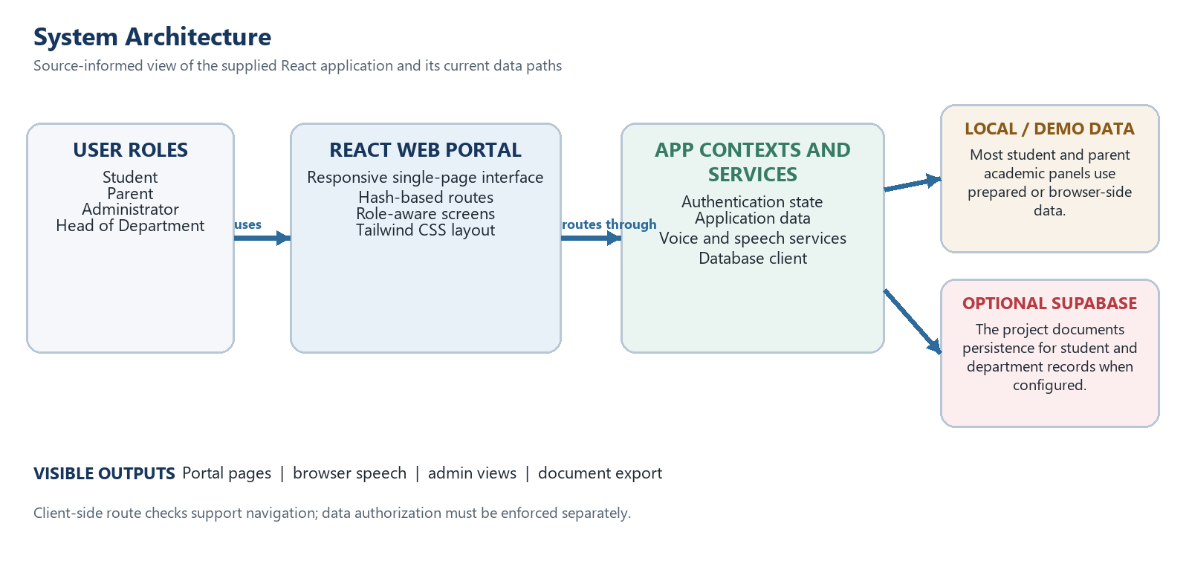

The supplied application runs its interface in the browser. React routes and contexts coordinate page state, authentication presentation and voice features. The archive documents an optional Supabase path for student and department records. Most student-facing academic screens remain backed by sample or local data, so the diagram separates those paths instead of suggesting that every screen shares one live database.
Table 3.4: Request Types and Current Data Sources
Request | Visible area | Current data or processing boundary
Attendance, results and fees | Student/parent portal screens | Prepared or local demo values; live synchronization is not established.
Timetable and exam schedule | Portal screens and packaged image assets | Static source content is present; current-term accuracy and dynamic database loading are not verified.
Student administration | Admin screens and Supabase client | Persistence is documented when configured; deployment and access rules need verification.
Department administration | Admin screens and Supabase client | Department records are in the documented database path; production policies need verification.
CSV bulk input | CSV validation interface | Rows are parsed and checked; the current flow does not save them to the live database.
Voice question | Browser speech and phrase handler | Known phrases trigger prepared responses or navigation; this is not generative AI.
3.5 Technology Stack
The versions below are read from the supplied package manifest. Browser-native APIs depend on the browser and device and are not npm package versions.
Table 3.2: Main Technology Stack
Technology | Version or source | Use in the project
React / React DOM | 18.2.0 | Component-based user interface and state
Vite | 5.1.6 | Development server and production build
React Router DOM | 6.22.3 | Hash-based client navigation and route guards
Tailwind CSS | 3.4.1 | Utility-based page styling and responsive layout
Supabase JS | 2.45.0 range | Optional client connection for student and department administration
Web Speech API | Browser native | Speech synthesis and speech recognition where supported
Recharts | 2.12.2 | Administrative visualizations
jsPDF / html2canvas | 2.5.1 / 1.4.1 | Client-side PDF generation helpers
Papa Parse | 5.4.1 | CSV parsing and preview
Lucide React | 0.344.0 | Interface icons

3.6 Data Organization and Persistence
The SQL schema defines departments and students tables. Department records include a code, name, contact fields, building, establishment year, IVR extension and status. Student records include identifiers, name, email, department, year, section, contact details and status. The schema applies RLS and policy rules for admin-role sessions. The student portal’s attendance, results, fee, timetable, notice and profile information is described in the project notes as browser-side demonstration data. Several administrative areas are also local demo state. The distinction is important: a visible edit in a demo screen must not be represented as a durable database update unless its service is confirmed to write to Supabase.
Table 3.3: Data Persistence Map
Data group | Current source in archive | Persistence status stated by project
Students | Supabase service plus demo fallback | Admin CRUD can persist when configured; student/parent portal data is not connected
Departments | Supabase service plus department presentation styles | Admin CRUD can persist when configured
Attendance, results, fees, timetable | Local mock stores and browser state | Not connected to Supabase
Teachers, HODs, notices, notifications, IVR logs | Local demonstration data | Not connected to Supabase
Bulk CSV rows | Parsed and validated in the browser | Validation only; import is not saved

3.7 Security and Privacy Considerations
The frontend uses environment variables for the Supabase URL and public client key, and the SQL policies require an authenticated admin role for the two exposed tables. The project notes also state that student and parent sign-in still uses local demo data, that a shortcut PIN remains in the demo authentication path, and that HOD scoping is UI-only. These weaknesses make the current build unsuitable for real student information. A production version should remove demo credentials and bypasses, authenticate every user through a trusted identity service, enforce least-privilege policies in the database, validate all inputs on the server-side boundary, avoid storing sensitive values in local storage, and test both allowed and denied access.
Figure 3.2: Role-Aware Navigation by User Type
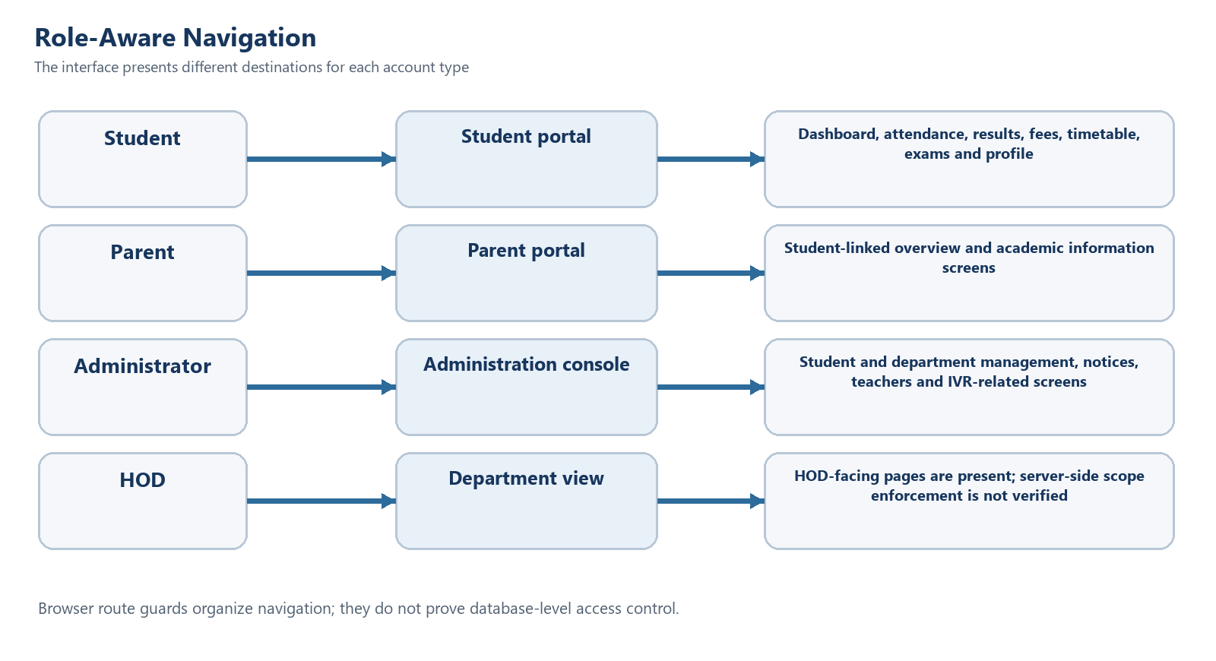
The route layout helps each account reach relevant screens. Since those checks run in client code, they are navigation controls. A real deployment must separately verify authentication, record ownership and role permissions at the database or server boundary. HOD pages are visible, but the supplied materials do not establish production enforcement of department-level scope.

4. IMPLEMENTATION

4.1 Application Startup and Navigation
The HTML entry page loads the React application, while Vite resolves the source modules and produces the bundled assets. The application wraps its routes in shared providers for theme, voice, application data and authentication. The router uses hash-based paths. Protected routes redirect unauthenticated users to the login page and send users to a page appropriate to their role. The route guard improves navigation clarity, but it executes in the browser and is not a substitute for backend authorization.
4.2 Student and Parent Portal
The student dashboard acts as a summary screen with links to attendance, results, timetable, fee status, announcements and voice search. Separate pages present subject attendance, semester results, fee components, examination schedules, college information, notifications and profile details. Login, first-time setup, forgotten PIN and PIN-change pages form the account interface. Parent routes are read-oriented and use a student record to show the associated information. The project's database notes classify these portal functions as local demo data rather than live database-connected services.
The archive includes two institutional image assets that make academic dates and weekly scheduling easier to scan. They are concrete examples of the information the portal is intended to organize. Their presence in the archive does not prove that every screen loads them dynamically or that the dates remain current for a later term.

Figure 4.1: Academic Calendar Image Included in the Project Assets
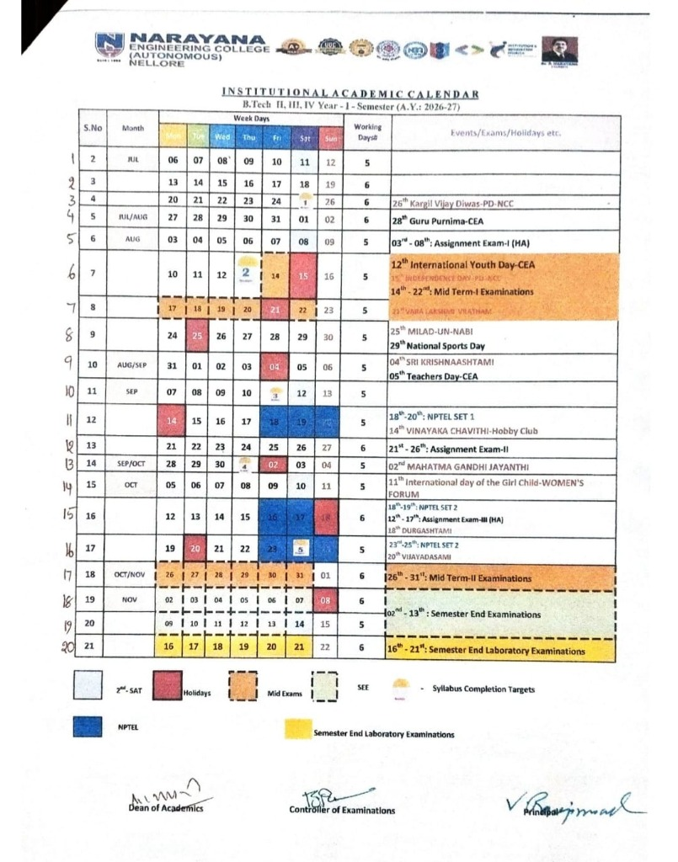
A calendar image lets readers locate examination periods, holidays and semester milestones at a glance. Before a live release, staff should replace it with the approved calendar for the active academic year and provide a text alternative for people who cannot read the image.
Figure 4.2: Timetable Image Included in the Project Assets
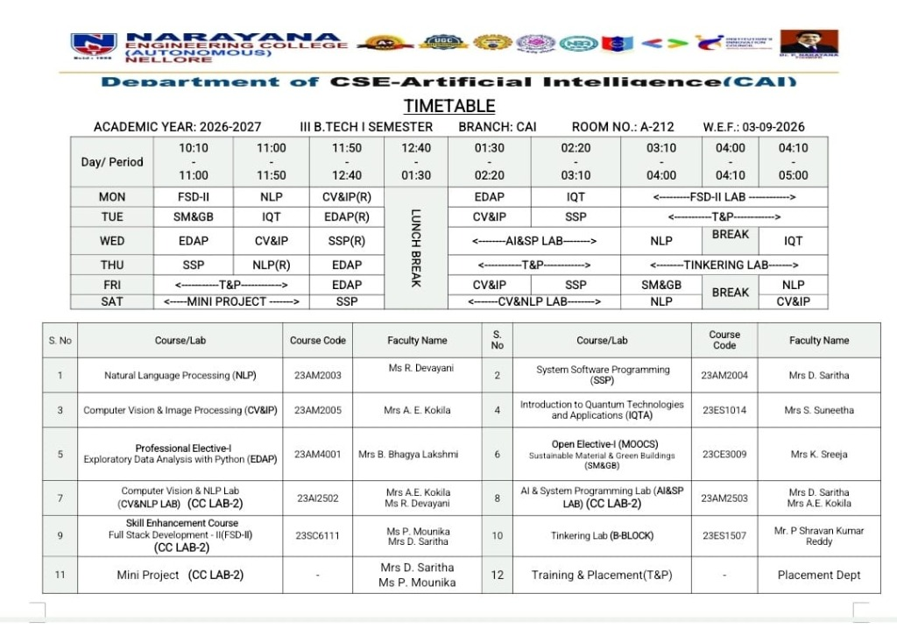
The timetable image places days and periods in a grid for quick lookup. A responsive page should also provide a text-based or mobile-friendly version so small-screen users and assistive technologies can read each class without zooming. Confirm the section and term before publication.
4.3 Voice Assistant and IVR Simulation
The voice context exposes speech status, selected voice, speech rate, transcript and start/stop controls. The speech-recognition module uses the browser's SpeechRecognition implementation when present and configures recognition for English (United States). The text-to-speech module selects an available voice for a requested language and includes code paths for English, Telugu and Hindi responses. Actual language quality depends on the voices installed on the device. The query handler checks for known topics such as attendance, results, examinations, timetable and fees and returns prepared responses with links to the related page. This is a deterministic, rule-based prototype; it does not call an external AI model.
The IVR assistant screen and dial pad model a menu interaction inside the browser. They help demonstrate how a caller might choose an information category, but the archive does not contain a verified telephony provider connection. Administrative call volumes and similar analytics are identified in the project notes as hard-coded demonstration values.
A request moves through speech recognition, phrase matching, data lookup and response. The source configures browser recognition for English (en-US), while prepared responses include selected English, Telugu and Hindi text. Browser support and microphone permissions vary, so a text and touch path remains necessary.
Figure 4.3: Speech Query and Response Flow
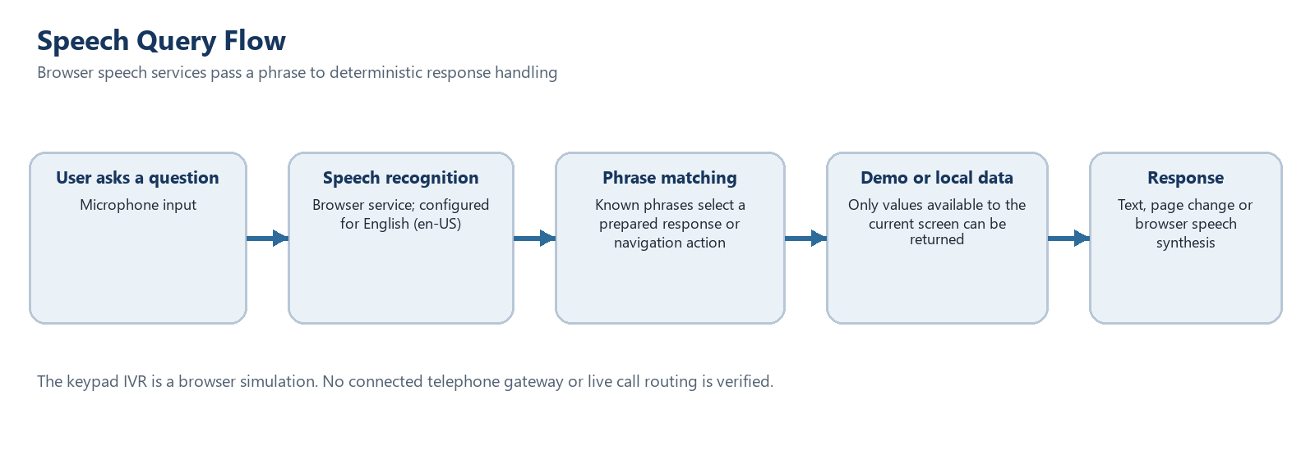
The keypad screen imitates a DTMF menu inside the web application. A real IVR also needs a telephone carrier or gateway, call-session handling, secure data access and monitoring; those integrations are not demonstrated by the archive.
4.4 Administrative Console
The administrative area contains pages for dashboard summaries, departments, teachers, students, HODs, user control, IVR configuration, reports, notifications, security schema, data upload and announcements. The service layer maps Supabase records into application objects and implements student insertion, update and deletion, along with department updates. According to the database notes, student directory and department data are the connected admin areas; other pages remain local demo data. Department counts can be derived from the connected student records when the database is configured.
4.5 CSV Validation and Document Export
The bulk-upload page parses CSV files and checks that each row has a roll-number field. It shows a preview and validation status, but the source explicitly labels the action as validation only and says the rows are not saved. The project also includes browser-side PDF helpers based on jsPDF and html2canvas. These helpers support exports from selected page elements or structured rows. The source contains an institutional label inside one PDF helper that differs from the college name used elsewhere; it should be corrected and the generated files reviewed before they are presented as official college documents.
The bulk-input screen should be understood as a validation aid. It checks the uploaded file and reports acceptable or problematic rows, giving an administrator a chance to correct formatting before a future import process is implemented.
Figure 4.4: CSV Validation Flow and Current Save Boundary
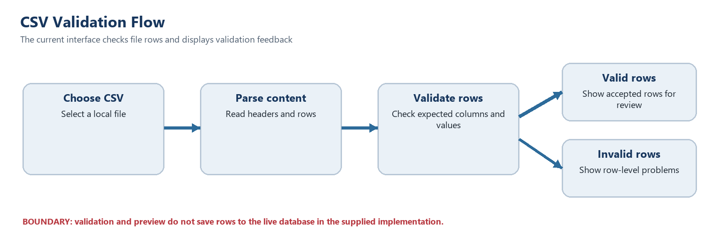
A production import should add confirmation, transaction handling, duplicate detection, rollback on failure, an audit record and a clear summary of saved versus rejected rows. Those are recommendations, not current capabilities.
4.6 Module Summary
The implementation separates student-facing features, administrative tools and shared voice services. The table below records the principal feature groups and the data status supported by the source archive.
Table 4.1: Implemented Feature Groups and Boundaries
Feature group | Examples in the interface | Evidence boundary
Student/parent portal | Attendance, results, fees, timetable, exams, announcements, profile | UI and demo data are present; live academic data integration is not stated
Voice services | TTS, speech input, phrase-based query answers, voice visualizer | Browser support and available voices vary; speech input is configured for English
IVR | On-screen keypad, menu choices and spoken prompts | Browser simulator; no live telephone trunk verified
Administration | Student and department directory, faculty/HOD and reporting screens | Only student and department CRUD is described as Supabase-connected
CSV/PDF utilities | CSV parse/preview and client-side PDF helpers | CSV import is validation-only; exported PDF identity needs review
4.7 Common Task Walkthrough
These short paths show how readers can approach common tasks. The expected results describe the available interface flow; they do not claim that every record comes from a live institutional database.
Table 4.2: Common User Task Walkthrough
Role | Task | Steps | What to keep in mind
Student | Check attendance | Sign in, open Attendance, choose the term or course if offered, then review displayed totals. | Confirm whether displayed values are connected or demonstration data.
Parent | Review academic updates | Open the parent experience, select the student context shown, then review notices, results or schedule information. | Use an authorized account and verify that the linked student is correct.
Administrator | Review a student record | Open administration, choose student management, search or select a record and review details. | Persistence depends on configured Supabase and verified role policies.
Administrator | Check a CSV file | Choose a CSV file, review parsed rows and validation messages, then correct errors. | Validation is not a completed database import.
Student or parent | Ask a voice question | Allow microphone access, speak a supported phrase, then read or listen to the matched response. | Browser permissions, language settings and phrase coverage affect results.

5. TESTING & DEPLOYMENT

5.1 Verification Status
This report is based on inspection of the supplied source archive and its project notes. No browser session, automated test suite, live database connection or deployment was run for this report. The archive contains a built web asset directory and package scripts for development, build, lint and preview. The README_DATABASE file explicitly says the Supabase setup has not been tested against a live project and provides a separate manual checklist. Accordingly, the cases below are a verification plan, not passed test results.
5.2 Test Plan
The following checks should be performed in a non-production environment with fictional records. Confirm both the expected allowed action and the appropriate denied or error behavior. Record actual results only after running each test.
Table 5.1: Verification Plan
Area | Check | Expected result | Status in this report
Routing | Open a protected page while signed out | Redirect to login; no protected data is shown | Not run
Student portal | Review attendance, results, fees and schedules | Displayed values match the approved test record | Not run; demo data only per project notes
Voice | Use microphone and text-to-speech on supported browsers | Clear fallback message when an API is unsupported; correct response when supported | Not run
IVR simulator | Choose each available keypad option | Correct screen state and spoken prompt for each option | Not run
Student CRUD | Create, edit, search and delete a fictional student | Valid changes persist after reload; invalid duplicates are rejected | Not run; requires live Supabase configuration
Department CRUD | Update a department and refresh | Permitted change persists and counts remain consistent | Not run; requires live Supabase configuration
RLS | Attempt data access without admin role | Database rejects access to protected rows | Not run
CSV | Upload valid and invalid files | Rows are parsed and validation errors are clear; no false saved status | Not run; source says import does not save rows
PDF export | Export sample attendance/result output | Readable file with correct institution identity and values | Not run
Responsive UI | Inspect narrow and wide viewports | Navigation and data remain readable without horizontal overflow | Not run

5.3 Deployment Procedure
For local development, the package manifest defines a Vite development command and the project configuration uses port 3000. The supplied database instructions describe creating a Supabase project, applying the schema and seed SQL, creating an admin identity, granting the admin application role, and setting the VITE_SUPABASE_URL and VITE_SUPABASE_ANON_KEY environment variables in a local environment file. The package also defines a production build and preview command. A deployment should use the public client key only, keep any privileged secret on a trusted server, and use database policies for every exposed table.
5.4 Readiness Conditions
Before deployment with real records, complete the project checklist against a live test database; replace demonstration authentication and records; connect academic and administrative modules to approved data sources; enforce role and department permissions in the database; verify exports; add regression tests; and conduct privacy, accessibility and security reviews. A static production bundle alone is not evidence that these conditions have been met.

6. RESULTS AND DISCUSSION

5.5 Suggested Manual Verification Walkthrough
These cases are a practical checklist for a demonstration or deployment review. They are proposed checks only; they were not executed against a running website for this report. Record the browser, device, data source and actual result when performing them.
Table 5.2: Suggested Manual Verification Cases
Case | Procedure | Expected evidence | Execution
Sign-in and role routing | Sign in with each approved test role; try direct URLs for other roles. | Only intended screens appear; direct route attempts are handled consistently. | Not run here
Student record lookup | Open attendance, results and fee pages using a known test record. | Values match an approved fixture and sample data is identified. | Not run here
Parent linkage | Use separate parent test accounts linked to different students. | Each account sees only its authorized student information. | Not run here
Voice permission | Test microphone allowed, denied and unavailable cases. | Voice works when allowed; text and touch fallback remains clear. | Not run here
Phrase handling | Try a supported phrase, unsupported query and low-confidence result. | Known phrases yield prepared answers; unsupported input gets a fallback. | Not run here
Keypad IVR | Select every menu option and invalid key in the browser simulation. | Clear feedback appears and the menu returns to a safe state. | Not run here
CSV validation | Try valid data, missing headers, blank cells and duplicate rows. | Errors identify row/field; previews are accurate; no save is implied. | Not run here
Supabase persistence | With an approved test project, add, edit and read student/department records. | Changes persist and are limited by tested role policies. | Not run here
Responsive layout | Review phone, tablet and desktop sizes with keyboard navigation. | Controls remain readable and operable without clipping. | Not run here
Export and print | Generate available PDF/document output and review branding and values. | The file opens and contains the correct institution and current information. | Not run here
6.1 Findings from the Source Review
The archive contains a broad user-interface prototype with separate student/parent and administration routes. It includes academic-information pages, a voice layer, a menu-style IVR screen, charts and utilities for CSV preview and PDF generation. The source also includes both source modules and a prebuilt distribution directory. These findings establish that a substantial interface and demonstration workflow are present; they do not establish runtime correctness or production readiness.
6.2 Functional Coverage
The strongest coverage is in the breadth of screens and shared navigation. Students and parents have entry points for common academic topics, and administrative users have a separate set of management pages. Voice output and prepared multilingual answer strings demonstrate an accessibility-oriented interaction path. However, speech recognition is configured for English in its service, while the multilingual behavior is concentrated in selected prepared responses. Browser speech support and installed voices can change what a user experiences.
6.3 Persistence and Data Quality
The project has a defined Supabase schema for students and departments and client methods for administrative CRUD on those records. Its database notes are candid that most other portal data remains local demonstration state and that the live connection is untested. The CSV upload screen similarly validates and previews data but does not save it. This split allows a prototype walkthrough, but it means data shown on different pages may not represent a single authoritative record.
6.4 Security and Operational Discussion
The route structure separates staff pages from student pages, and the SQL schema adds database row policies for selected tables. Yet client-side route guards cannot secure records by themselves. The project's own notes flag the demo student login shortcut and UI-only HOD scoping. The current authentication and persistence design must therefore remain limited to fictional demonstration data. Any real deployment needs server-verified identities, database-enforced least privilege, safe handling of credentials and audit-ready tests.
6.5 Limitations
The source review found no evidence of an operational telephone connection, production database for the student portal, persisted bulk import, external validation dataset, or completed test run. The IVR metrics are partly demonstration values, and one PDF helper contains an institution name inconsistent with the college-branded portal. The project archive does not prove offline behavior despite including a web-app manifest. These limits are implementation boundaries, not measured failures in a live deployment.
6.6 Overall Discussion
The project is best understood as a feature-rich academic portal prototype. Its value is the joined interaction model: students can browse a range of services, staff can inspect administrative flows, and voice controls demonstrate an additional access path. Its next stage is data and identity integration. Treating the local demo as a working institutional system would overstate what the archive supports.

7. CONCLUSION AND FUTURE SCOPE

6.7 Prototype Readiness Snapshot
This summary separates features visible in the source from persistence and integrations that still require verification. It can serve as a quick guide during a project presentation.
Table 6.1: Current Prototype Readiness Snapshot
Area | Evidence in the archive | Readiness implication
Student and parent pages | Present in supplied source | Useful interface to demonstrate; confirm source and freshness of displayed data.
Administration screens | Present in supplied source | CRUD and list views exist; test actions on authorized non-production data.
Student and department persistence | Optional Supabase route documented | Connection, schema, environment and permissions need verification in deployment.
CSV bulk persistence | Not established | The current flow validates and previews; database import remains future work.
Voice query | Browser speech and deterministic matching | Permissions, browser support and phrase coverage affect results.
Telephone IVR | Web keypad simulation only | A connected phone gateway or live call workflow is not verified.
Production security | Not established by source review | Replace demo credentials, enforce server/database policies and review data protection.
7.1 Conclusion
The IVR College Information System brings student services, administrative screens and browser-based voice interaction into one React application. The supplied code includes navigation for attendance, results, fees, schedules, notices and college information, together with an administrative console and selected Supabase CRUD functions. The report's source-based assessment also identifies clear boundaries: most student and parent data is demonstrative, CSV upload does not persist rows, the voice query engine is rule-based, the keypad is a simulator, and the live Supabase setup is untested. The project is therefore a useful prototype, while real institutional use depends on completing identity, persistence, security and verification work.
7.2 Future Scope
The following work is recommended in priority order:
• Replace demo student and parent authentication with a verified identity flow and remove all bypasses and sample credentials from production builds.
• Connect attendance, results, fees, timetable, announcements and profile data to approved backend services, with role-specific database policies and audit trails.
• Replace UI-only department scoping with database-enforced HOD access and test both allowed and denied operations.
• Implement transactional CSV import with preview, validation, duplicate handling, error reporting and a rollback or correction path.
• Integrate a real telephony provider only if required, then test call routing, consent, accessibility and failure handling; otherwise label the feature consistently as an IVR simulator.
• Correct the institutional identity in generated PDFs and verify exported documents against approved formats.
• Add automated component, route, service and database-policy tests; test supported browsers, speech permissions, language availability and responsive layouts.
• Review accessibility with keyboard and screen-reader use, provide text alternatives to voice controls and document supported language behavior.
• Add and verify offline caching only if the project intends to support an installable offline-capable PWA.
Table 7.1: Recommended Delivery Roadmap
Phase | Work | Completion evidence
1. Confirm information | Approve academic data, terms, role ownership and source-of-truth records. | Approved calendar, timetable, fees and notices for a named term.
2. Secure access | Replace demo login paths; define student links; enforce roles and row-level access on the server/database. | Positive and negative access tests for student, parent, admin and HOD roles.
3. Complete data workflows | Implement tested CRUD and transactional CSV import with duplicate and error handling. | Audit trail, import report and rollback evidence on test data.
4. Improve voice and IVR | Keep touch/text alternatives; test language support; add telephony only if calls are required. | Browser compatibility checks and, if in scope, a tested end-to-end call.
5. Prepare deployment | Use HTTPS, protected secrets, backups, monitoring and an agreed support process. | Release checklist, restore evidence and a named operational owner.
The phases below turn the prototype into a safer and more dependable college service. Each phase should be accepted only after its data, access and usability checks are demonstrated.
7.3 Recommended Delivery Roadmap
7.4 Closing Note
A staged delivery is appropriate: first secure authentication and connect authoritative data, then verify the complete application in a controlled environment, and only after those checks consider use with real student records.

REFERENCES
[1] React, “Quick Start,” React Documentation. https://react.dev/learn (accessed 12 October 2026).
[2] Vite, “Getting Started,” Vite Documentation. https://vite.dev/guide/ (accessed 12 October 2026).
[3] MDN Web Docs, “Web Speech API,” Mozilla. https://developer.mozilla.org/en-US/docs/Web/API/Web_Speech_API (accessed 12 October 2026).
[4] Supabase, “Row Level Security,” Supabase Documentation. https://supabase.com/docs/guides/database/postgres/row-level-security (accessed 12 October 2026).
[5] Tailwind CSS, “Responsive Design,” Tailwind CSS Documentation. https://tailwindcss.com/docs/responsive-design (accessed 12 October 2026).
[6] Supplied project archive, 5.zip: yana/src, yana/supabase, yana/package.json, yana/README_DATABASE.md and bundled distribution files. Source artifact supplied by the user.

APPENDIX A SOURCE FILE GUIDE

Table A.1: Project Files Reviewed for This Report
Path or files | Area | How it informs this report
package.json; vite.config.js | Build setup | Identifies the frontend toolchain and build configuration.
src/App.jsx; src/main.jsx | Application entry and routes | Shows startup, route composition and page structure.
src/context/AuthContext.jsx | Authentication presentation | Contains browser account and role state; demo behavior is not production authentication.
src/context/AppContext.jsx; src/services/mockData.js | Application data | Helps distinguish prepared portal values from database-backed records.
src/context/VoiceContext.jsx; src/services/speechRecognition.js; src/services/ttsService.js | Voice interaction | Shows recognition, phrase handling and text-to-speech behavior.
src/services/supabaseClient.js; supabase/schema.sql; README_DATABASE.md | Optional persistence | Documents the Supabase client and the stated setup and scope limits.
src/pages/*; src/services/ivrAdminData.js | Portal and admin features | Supports the feature groups discussed in Chapters 1 and 4.
public/academic_calendar.jpg; public/timetable.jpg; public/narayana_logo.png | Static visual assets | Images extracted from the supplied archive and reused in this report.

