Industry Surveys Database System
MAR-SCI-611AA

USER Guide

Prepared for

The Department of Fisheries and Oceans Canada
Scotia Fundy Region International Observer Program
Marine Fish Division – Bedford Institute of Oceanography
Sciences Branch, Maritimes Region

Version 1.13 as of 18 September 2001

Section 1 System Set-Up 3
System Requirements 3
1.1 Using the ISDB application 3
1.2 Startup 4
Logging into the System 4
Section 2 Tables Included in the Database 5
2.1 Look-up tables 5
2.2 Edit Tables 5
2.3 Error Tables 5
2.4 Production Tables 5
2.5 Security Tables 5
Section 3 - Industry Surveys Database Form 6
3.1 Trips 9
3.1.1 Trips - Validate Data 12
3.1.2 Trips – Load Data 12
3.1.3 Trips – Report Screen 13
3.2 Gear 14
3.3 Gear Features 16
3.4 Fish Sets 18
3.5 Set Profile 21
3.6 Catches 24
3.7 Samples 27
3.8 Fish Lengths 30
3.9 Fish 33
3.10 Fish Stomach Analysis 36
3.11 Fish Morphs 39
3.12 Fish Prey 41
3.13 Privileges ……………………………………………………………………………………………..43
Section 4 Account Setup 44
4.1 Setup of Client Account 44
4.1.1 Oracle Setup 44
4.1.2 UNIX Setup 46
4.2 Setup of Production Account 46
4.2.1 Oracle Setup 46
4.2.2 UNIX Setup 48
4.3 Installing Updated source code 48

Section 1 System Set-Up

System Requirements
The Industry Surveys Database System application requires the following, as a minimum:
- An Oracle account on CANSO2 with access to the OBSERVER system account on CANSO2. For individuals performing data loads a Unix account is also required.
- 486 PC as a mininum; Pentium PC is recommended; minimum speed: 133 MHz.
- Deployment through SMS of the application to the individual’s PC, as a Regional Application (SMS).
- SQL*Plus 3.3 for Windows (available with Regional SMS deployment).

1.1 Using the ISDB application

Database Setup
The renovated system production data will reside in the OBSERVER Oracle account on CANSO2. Edit Tables will reside in Personal Oracle accounts on CANSO2. The database schema for the renovated system is installed on the OBSERVER account. The schema contains changes in the table definitions required for Y2K readiness.

1.2 Startup
After installing the application, start the application by performing the following:

- Select the application from the Windows Start Menu by selection Start – Programs – Regional Applications (SMS) – ISDB. The application will present the Oracle database login dialog.
- Enter an appropriate username and password. Enter bank2 as the database.
- The application starts by presenting the Trips screen. This confirms successful startup of the application.
- The application automatically performs a query to retrieve the first set of trip records.

Logging into the System
The application is started by using the Windows 95 Start Menu to select the application. Starting the application brings up the Oracle Forms Logon screen.

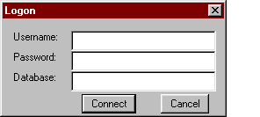Figure 1.1 The Oracle Forms Logon Screen

Enter the username and password for the OBSERVER Oracle account. Enter bank2 in the Database field. Click Connect to connect to Oracle and start the application.

Section 2 Tables Included in the Database

2.1 Look-up tables

ISAGERCODES
ISAREADEFS
ISBOTTOMCODES
ISCOMMAREAS
ISCOUNTRYCODES
ISCOUNTRYGEARSPECIES
ISEEZAREAS
ISERRORCODES
ISGEARCODES
ISGEARFEATURECLASSES
ISGEARFEATURECODES
ISHAULCOMMENTCODES
ISHYDROCODES
ISMATURITYCODES
ISMORPHCODES
ISMORPHVALUECODES
ISNAFOAREAS
ISOBSERVERCODES
ISOPERATIONCODES
ISPOINTCODES
ISPRODUCTIONCODES
ISRESAREAS
ISSETTYPECODES
ISSEXCODES
ISSPECIESCODES
ISSPECIESSOUGHTCODES
ISSTARTLENGTHVALUES
ISSTMCNTNTCNDCODES
ISSTMITEMCLASSES
ISSTMITEMCODES
ISSTRATA
ISTECHNICIANCODES
ISTONNAGECLASSCODES
ISTRIPTYPECODES
ISUSERPROFILES
ISVESSELOWNERGROUPS
ISVESSELS

2.2 Edit Tables

ISEDITCATCHES
ISEDITFISH
ISEDITFISHLENGTHS
ISEDITFISHMORPHS
ISEDITFISHPREY
ISEDITFISHSETS
ISEDITFISHSTMANALYSIS
ISEDITGEARFEATURES

ISEDITGEARS
ISEDITSAMPLES
ISEDITSETPROFILE
ISEDITTRIPS

2.3 Error Tables

ISEDITCATCHESERRORS
ISEDITFISHERRORS
ISEDITFISHLENGTHSERRORS
ISEDITFISHMORPHSERRORS
ISEDITFISHPREYERRORS
ISEDITFISHSETSERRORS
ISEDITFISHSTMANALYSISERRORS
ISEDITGEARFEATURESERRORS
ISEDITGEARSERRORS
ISEDITSAMPLESERRORS
ISEDITSETPROFILEERRORS
ISEDITTRIPSERRORS

2.4 Production Tables

ISCATCHES
ISFISH
ISFISHLENGTHS
ISFISHMORPHS
ISFISHPREY
ISFISHSETS
ISFISHSTMANALYSIS
ISGEARFEATURES
ISGEARS
ISSAMPLES
ISSETPROFILE
ISTRIPS

2.5 Security Tables

ISUSERPROFILES
ISEDITCATCHESAUDIT
ISEDITFISHAUDIT
ISEDITFISHLENGTHSAUDIT
ISEDITFISHMORPHSAUDIT
ISEDITFISHPREYAUDIT
ISEDITFISHSETSAUDIT
ISEDITFISHSTMANALYSISAUDIT
ISEDITGEARFEATURESAUDIT
ISEDITGEARSAUDIT
ISEDITSAMPLESAUDIT
ISEDITSETPROFILEAUDIT
ISEDITTRIPSAUDIT

Section 3 - Industry Surveys Database Form

This section discusses the Oracle Forms user interface of the Industry Surveys Database System.

Each edit table of ISDB may be accessed through its own, independent screen, each of which may be navigated to from the central Trips screen. Navigating through the system by using the structure of the data model, each screen may called from the other in the following manner:

Gear Features

Gears

Transfer From Production

Data Validation and Transfer
Trips
Set Profile Fish Lengths

Fish Sets Samples

Catches Fish Morphologies

Fish Fish Prey

Fish Stomach Analysis

Each screen corresponding with an edit table is nearly identical in functionality and requires identical actions to perform Insertion, Updating and Deletion of records, as well as for navigating through records and between screens.

Common Components within the ISDB system

ToolBar

The ISDB system has a common ToolBar interface which is used to perform database functions and navigate between screens. The functionality of each button is described in the context of each screen; however, the ToolBar also has common behaviours which will be described here.

A typical ISDB ToolBar appears as follows:

Each button is enabled only on an as-needed basis. Thus, if a button is disabled, the functionality available from it is not available at that time. The Expert button enables and disables the editing of fields which the user technically should not be able to alter (as they are part of the record’s unique identifier) but which they may need to be changed due to an error in the raw data received from an Observer. Since only some screens require this functionality, the Expert button will be found disabled where not required. When clicked, the Expert button’s label changes to ‘Standard’ and clicking the button again will re-disable the primary key fields made available through Expert mode. Fields accessible through Expert mode are noted as being ‘expert-only editable’ in this document.

The Show Errors button will call the Errors screen and the label will change to ‘Hide Errors’. Clicking this button a second time will hide the Errors screen and change the button’s label back to ‘Show Errors’.

Some toolbars also have buttons (appearing on a second row) which permit the user to navigate to different screens. If enabled, clicking the button will bring the user to the screen named on the button’s label.

Errors Screen

Each system screen has a corresponding errors screen which displays all errors and warnings which have been registered for the currently displayed record. This screen may be moved to any location on Forms screen to suit the user’s preferences. As the Errors screen ‘floats’ within the ISDB environment without affecting other screens, it is possible to ‘hide’ it behind other screens. If this occurs, simply press the Show Errors button (described above) again and the window will be brought to the front of all active screens.

A typical Errors Screen appears as follows:

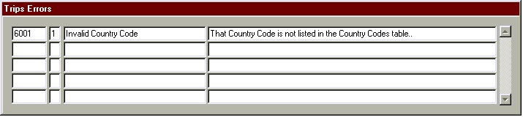

The errors are listed in order of their priority, with genuine errors followed by warnings, and sorted by the Error Code. Each Errors screen has the following columns, listed left to right: an Error Code to assist in identifying the error; an Error Priority to indicate its severity (5 indicates a warning, 1 indicates a genuine error); an Error Cause, to quickly highlight where the problem is occuring; and an Error Description, to describe the problem and indicate how it might be resolved. A scroll bar to the right enables the user to scan through all errors found, should there be more than five for the current record.

Display Items

Each ISDB screen uses a variety of data fields and other display tools to present the system data to the user for display or editing. The various types of display items are as follows:

Display Only Field – This field only permits the user to observe the data shown. Values in a Display Only Field can never be edited by the user.

Editable Field – This field displays the data currently held within the ISDB system and permits the user to change the value. Changes will be saved once the user clicks the Update or Insert buttons, as indicated on the individual screen descriptions (below).

Expert-Only Editable Field – As with the Editable field, the data held in an Expert-Only Editable Field can be changed by the user. However, the user must first click the ‘Expert’ button before this is permitted. In normal operations, Expert-Only Editable Fields appear as Display Only fields and the data within cannot be changed.

Checkbox – This data item displays a Yes or No value. It is editable by the user and if the box is checked , it indicates a positive value (Yes, True, 1, etc.) and if not checked, indicates a negative value (No, False, 0, etc.) for this record.

LOV Button – List Of Value (LOV) buttons appear beside each Editable and Expert-Only Editable field which permits user entry AND is validated against a code table in the ISDB database. When clicked, this button will bring up a list box from which the user can select all valid values available to the corresponding data field.

Table Window – Each system screen displays a table window at the bottom third of the visible screen. This window lists all records available for selection and gives a quick summary of the data held in each, as well as a sum of the errors and warnings which are currently registered against that record. When a row of the table is clicked, the record displayed in that row of the Table Window is brought forward to be displayed on the user’s screen, where they can then examine the record in more detail and modify it as they see fit.

Normally the records displayed on a screen are linked to those from the previous parent screen. For example when the Fish Morphs screen is displayed only the fish morphs belonging to the current fish from the parent Fish screen are shown.

In some cases the user may wish to see all of the records for the current trip on a given screen. This can be useful in locating orphaned records and dealing with all of the records at a given level without repeatedly having to navigate up and down between the parent screen and the child screen. This can be invoked by navigating to the group of records in the table window and pressing the F8 key. This will select all of the records for the current trip into the table window.

Normally when using the scrollbar in the table window, records are retrieved in groups of five. When dealing with large record sets the user can retrieve the entire set from the database into the table window by navigating to the table window and pressing the Page Down key.

The user also has the ability to run ad hoc queries from the Trips and Vessels screens. This is done by placing the cursor in the multi-row block at the bottom of the screen and pressing the F7 key. The multi-row block is cleared and the user is able to type in an expression in the first line of the block indicating which records to select. Oracle wild card operators can be used. After entering the query criteria press F8 to execute the query and fetch the selected records.

For example, suppose the user wanted to view all vessels from the USSR for 1985 whose license number started with 214. Perform the following actions:

- Navigate to the Vessels screen
- Place the blinking cursor in the Records Received multi-row block at the bottom of the screen
- Press F7. The block will be cleared and ENTER QUERY will appear on the Form status bar
- Type USSR in the country field, 1985 in the Reg Year field, and 214% in the License No field. Note the use of the Oracle wild card operator %. The same Oracle wild cards and relational expressions from Oracle SQL are available in Enter Query mode.
- Press F8 to execute the query. The selected records appear in the multi-row block and the user is able to navigate among them in the usual way.

3.1 Trips

The Trips screen is the core of the ISDB application, with all other system screens cascading downwards from this point. From here, individual trips are selected, data is loaded to and from the production system and the dialog which runs the system edit checks is invoked. Other global functionality, such as the automatic generation of sample weights, has also been placed on this screen.

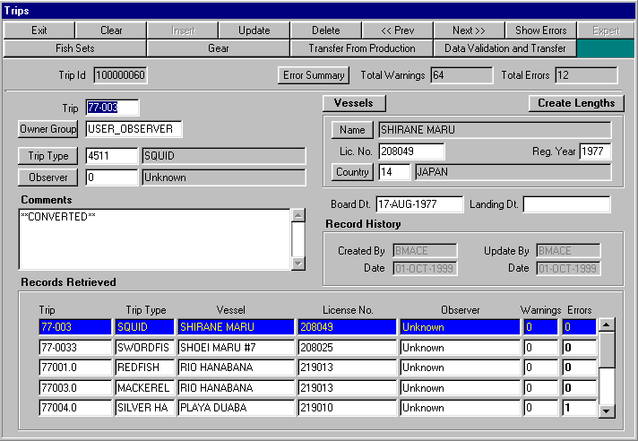
ToolBar Buttons

The following table lists all of the toolbar buttons used on the Trips screen and describes their functionality in detail.

Button | Functionality
Exit | When clicked, this button Exits the Trips screen and the ISDB application.
Clear | When clicked, this button refreshes the Trips screen, re-querying the Trips table and counting the total number of warnings and errors held against each Trip and all related child tables.
Insert | This button is not used on the Trips screen and has been disabled. To add a new trip, raw data must be uploaded by using the SQL*Loader utility described elsewhere in this document.
Update | When clicked, this button writes the changes made on-screen to the Trip database table.
Delete | When clicked, this button deletes the Trip record currently displayed on the screen. The option is also provided to delete all other child-records associated with this Trip. As orphaned records may result from not removing child records at the time of deletion, it is recommended that the user choose ‘Yes’ when presented with this option.
<< Prev | Moves the cursor in the Trips screen’s table window to the previous Trip record and displays the data on-screen.
Next >> | Moves the cursor in the Trips screen’s table window to the next Trip record and displays the data on-screen.
Show Errors | This button displays the Trip Errors screen, which lists all warnings and errors associated with the currently displayed Trip record.
Expert | This button is not used on the Trips screen and has been disabled.
Fish Sets | This button calls the Fish Sets screen and displays all Fish Set records associated with the Trip record currently displayed.
Gears | This button calls the Gears screen and displays all Gear records associated with the Trip record currently displayed
Transfer From Production | This button calls the Transfer From Production dialog, which is used to load data from the Production system into the Edit tables.
Data Validatation and Transfer | This button calls the Data Validation and Transfer dialog, which is used to run a series of edit checks against the current Trip and all associated child records. A report summarizing all warnings and errors found by the edit checks may also be generated from this dialog.  Once all edit checks have passed, this dialog may also be used to upload data into the Production system.

Current Record Edit Items

The following table lists all of the data fields, push buttons, display fields and other functional items which are used to display and edit the record data currently displayed on the screen.

Item | Functionality
Trip Id | This display-only field shows the unique ID assigned to the Trip. If this field does not contain a number, it means that the record currently on the screen has not yet been loaded to the production database.
Total Warnings | This display-only field shows the total number of warnings generated by the edit checks for this Trip record and all associated child records.
Total Errors | This display-only field shows the total number of errors generated by the edit checks for this Trip record and all associated child records.
Trip | This editable field shows the Trip number assigned by the observer for this Trip.
Owner Group | This editable field shows the owner group to which this Trip record, and all associated child records, have been assigned. Only users who have been assigned as members of a given owner group may examine Trips listed as being under that owner group. This field also has an associated List Of Values (LOV) pushbutton which will invoke a quick-list from which the user may choose a valid owner group.
Trip Type | This editable field shows the Trip Type code assigned to this Trip record. This field also has an associated display field, which will show the text description for the code, and an LOV pushbutton, which will invoke a quick-list from which the user may choose a valid Trip Type.
Observer | This editable field shows the Observer code assigned to this Trip record. This field also has an associated display field, which will show the text description for the code, and an LOV pushbutton, which will invoke a quick-list from which the user may choose a valid Observer.
Comments | This editable field permits the user to enter any free-form comments they may have regarding this Trip.
Vessels Pushbutton | This pushbutton calls the Vessels screen, which may be used to Insert new or edit existing Vessel records.
Create Lengths | When clicked (and after two confirmations from the user), this button will create sample weights when the round weight of the individual animal is in the ISEditFishMorphs table (mrphcd_id=12) and the Quant_value (round weight in this case) is in kgs. It will create the length frequency without weights and will update the number of fish caught (listed in the ISEditCatches table). You will be prompted before the button will update the number of fish caught. You can deny this request and only have length frequency created.  It should be stressed that the use of this button to create the length and sample information should only be in cases where the entire catch of the species had details (morphologies) performed on them.
Name Pushbutton | This pushbutton calls a List Of Values from which the user may select a vessel for this Trip.
Name | This display-only field shows the name of the vessel registered for this trip.
Lic. No. | This editable field shows the License Number of the vessel registered for this trip.
Reg. Year | This editable field shows the Registration Year of the vessel registered for this trip.
Country | This editable field shows the Country code assigned to the Vessel registered for this Trip. This field also has an associated display field, which will show the text description for the code, and an LOV pushbutton, which will invoke a quick-list from which the user may choose a valid Country.
Board Date | This editable field shows the Boarding Date of the Trip.
Land Date | This editable field shows the Landing Date of the Trip.
Created By | This display-only field shows the username of the person who originally created this record.
Created Date | This display-only field shows the date upon which the current record was originally created.
Update By | This display-only field shows the username of the person who last updated the record.
Update Date | This display-only field shows the date upon which the current record was last updated.
Error Summary | When clicked this button will display a dialog box summarising the count of errors and warnings for this trip and its child objects.
Table Window | The lower table window shows all Trip records which may currently be selected by the user for editing. Various columns of data are shown to provide a quick-glance for easy selection of a record, and Warnings and Errors columns are provided to show the total number of Warnings and Errors which are currently registered against the listed Trip.

3.1.1 Trips - Validate Data

From within the Trips screen, the Validate Data dialog may be called. From this dialog, all edit checks may be run against the current Trip record and, if all checks pass, the user may upload the Trip record and all associated child records to the Production system. The data validation and upload process may be started by clicking the ‘Validate Data’ pushbutton. The status of the validation is displayed on the dialog’s output screen.

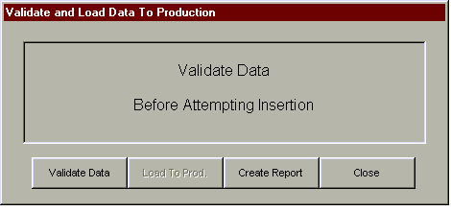

Once the validation has been completed, the user will be informed that either the validation has failed (and so they must return to the ISDB system and correct any errors found) or that the validation has passed (and that the Trip may be uploaded to the Production database). To upload the record to production, click the button labelled ‘Load To Prod’ once it becomes enabled. After the load has been completed, the loaded trip will be cleared from the ISDB system and the Edit process will have ended for that Trip. The Trip may be retrieved for further editing using the Transfer From Production dialog, described below.

A report summarizing the errors generated by the data validation process is also available to the user. Clicking the ‘Create Report’ button will generate the report, which the user may then either print or discard as they see fit.

3.1.2 Trips – Load Data
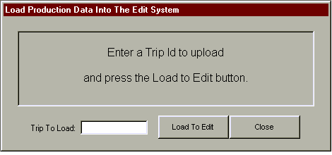

The Load Production dialog is used to retrieve Trip data from the production system for editing within the ISDB application. After the user has entered the Trip Id in the provided data field (NOTE: This is not the Trip Number but the number generated by Oracle to uniquely identify each record. It can be found at the top, left corner of each ISDB screen), clicking the Load To Edit button will transfer the corresponding Trip and child records to the edit database for further modifications.

3.1.3 Trips – Report Screen

The report screen appears when the user selects ‘Create Report’ from the Validate Data screen.

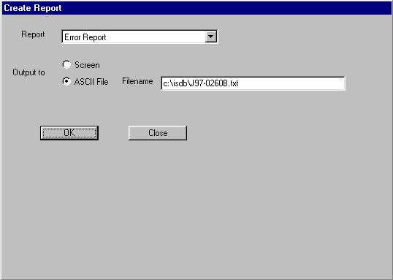
From this screen the user selects the Error Report or Production Load Status Report. The user also selects if the report is to be displayed on the screen or written to the specified ASCII file.

Click ‘OK’ to run the selected report. Click ‘Close’ to return to the Validate Data screen.

3.2 Gear

The Gear screen displays all Gear records currently associated with the selected Trip. From this screen, the user can navigate to the Gear Features screen or move back to the Trips screen.

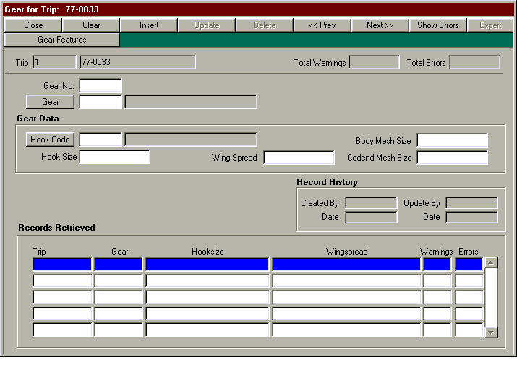
ToolBar Buttons

The following table lists all of the toolbar buttons used on the Gear screen and describes their functionality in detail.

Button | Functionality
Close | When clicked, this button Exits the Gear screen to return to the Trips screen.
Clear | When clicked, this button clears all data fields and puts the screen into Insert mode. Values for the Gear’s Trip Id and Trip number are also automatically set to those values held by the parent Trip record.
Insert | When clicked, this button adds a new Gear record to the database using the data currently displayed on the screen.
Update | When clicked, this button writes the changes made on-screen to the Gear database table.
Delete | When clicked, this button deletes the Gear record currently displayed on the screen. The option is also provided to delete all other child-records associated with this Gear. As orphaned records may result from not removing child records at the time of deletion, it is recommended that the user choose ‘Yes’ when presented with this option.
<< Prev | Moves the cursor in the Gear screen’s table window to the previous Gear record and displays the data on-screen.
Next >> | Moves the cursor in the Gear screen’s table window to the next Gear record and displays the data on-screen.
Show Errors | This button displays the Gear Errors screen, which lists all warnings and errors associated with the currently displayed Gear record.
Expert | This button is not used on the Gear screen and has been disabled.
Gear Features | This button calls the Gear Features screen and displays all Gear Feature records associated with the Gear record currently displayed.

Current Record Edit Items

The following table lists all of the data fields, push buttons, display fields and other functional items which are used to display and edit the record data currently displayed on the screen.

Item | Functionality
Trip Id | This display-only field shows the unique ID assigned to the Trip. If this field does not contain a number, it means that the record currently on the screen has not yet been loaded to the production database.
Trip | This display-only field shows the Trip number assigned by the observer for this Trip.
Total Warnings | This display-only field shows the total number of warnings generated by the edit checks for all records associated with the Trip.
Total Errors | This display-only field shows the total number of errors generated by the edit checks for all records associated with the Trip.
Gear No | This editable field shows the Gear Number associated with this Gear record.
Gear | This editable field shows the Gear code assigned to this Gear record. This field also has an associated display field, which will show the text description for the code, and an LOV pushbutton, which will invoke a quick-list from which the user may choose a valid Gear.
Hook Code | This editable field shows the Hook code assigned to this Gear record. This field also has an associated display field, which will show the text description for the code, and an LOV pushbutton, which will invoke a quick-list from which the user may choose a valid Hook Code.
Hook Size | This editable field shows the Hook Size for this Gear.
Wing Spread | This editable field shows the Wing Spread for this Gear.
Body Mesh Size | This editable field shows the Body Mesh Size for this Gear.
Codend Mesh Size | This editable field shows the Codend Mesh Size for this Gear.
Created By | This display-only field shows the username of the person who originally created this record.
Created Date | This display-only field shows the date upon which the current record was originally created.
Update By | This display-only field shows the username of the person who last updated the record.
Update Date | This display-only field shows the date upon which the current record was last updated.
Table Window | The lower table window shows all Gear records which may currently be selected by the user for editing. Various columns of data are shown to provide a quick-glance for easy selection of a record, and Warnings and Errors columns are provided to show the total number of Warnings and Errors which are currently registered against the listed Gear.

3.3 Gear Features
The Gear Features screen displays all Gear Feature records currently associated with the selected Gear. From this screen, the user can navigate back to the Gear screen.

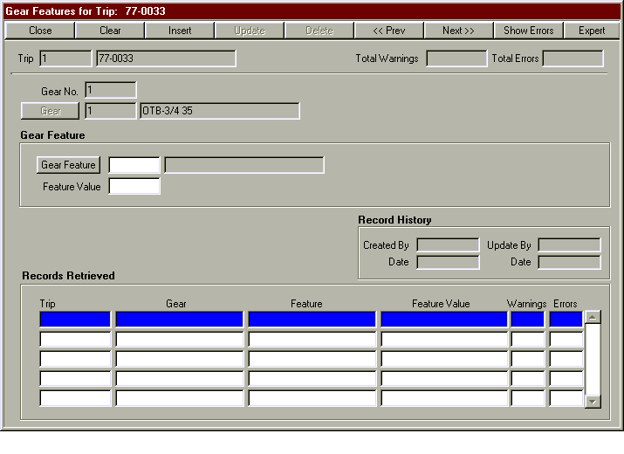
ToolBar Buttons

The following table lists all of the toolbar buttons used on the Gear Features screen and describes their functionality in detail.

Button | Functionality
Close | When clicked, this button Exits the Gear Features screen to return to the Gear screen.
Clear | When clicked, this button clears all data fields and puts the screen into Insert mode. Values for the Gear Feature’s Trip Id, Trip number, Gear No. and Gear are also automatically set to those values held by the parent Gear record.
Insert | When clicked, this button adds a new Gear Feature record to the database using the data currently displayed on the screen.
Update | When clicked, this button writes the changes made on-screen to the Gear Feature database table.
Delete | When clicked, this button deletes the Gear Feature record currently displayed on the screen. It will prompt you whether you want to delete the record from the production system as well as the edit system
<< Prev | Moves the cursor in the Gear Features screen’s table window to the previous Gear Feature record and displays the data on-screen.
Next >> | Moves the cursor in the Gear Features screen’s table window to the next Gear Feature record and displays the data on-screen.
Show Errors | This button displays the Gear Feature Errors screen, which lists all warnings and errors associated with the currently displayed Gear Feature record.
Expert | When clicked, this button enables the Gear No. and Gear Code fields for editing. As Gear No. and Gear Code are part of the unique identifier for this Gear Feature, it is suggested that this option be used with the greatest of care.

Current Record Edit Items

The following table lists all of the data fields, push buttons, display fields and other functional items which are used to display and edit the record data currently displayed on the screen.

Item | Functionality
Trip Id | This display-only field shows the unique ID assigned to the Trip. If this field does not contain a number, it means that the record currently on the screen has not yet been loaded to the production database.
Trip | This display-only field shows the Trip number assigned by the observer for this Trip.
Total Warnings | This display-only field shows the total number of warnings generated by the edit checks for all records associated with the Trip.
Total Errors | This display-only field shows the total number of errors generated by the edit checks for all records associated with the Trip.
Gear No | This expert-only editable field shows the Gear No. associated with this Gear Feature record.
Gear | This expert-only editable field shows the Gear code assigned to this Gear Feature record. This field also has an associated display field, which will show the text description for the code, and an LOV pushbutton, which will invoke a quick-list from which the user may choose a valid Gear.
Gear Feature | This editable field shows the Gear Feature code assigned to this Gear Feature record. This field also has an associated display field, which will show the text description for the code, and an LOV pushbutton, which will invoke a quick-list from which the user may choose a valid Gear Feature.
Feature Value | This editable field shows the Feature Value for this Gear Feature.
Created By | This display-only field shows the username of the person who originally created this record.
Created Date | This display-only field shows the date upon which the current record was originally created.
Update By | This display-only field shows the username of the person who last updated the record.
Update Date | This display-only field shows the date upon which the current record was last updated.
Table Window | The lower table window shows all Gear Feature records which may currently be selected by the user for editing. Various columns of data are shown to provide a quick-glance for easy selection of a record, and Warnings and Errors columns are provided to show the total number of Warnings and Errors which are currently registered against the listed Gear Feature.

3.4 Fish Sets

The Fish Sets screen displays all Fish Set records currently associated with the selected Trip. From this screen, the user can navigate to the Catches and Set Profile screens or move back to the Trips screen.

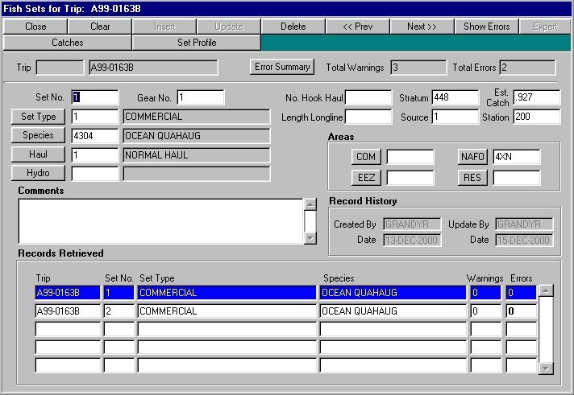
ToolBar Buttons

The following table lists all of the toolbar buttons used on the Fish Sets screen and describes their functionality in detail.

Button | Functionality
Close | When clicked, this button Exits the Fish Sets screen to return to the Trips screen.
Clear | When clicked, this button clears all data fields and puts the screen into Insert mode. Values for the Fish Set’s Trip Id and Trip number are also automatically set to those values held by the parent Trip record.
Insert | When clicked, this button adds a new Fish Set record to the database using the data currently displayed on the screen.
Update | When clicked, this button writes the changes made on-screen to the Fish Set database table.
Delete | When clicked, this button deletes the Fish Set record currently displayed on the screen. The option is also provided to delete all other child-records associated with this Fish Set. As orphaned records may result from not removing child records at the time of deletion, it is recommended that the user choose ‘Yes’ when presented with this option.
<< Prev | Moves the cursor in the Fish Sets screen’s table window to the previous Fish Set record and displays the data on-screen.
Next >> | Moves the cursor in the Fish Sets screen’s table window to the next Fish Set record and displays the data on-screen.
Show Errors | This button displays the Fish Set Errors screen, which lists all warnings and errors associated with the currently displayed Fish Set record.
Expert | This button is not used on the Fish Sets screen and has been disabled.
Catches | This button calls the Catches screen and displays all Catch records associated with the Fish Set record currently displayed.
Set Profile | This button calls the Set Profiles screen and displays all Set Profile records associated with the Fish Set record currently displayed

Current Record Edit Items

The following table lists all of the data fields, push buttons, display fields and other functional items which are used to display and edit the record data currently displayed on the screen.

Item | Functionality
Trip Id | This display-only field shows the unique ID assigned to the Trip. If this field does not contain a number, it means that the record currently on the screen has not yet been loaded to the production database.
Trip | This display-only field shows the Trip number assigned by the observer for this Trip.
Total Warnings | This display-only field shows the total number of warnings generated by the edit checks for all records associated with the Trip.
Total Errors | This display-only field shows the total number of errors generated by the edit checks for all records associated with the Trip.
Set No | This editable field shows the Set Number for this Fish Set record.
Gear No | This editable field shows the Gear Number associated with this Fish Set record. This Gear Number corresponds with a record to be found on the Gears screen for this Trip.
Set Type | This editable field shows the Set Type code assigned to this Fish Set record. This field also has an associated display field, which will show the text description for the code, and an LOV pushbutton, which will invoke a quick-list from which the user may choose a valid Set Type.
Species | This editable field shows the Species code assigned to this Fish Set record. This field also has an associated display field, which will show the text description for the code, and an LOV pushbutton, which will invoke a quick-list from which the user may choose a valid Species.
Haul | This editable field shows the Haul code assigned to this Fish Set record. This field also has an associated display field, which will show the text description for the code, and an LOV pushbutton, which will invoke a quick-list from which the user may choose a valid Haul.
Hydro | This editable field shows the Hydro code assigned to this Fish Set record. This field also has an associated display field, which will show the text description for the code, and an LOV pushbutton, which will invoke a quick-list from which the user may choose a valid Hydro.
Comments | This editable field permits the user to enter any free-form comments they may have regarding this Fish Set.
No. Hook Haul | This editable field shows the number of hooks hauled for this Fish Set record.
Length Longline | This editable field shows the length of the longline used for this Fish Set record.
Stratum | This editable field shows the Stratum for this Fish Set record.
Source | This editable field shows the Source for this Fish Set record.
Est. Catch | This editable field shows the estimated catch for this Fish Set record.
Comm | This editable field shows the Comm. Area code assigned to this Fish Set record. This field also has an associated LOV pushbutton, which will invoke a quick-list from which the user may choose a valid Comm Area.
EEZ | This editable field shows the EEZ Area code assigned to this Fish Set record. This field also has an associated LOV pushbutton, which will invoke a quick-list from which the user may choose a valid EEZ Area.
NAFO | This editable field shows the NAFO Area code assigned to this Fish Set record. This field also has an associated LOV pushbutton, which will invoke a quick-list from which the user may choose a valid NAFO Area.
RES | This editable field shows the RES Area code assigned to this Fish Set record. This field also has an associated LOV pushbutton, which will invoke a quick-list from which the user may choose a valid RES Area.
Created By | This display-only field shows the username of the person who originally created this record.
Created Date | This display-only field shows the date upon which the current record was originally created.
Update By | This display-only field shows the username of the person who last updated the record.
Update Date | This display-only field shows the date upon which the current record was last updated.
Error Summary | When clicked this button will display a dialog box summarising the count of errors and warnings for this fish set and its child objects.
Table Window | The lower table window shows all Fish Set records which may currently be selected by the user for editing. Various columns of data are shown to provide a quick-glance for easy selection of a record, and Warnings and Errors columns are provided to show the total number of Warnings and Errors which are currently registered against the listed Fish Set.

3.5 Set Profile

The Set Profile screen displays all Set Profile records currently associated with the selected Fish Set. From this screen, the user can navigate back to the Fish Sets screen.

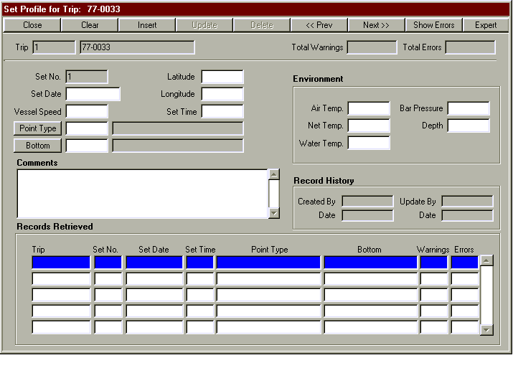
ToolBar Buttons

The following table lists all of the toolbar buttons used on the Set Profile screen and describes their functionality in detail.

Button | Functionality
Close | When clicked, this button Exits the Set Profile screen to return to the Fish Sets screen.
Clear | When clicked, this button clears all data fields and puts the screen into Insert mode. Values for the Set Profile’s Trip Id, Trip number and Set No. are also automatically set to those values held by the parent Fish Set record.
Insert | When clicked, this button adds a new Set Profile record to the database using the data currently displayed on the screen.
Update | When clicked, this button writes the changes made on-screen to the Set Profile database table.
Delete | When clicked, this button deletes the Set Profile record currently displayed on the screen.
<< Prev | Moves the cursor in the Set Profile screen’s table window to the previous Set Profile record and displays the data on-screen.
Next >> | Moves the cursor in the Set Profile screen’s table window to the next Set Profile record and displays the data on-screen.
Show Errors | This button displays the Set Profile Errors screen, which lists all warnings and errors associated with the currently displayed Set Profile record.
Expert | When clicked, this button enables the Set No. field for editing. As Set No. is part of the unique identifier for this Set Profile, it is suggested that this option be used with the greatest of care.

Current Record Edit Items

The following table lists all of the data fields, push buttons, display fields and other functional items which are used to display and edit the record data currently displayed on the screen.

Item | Functionality
Trip Id | This display-only field shows the unique ID assigned to the Trip. If this field does not contain a number, it means that the record currently on the screen has not yet been loaded to the production database.
Trip | This display-only field shows the Trip number assigned by the observer for this Trip.
Total Warnings | This display-only field shows the total number of warnings generated by the edit checks for all records associated with the Trip.
Total Errors | This display-only field shows the total number of errors generated by the edit checks for all records associated with the Trip.
Set No | This expert-only editable field shows the Set No. associated with this Set Profile record.
Set Date | This editable field shows the Set Date for this Set Profile record.
Vessel Speed | This editable field shows the Vessel Speed for this Set Profile record.
Latitude | This editable field shows the Latitude for this Set Profile record.  If the Latitude is unknown, it should be indicated by entering the value: ‘99999.99’. This will be listed as NULL in the Production system and indicates to the Edit System both that the value is unknown and that the entering user is aware it will be entered into the production system as a NULL value.
Longitude | This editable field shows the Longitude for this Set Profile record.  If the Longitude is unknown, it should be indicated by entering the value: ‘99999.99’. This will be listed as NULL in the Production system and indicates to the Edit System both that the value is unknown and that the entering user is aware it will be entered into the production system as a NULL value.
Set Time | This editable field shows the Set Time for this Set Profile record.  If the Set Time is unknown, it should be indicated by entering the value: ‘9999’. This will be listed as NULL in the Production system and indicates to the Edit System both that the value is unknown and that the entering user is aware it will be entered into the production system as a NULL value.
Point Type | This editable field shows the Point Type assigned to this Set Profile record. This field also has an associated display field, which will show the text description for the code, and an LOV pushbutton, which will invoke a quick-list from which the user may choose a valid Point Type.
Bottom Code | This editable field shows the Bottom Code assigned to this Set Profile record. This field also has an associated display field, which will show the text description for the code, and an LOV pushbutton, which will invoke a quick-list from which the user may choose a valid Bottom Code.
Comments | This editable field permits the user to enter any free-form comments they may have regarding this Set Profile.
Air Temp. | This editable field shows the Air Temperature for this Set Profile.
Net Temp. | This editable field shows the Net Temperature for this Set Profile.
Water Temp. | This editable field shows the Water Temperature for this Set Profile.
Bar Pressure | This editable field shows the Bar Pressure for this Set Profile.
Depth | This editable field shows the Depth for this Set Profile.  If the Depth is unknown, it should be indicated by entering the value: ‘9999’. This will be listed as NULL in the Production system and indicates to the Edit System both that the value is unknown and that the entering user is aware it will be entered into the production system as a NULL value.
Created By | This display-only field shows the username of the person who originally created this record.
Created Date | This display-only field shows the date upon which the current record was originally created.
Update By | This display-only field shows the username of the person who last updated the record.
Update Date | This display-only field shows the date upon which the current record was last updated.
Table Window | The lower table window shows all Set Profile records which may currently be selected by the user for editing. Various columns of data are shown to provide a quick-glance for easy selection of a record, and Warnings and Errors columns are provided to show the total number of Warnings and Errors which are currently registered against the listed Set Profile.

3.6 Catches

The Catches screen displays all Catch records currently associated with the selected Fish Set. From this screen, the user can navigate to the Fish or Samples screen or move back to the Fish Sets screen.

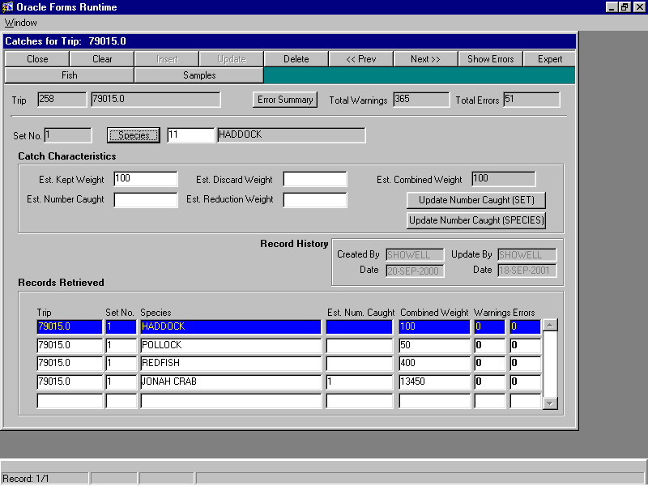
ToolBar Buttons

The following table lists all of the toolbar buttons used on the Catches screen and describes their functionality in detail.

Button | Functionality
Close | When clicked, this button Exits the Catches screen to return to the Fish Sets screen.
Clear | When clicked, this button clears all data fields and puts the screen into Insert mode. Values for the Catch’s Trip Id, Trip number and Set No. are also automatically set to those values held by the parent Fish Set record.
Insert | When clicked, this button adds a new Catch record to the database using the data currently displayed on the screen.
Update | When clicked, this button writes the changes made on-screen to the Catch database table.
Delete | When clicked, this button deletes the Catch record currently displayed on the screen. The option is also provided to delete all other child-records associated with this Catch. As orphaned records may result from not removing child records at the time of deletion, it is recommended that the user choose ‘Yes’ when presented with this option.
Update Number Caught (Set) | When pressed this button will update the estimated number caught in the ISEDITCATCHES table based on information from the ISEDITFISH table. The number caught will be updated for the whole set.
Update  Number  Caught  (Species) | This button will update the estimated number caught in the iseditcatches table for a particular species of a particular set. It is more limited in scope than the previously mentioned button. This is useful if only certain species of a fish set were sampled.
<< Prev | Moves the cursor in the Catches screen’s table window to the previous Catch record and displays the data on-screen.
Next >> | Moves the cursor in the Catches screen’s table window to the next Catch record and displays the data on-screen.
Show Errors | This button displays the Catch Errors screen, which lists all warnings and errors associated with the currently displayed Catch record.
Expert | When clicked, this button enables the Set No. field for editing. As Set No. is part of the unique identifier for this Catch, it is suggested that this option be used with the greatest of care.
Fish | This button calls the Fish screen and displays all Fish records associated with the Catch record currently displayed.
Samples | This button calls the Samples screen and displays all Sample records associated with the Catch record currently displayed.

Current Record Edit Items

The following table lists all of the data fields, push buttons, display fields and other functional items which are used to display and edit the record data currently displayed on the screen.

Item | Functionality
Trip Id | This display-only field shows the unique ID assigned to the Trip. If this field does not contain a number, it means that the record currently on the screen has not yet been loaded to the production database.
Trip | This display-only field shows the Trip number assigned by the observer for this Trip.
Total Warnings | This display-only field shows the total number of warnings generated by the edit checks for all records associated with the Trip.
Total Errors | This display-only field shows the total number of errors generated by the edit checks for all records associated with the Trip.
Set No | This expert-only editable field shows the Set No. associated with this Catch record.
Species | This editable field shows the Species code assigned to this Catch record. This field also has an associated display field, which will show the text description for the code, and an LOV pushbutton, which will invoke a quick-list from which the user may choose a valid Species.
Est. Kept Weight | This editable field shows the Estimated Kept Weight for this Catch.
Est. Number Caught | This editable field shows the Estimated Number Caught for this Catch.
Est. Discard Weight | This editable field shows the Estimated Discard Weight for this Catch.
Est. Reduction Weight | This editable field shows the Estimated Reduction Weight for this Catch.
Est. Combined Weight | This display-only field shows the Estimated Combined Weight for this Catch. The value in this field is calculated by summing the Est. Kept Weight and Est. Discard Weight of the current record.
Created By | This display-only field shows the username of the person who originally created this record.
Created Date | This display-only field shows the date upon which the current record was originally created.
Update By | This display-only field shows the username of the person who last updated the record.
Update Date | This display-only field shows the date upon which the current record was last updated.
Error Summary | When clicked this button will display a dialog box summarising the count of errors and warnings for this catch and its child objects.
Table Window | The lower table window shows all Catch records which may currently be selected by the user for editing. Various columns of data are shown to provide a quick-glance for easy selection of a record, and Warnings and Errors columns are provided to show the total number of Warnings and Errors which are currently registered against the listed Catch.

3.7 Samples

The Samples screen displays all Sample records currently associated with the selected Catch. From this screen, the user can navigate to the Fish Lengths screen or move back to the Catches screen.

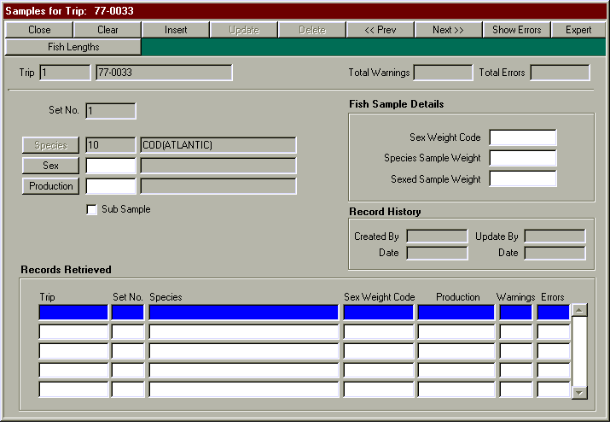
ToolBar Buttons

The following table lists all of the toolbar buttons used on the Samples screen and describes their functionality in detail.

Button | Functionality
Close | When clicked, this button Exits the Samples screen to return to the Catches screen.
Clear | When clicked, this button clears all data fields and puts the screen into Insert mode. Values for the Fish’s Trip Id, Trip number, Set No. and Species are also automatically set to those values held by the parent Catch record.
Insert | When clicked, this button adds a new Sample record to the database using the data currently displayed on the screen.
Update | When clicked, this button writes the changes made on-screen to the Sample database table.
Delete | When clicked, this button deletes the Sample record currently displayed on the screen. The option is also provided to delete all other child-records associated with this Sample. As orphaned records may result from not removing child records at the time of deletion, it is recommended that the user choose ‘Yes’ when presented with this option.
<< Prev | Moves the cursor in the Sample screen’s table window to the previous Sample record and displays the data on-screen.
Next >> | Moves the cursor in the Sample screen’s table window to the next Sample record and displays the data on-screen.
Show Errors | This button displays the Sample Errors screen, which lists all warnings and errors associated with the currently displayed Sample record.
Expert | When clicked, this button enables the Set No. and Species fields for editing. As Set No. and Species Code are part of the unique identifier for this Sample, it is suggested that this option be used with the greatest of care.
Fish Lengths | This button calls the Fish Lengths screen and displays all Fish Length records associated with the Sample record currently displayed.

Current Record Edit Items

The following table lists all of the data fields, push buttons, display fields and other functional items which are used to display and edit the record data currently displayed on the screen.

Item | Functionality
Trip Id | This display-only field shows the unique ID assigned to the Trip. If this field does not contain a number, it means that the record currently on the screen has not yet been loaded to the production database.
Trip | This display-only field shows the Trip number assigned by the observer for this Trip.
Total Warnings | This display-only field shows the total number of warnings generated by the edit checks for all records associated with the Trip.
Total Errors | This display-only field shows the total number of errors generated by the edit checks for all records associated with the Trip.
Set No | This expert-only editable field shows the Set No. associated with this Sample record.
Species | This expert-only editable field shows the Species code assigned to this Sample record. This field also has an associated display field, which will show the text description for the code, and an LOV pushbutton, which will invoke a quick-list from which the user may choose a valid Species.
Sex | This editable field shows the Sex code assigned to this Sample record. This field also has an associated display field, which will show the text description for the code, and an LOV pushbutton, which will invoke a quick-list from which the user may choose a valid Sex.
Production | This editable field shows the Production code assigned to this Sample record. This field also has an associated display field, which will show the text description for the code, and an LOV pushbutton, which will invoke a quick-list from which the user may choose a valid Production code.
Sub Sample | This editable check box indicates whether or not this Sample record is a sub-sample.
Sex Weight Code | This editable field shows the Sex Weight Code assigned to this Sample record.
Species Sample Weight | This editable field shows the Species Sample Weight assigned to this Sample record.
Sexed Sample Weight | This editable field shows the Sexed Sample Weight assigned to this Sample record.
Created By | This display-only field shows the username of the person who originally created this record.
Created Date | This display-only field shows the date upon which the current record was originally created.
Update By | This display-only field shows the username of the person who last updated the record.
Update Date | This display-only field shows the date upon which the current record was last updated.
Table Window | The lower table window shows all Sample records which may currently be selected by the user for editing. Various columns of data are shown to provide a quick-glance for easy selection of a record, and Warnings and Errors columns are provided to show the total number of Warnings and Errors which are currently registered against the listed Sample.

3.8 Fish Lengths
The Samples screen displays all Sample records currently associated with the selected Catch. From this screen, the user can navigate to the Fish Lengths screen or move back to the Catches screen.
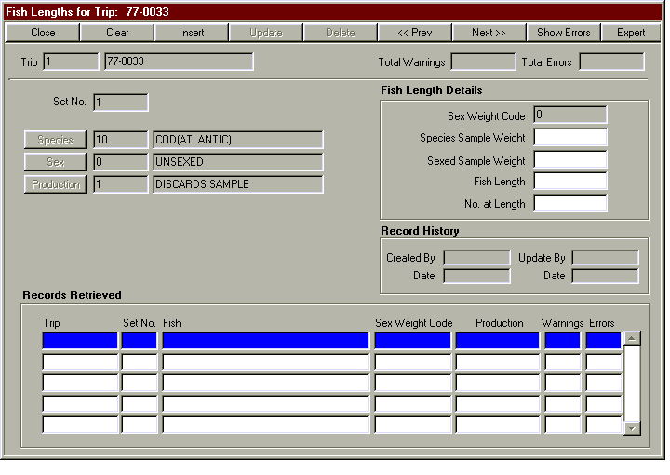
ToolBar Buttons

The following table lists all of the toolbar buttons used on the Fish Lengths screen and describes their functionality in detail.

Button | Functionality
Close | When clicked, this button Exits the Fish Lengths screen to return to the Samples screen.
Clear | When clicked, this button clears all data fields and puts the screen into Insert mode. Values for the Fish Length’s Trip Id, Trip number, Set No., Species, Sex, Production Code and Sex Weight Code are also automatically set to those values held by the parent Sample record.
Insert | When clicked, this button adds a new Fish Length record to the database using the data currently displayed on the screen.
Update | When clicked, this button writes the changes made on-screen to the Fish Length database table.
Delete | When clicked, this button deletes the Fish Length record currently displayed on the screen.
<< Prev | Moves the cursor in the Fish Length screen’s table window to the previous Fish Length record and displays the data on-screen.
Next >> | Moves the cursor in the Fish Length screen’s table window to the next Fish Length record and displays the data on-screen.
Show Errors | This button displays the Fish Length Errors screen, which lists all warnings and errors associated with the currently displayed Fish Length record.
Expert | When clicked, this button enables the Set No., Species, Sex, Production Code and Sex Weight Code fields for editing. As Set No., Species Code, Sex Code, Production Code and Sex Weight Code are part of the unique identifier for this Fish Length, it is suggested that this option be used with the greatest of care.

Current Record Edit Items

The following table lists all of the data fields, push buttons, display fields and other functional items which are used to display and edit the record data currently displayed on the screen.

Item | Functionality
Trip Id | This display-only field shows the unique ID assigned to the Trip. If this field does not contain a number, it means that the record currently on the screen has not yet been loaded to the production database.
Trip | This display-only field shows the Trip number assigned by the observer for this Trip.
Total Warnings | This display-only field shows the total number of warnings generated by the edit checks for all records associated with the Trip.
Total Errors | This display-only field shows the total number of errors generated by the edit checks for all records associated with the Trip.
Set No | This expert-only editable field shows the Set No. associated with this Fish Length record.
Species | This expert-only editable field shows the Species code assigned to this Fish Length record. This field also has an associated display field, which will show the text description for the code, and an LOV pushbutton, which will invoke a quick-list from which the user may choose a valid Species.
Sex | This expert-only editable field shows the Sex code assigned to this Fish Length record. This field also has an associated display field, which will show the text description for the code, and an LOV pushbutton, which will invoke a quick-list from which the user may choose a valid Sex.
Production | This expert-only editable field shows the Production code assigned to this Fish Length record. This field also has an associated display field, which will show the text description for the code, and an LOV pushbutton, which will invoke a quick-list from which the user may choose a valid Production code.
Sex Weight Code | This expert-only editable field shows the Sex Weight Code assigned to this Fish Length record.
Species Sample Weight | This editable field shows the Species Sample Weight assigned to this Fish Length record.
Sexed Sample Weight | This editable field shows the Sexed Sample Weight assigned to this Fish Length record.
Fish Length | This editable field shows the Fish Length assigned to this Fish Length record.
No. At Length | This editable field shows the No. At Length assigned to this Fish Length record.
Created By | This display-only field shows the username of the person who originally created this record.
Created Date | This display-only field shows the date upon which the current record was originally created.
Update By | This display-only field shows the username of the person who last updated the record.
Update Date | This display-only field shows the date upon which the current record was last updated.
Table Window | The lower table window shows all Fish Length records which may currently be selected by the user for editing. Various columns of data are shown to provide a quick-glance for easy selection of a record, and Warnings and Errors columns are provided to show the total number of Warnings and Errors which are currently registered against the listed Fish Length.

3.9 Fish

The Fish screen displays all Fish records currently associated with the selected Catch. From this screen, the user can navigate to the Fish Stomach Analysis or Fish Morphologies screen or move back to the Catches screen.

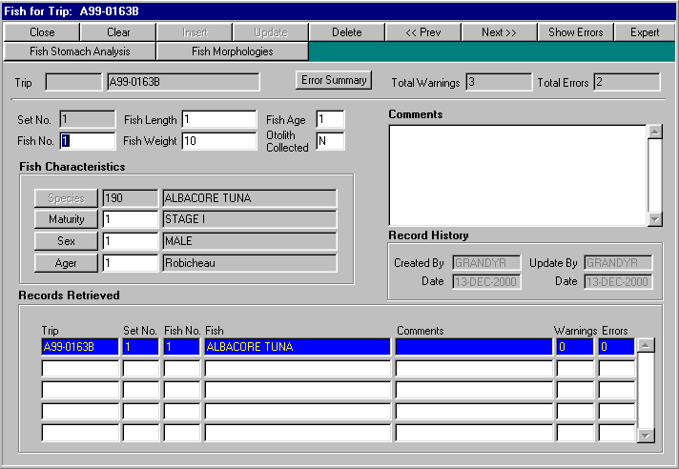

ToolBar Buttons

The following table lists all of the toolbar buttons used on the Fish screen and describes their functionality in detail.

Button | Functionality
Close | When clicked, this button Exits the Fish screen to return to the Catches screen.
Clear | When clicked, this button clears all data fields and puts the screen into Insert mode. Values for the Fish’s Trip Id, Trip number, Set No. and Species are also automatically set to those values held by the parent Catch record.
Insert | When clicked, this button adds a new Fish record to the database using the data currently displayed on the screen.
Update | When clicked, this button writes the changes made on-screen to the Fish database table.
Delete | When clicked, this button deletes the Fish record currently displayed on the screen. The option is also provided to delete all other child-records associated with this Fish. As orphaned records may result from not removing child records at the time of deletion, it is recommended that the user choose ‘Yes’ when presented with this option.
<< Prev | Moves the cursor in the Fish screen’s table window to the previous Fish record and displays the data on-screen.
Next >> | Moves the cursor in the Fish screen’s table window to the next Fish record and displays the data on-screen.
Show Errors | This button displays the Fish Errors screen, which lists all warnings and errors associated with the currently displayed Fish record.
Expert | When clicked, this button enables the Set No. and Species fields for editing. As Set No. and Species Code are part of the unique identifier for this Fish, it is suggested that this option be used with the greatest of care.
Fish Stomach Analysis | This button calls the Fish Stomach Analysis screen and displays all Fish Stomach Analysis records associated with the Fish record currently displayed.
Fish Morphologies | This button calls the Fish Morphologies screen and displays all Fish Morphology records associated with the Fish record currently displayed.

Current Record Edit Items

The following table lists all of the data fields, push buttons, display fields and other functional items which are used to display and edit the record data currently displayed on the screen.

Item | Functionality
Trip Id | This display-only field shows the unique ID assigned to the Trip. If this field does not contain a number, it means that the record currently on the screen has not yet been loaded to the production database.
Trip | This display-only field shows the Trip number assigned by the observer for this Trip.
Total Warnings | This display-only field shows the total number of warnings generated by the edit checks for all records associated with the Trip.
Total Errors | This display-only field shows the total number of errors generated by the edit checks for all records associated with the Trip.
Set No | This expert-only editable field shows the Set No. associated with this Fish record.
Fish No | This editable field shows the Fish No. associated with this Fish record.
Fish Length | This editable field shows the Fish Length associated with this Fish record.
Fish Weight | This editable field shows the Fish Weight associated with this Fish record.
Fish Age | This editable field shows the Fish Age associated with this Fish record.
Otolith Collected | This editable field shows whether or not an Otolith has been Collected for this Fish record. Valid values are Y, R, S or N.
Species | This expert-only editable field shows the Species code assigned to this Fish record. This field also has an associated display field, which will show the text description for the code, and an LOV pushbutton, which will invoke a quick-list from which the user may choose a valid Species.
Maturity | This editable field shows the Maturity code assigned to this Fish record. This field also has an associated display field, which will show the text description for the code, and an LOV pushbutton, which will invoke a quick-list from which the user may choose a valid Maturity code.
Sex | This editable field shows the Sex code assigned to this Fish record. This field also has an associated display field, which will show the text description for the code, and an LOV pushbutton, which will invoke a quick-list from which the user may choose a valid Sex.
Ager | This editable field shows the Ager code assigned to this Fish record. This field also has an associated display field, which will show the text description for the code, and an LOV pushbutton, which will invoke a quick-list from which the user may choose a valid Ager.
Comments | This editable field permits the user to enter any free-form comments they may have regarding this Fish.
Created By | This display-only field shows the username of the person who originally created this record.
Created Date | This display-only field shows the date upon which the current record was originally created.
Update By | This display-only field shows the username of the person who last updated the record.
Update Date | This display-only field shows the date upon which the current record was last updated.
Error Summary | When clicked this button will display a dialog box summarising the count of errors and warnings for this fish and its child objects.
Table Window | The lower table window shows all Fish records which may currently be selected by the user for editing. Various columns of data are shown to provide a quick-glance for easy selection of a record, and Warnings and Errors columns are provided to show the total number of Warnings and Errors which are currently registered against the listed Fish.

3.10 Fish Stomach Analysis

The Fish Stomach Analysis screen displays all Fish Stomach Analysis records currently associated with the selected Fish. From this screen, the user can navigate to the Fish Prey screen or move back to the Fish screen.

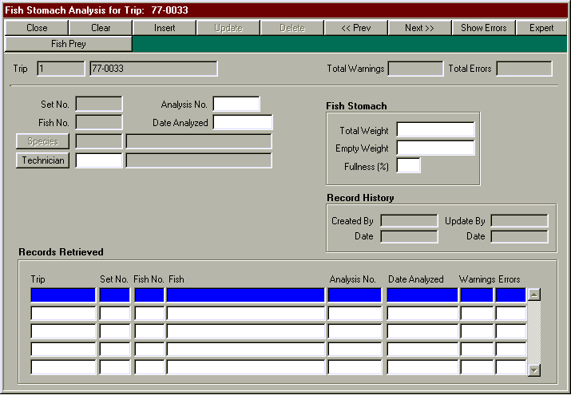
ToolBar Buttons

The following table lists all of the toolbar buttons used on the Fish Stomach Analysis screen and describes their functionality in detail.

Button | Functionality
Close | When clicked, this button Exits the Fish Stomach Analysis screen to return to the Fish screen.
Clear | When clicked, this button clears all data fields and puts the screen into Insert mode. Values for the Fish Stomach Analysis’s Trip Id, Trip number, Set No., Fish No. and Species are also automatically set to those values held by the parent Fish record.
Insert | When clicked, this button adds a new Fish Stomach Analysis record to the database using the data currently displayed on the screen.
Update | When clicked, this button writes the changes made on-screen to the Fish Stomach Analysis database table.
Delete | When clicked, this button deletes the Fish Stomach Analysis record currently displayed on the screen. The option is also provided to delete all other child-records associated with this Fish Stomach Analysis. As orphaned records may result from not removing child records at the time of deletion, it is recommended that the user choose ‘Yes’ when presented with this option.
<< Prev | Moves the cursor in the Fish Stomach Analysis screen’s table window to the previous Fish Stomach Analysis record and displays the data on-screen.
Next >> | Moves the cursor in the Fish Stomach Analysis screen’s table window to the next Fish Stomach Analysis record and displays the data on-screen.
Show Errors | This button displays the Fish Stomach Analysis Errors screen, which lists all warnings and errors associated with the currently displayed Fish Stomach Analysis record.
Expert | When clicked, this button enables the Set No., Fish No. and Species fields for editing. As Set No., Fish No. and Species Code are part of the unique identifier for this Fish Stomach Analysis, it is suggested that this option be used with the greatest of care.
Fish Prey | This button calls the Fish Prey screen and displays all Fish Prey records associated with the Fish Stomach Analysis record currently displayed.

Current Record Edit Items

The following table lists all of the data fields, push buttons, display fields and other functional items which are used to display and edit the record data currently displayed on the screen.

Item | Functionality
Trip Id | This display-only field shows the unique ID assigned to the Trip. If this field does not contain a number, it means that the record currently on the screen has not yet been loaded to the production database.
Trip | This display-only field shows the Trip number assigned by the observer for this Trip.
Total Warnings | This display-only field shows the total number of warnings generated by the edit checks for all records associated with the Trip.
Total Errors | This display-only field shows the total number of errors generated by the edit checks for all records associated with the Trip.
Set No | This expert-only editable field shows the Set No. associated with this Fish Stomach Analysis record.
Fish No. | This expert-only editable field shows the Fish No. associated with this Fish Stomach Analysis record.
Analysis No. | This editable field shows the Analysis No. associated with this Fish Stomach Analysis record.
Date Analyzed | This editable field shows the Date Analyzed value associated with this Fish Stomach Analysis record.
Species | This expert-only editable field shows the Species code assigned to this Fish Stomach Analysis record. This field also has an associated display field, which will show the text description for the code, and an LOV pushbutton, which will invoke a quick-list from which the user may choose a valid Species.
Technician | This editable field shows the Technician code assigned to this Fish Stomach Analysis record. This field also has an associated display field, which will show the text description for the code, and an LOV pushbutton, which will invoke a quick-list from which the user may choose a valid Technician.
Total Weight | This editable field shows the Total Weight assigned to this Fish Stomach Analysis record.
Empty Weight | This editable field shows the Empty Weight assigned to this Fish Stomach Analysis record.
Fullness | This editable field shows the % Fullness assigned to this Fish Stomach Analysis record.
Created By | This display-only field shows the username of the person who originally created this record.
Created Date | This display-only field shows the date upon which the current record was originally created.
Update By | This display-only field shows the username of the person who last updated the record.
Update Date | This display-only field shows the date upon which the current record was last updated.
Table Window | The lower table window shows all Fish Stomach Analysis records which may currently be selected by the user for editing. Various columns of data are shown to provide a quick-glance for easy selection of a record, and Warnings and Errors columns are provided to show the total number of Warnings and Errors which are currently registered against the listed Fish Stomach Analysis.

3.11 Fish Morphs

The Fish Morphs screen displays all Fish Morphology records currently associated with the selected Fish. From this screen, the user can navigate back to the Fish screen.

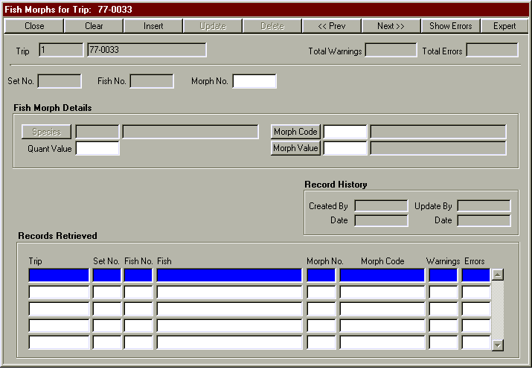
ToolBar Buttons

The following table lists all of the toolbar buttons used on the Fish Morphs screen and describes their functionality in detail.

Button | Functionality
Close | When clicked, this button Exits the Fish Morphs screen to return to the Fish screen.
Clear | When clicked, this button clears all data fields and puts the screen into Insert mode. Values for the Fish Morph’s Trip Id, Trip number, Set No., Fish No. and Species are also automatically set to those values held by the parent Fish record.
Insert | When clicked, this button adds a new Fish Morph record to the database using the data currently displayed on the screen.
Update | When clicked, this button writes the changes made on-screen to the Fish Morphs database table.
Delete | When clicked, this button deletes the Fish Morph record currently displayed on the screen.
<< Prev | Moves the cursor in the Fish Morphs screen’s table window to the previous Fish Morph record and displays the data on-screen.
Next >> | Moves the cursor in the Fish Morphs screen’s table window to the next Fish Morph record and displays the data on-screen.
Show Errors | This button displays the Fish Morph Errors screen, which lists all warnings and errors associated with the currently displayed Fish Morph record.
Expert | When clicked, this button enables the Set No., Fish No. and Species fields for editing. As Set No., Fish No. and Species Code are part of the unique identifier for this Fish Morph, it is suggested that this option be used with the greatest of care.

Current Record Edit Items

The following table lists all of the data fields, push buttons, display fields and other functional items which are used to display and edit the record data currently displayed on the screen.

Item | Functionality
Trip Id | This display-only field shows the unique ID assigned to the Trip. If this field does not contain a number, it means that the record currently on the screen has not yet been loaded to the production database.
Trip | This display-only field shows the Trip number assigned by the observer for this Trip.
Total Warnings | This display-only field shows the total number of warnings generated by the edit checks for all records associated with the Trip.
Total Errors | This display-only field shows the total number of errors generated by the edit checks for all records associated with the Trip.
Set No | This expert-only editable field shows the Set No. associated with this Fish Morph record.
Fish No. | This expert-only editable field shows the Fish No. associated with this Fish Morph record.
Morph No. | This editable field shows the Morph No. associated with this Fish Morph record.
Species | This expert-only editable field shows the Species code assigned to this Fish Morph record. This field also has an associated display field, which will show the text description for the code, and an LOV pushbutton, which will invoke a quick-list from which the user may choose a valid Species.
Quant Value | This editable field shows the Quant Value associated with this Fish Morph record.
Morph Code | This editable field shows the Morph code assigned to this Fish Morph record. This field also has an associated display field, which will show the text description for the code, and an LOV pushbutton, which will invoke a quick-list from which the user may choose a valid Morph code.
Morph Value | This editable field shows the Morph Value code assigned to this Fish Morph record. This field also has an associated display field, which will show the text description for the code, and an LOV pushbutton, which will invoke a quick-list from which the user may choose a valid Morph Value code.
Created By | This display-only field shows the username of the person who originally created this record.
Created Date | This display-only field shows the date upon which the current record was originally created.
Update By | This display-only field shows the username of the person who last updated the record.
Update Date | This display-only field shows the date upon which the current record was last updated.
Table Window | The lower table window shows all Fish Morph records which may currently be selected by the user for editing. Various columns of data are shown to provide a quick-glance for easy selection of a record, and Warnings and Errors columns are provided to show the total number of Warnings and Errors which are currently registered against the listed Fish Morph.

3.12 Fish Prey

The Fish Prey screen displays all Fish Prey records currently associated with the selected Fish Stomach Analysis. From this screen, the user can navigate back to the Fish Stomach Analysis screen.

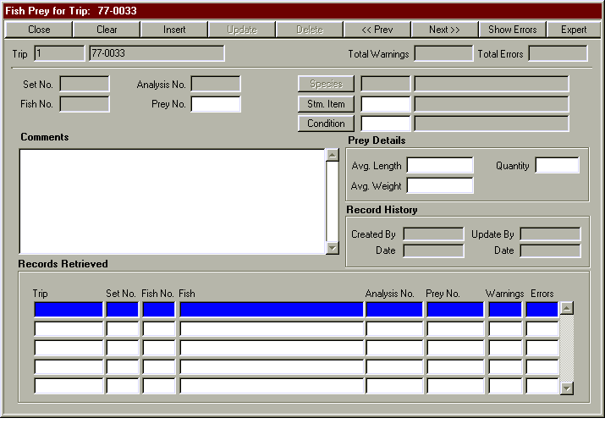
ToolBar Buttons

The following table lists all of the toolbar buttons used on the Fish Prey screen and describes their functionality in detail.

Button | Functionality
Close | When clicked, this button Exits the Fish Prey screen to return to the Fish Stomach Analysis screen.
Clear | When clicked, this button clears all data fields and puts the screen into Insert mode. Values for the Fish Morph’s Trip Id, Trip number, Set No., Fish No., Analysis No. and Species are also automatically set to those values held by the parent Fish Stomach Analysis record.
Insert | When clicked, this button adds a new Fish Prey record to the database using the data currently displayed on the screen.
Update | When clicked, this button writes the changes made on-screen to the Fish Prey database table.
Delete | When clicked, this button deletes the Fish Prey record currently displayed on the screen.
<< Prev | Moves the cursor in the Fish Prey screen’s table window to the previous Fish Prey record and displays the data on-screen.
Next >> | Moves the cursor in the Fish Prey screen’s table window to the next Fish Prey record and displays the data on-screen.
Show Errors | This button displays the Fish Prey Errors screen, which lists all warnings and errors associated with the currently displayed Fish Prey record.
Expert | When clicked, this button enables the Set No., Fish No., Analysis No. and Species fields for editing. As Set No., Fish No., Analysis No. and Species Code are part of the unique identifier for this Fish Prey, it is suggested that this option be used with the greatest of care.

Current Record Edit Items

The following table lists all of the data fields, push buttons, display fields and other functional items which are used to display and edit the record data currently displayed on the screen.

Item | Functionality
Trip Id | This display-only field shows the unique ID assigned to the Trip. If this field does not contain a number, it means that the record currently on the screen has not yet been loaded to the production database.
Trip | This display-only field shows the Trip number assigned by the observer for this Trip.
Total Warnings | This display-only field shows the total number of warnings generated by the edit checks for all records associated with the Trip.
Total Errors | This display-only field shows the total number of errors generated by the edit checks for all records associated with the Trip.
Set No | This expert-only editable field shows the Set No. associated with this Fish Prey record.
Fish No. | This expert-only editable field shows the Fish No. associated with this Fish Prey record.
Analysis No. | This expert-only editable field shows the Analysis No. associated with this Fish Prey record.
Prey No. | This editable field shows the Prey No. associated with this Fish Prey record.
Comments | This editable field permits the user to enter any free-form comments they may have regarding this Fish Prey record.
Species | This expert-only editable field shows the Species code assigned to this Fish Prey record. This field also has an associated display field, which will show the text description for the code, and an LOV pushbutton, which will invoke a quick-list from which the user may choose a valid Species.
Stm. Item | This editable field shows the Stomach Item code assigned to this Fish Prey record. This field also has an associated display field, which will show the text description for the code, and an LOV pushbutton, which will invoke a quick-list from which the user may choose a valid Stomach Item code.
Condition | This editable field shows the Condition code assigned to this Fish Prey record. This field also has an associated display field, which will show the text description for the code, and an LOV pushbutton, which will invoke a quick-list from which the user may choose a valid Condition code.
Avg. Length | This editable field shows the Average Length assigned to this Fish Prey record.
Avg. Weight | This editable field shows the Average Weight assigned to this Fish Prey record.
Quantity | This editable field shows the Quantity assigned to this Fish Prey record.
Created By | This display-only field shows the username of the person who originally created this record.
Created Date | This display-only field shows the date upon which the current record was originally created.
Update By | This display-only field shows the username of the person who last updated the record.
Update Date | This display-only field shows the date upon which the current record was last updated.
Table Window | The lower table window shows all Fish Prey records which may currently be selected by the user for editing. Various columns of data are shown to provide a quick-glance for easy selection of a record, and Warnings and Errors columns are provided to show the total number of Warnings and Errors which are currently registered against the listed Fish Prey.

3.13 SECURITY FORM

This screen allows any user to view the privileges that have been granted on their tables. It also allows a user to grant or revoke privileges on tables that they own. The form is in ENTER-QUERY mode when it is navigated to so the user only has to enter in a user and/ or table name and press the EXECUTE QUERY button to find out about the current privileges. To enter another query the user first has to press the ENTER QUERY button to put the form in enter query mode and then repeat the query process.

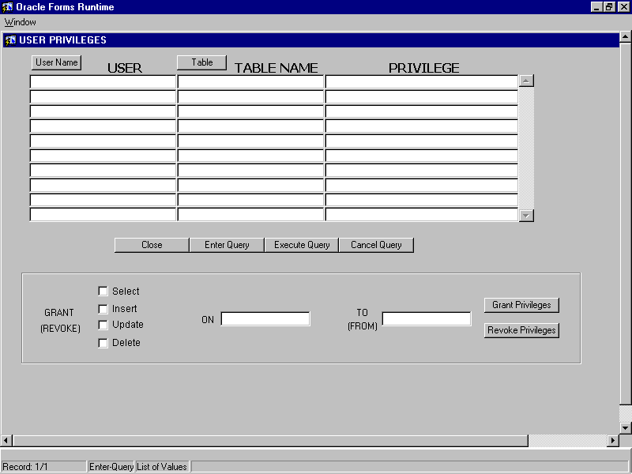
BUTTON FUNCTIONALITY
USER NAME | A list of values containing all the users with privileges to a user’s tables.
TABLE | Displays a list of all the tables and views owned by the user.
CLOSE | Exits the screen and brings the user to the TRIPS screen.
ENTER QUERY | This button clears the upper half of the screen and allows the user to enter a new query. The form gives an indication at the bottom if it is in ENTER-QUERY mode.
EXECUTE QUERY | This button will execute a query for the user based on the user and table entered as criteria for the query
CANCEL QUERY | Will cancel a query for the user

To grant or revoke privileges simply enter in the username and table you wish to grant or revoke privileges on. Then choose the privileges. Finally just press the appropriate button to grant or revoke the privileges. A message will display on the bottom of the screen indicating if the operation was successful.

Section 4 Account Setup

This section discusses the procedures to set up a client account to use the ISDB system, as well as how to set up the production account.

The source code for the client and production account setup is in the asdmfd CANSO2 account under the /usr/users/asdmfd/isdb directory. The loader subdirectory contains the raw file loader code. The setup directory contains the Oracle setup code for the client and production accounts.

4.1 Setup of Client Account

4.1.1 Oracle Setup

The code for the Oracle client setup is under /usr/users/asdmfd/isdb/setup/client. The instructions to set up the client Oracle account are in the ReadMe.txt file in this directory. This file is copied here:

This ReadMe file details how to set up a User Account for the ISDB system.
The procedures for setting up a Test account and for installing the audit trail
after an account installation are also detailed below.

------------------------------------------------------------------------------------
ISDB Production Environment
------------------------------------------------------------------------------------

To configure a regular user account for within the Production system, step through
the following process:

1) Navigate to /usr/users/asdmfd/isdb/setup/production.
Start SQL*Plus and log into the Observer account.

2) If you wish to log the configuration process, enter
'Spool /usr/users/asdmfd/logs/<username>_grants.log' at the SQL> prompt.

3) Activate the create roles script by typing:
'@ create_roles_and_grants.sql <username>' where <username> is the
account name of the user you are configuring for ISDB. The roles should now be created.

4) If you chose to log the process in step 2), type 'Spool Off' at the SQL> prompt.
An ASCII text file log of all actions performed during the granting process can
now be found in /usr/users/asdmfd/logs/'<username>_grants.log'.

5) Log out of the Observer account.

6) Navigate to /usr/users/asdmfd/isdb/setup/client.
Log into the Oracle account of the user you wish to configure.

7) If you wish to log the configuration process, enter
'Spool /usr/users/asdmfd/logs/<username>_configure.log at the SQL> prompt.

8) Activate the installation script by typing '@ setup_dbms.txt'.
The installation process will then continue until the banner

Edit System setup is now complete

**********************************/

appears in the SQL*Plus window. At this time, the configuration of the
user's account has been completed and the tables are now ready to accept
data.

9) If you chose to log the process in step 7), type 'Spool Off' at the SQL> prompt.
An ASCII text file log of all actions performed during the setup process can
now be found in /usr/users/asdmfd/logs/'<username>_configure.log'.

10) Log out of the user's account. ISDB User Production Environment
setup is now complete and ready to receive data. No data should be loaded into
the edit tables at this time.

------------------------------------------------------------------------------------
ISDB TEST Environment
------------------------------------------------------------------------------------

To configure a user account within a TEST environment such as TBank2, step through
the following process. NOTE: For configuring a user account in a normal production
environment, please follow the process outlined above. The process documented here
is ONLY for use in the configuring of a test account.

1) Navigate to /usr/users/asdmfd/isdb/setup/production.
Start SQL*Plus and log into the Observer account.

2) If you wish to log the configuration process, enter
'Spool /usr/users/asdmfd/logs/<username>_grants.log' at the SQL> prompt.

3) Activate the create roles script by typing:
'@ create_roles_and_grants.sql <username>' where <username> is the
account name of the user you are configuring for ISDB. The roles should now be created.

4) If you chose to log the process in step 2), type 'Spool Off' at the SQL> prompt.
An ASCII text file log of all actions performed during the granting process can
now be found in /usr/users/asdmfd/logs/'<username>_grants.log'.

5) Log out of the Observer account.

6) Navigate to /usr/users/asdmfd/isdb/setup/client.
Log into the Oracle account of the user you wish to configure.

REMEMBER: This process is ONLY for the installation of a test account in an
environment such as TBank2! If you are installing a regular user's account in a
production environment, table sizing information required for production (but not
test) databases will NOT be added to the system when following this process.

7) If you wish to log the configuration process, enter
'Spool /usr/users/asdmfd/logs/<username>_configure.log at the SQL> prompt.

8) Activate the installation script by typing '@ setup_test_dbms.txt' at
the SQL> prompt. The installation process will then continue until the banner

Edit System Test Environment setup is now complete

****************************************************/

appears in the SQL*Plus window. At this time, the configuration of the
user's account has been completed and the tables are now ready to accept
data.

9) If you chose to log the process in step 7), type 'Spool Off' at the SQL> prompt.
An ASCII text file log of all actions performed during the setup process can
now be found in /usr/users/asdmfd/logs/'<username>_configure.log'.

10) Log out of the user's account. ISDB User Test Environment setup
is now complete and ready to receive data. No data should be loaded into
the edit tables at this time.

------------------------------------------------------------------------------------
ISDB Audit Trail
------------------------------------------------------------------------------------

The code for the activation of the ISDB audit trail is installed by default when
configuring a regular or test account, as detailed above. However, in some cases
(such as in data conversion) the environment may have been custom-configured without
an audit trail, so as to speed data processing for a temporary period.

Should the audit trail need to be installed at some point after an ISDB user's
system has been created, the following steps should be performed to activate the
required triggers. The same process applies for both the User and Test accounts
outlined above.

To install the audit trail at any point after a custom installation:

1) Navigate to /usr/users/asdmfd/isdb/setup/client.
Log into the Oracle account of the user you wish to configure. This account
should already have the ISDB system tables in place and ONLY be missing the audit
trail triggers.

3) If you wish to log the configuration process, enter
'Spool /usr/users/asdmfd/logs/<username>_Audit.log' at the SQL> prompt.

4) Activate the installation script by typing '@ setup_audit_trail.txt'.
The installation process will then continue until the banner

Edit System Audit Trail setup is now complete

***********************************************/

appears in the SQL*Plus window. At this time, the configuration of the
user's account has been completed and the audit trail tables will now automatically
log user transactions.

5) If you chose to log the process in step 3), type 'Spool Off' at the SQL> prompt.
An ASCII text file log of all actions performed during the setup process can
now be found in /usr/users/asdmfd/logs/'<username>_Audit.log'.

6) Log out of the user's account. ISDB Audit Trail Installation
is now complete.

4.1.2 UNIX Setup

In order to invoke the raw file loader the user must have an environment variable called ISDB_HOME that points to /usr/users/asdmfd/isdb/loader. The .profile file of ISDB users needs to have the following line added:

export ISDB_HOME=/usr/users/asdmfd/isdb/loader

The loader is then invoked as described in the Observer Edit Data Loader User's Guide.doc file.

4.2 Setup of Production Account

4.2.1 Oracle Setup

The code for the Oracle client setup is under /usr/users/asdmfd/isdb/setup/production. The instructions to set up the client Oracle account are in the ReadMe.txt file in this directory. This file is copied here:

This ReadMe file details how to set up the Production Account (Observer) for
the ISDB system. The procedure for setting up a Test Observer account is also
detailed below.

------------------------------------------------------------------------------------
ISDB Production Environment - Observer Account
------------------------------------------------------------------------------------

To configure the Production account (Observer) for within the ISDB Production system,
step through the following process:

1) Navigate to /usr/users/asdmfd/isdb/setup/production.
Start SQL*Plus and log into the Observer account.

2) If you wish to log the configuration process, enter
'Spool /usr/users/asdmfd/logs/observer_configure.log' at the SQL> prompt.

3) Activate the installation script by typing: '@ setup_prod_dbms.txt'.
The installation process will then continue until the banner

ISDB Observer account setup is now complete

*********************************************/

appears in the SQL*Plus window. At this time, the configuration of the
observer account has been completed and the tables are now ready to accept
data.

4) If you chose to log the process in step 2), type 'Spool Off' at the SQL> prompt.
An ASCII text file log of all actions performed during the setup process can
now be found in /usr/users/asdmfd/logs/'observer_configure.log'.

5) Log out of the observer account. ISDB Observer
Production Environment setup is now complete and ready to receive data.
No data should be loaded into the system tables at this time.

------------------------------------------------------------------------------------
ISDB TEST Environment - Observer Account
------------------------------------------------------------------------------------

To configure the Observer account within a TEST environment such as TBank2, step through
the following process. NOTE: For configuring the Observer account in a normal production
environment, please follow the process outlined above. The process documented here
is ONLY for use in the configuring of a test account.

1) Navigate to /usr/users/asdmfd/isdb/setup/production.
Start SQL*Plus and log into the Observer account.

REMEMBER: This process is ONLY for the installation
of a test account in an environment such as TBank2! If you are installing the Observer
account in a production environment, table sizing information required for production
(but not test) databases will NOT be added to the system when following this process.

2) If you wish to log the configuration process, enter
'Spool /usr/users/asdmfd/logs/observer_configure.log' at the SQL> prompt.

3) Activate the installation script by typing: '@ setup_test_prod_dbms.txt'.
The installation process will then continue until the banner

ISDB Observer Test account setup is now complete

**************************************************/

appears in the SQL*Plus window. At this time, the configuration of the
observer account has been completed and the tables are now ready to accept
data.

4) If you chose to log the process in step 2), type 'Spool Off' at the SQL> prompt.
An ASCII text file log of all actions performed during the setup process can
now be found in /usr/users/asdmfd/logs/'observer_configure.log'.

5) Log out of the user's account. ISDB Observer
Test Environment setup is now complete and ready to receive data. No data
should be loaded into the system tables at this time.

4.2.2 UNIX Setup

No UNIX Setup is needed for the ISDB production account.

4.3 Installing Updated source code

As the system evolves it may be necessary to change the stored source code to address a MMARF. The following procedure should be followed for updating the ISDB source code.

- Copy the file from setup/client to a different working directory.
- Update the file in the working directory to address the MMARF.
- Test the update in a tbank2 account.
- Install on other tbank2 accounts and obtain client acceptance of the fix.

After the code has been tested it can be placed in the official release directory and can then be installed on all of the client accounts.

- Copy the updated file into setup/client, overwriting the obsolete version with the latest version.
- Navigate to setup/client and run the install_code.sh script to automatically install the source code on all defined user accounts.
The script will install all of the source code modules for the following accounts:
yorka/tbank2
bmace/tbank2
beanland/tbank2
observer/tbank2
lambert/tbank2
yorka/bank2
bmace/bank2
observer/bank2
beanland/bank2
If there are any ISDB users who are not in this set then the installer will have to install the updated source code manually from the SQL*Plus command line. The sms_install_code.sql script in the setup/client directory will install all of the ISDB source code for a user.

The results from the install_code.sh script are written to the log file /usr/users/asdmfd/logs/isdb_log.txt.

