**Experiment 2.1**

|  |  |
| --- | --- |
| **Student Name: TARUN SINGHAL** | **UID:** 20BCS3552 |
| **Branch:** AIT CSE – Information Security | **Section & Group:** 20BIS1-A |
| **Semester:** 5th | **Date:** 12.10.2022 |
| **Course Name**: Computer Networks Lab | **Course Code:** 20CSP-342 |

**1. Aim/Overview of the practical:**

To configure dynamic routing protocol RIP.

**2. Task to be done:**

To create two different networks and configure them with routers using dynamic routing.

**3. Steps for experiment/practical:**

1) Place the end devices and connecting devices like switch and router.  
2) Connect the routers using copper cross-over and the rest with copper straight-through cables.  
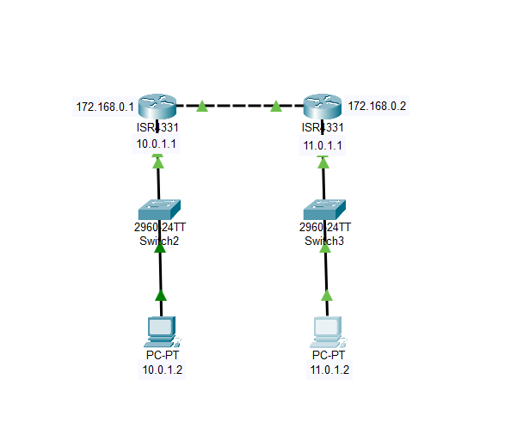  
3) Assign each router’s interface and then assign each PC’s IP address, default gateway and subnet mask.  
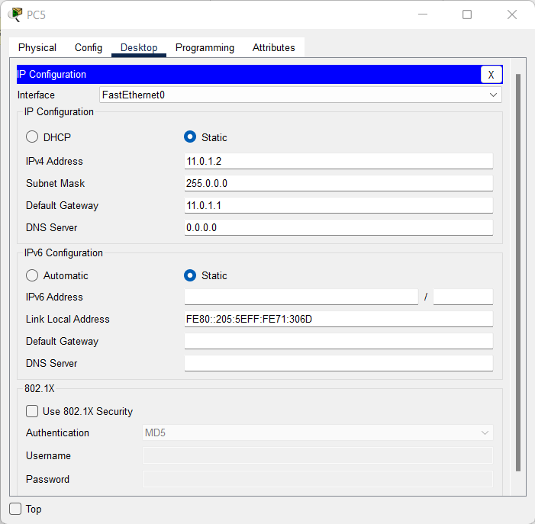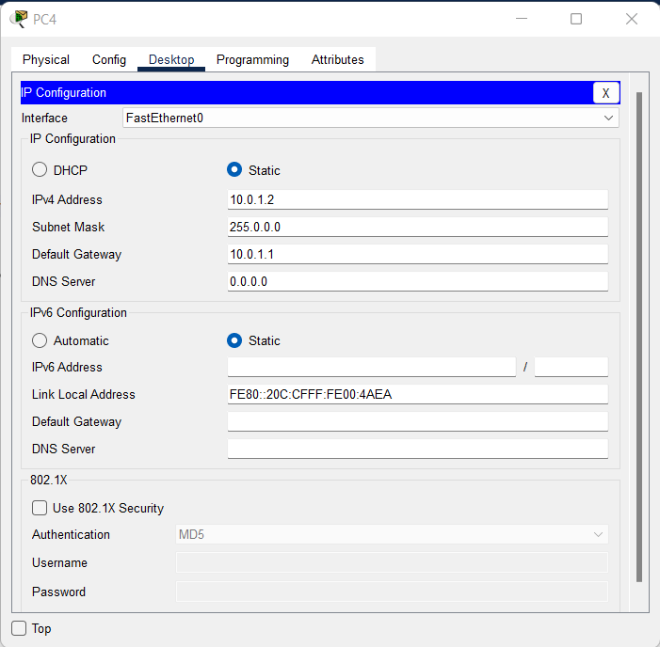  
4) For the dynamic routing:  
a) Click on the router and then go to Router and thereafter RIP.  
b) Add the network address of the router’s interface with the end devices and with the other router.  
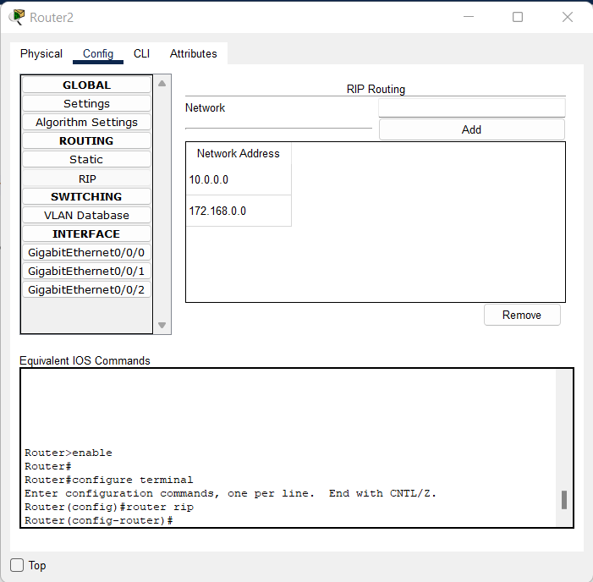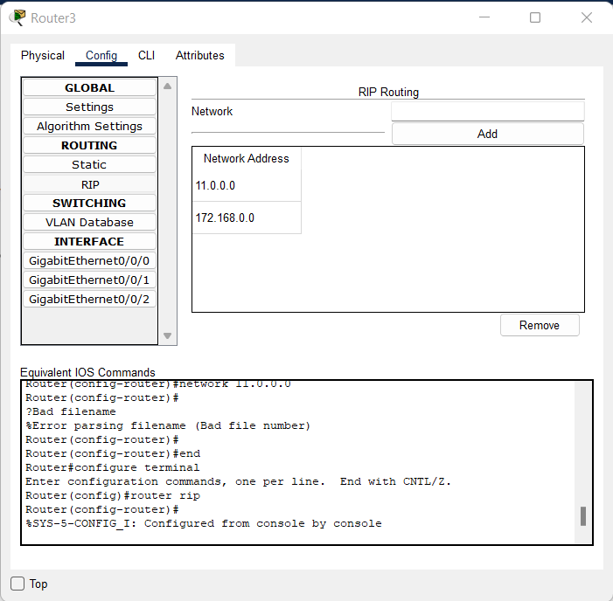  
c) Move to global and then settings. Go to NVRAM and click on save to save the configuration made in the RIP.  
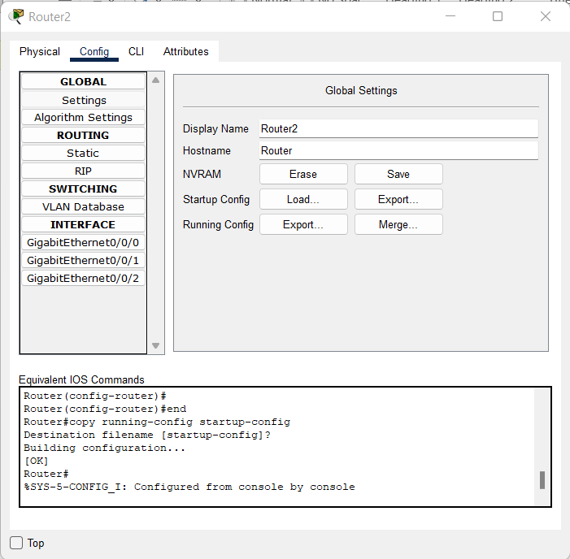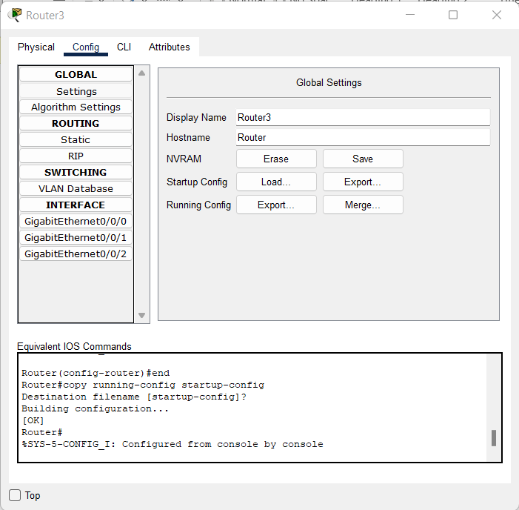  
5) Ping the PC of the other network to check the connection.

**4. Algorithm (For Programming)**

Nil.

**5. Pseudocode (For Programming)**

Nil.

**6. Code (For Programming)**

 Nil.

**7. Result/Output/Writing Summary:**

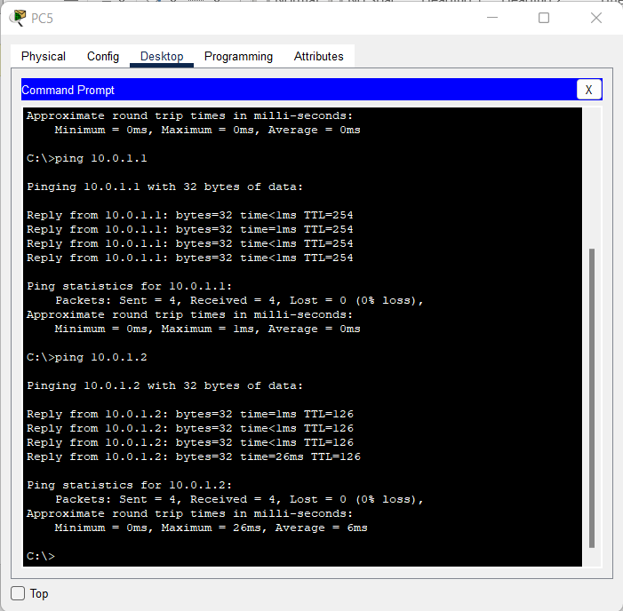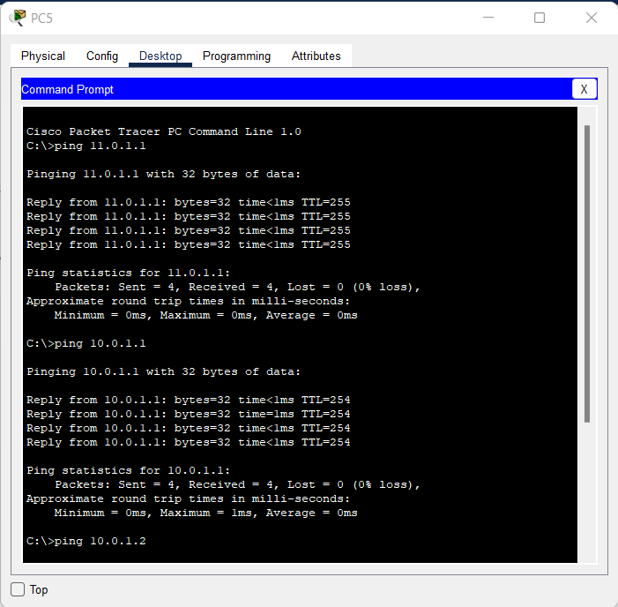

**Learning outcomes (What I have learnt):**

1) Configuring end devices and network devices.  
2) Implementing dynamic routing.

**Evaluation Grid (Created as per the Assessment Model):**

|  |  |  |  |
| --- | --- | --- | --- |
| Sr. No. | Parameters | Marks Obtained | Maximum Marks |
| 1. | Worksheet completion |  | 8 |
| 2. | Conduct of Experiment |  | 12 |
| 3. | Quiz/Viva Voce |  | 10 |
|  | Total |  | 30 |