**Student Name: Lagan Verma UID:20BCS3515**

**Branch: Information Security Section/Group: 20BIS1/A**

**Semester: 5th Date of Performance: 15.08.2022**

**Subject Name: Network Defense Essentials Lab Subject Code: 20CSB-331**

**1. Aim/Overview of the practical:**

|  |  |
| --- | --- |
| **WS1** | Implementing Access Controls in Windows Machine and Managing Access Controls in linux machine. |

**2. Steps for experiment:**

* Right click on the file in which we want to implement access control.
* Go to properties then go to the security tab.
* Under Group or user names menu , click on edit then click on add.
* Type users in object name and click on check names.
* Click on ok, then user will be created with the name Users, click on apply.
* Click on advance then select the user, click on edit, select the permissions
* Click on ok then click on apply to apply the settings and click on yes to accept the changes.
* Open the file, settings will be displayed.

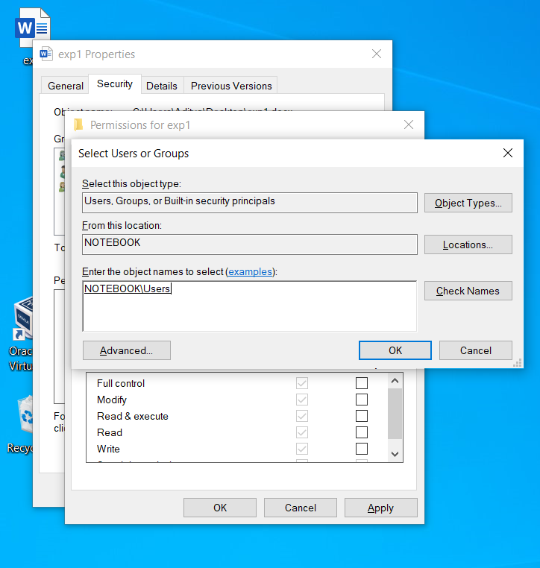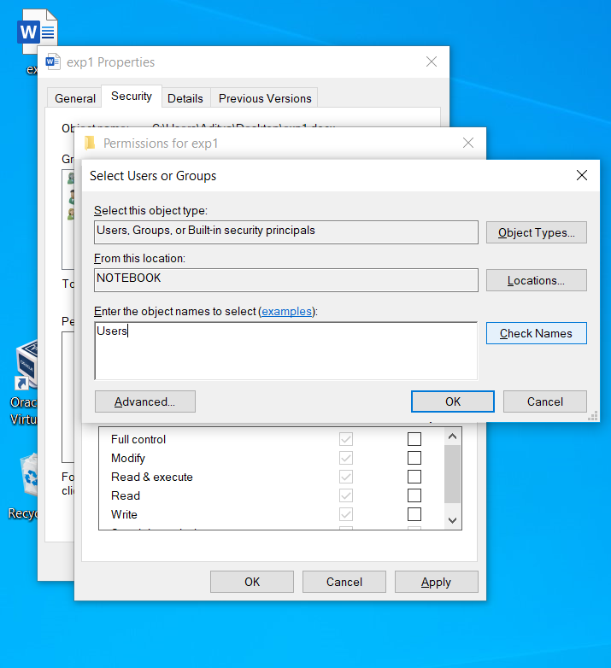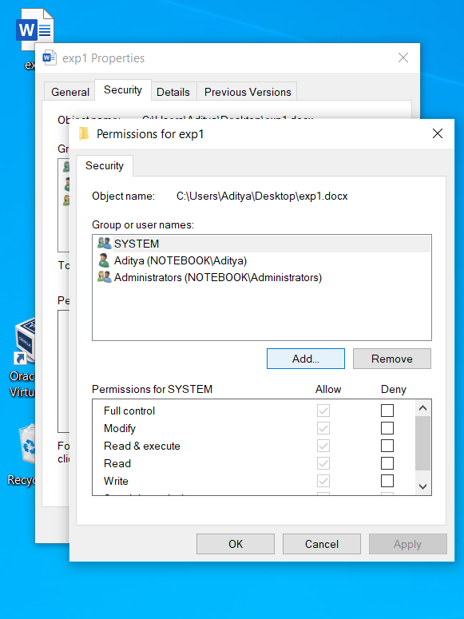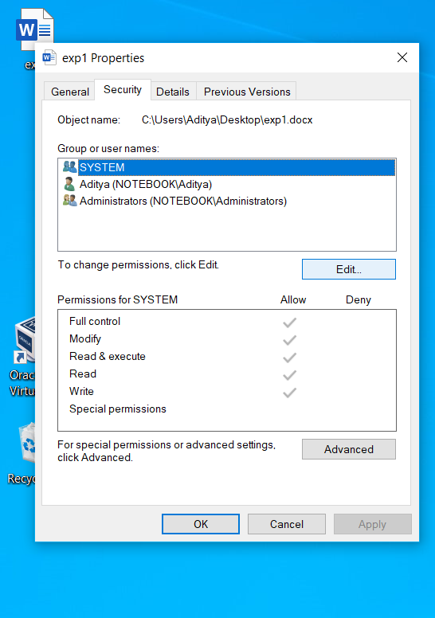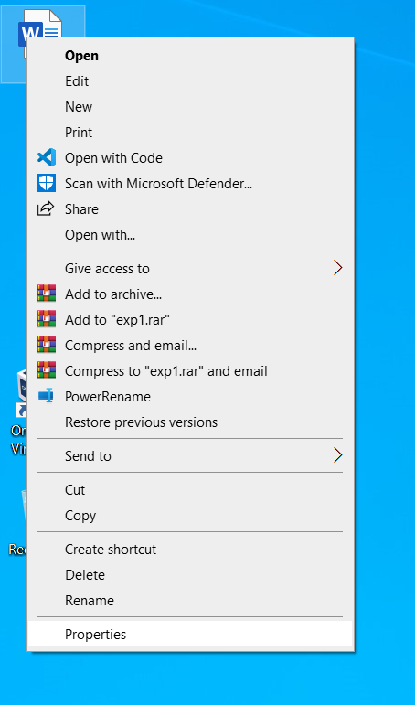**4. Screenshots:**

