**ASSIGNMENT-1**

# Student Name: Lagan Verma UID: 20BCS3515

**Branch: Information Security Section/Group:20BIS1/A**

# Semester: 5th

**Subject Name:** Security and Cryptography **Subject Code:** 20CSP-344

**Aim:** Implementing role-based access control in windows

# Steps for Role-Based Access control.

1. Open Window Admin Centre

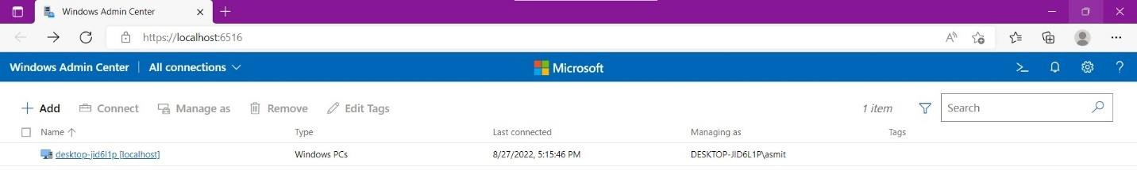

1. For connecting Window Admin centre with Microsoft Azure, we must create a Microsoft account

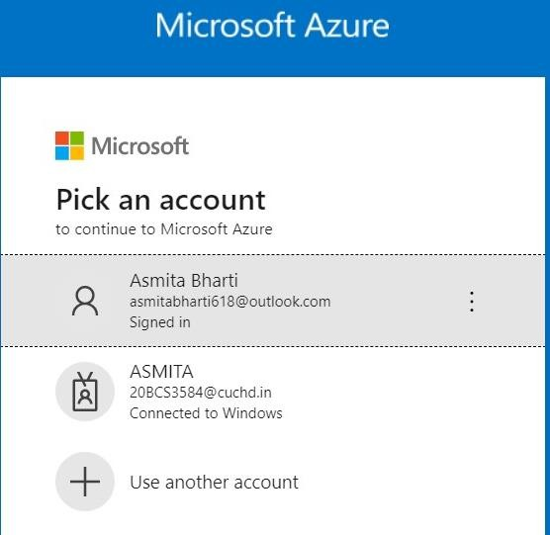

1. Now Go to settings and in settings click on **Register** and then register in Azure

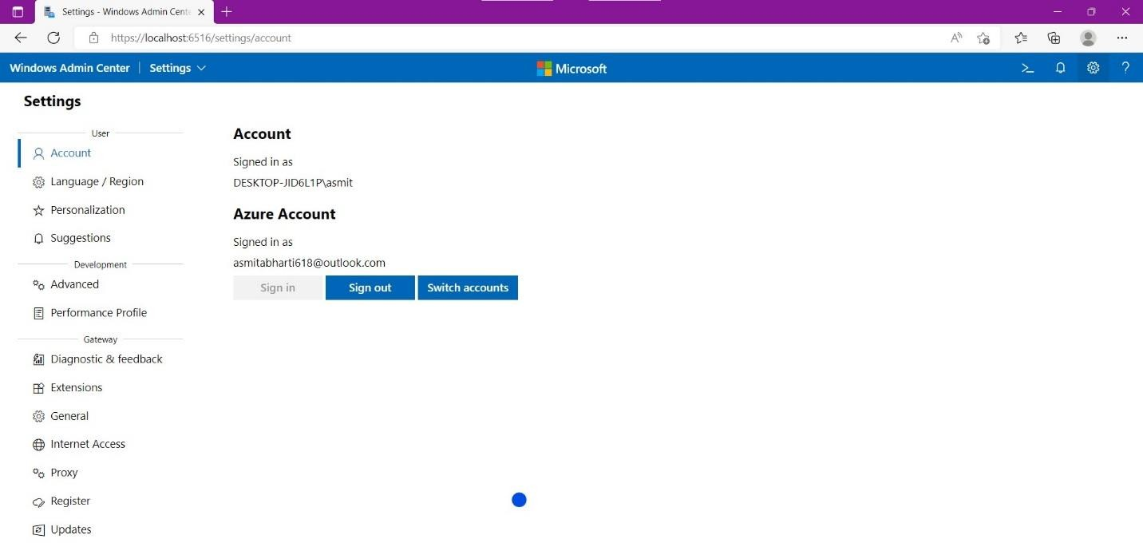

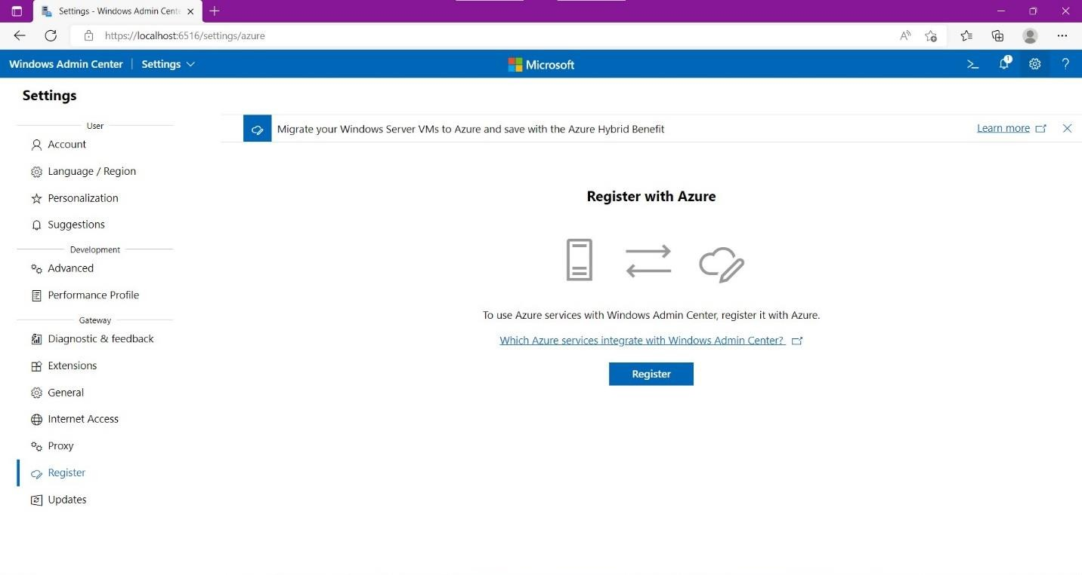

1. After Clicking on register a pop-up window will appear named **“Get started with Azure in Windows admin centre**” will appear.

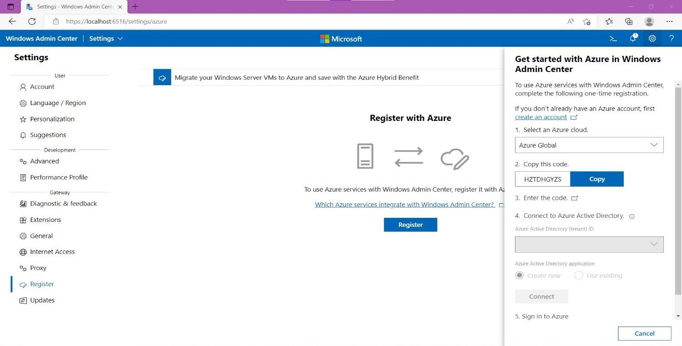

1. In the pop-up window copy the code and click on **“Enter the code”** a new window will appear and now paste the code.



1. Under Azure Active Directory application, select **“Create new”** and click on Connect.

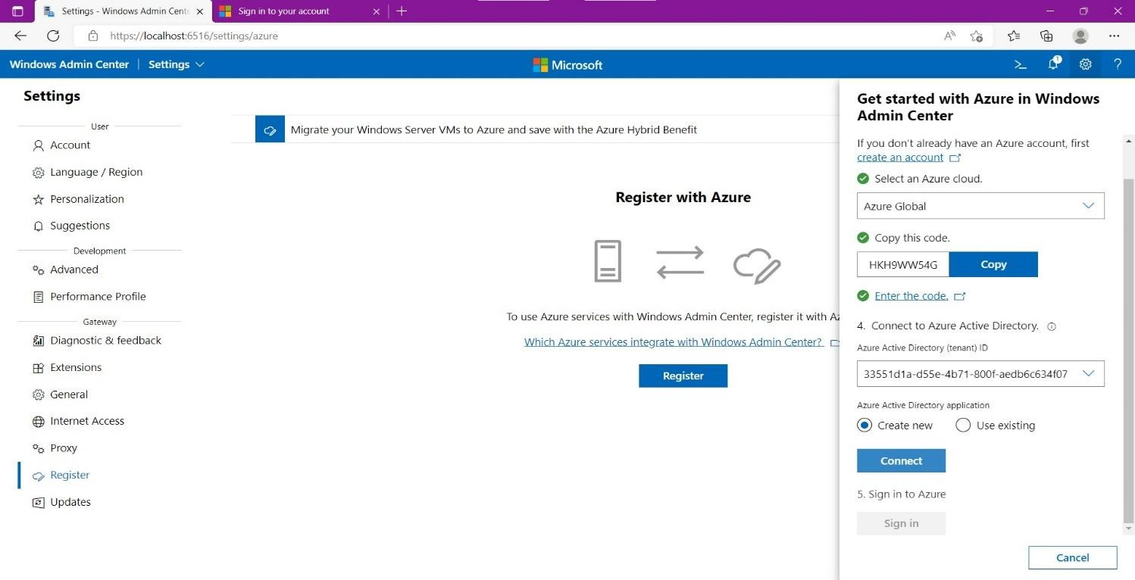

1. Now, you will be redirected to Microsoft Azure.

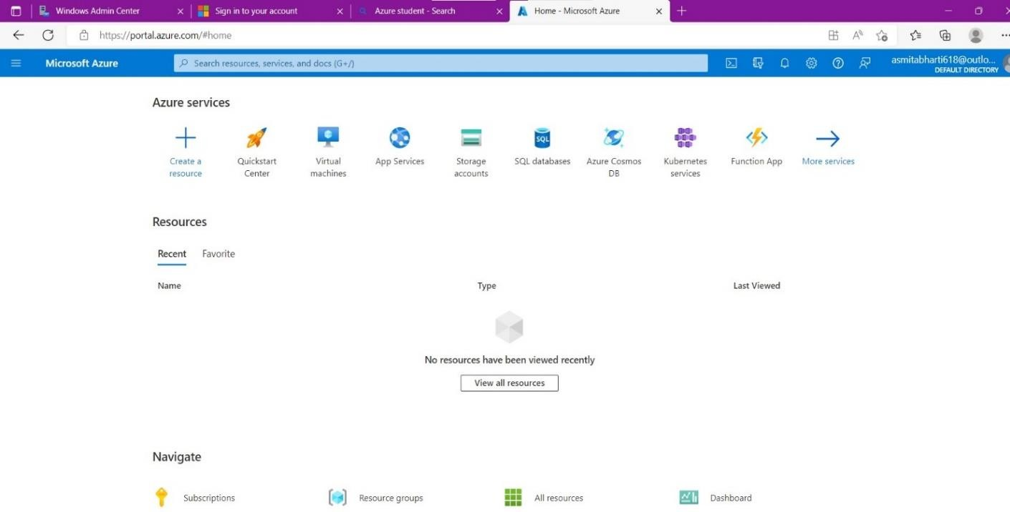

1. In the search bar, search for Azure Ad roles. Select Azure AD roles and administrators

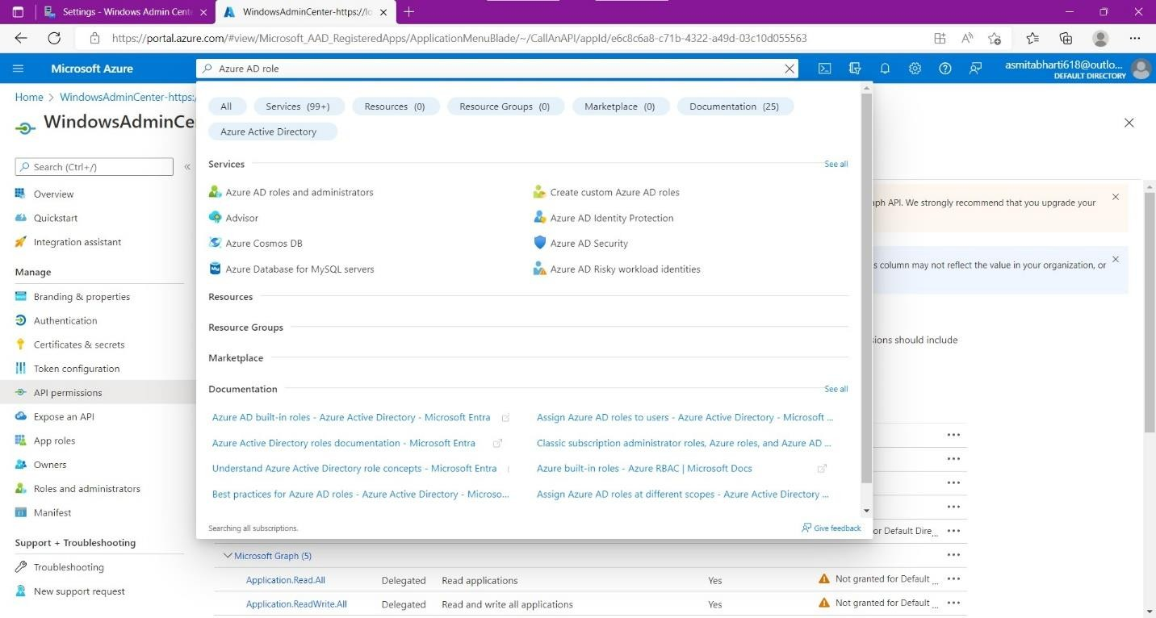

1. After selecting Azure Ad roles and administrator we can see that our role is Global administrator. Now we can change the roles of users in it.

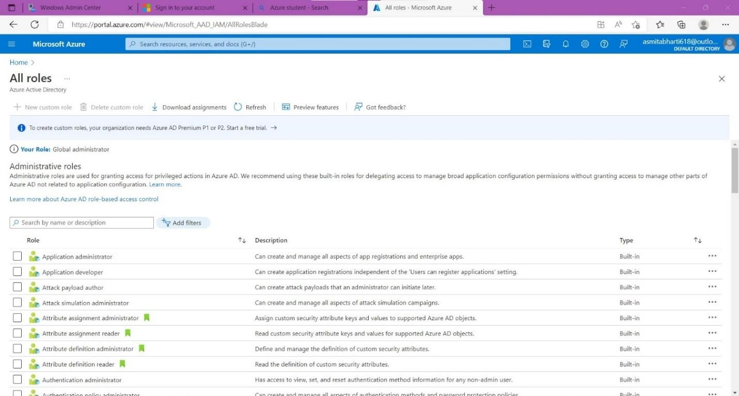

1. Click on your roles.

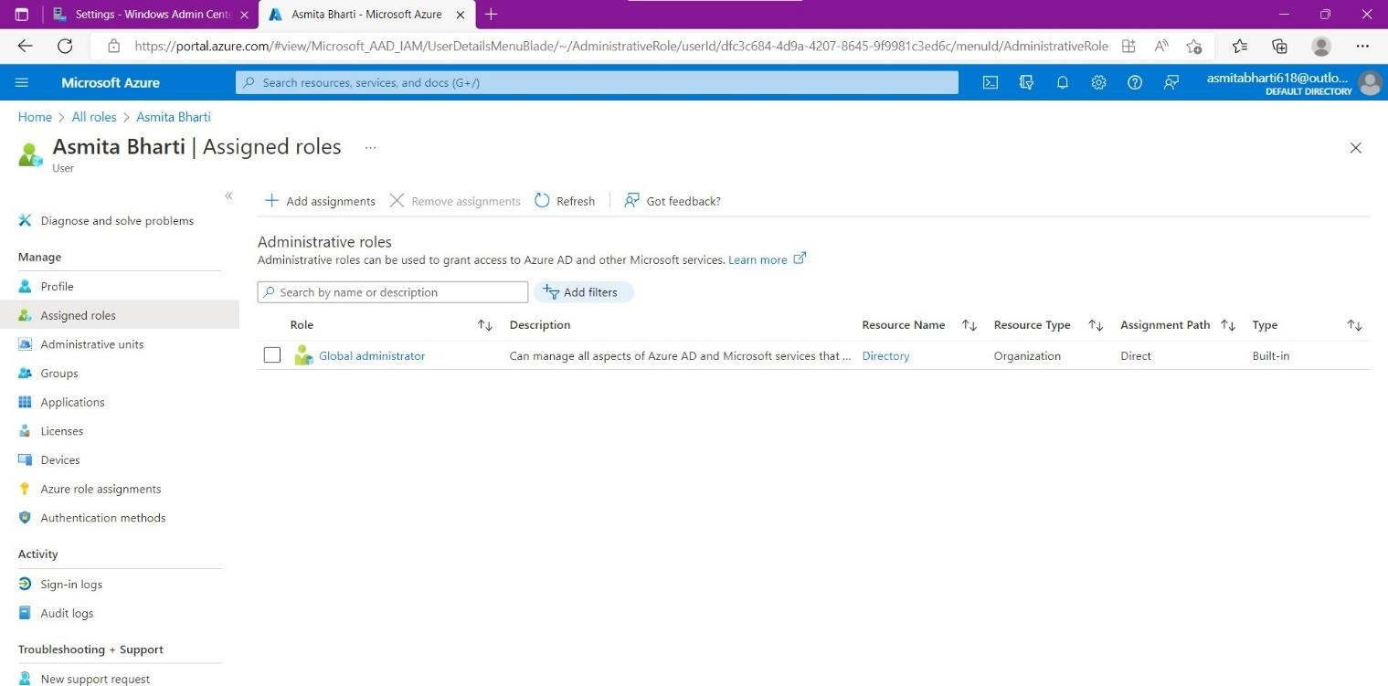

1. Click on Add assignments. A pop up will appear named Directory roles search user in it.

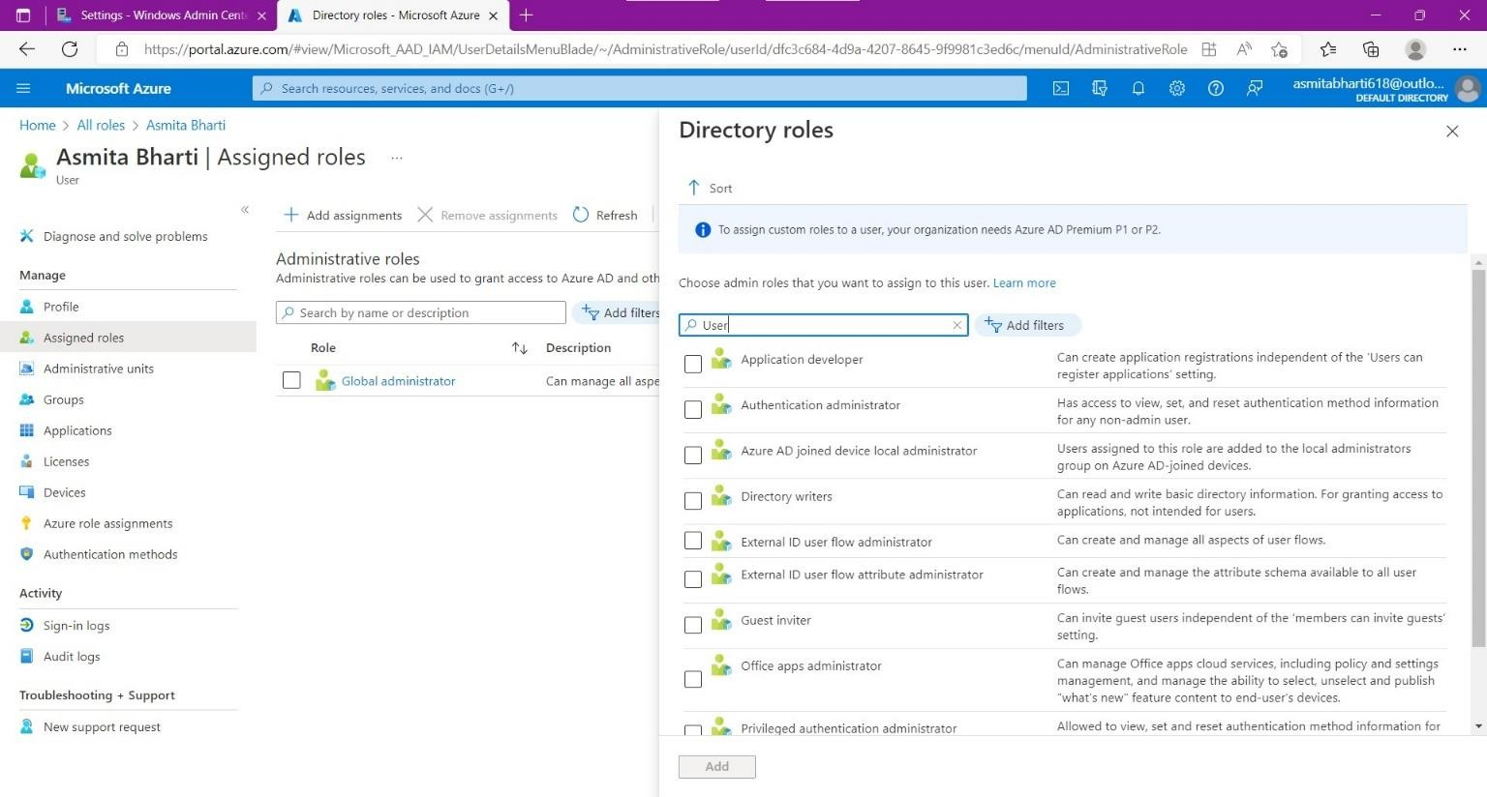

1. Now we can assign any role to the user. Select any role you want to assign to the user. Click on Add. (Here, we are selecting Directory writers).

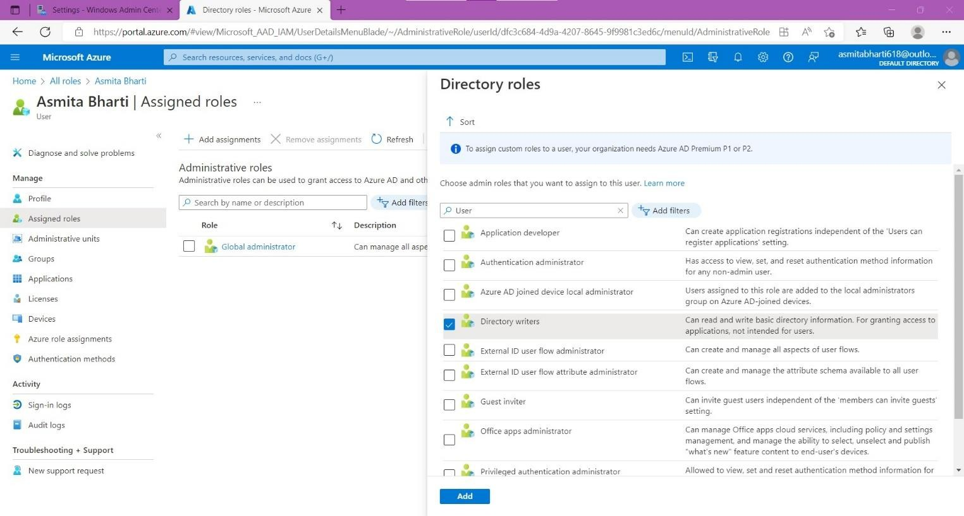

1. Now refresh the page. After refreshing we can see the Directory writer roles assigned to the user.

